
A
PROJECT REPORT
ON

“PustakSetu : Library Management System”

SUBMITTED AS A PARTIAL REQUIREMENT FOR BACHELOR OF COMPUTER APPLICATION
(SEMESTER V)


SUBMITTED BY:
Student names 1
Student names 2
Student names 3
GUIDED BY:
Ms. Minal desai

YEAR 2025-26
Acknowledgement
The success and outcome of this project required a lot of guidance and assistance from many people, and we are extremely fortunate to have gotten this all along with the completion of our project work. Whatever we have done is only due to such guidance and assistance.

We would not forget to thank Principal Dr. Ashish Desai, BCA coordinators Dr. Shalini Mali and Ms. Heta Desai and our project guide Ms. Minal Desai and all other assistant professors, who took a keen interest in our project work and guided us all along till the completion of our project work by providing all the necessary information for developing a good system.

We are extremely grateful to them for providing such nice support and guidance, though he/she had a busy schedule managing the college dealings.

We are thankful and fortunate enough to have gotten support and guidance from all the teaching staff in the Bachelor of Computer Application Department, which helped us successfully complete our project work. Also, we would like to extend our sincere regards to all the non-teaching staff of the Bachelor of Computer Application Department for their timely support.

Student names 1
Student names 2
Student names 3

INDEX

SR. NO. | CONTENT | PAGE NO.
1 | Introduction
1 | 1.1 Project Profile
2 | Environment Description
2 | 2.1 Hardware & Software Requirements
2 | 2.2 Technology Used
3 | System Requirement Specification
3 | 3.1 Data Dictionary
3 | 3.2 Feasibility Analysis  3.2.1 Economic Feasibility  3.2.2 Technical Feasibility  3.2.3 Behavioural Feasibility
3 | 3.3 E-R Diagram & Data Dictionary
3 | 3.4 Data Flow Diagram
4 | Software Project Planning
4 | 4.1 Scope
4 | 4.2 Objectives
4 | 4.3 Expected Advantages
4 | 5.1 Input Design

 | 5.2 Output Design
6 | Software Testing
6 | 6.1 Introduction
6 | 6.2 Objectives
6 | 6.3 Levels of Testing
6 | 6.4 Test Case
7 | References/Bibliography

Abstract:
PustakSetu – Library Management System is a web-based application developed to simplify and modernize the management of library resources and student borrowing activities. Traditional library management processes often depend on manual records for maintaining book information, member details, issue and return transactions, inventory, and fine records. Such processes can be time-consuming, difficult to maintain, and may result in errors or delays in accessing accurate information.
The proposed system, PustakSetu, provides a centralized platform for managing library operations digitally. The system allows administrators to manage books, categories, members, inventory, book issuance, returns, overdue records, and fines. Students can register and securely log in to the system, browse the available book catalog, search and filter books, view detailed book information, and check the physical rack or shelf location of books. They can also monitor currently borrowed books, return deadlines, overdue information, and borrowing history through their personal dashboard.
The system is developed using modern web technologies to provide a responsive and efficient user experience. The frontend is implemented using React.js with Vite and Bootstrap 5, while the backend uses Node.js and Express.js to provide RESTful APIs and handle application logic. JWT-based authentication is used for secure user sessions and role-based access control. The database manages important information related to users, books, categories, inventory, issue and return transactions, fines, and other library operations.
The primary objective of PustakSetu is to provide a reliable, organized, and user-friendly digital library management solution. By reducing dependency on manual record keeping and providing centralized access to library information, the system improves the efficiency of circulation and inventory management. It also enables students to conveniently discover books and track their borrowing activities while providing administrators with better control over library resources and operational records.

1. Introduction
1.1 Project Profile
PustakSetu – Library Management System is a web-based application developed to simplify and improve the management of library resources and student borrowing activities. Traditional library systems often depend on manual records for maintaining information about books, members, issue and return transactions, inventory, and fines. Managing these records manually can require considerable time and may lead to difficulties in maintaining accurate and up-to-date information.

The proposed system, PustakSetu, aims to overcome these limitations by providing a centralized digital platform for managing important library operations. The system enables administrators to manage the book catalog, categories, members, inventory, book issuance, returns, overdue records, and fine-related information. This provides a structured method for maintaining library resources and reduces dependency on manual record keeping.

The platform primarily supports three types of users: Administrators, Students/Members, and Visitors. Administrators can manage books, categories, member accounts, circulation activities, inventory records, and library-related reports. Students can securely register and log in, search and filter books, view book details and shelf locations, and monitor their currently borrowed books, return deadlines, overdue information, and borrowing history. Visitors can access publicly available library information and explore the book catalog without requiring an authenticated account.

The system is developed using modern web technologies to provide a responsive and maintainable application. The frontend is implemented using React.js with Vite, while Bootstrap 5 and Bootstrap Icons are used for the user interface and responsive styling. The backend is implemented using Node.js and Express.js, which provide the server-side logic and RESTful API services. JWT-based authentication and role-based access control are used to provide secure access to the appropriate features of the system.

The main objective of PustakSetu is to provide an organized, reliable, and user-friendly digital solution for library management. By centralizing library information and circulation activities, the system helps administrators manage resources more efficiently while allowing students to conveniently discover books and monitor their borrowing activities. Overall, PustakSetu provides a practical approach to digitizing essential library operations and improving accessibility, accuracy, and efficiency.

2. Environment description
2.1 Hardware & Software Requirements
The development and execution of the PustakSetu – Library Management System require suitable hardware and software resources to ensure smooth development, testing, and operation of the web application. Since the system is a web-based application, it does not require specialized or high-end hardware and can operate efficiently on a standard computer system.
Hardware Requirements
The minimum hardware requirements for development and usage of the PustakSetu system are as follows:
- Processor: Intel Core i3 or higher
- RAM: Minimum 4 GB (8 GB recommended for development)
- Storage: At least 256 GB HDD or SSD
- Display: Standard monitor with 1366 × 768 resolution or higher
- Internet Connection: Stable internet connection for package installation, development services, and application access
These specifications are sufficient for running the development environment, web browser, backend server, database services, and other tools required for the project.

Software Requirements
The following software components are required for developing and running the system:
- Operating System: Windows, Linux, or macOS
- Code Editor: Visual Studio Code (VS Code)
- Web Browser: Google Chrome or Microsoft Edge
- Runtime Environment: Node.js
- Frontend Framework: React.js
- Build Tool: Vite
- Backend Framework: Express.js
- Database: Relational database used by the PustakSetu backend
- Version Control: Git
- API Testing: Postman or equivalent REST API testing tool
These software tools provide the required environment for developing, testing, debugging, and maintaining the PustakSetu web application.

2.2 Technology Used
PustakSetu is developed using modern web technologies to provide a responsive, reliable, and user-friendly library management platform. The system follows a client-server architecture in which the React-based frontend communicates with the Node.js and Express.js backend through RESTful APIs. The selected technologies support modular development, easy maintenance, secure authentication, and efficient management of library operations.
Frontend Technologies
React.js: Used to build the user interface using reusable components and dynamic pages.
Vite: Used as the frontend development and build tool, providing fast development and efficient application builds.
React Router DOM: Used for client-side routing and navigation between pages such as Home, Books, Book Details, Login, Register, My Books, and Profile.
Bootstrap 5: Used for responsive layout, forms, tables, buttons, cards, and other interface components.
Bootstrap Icons: Used to provide consistent icons throughout the application.
Axios: Used for communication between the frontend and backend REST APIs. JWT authentication tokens are handled through Axios interceptors.
React Context API: Used for managing authentication and user session state across the application.
Backend Technologies
Node.js: Provides the runtime environment for executing the server-side application.
Express.js: Used to develop RESTful APIs for authentication, books, categories, members, issue/return operations, and other library management functions.
JWT (JSON Web Token): Used for secure user authentication and maintaining authenticated sessions.
Role-Based Access Control (RBAC): Used to restrict administrative functions and ensure that Admin and Student/Member users can access only the operations permitted for their roles.
Database
A relational database is used to store and manage structured library information such as users, books, categories, inventory, issues, returns, and fine-related records. The backend communicates with the database through the server-side application, keeping data operations centralized and controlled.
Overall, these technologies provide PustakSetu with a scalable and maintainable foundation for digitizing library management and improving access to library services.

3. SYSTEM REQUIREMENT SPECIFICATION
3.1 Data Dictionary
The Data Dictionary of PustakSetu defines the important data elements used by the Library Management System. It provides a structured description of the information stored and processed by different modules of the system. The major data elements include user information, book information, category details, inventory records, issue and return transactions, and fine-related information.
Data Element | Description
User_ID | Unique identification number of a registered user.
Name | Name of the student/member or administrator.
Email | Email address used for identification and communication.
Password | Encrypted user authentication credential.
Role | Defines the access level of the user, such as Admin or Student.
Student_ID | Unique identification assigned to a student/member.
Book_ID | Unique identification number assigned to each book.
Title | Title/name of the book.
Author | Author or authors of the book.
ISBN | International Standard Book Number used to identify a book edition.
Category_ID | Unique identifier of a book category.
Category_Name | Name of the category or subject to which a book belongs.
Quantity | Total number of copies available in the library inventory.
Available_Quantity | Number of copies currently available for borrowing.
Issue_ID | Unique identifier of a book issue transaction.
Issue_Date | Date on which a book is issued to a student/member.
Due_Date | Date by which the issued book should be returned.
Return_Date | Actual date on which the book is returned.
Fine | Amount applicable when a book is returned after its due date.
The Data Dictionary helps maintain consistency in database design, API development, validation, testing, and documentation of the PustakSetu system.

3.2 Feasibility Analysis
Feasibility analysis is conducted to determine whether the proposed PustakSetu — Library Management System is practical and achievable within the available resources, technology, time, and organizational requirements. It evaluates the system from economic, technical, and behavioural perspectives before and during development.
3.2.1 Economic Feasibility
PustakSetu is economically feasible because it is developed using widely available and cost-effective technologies such as React.js, Vite, Bootstrap, Node.js, and Express.js. These technologies are freely available and do not require expensive proprietary software licenses.
The system can reduce the cost and effort associated with maintaining manual library records, searching for books, managing issue and return transactions, and tracking overdue books. Therefore, the expected benefits of improved efficiency and reduced administrative effort justify the development cost.
3.2.2 Technical Feasibility
The project is technically feasible because the technologies required for its development are mature, widely used, and well supported. React.js and Vite are used for developing the frontend, while Node.js and Express.js provide the backend REST APIs. Bootstrap 5 provides responsive interface components, and JWT-based authentication with role-based access control provides controlled access to system functions.
The system can operate on commonly available computers with a modern web browser and a stable network connection. The development team can also maintain and extend the system using standard development and testing tools.
3.2.3 Behavioural Feasibility
PustakSetu is behaviourally feasible because its interface is designed to be simple and easy to understand for different categories of users. Students can search and browse books, view availability, manage their borrowed books, and check due dates. Administrators can manage books, categories, members, inventory, and circulation activities through appropriate system functions.
The system reduces dependency on manual records and repetitive work, making library operations more organized and efficient. Since the system follows familiar web-based interaction patterns, users can adapt to it with minimal training.

3.3 E-R Diagram & Data Dictionary
The Entity-Relationship (E-R) Diagram represents the logical structure of the PustakSetu database. It identifies the major entities involved in the Library Management System and describes the relationships between them. The E-R model helps in organizing library information and provides a foundation for designing the relational database.
The major entities of PustakSetu include Users, Books, Categories, Inventory, Issues, Returns, and Fines. A user can have multiple book issue records, while each book belongs to a particular category. Inventory records maintain information about the available copies of books. Issue and return records maintain the complete circulation history of books, while fine records store applicable overdue charges.

In the PustakSetu system, the main entities include:
Data Dictionary – PustakSetu
1. Users Table
Column Name | Description
u_id | Unique ID of the user
u_name | Name of the user
u_email | Email address
u_password | User password
u_role | User role such as Admin or Student
u_studentId | Student identification number
u_phone | Contact number
u_cardId | Library card identification
u_isActive | Indicates whether the account is active
u_isDeleted | Indicates whether the record is deleted
u_deletedAt | Date/time of deletion
u_deletedBy | Administrator who deleted the record
u_createdAt | Account creation date
2. Categories Table
Column Name | Description
c_id | Unique category ID
c_name | Category name
c_description | Description of the category
c_isDeleted | Deletion status
c_deletedAt | Date/time of deletion
c_deletedBy | Administrator who deleted the category
c_createdAt | Category creation date
3. Books Table
Column Name | Description
b_id | Unique book ID
b_title | Book title
b_author | Author name
b_isbn | ISBN of the book
b_publisher | Publisher name
b_publicationYear | Year of publication
b_categoryFk | Reference to category
b_totalCopies | Total number of copies
b_availableCopies | Currently available copies
b_shelfLocation | Physical shelf/rack location
b_description | Book description
b_image | Book image
b_purchasePrice | Purchase price
b_isDeleted | Deletion status
b_deletedAt | Date/time of deletion
b_deletedBy | Administrator who deleted the book
b_createdAt | Creation date
b_updatedAt | Last update date
4. Inventories Table
Column Name | Description
inv_id | Unique inventory ID
inv_bookFk | Reference to the book
inv_totalCopies | Total copies
inv_availableCopies | Available copies
inv_issuedCopies | Currently issued copies
inv_reservedCopies | Reserved copies
inv_damagedCopies | Damaged copies
inv_lostCopies | Lost copies
inv_purchasePrice | Purchase price
inv_lowStockThreshold | Minimum stock threshold
inv_status | Inventory status
inv_isDeleted | Deletion status
inv_delAt | Deletion date/time
inv_createdAt | Creation date
inv_updatedAt | Last update date
5. Issues Table
Column Name | Description
iss_id | Unique issue transaction ID
iss_bookFk | Reference to the issued book
iss_studentFk | Reference to the student
iss_issueDate | Date of issue
iss_dueDate | Book return due date
iss_returnDate | Actual return date
iss_status | Current issue/return status
iss_fine | Fine applicable to the issue
6. FinePayments Table
Column Name | Description
fp_id | Unique fine payment ID
fp_studentFk | Reference to the student
fp_issueFk | Reference to the issue
fp_amount | Fine amount
fp_paymentMethod | Payment method
fp_razorpayOrderId | Razorpay order reference
fp_razorpayPaymentId | Razorpay payment reference
fp_razorpaySignature | Razorpay payment signature
fp_status | Payment status
fp_paidAt | Payment date/time
fp_collectedBy | Administrator handling the payment
fp_createdAt | Record creation date
fp_updatedAt | Last update date
7. Purchases Table
Column Name | Description
pur_id | Unique purchase ID
pur_studentFk | Reference to the student
pur_bookFk | Reference to the book
pur_amount | Purchase amount
pur_razorpayOrderId | Razorpay order reference
pur_razorpayPaymentId | Razorpay payment reference
pur_razorpaySignature | Razorpay payment signature
pur_status | Purchase status
pur_purchaseDate | Purchase date
pur_fulfilledAt | Fulfilment date
pur_fulBy | Administrator who fulfilled the purchase
pur_createdAt | Creation date
pur_updAt | Last update date
8. InventoryTransactions Table
Column Name | Description
it_id | Unique inventory transaction ID
it_bookFk | Reference to the book
it_inventoryFk | Reference to inventory
it_type | Type of inventory transaction
it_quantity | Quantity affected
it_previousAvailable | Previous available quantity
it_newAvailable | New available quantity
it_reason | Reason for stock change
it_referenceId | Related transaction reference
it_performedBy | User/admin who performed the action
it_createdAt | Transaction date/time
9. Counters Table
Column Name | Description
cnt_id | Unique counter ID
cnt_name | Counter name
cnt_sequenceValue | Current sequence value
cnt_createdAt | Creation date
cnt_updatedAt | Last update date

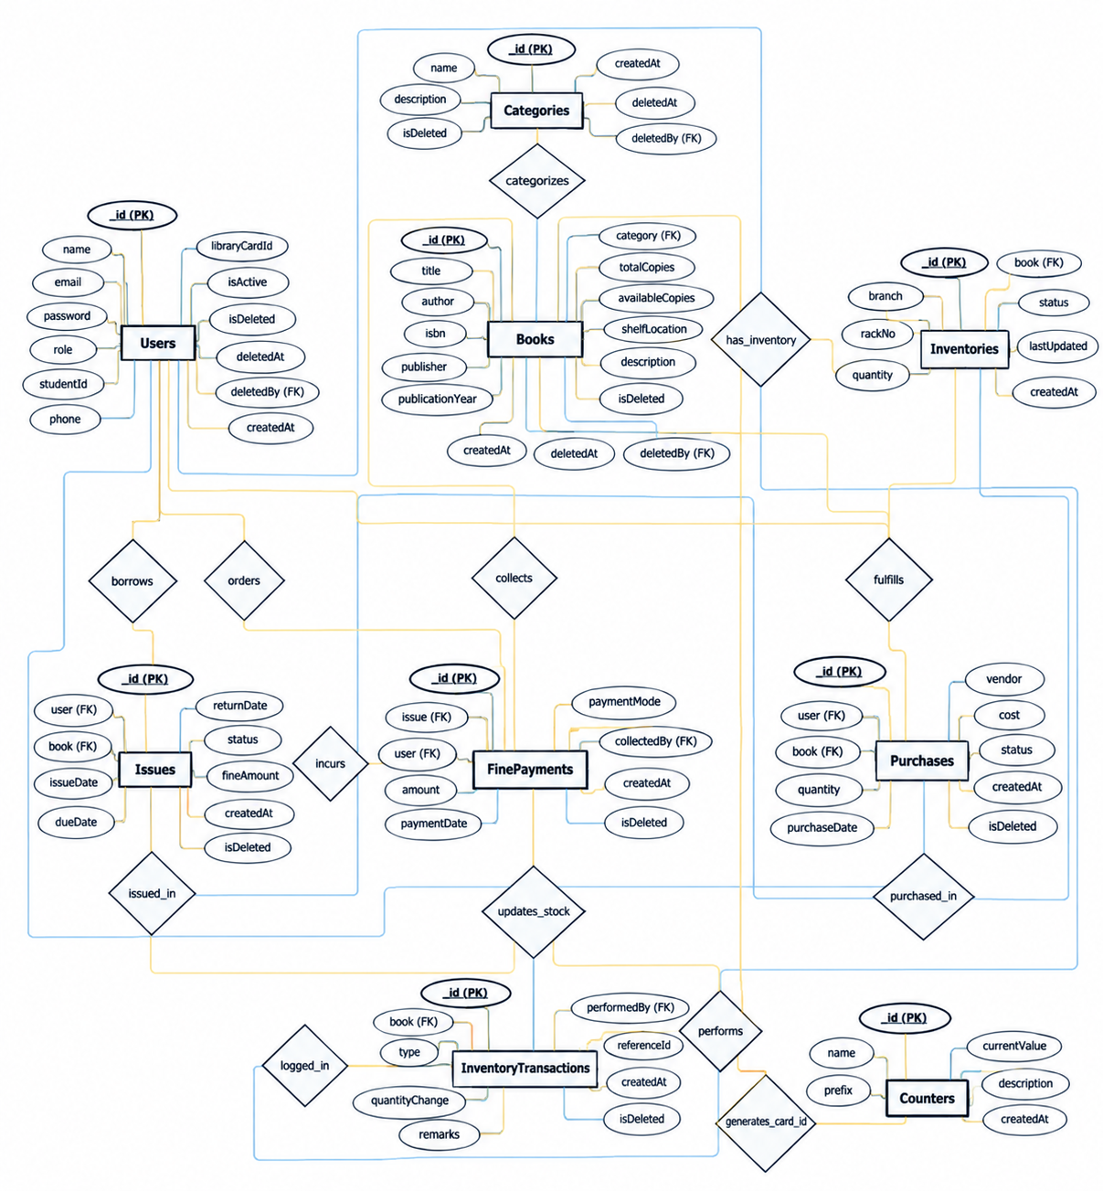
The relationships between these entities are as follows:
(2.0 Whole Systems ER dagram )

3.4 Data Flow Diagram (DFD)
The Data Flow Diagram (DFD) represents the flow of information between users, processes, and the PustakSetu Library Management System. It provides a logical view of how data enters the system, how it is processed, and how the resulting information is delivered to users.
PustakSetu mainly involves three categories of external users:
- Admin – manages books, categories, members, inventory, circulation, fines, and system records.
- Student/Member – registers and logs in, searches books, views availability and details, and manages borrowing-related information.
- Visitor/Public User – accesses publicly available library information and browses the book catalog.
The DFD is divided into different levels to provide increasing detail about the system processes.
DFD Levels
Level 0 – Context Diagram
Shows PustakSetu as a single central process and represents the major data exchanges between the system and Admin, Student/Member, and Visitor.
Level 1 – Major Processes
Breaks the complete system into major functional areas for Admin, Student/Member, and Visitor interactions.
Level 2 – Detailed Processes
Further decomposes the Level 1 processes into detailed operations such as authentication, book management, catalog search, issue/return processing, inventory management, fine management, and report generation.
The following DFD diagrams are included in this section:
- Level 0 – PustakSetu Library Management System
- Level 1 – Admin
- Level 1 – Student/Member
- Level 1 – Visitor
- Level 2 – Admin
- Level 2 – Student/Member
- Level 2 – Visitor

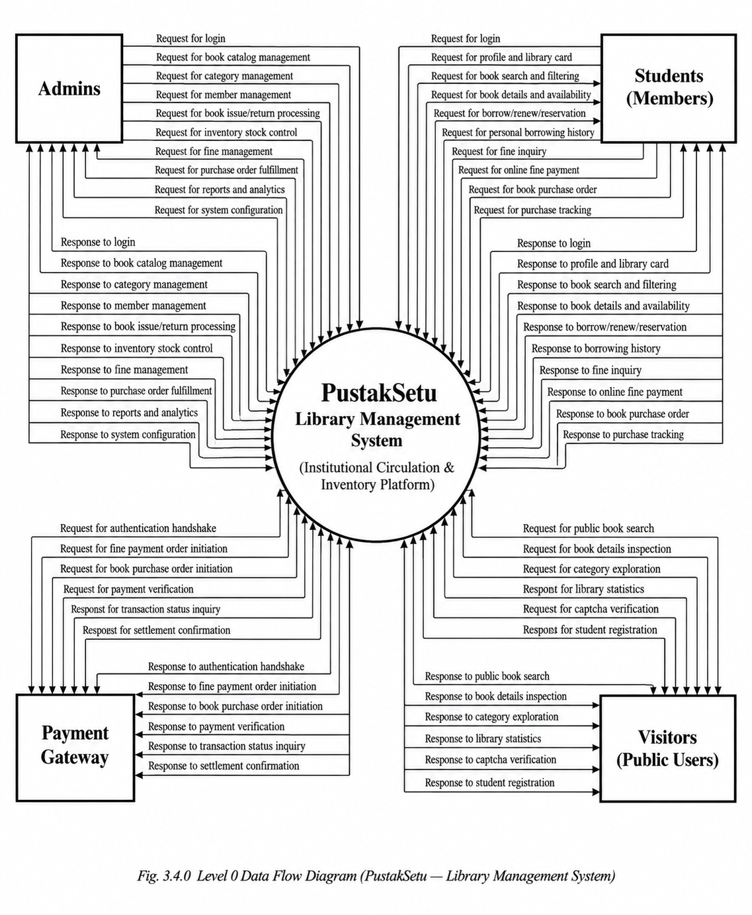
These diagrams provide a structured representation of the information flow within PustakSetu while maintaining consistency with the system's functional modules

Level 1 DFD – The Admin controls and manages the entire system.
Admin logs into the system and manages books, categories, members, and inventory. Admin also handles book issues, returns, overdue records, and fines. Additionally, admin monitors library activities and views relevant records and reports. The system stores and retrieves data related to books, users, inventory, issues, returns, and fines.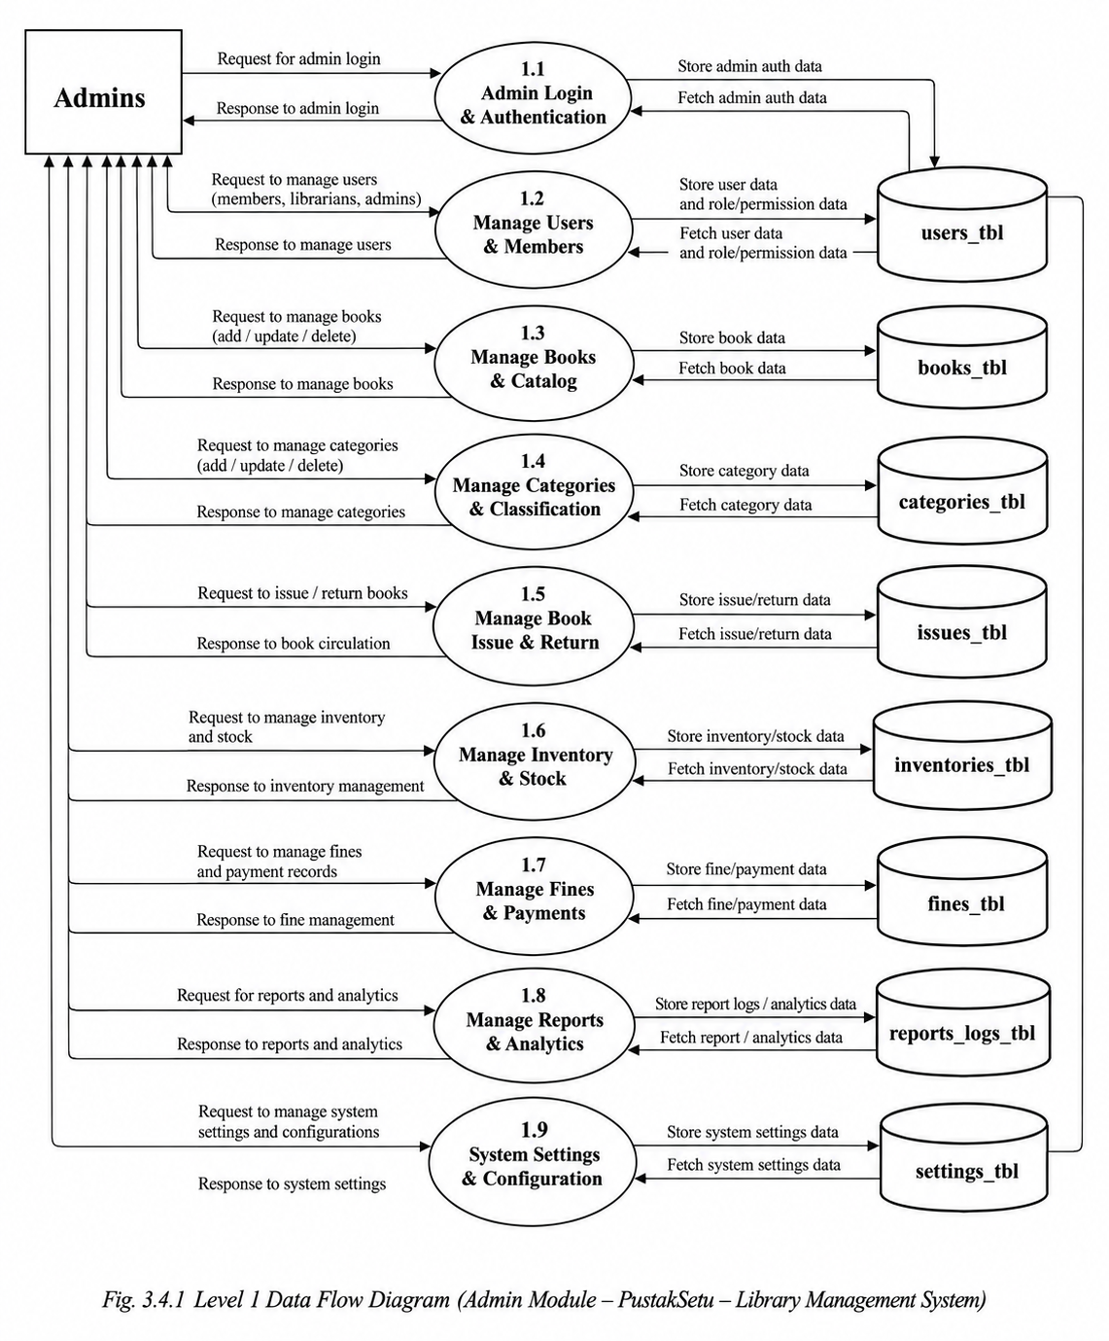

Level 1 DFD – Student/Member handles all student-related activities.he Student/Member.
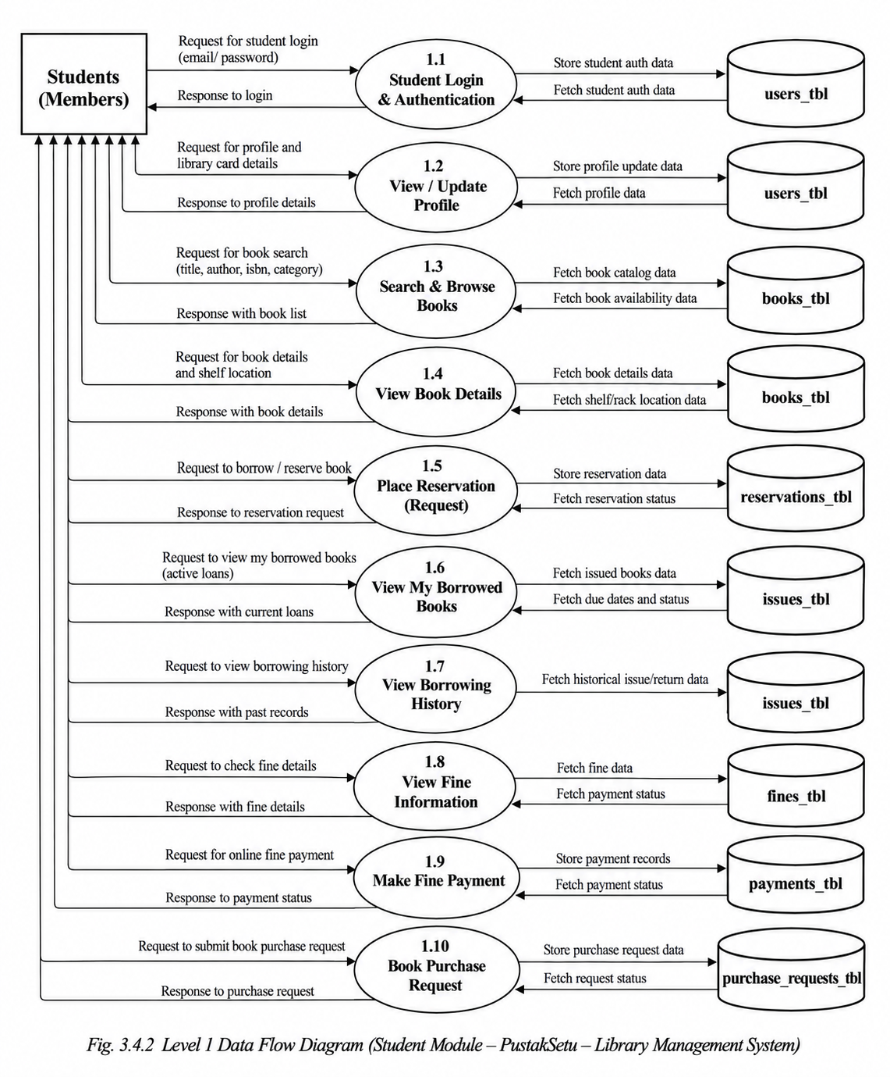
Student registers and logs in with authentication details, manages profile information, and searches for available books. Student can also view book details, shelf locations, borrowed books, due dates, overdue records, fines, and borrowing history. The system stores and retrieves student data, borrowing records, and book availability information.payment details.

Level 1 DFD – Visitor Module
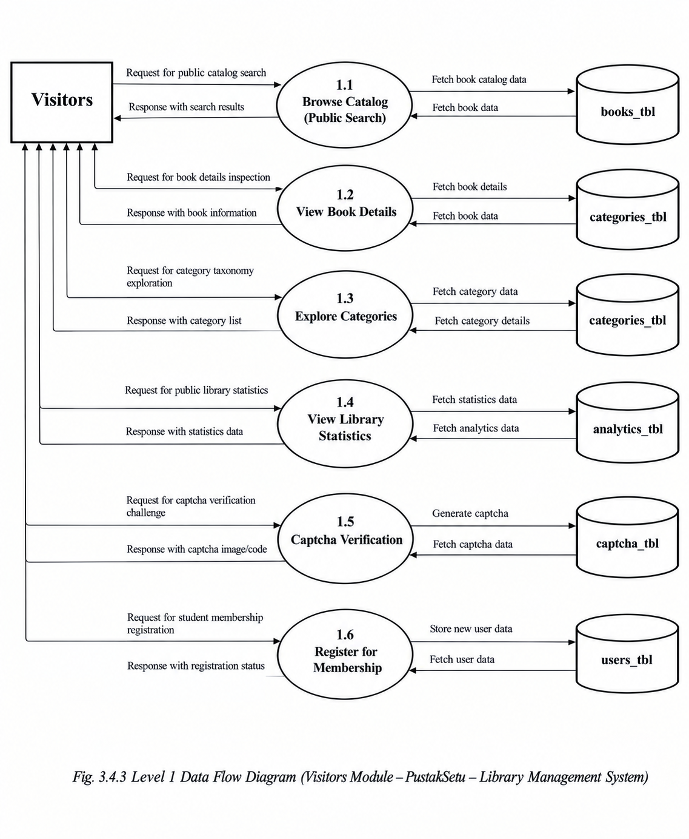
Visitor can browse available books, search and filter library resources, and view book details and availability. Visitor can access public library information without requiring authenticated access. The system fetches public book and category data and provides relevant information to the visitor.

Level 2 DFD – Admin Module
Admin logs into the system and performs detailed operations such as managing books, categories, members, and inventory. Admin also manages book issues, returns, overdue records, and fines. Additionally, admin monitors library activities and maintains system records. The system stores and retrieves data from books, users, inventory, issues, and fine records.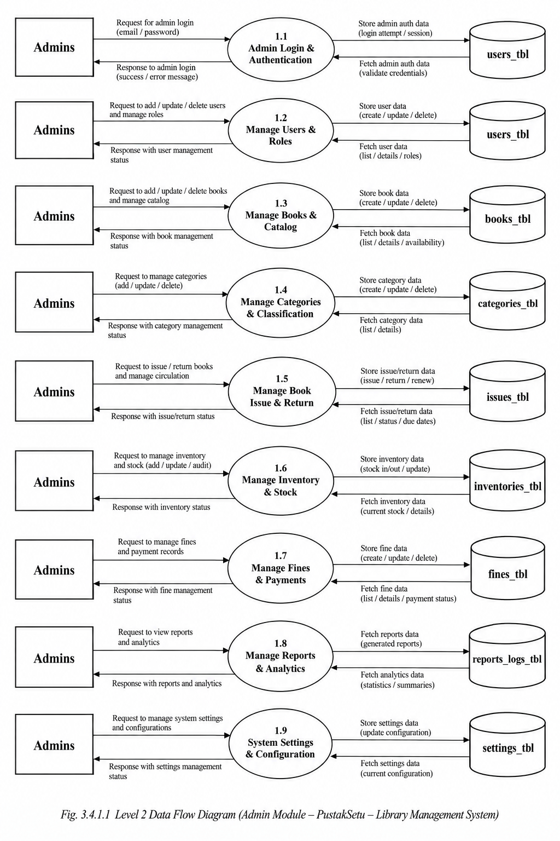
Level 2 DFD – Student/Member Module
Student registers and logs in with authentication details and manages profile information. Student searches and filters books, checks availability and shelf location, and views borrowed books, due dates, overdue records, fines, and borrowing history. 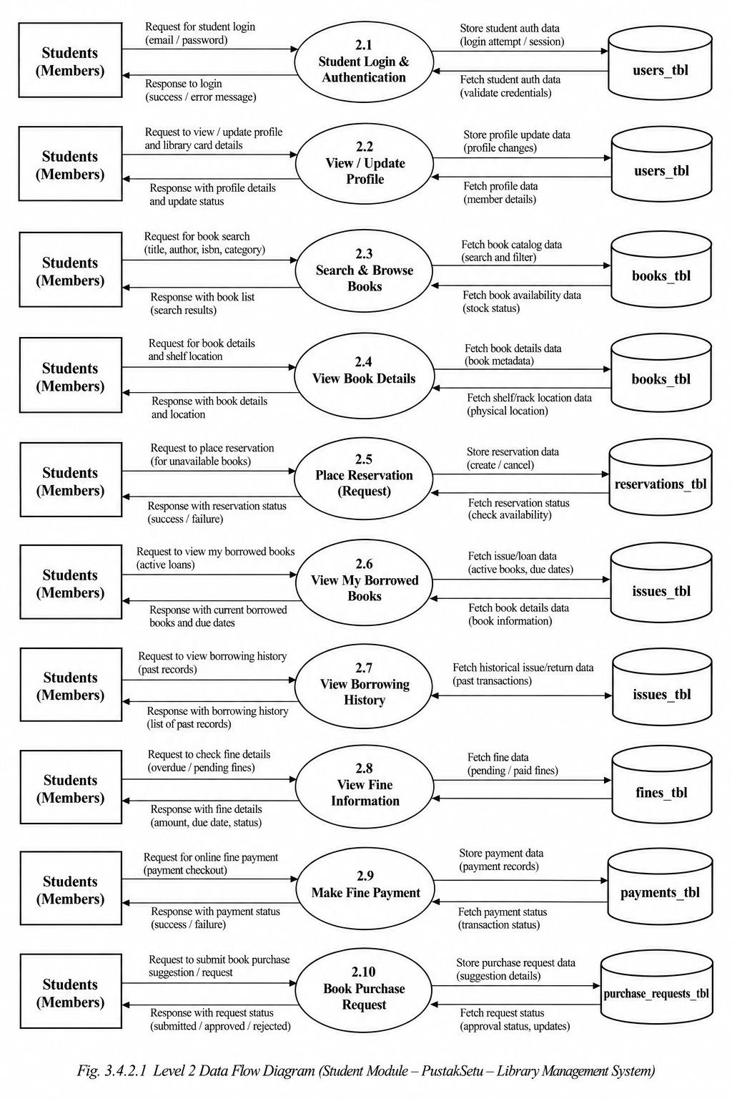
Level 2 DFD – Visitor Module
Visitor can browse books, search and filter available resources, and view book details, categories, and shelf locations. Visitor can check publicly available book information without logging in. The system fetches and displays relevant book, category, and availability data to the visitor.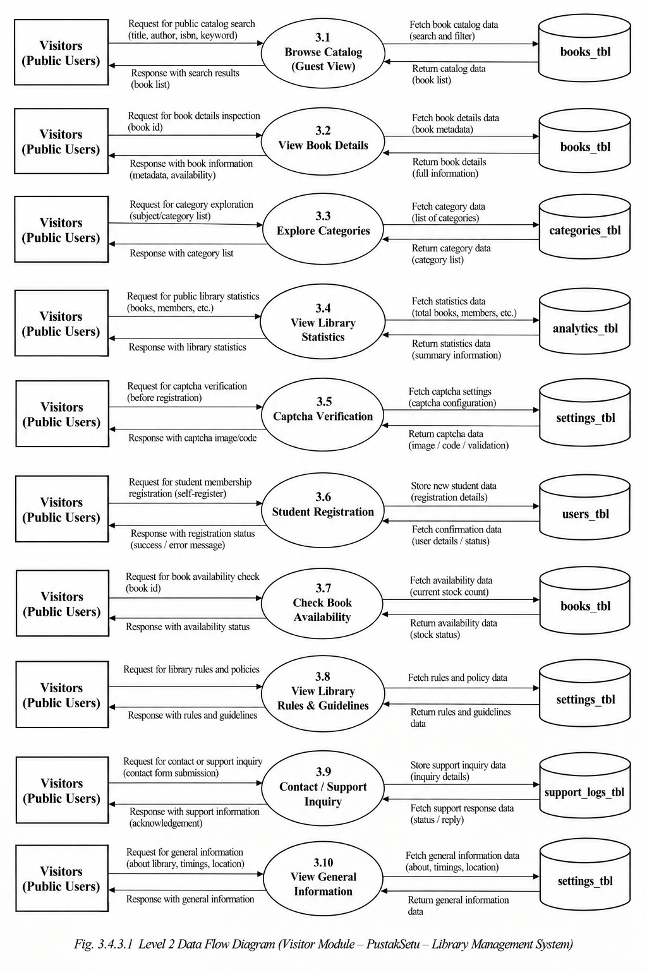

4. SOFTWARE PROJECT PLANNING
4.1 Scope
The scope of the PustakSetu — Library Management System covers the digital management of major library activities through a centralized web-based platform. The system is designed to provide different levels of access and functionality for Admins, Students/Members, and Visitors.
The system allows administrators to maintain book records, categories, member information, inventory details, and circulation activities. Admins can manage the availability of books, issue and return records, due dates, overdue information, and applicable fines. The system helps maintain organized and accurate library records while reducing dependency on manual record keeping.
Students/Members can create an account, securely log in, browse available books, search and filter the library catalogue, view book details and shelf locations, and access information about their borrowed books, due dates, overdue status, and borrowing history.
Visitors can access publicly available library information and browse the book catalogue without requiring authenticated access.
The major scope of the system includes:
- User registration and authentication.
- Role-based access for Admin and Student/Member.
- Book and category management.
- Book search, filtering, and availability information.
- Member management.
- Book issue and return management.
- Due-date and overdue tracking.
- Fine and circulation record management.
- Inventory and book availability management.
- Borrowing history and library records.
- Public access to the library catalogue and basic information.

The system can also provide a foundation for future expansion according to the requirements of the library.
4.2 Objectives
The main objective of the PustakSetu — Library Management System is to provide a centralized, efficient, and user-friendly platform for managing library operations digitally. The system aims to reduce manual effort, improve the accuracy of records, and provide quick access to information for both library staff and students.
The major objectives of the project are:
- To digitize and simplify day-to-day library management activities.
- To maintain accurate records of books, categories, members, and inventory.
- To provide secure user authentication and role-based access.
- To allow students to easily search, filter, and view available books.
- To provide book details such as author, ISBN, category, description, and shelf location.
- To efficiently manage book issue and return activities.
- To track due dates, overdue books, and applicable fines.
- To maintain borrowing history and circulation records.
- To provide administrators with better control over library resources.
- To reduce paperwork and minimize errors associated with manual record keeping.
- To improve the overall accessibility, reliability, and efficiency of library services.

4.3 Expected Advantages
The implementation of PustakSetu is expected to provide several advantages over traditional manual library management methods. By maintaining library information through a centralized digital system, routine operations can be performed more efficiently and records can be accessed whenever required.
The major expected advantages are:
- Reduced Manual Work: Automates common library management activities and reduces dependency on physical records.
- Accurate Record Management: Maintains organized and consistent records of books, members, issues, returns, and fines.
- Faster Book Search: Students can quickly search and filter books based on relevant information.
- Real-Time Availability: Provides current information about the availability of books.
- Efficient Circulation Management: Makes book issue, return, due-date, and overdue tracking easier.
- Better Inventory Control: Helps administrators monitor book quantities and availability.
- Secure Access: Authentication and role-based authorization restrict system functions according to user roles.
- Improved User Experience: Provides students with convenient access to catalogue and borrowing information.
- Reduced Paperwork: Digital records minimize the need for maintaining physical registers.
- Centralized Information: Important library data is maintained in one integrated system.
- Improved Administration: Admin users can manage library resources and records more systematically.
- Scalability: The system provides a foundation that can be extended with additional library functionality in the future.

5. SYSTEM DESIGN
System design defines how the PustakSetu — Library Management System accepts, processes, stores, and presents information to its users. A proper system design ensures that data entered by users is accurate, validated, and processed efficiently. It also ensures that the information generated by the system is presented in a clear and understandable manner.
The system provides separate interfaces and functions for Admins, Students/Members, and Visitors. The input and output designs are structured according to the requirements of each user type.

5.1 Input Design
Input design refers to the process of designing the interfaces through which data is entered into the system. A well-designed input system ensures accuracy, consistency, ease of use, and proper validation of information.
The major input interfaces of PustakSetu are:
- User Registration Form:
Students enter details such as name, email, password, Student ID, and other required information. Validation is applied to ensure that mandatory information is provided correctly.
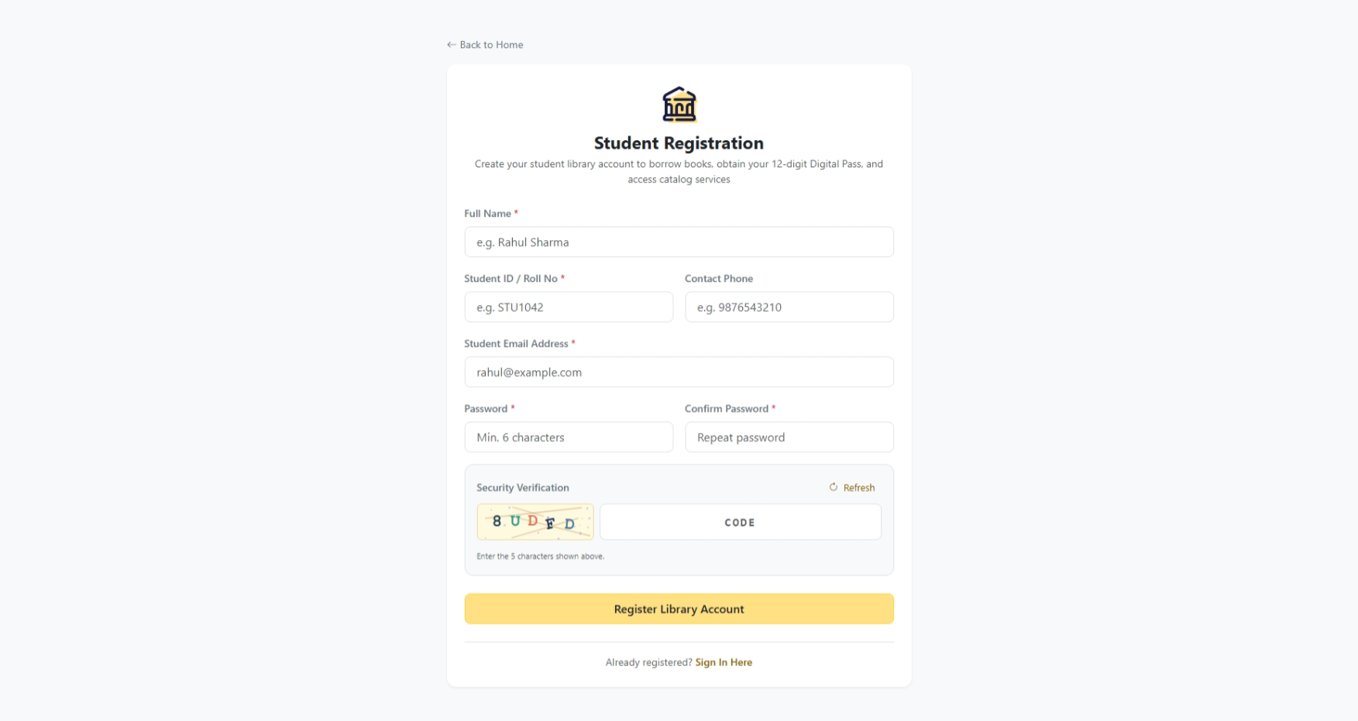
- Login Form:
Users enter their registered email and password to access the system. The credentials are validated before authentication is completed.
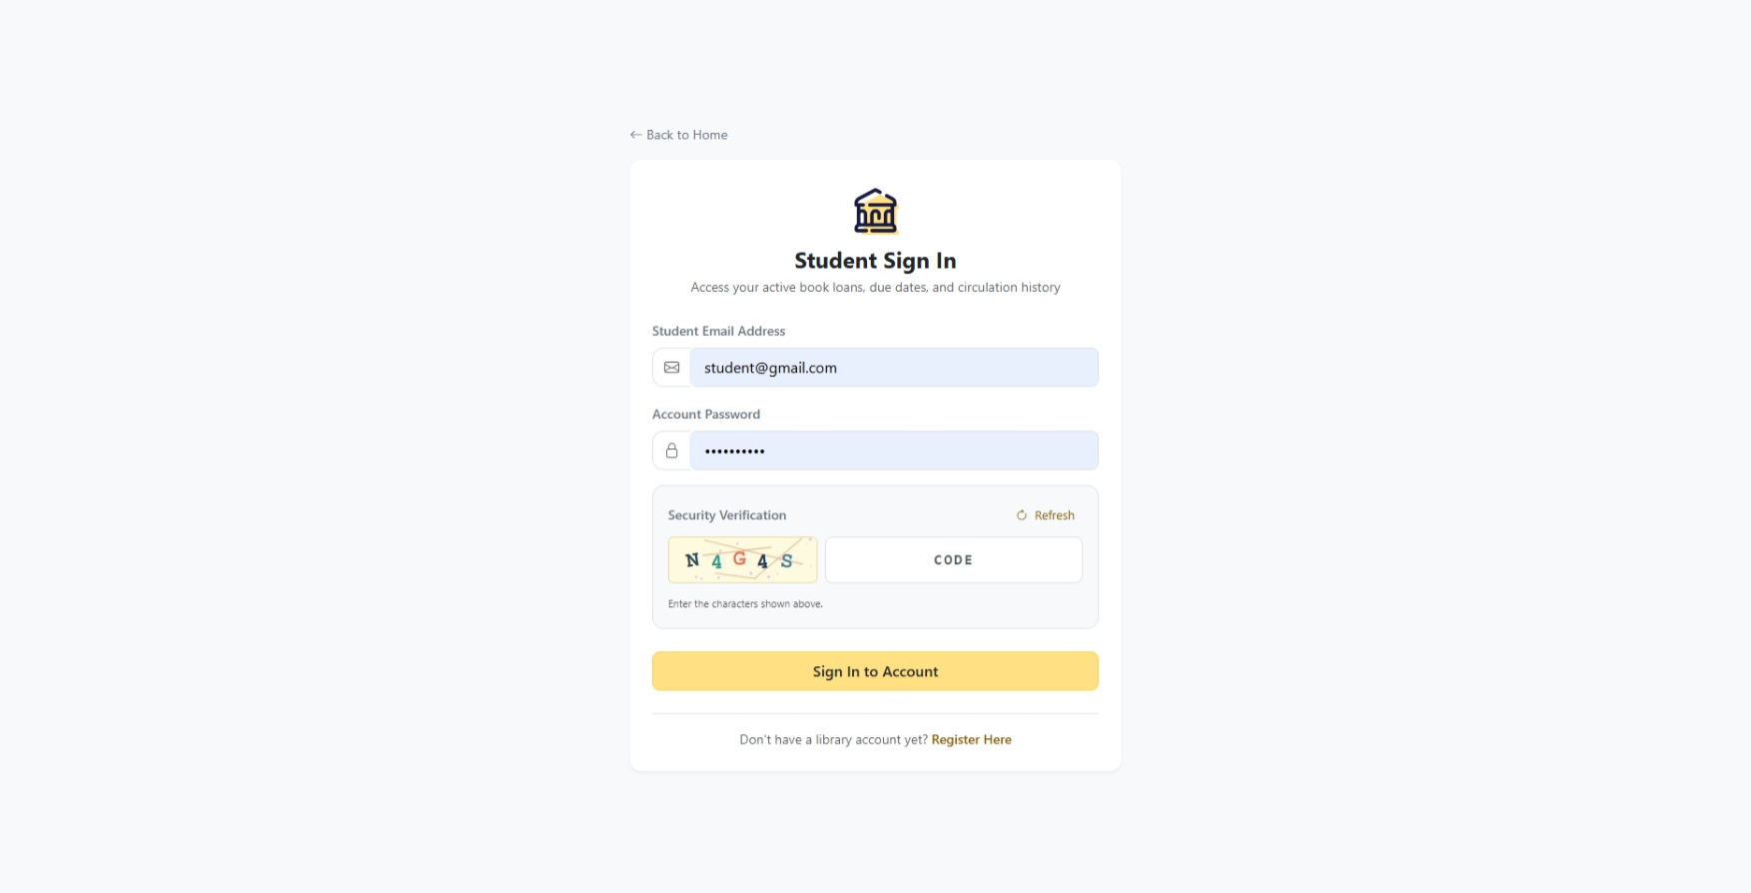
- Book Management Form:
Admins enter book information such as title, author, ISBN, publisher, publication year, category, number of copies, shelf location, and description.
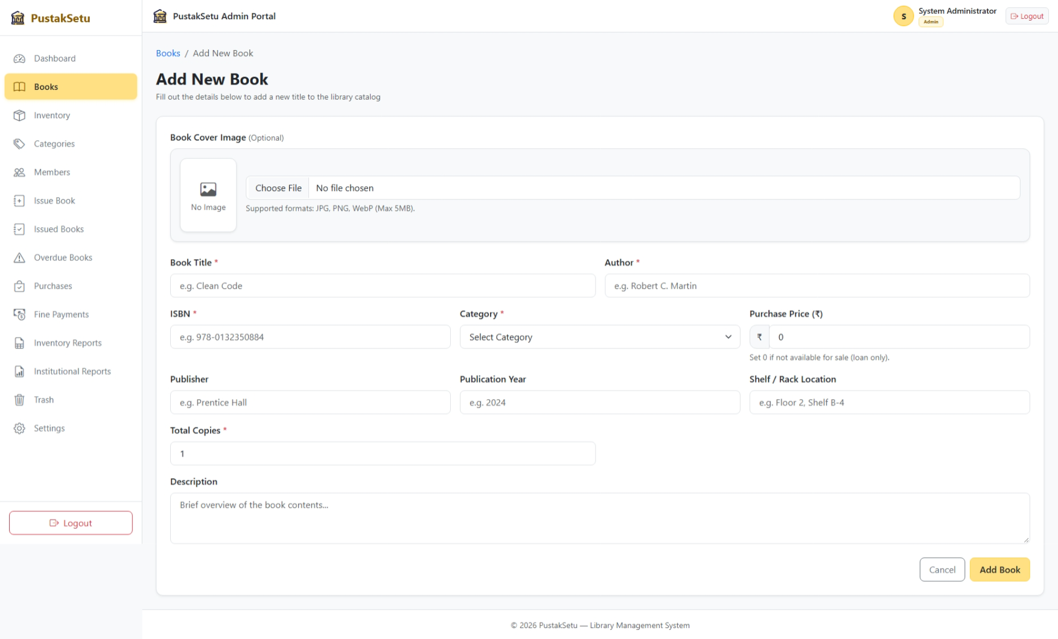
- Category Management Form:
Admins enter category information such as category name and description for organizing books.
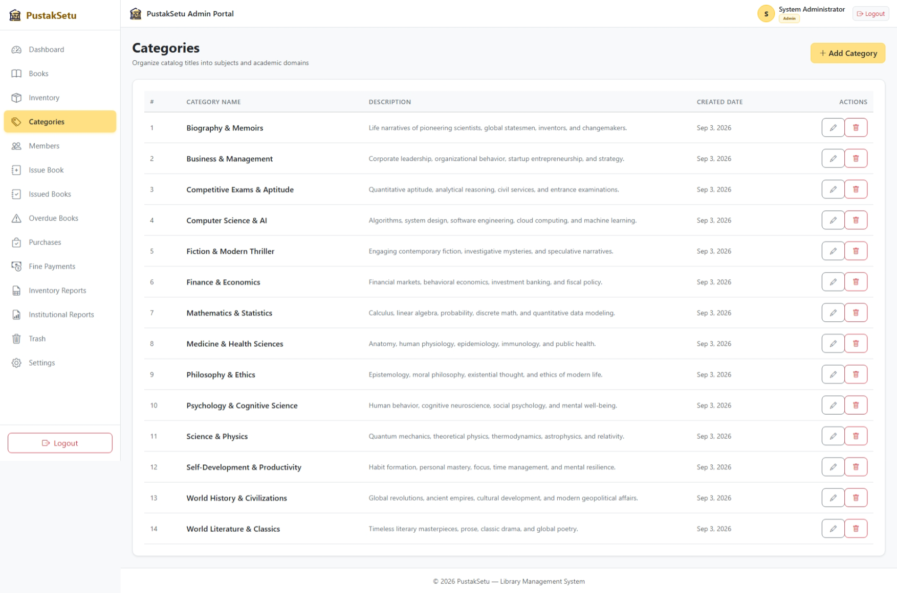
- Member Management Input:
Admins can manage required member information and account-related records.
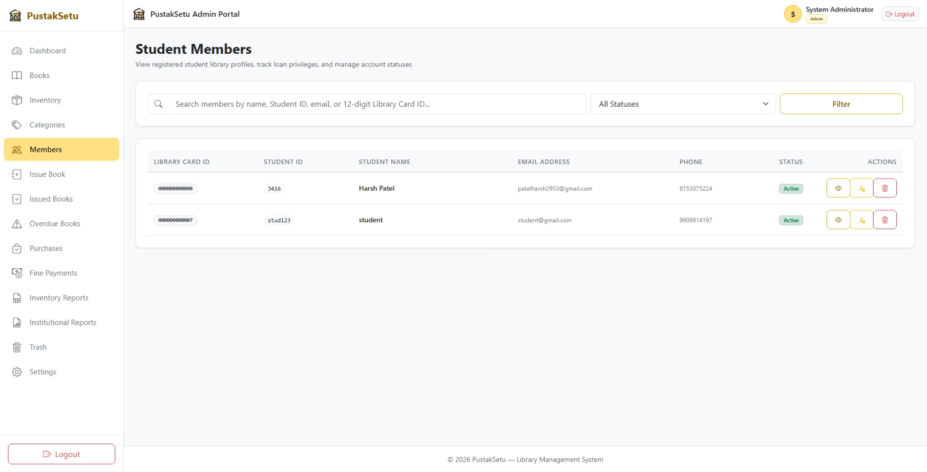
- Book Issue and Return Input:
Required information related to issuing and returning books is entered or processed to maintain accurate circulation records.
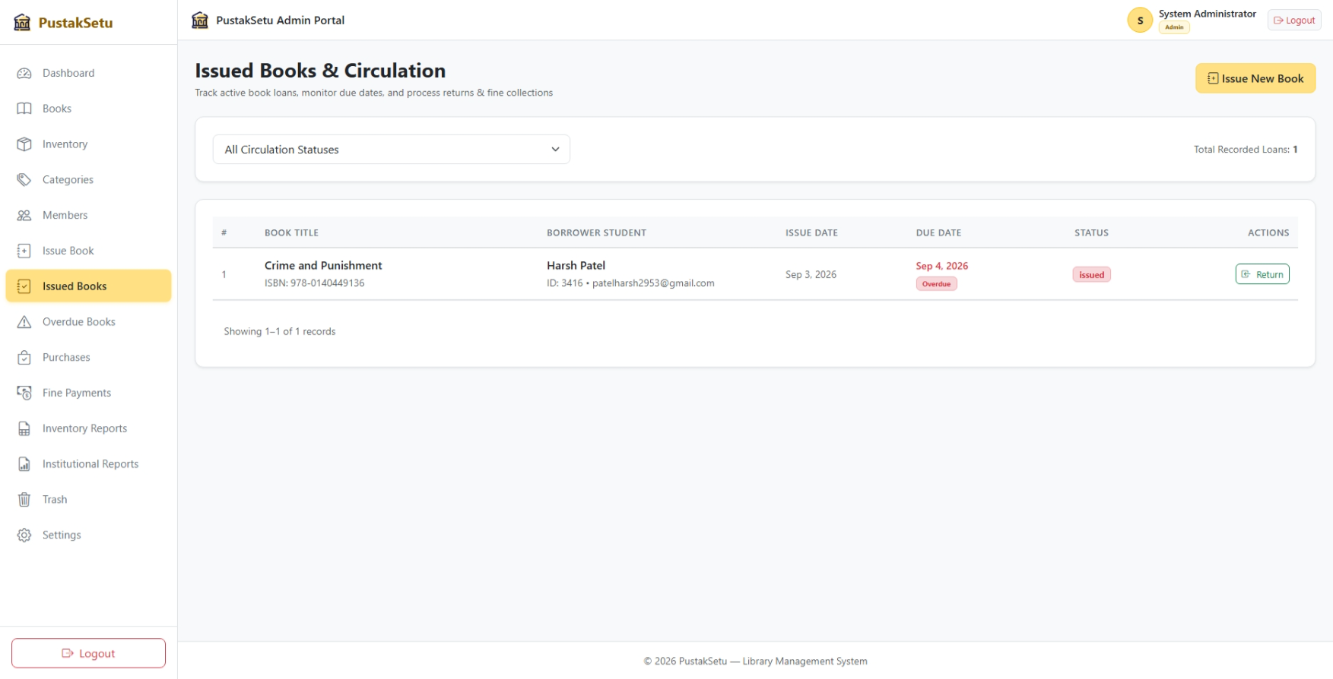
- Search and Filter Input:
Students and visitors can enter keywords or select filters to search for books according to title, author, ISBN, subject, or category.
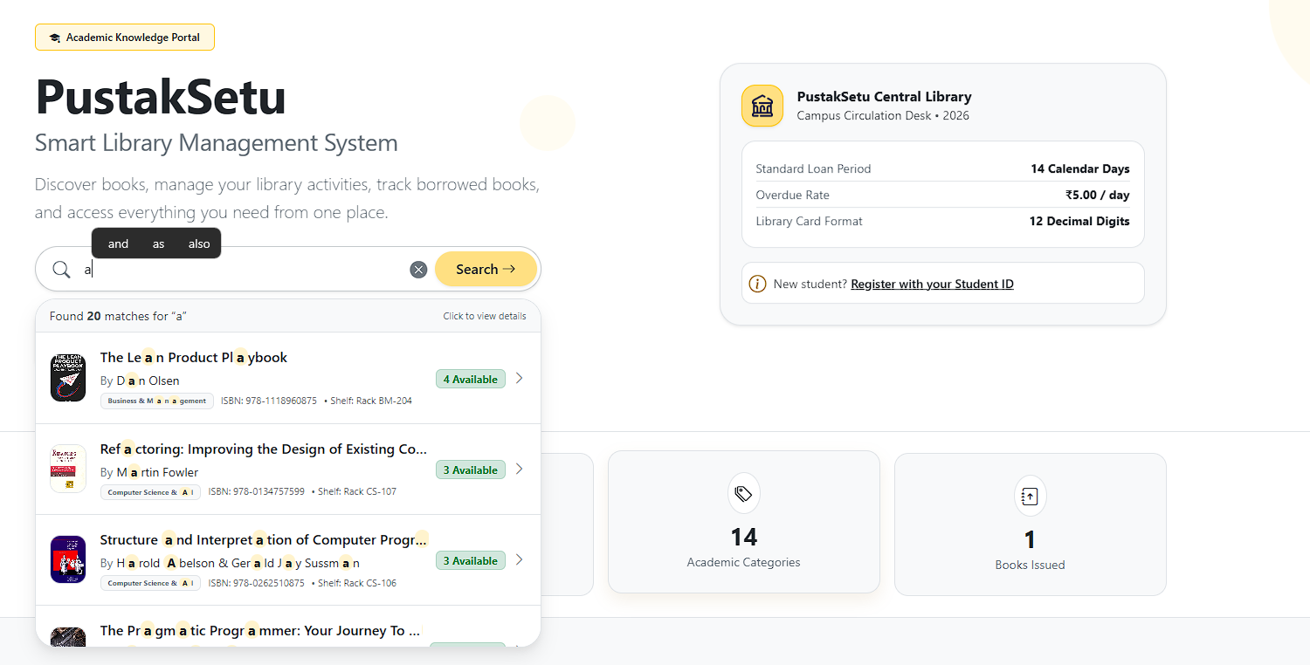

All input interfaces use appropriate validation techniques such as required-field validation, data-format checks, authentication checks, and error messages. This helps prevent incorrect data entry and improves system reliability.

5.2 Output Design
Output design refers to the way processed information is presented to users. The objective is to provide relevant information in a clear, organized, and easy-to-understand format.
The major outputs of PustakSetu include:
- Book Catalogue:
Displays available books with important information such as title, author, category, ISBN, and availability status.
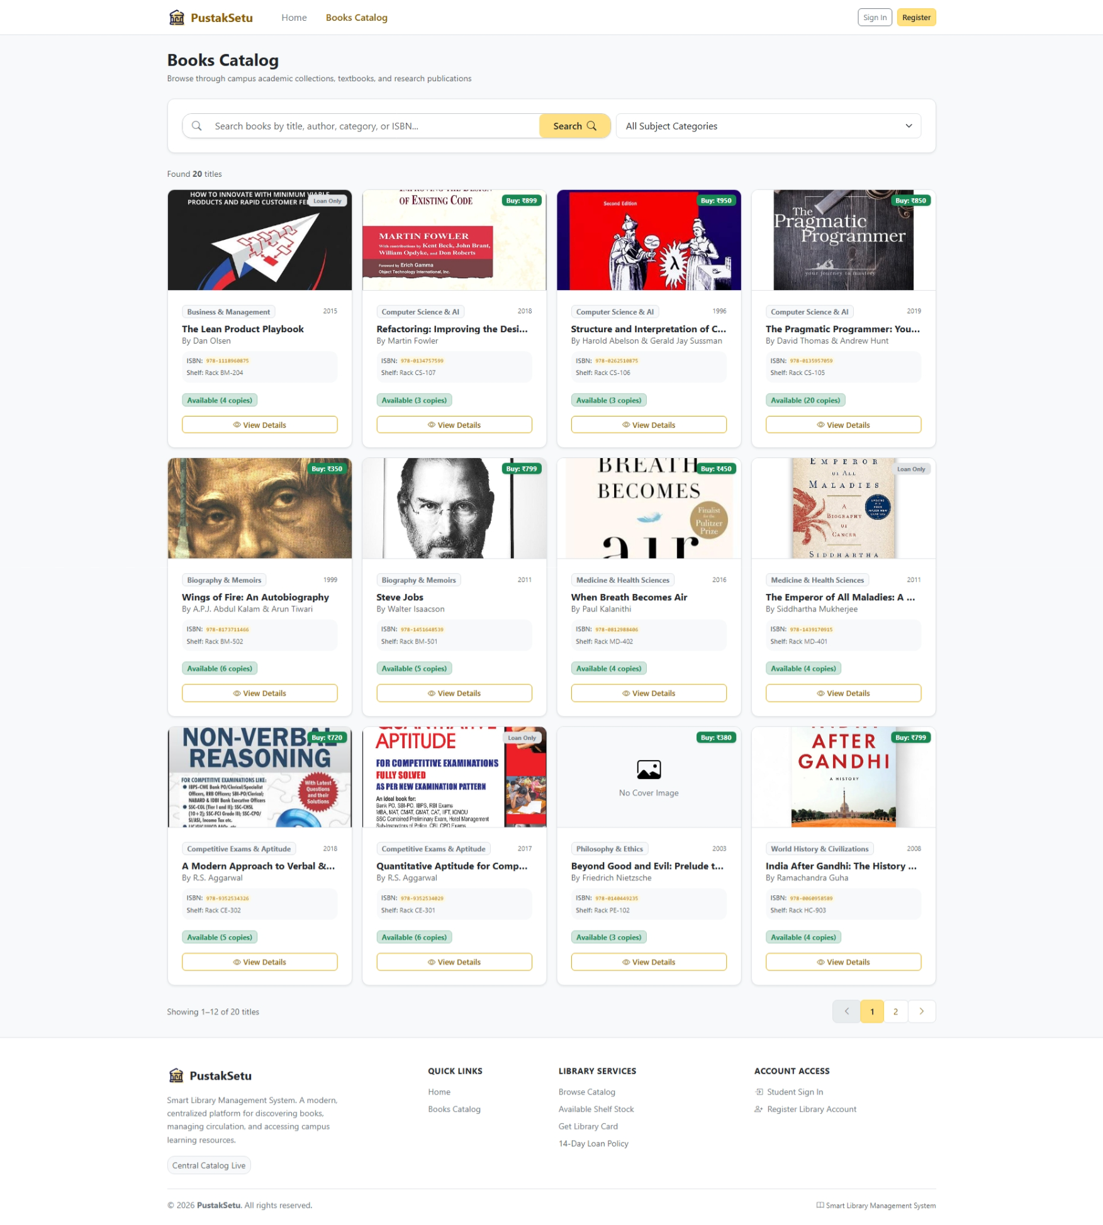
- Book Details:
Displays complete information about a selected book, including description, publication information, available copies, and shelf location.
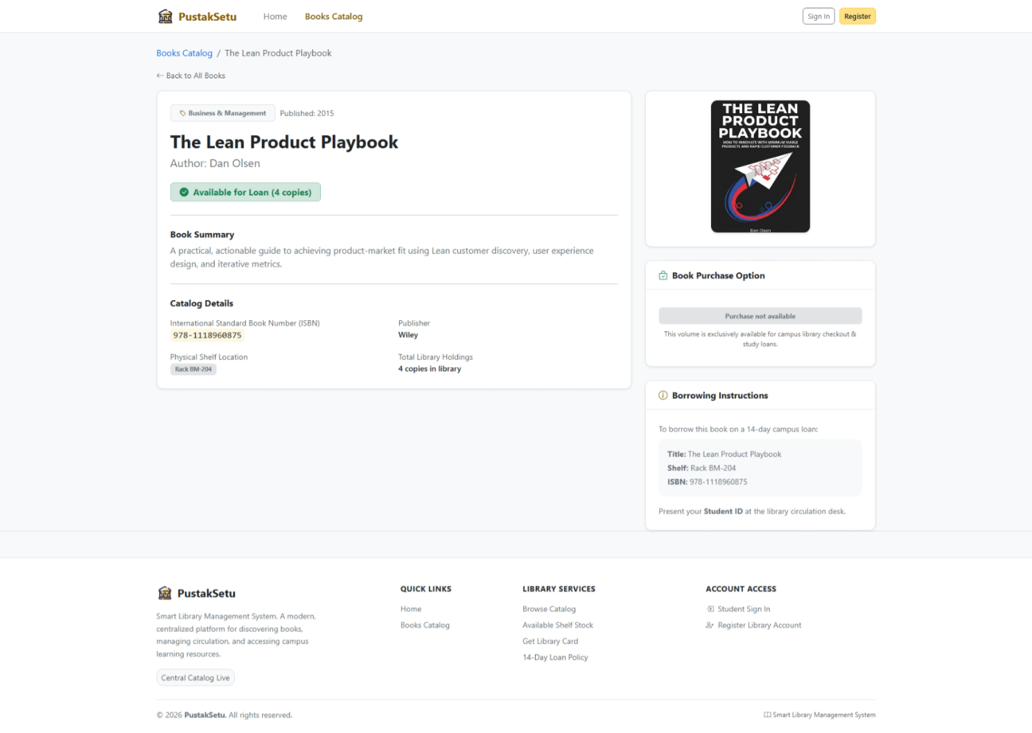

- Search Results:
Displays books matching the user's search keywords and selected filters.
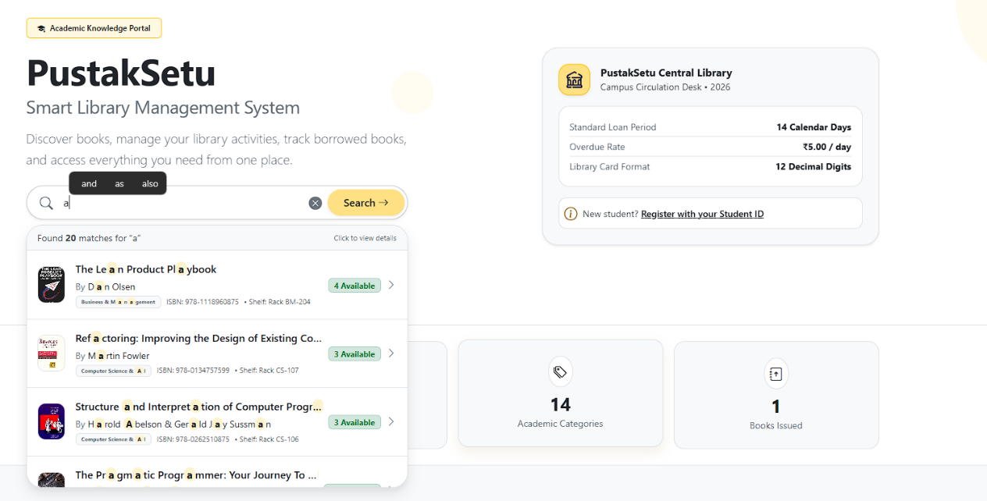
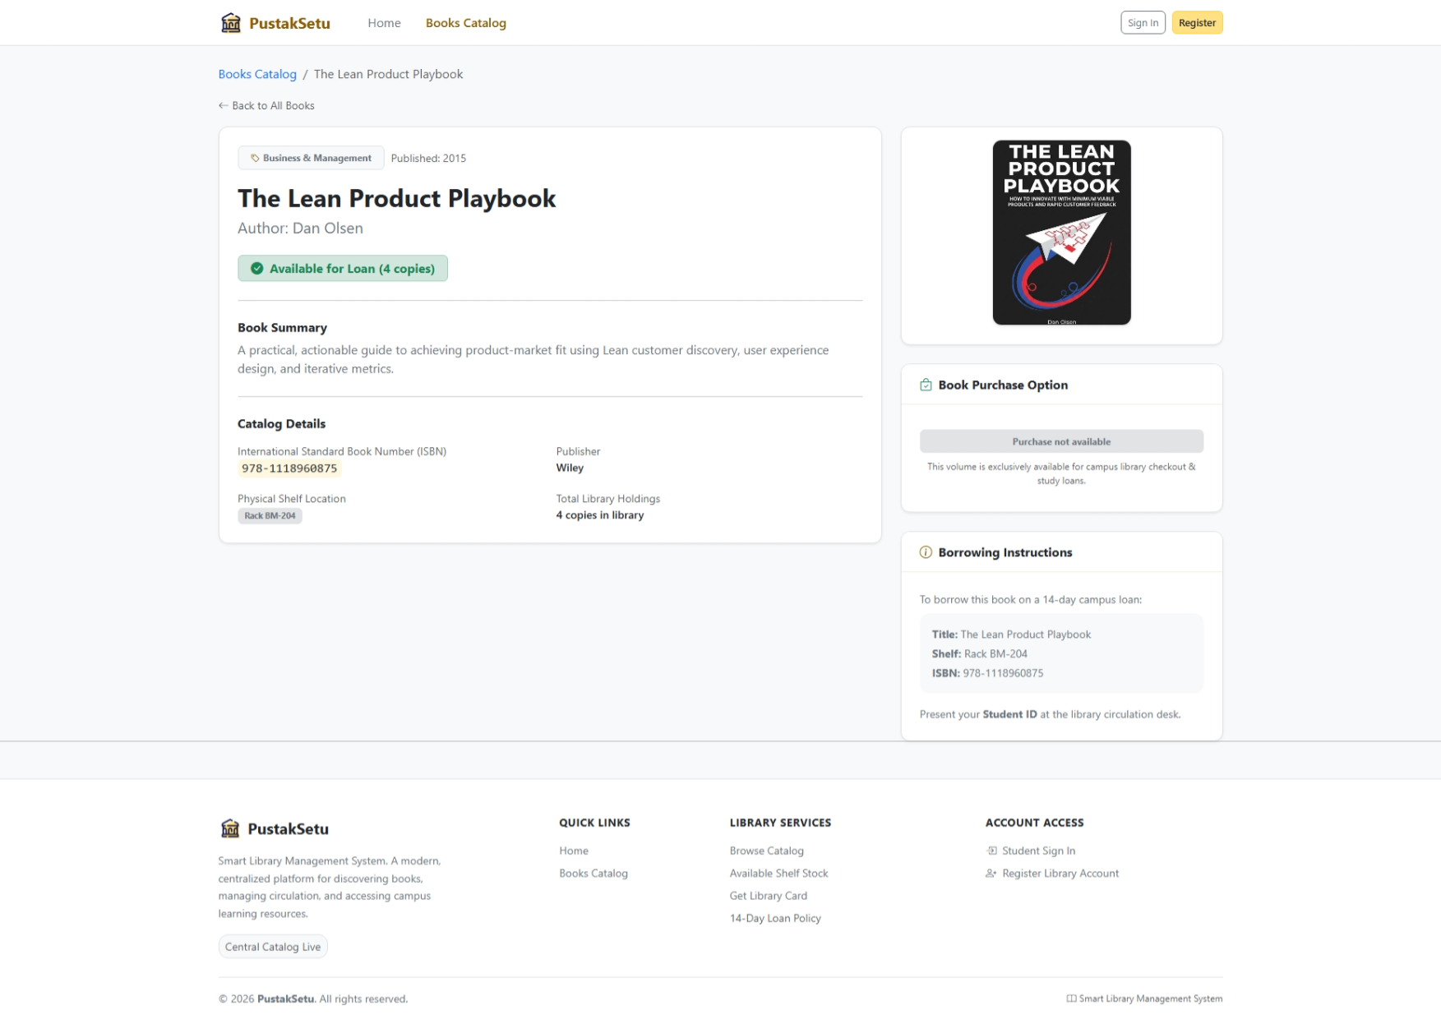
- Availability Information:
Shows whether a book is currently available for borrowing.

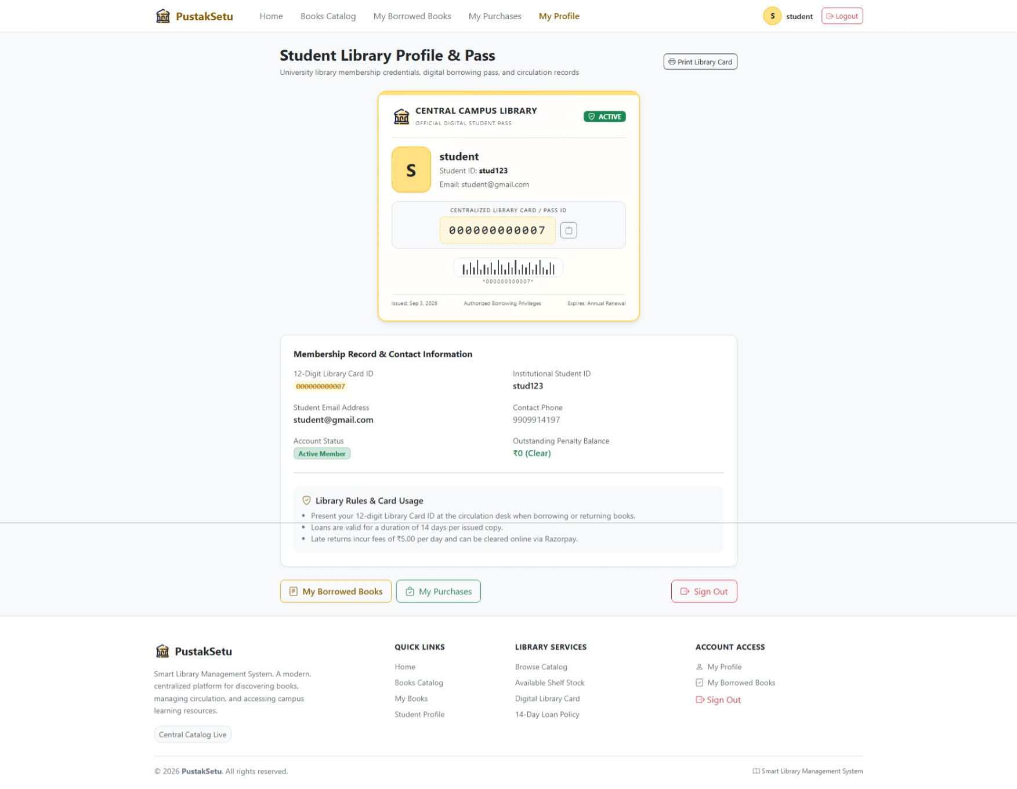
- Student Dashboard:
Displays the student's current borrowed books, due dates, overdue information, and borrowing history.

- Issue and Return Records:
Provides administrators with information about books issued to members, returned books, and their circulation status.
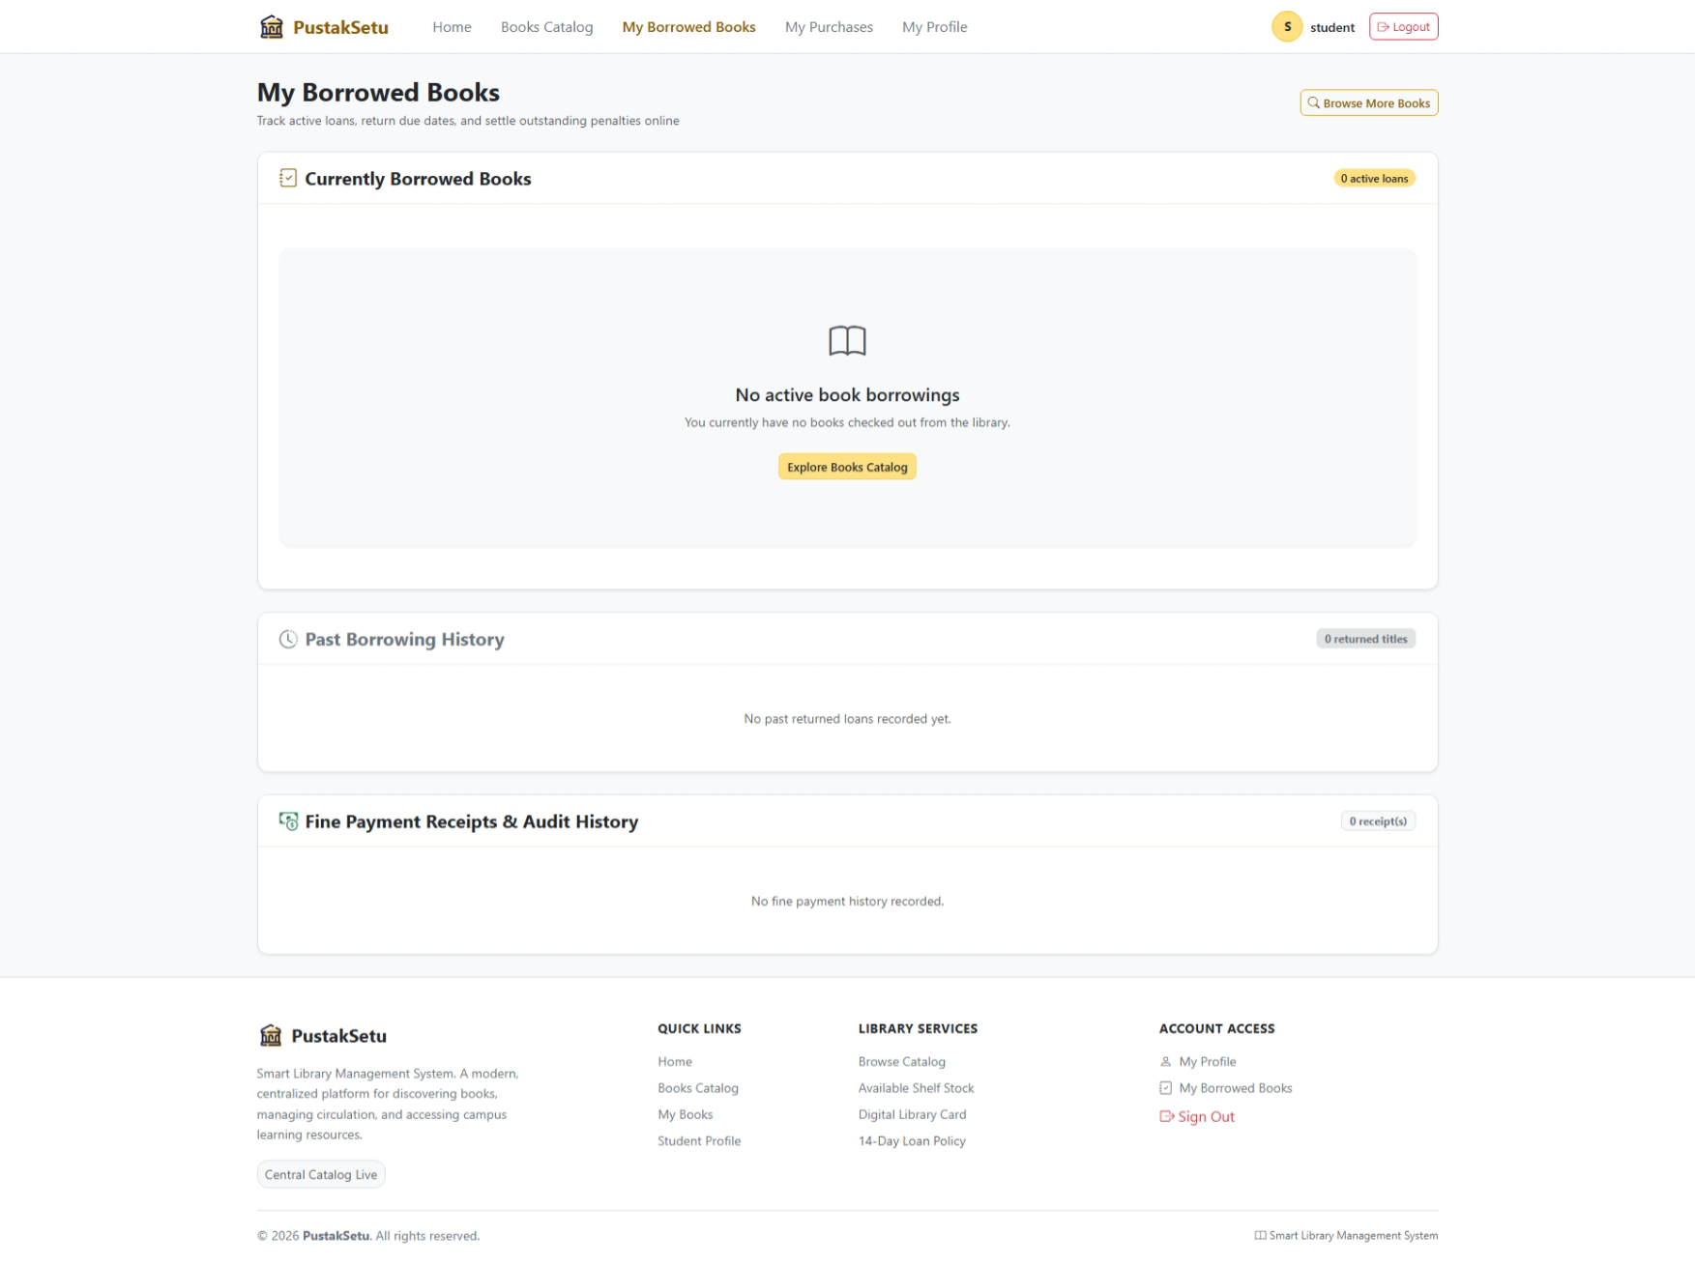
- Fine Information:
Displays applicable fine information associated with overdue library records.
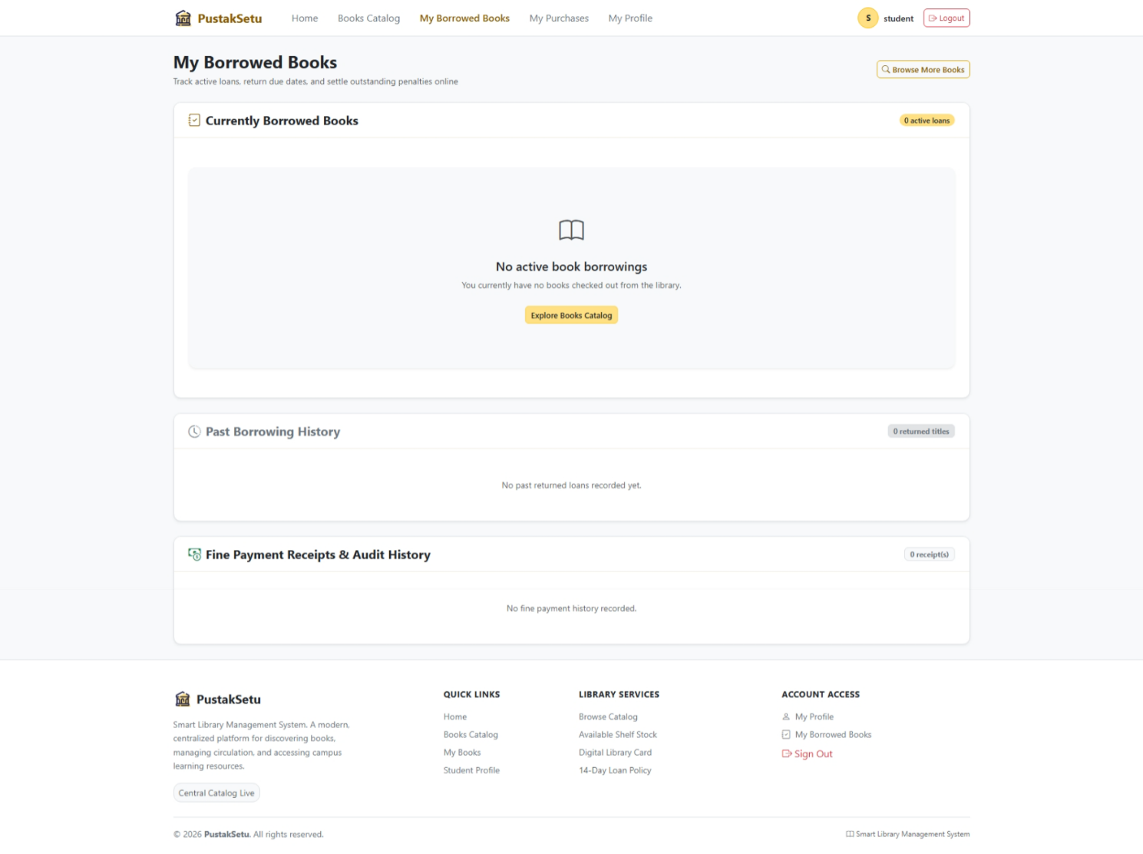
- Profile and Membership Information:
Displays relevant student information such as membership details and active borrowing information.

The outputs are designed to provide accurate and meaningful information while maintaining a consistent and user-friendly interface throughout the system.

6. SOFTWARE TESTING
6.1 Introduction
Software testing is an important phase in the development of the PustakSetu — Library Management System. It is performed to identify errors, verify system functionality, and ensure that the developed application behaves according to the specified requirements.
Testing involves checking individual components as well as complete workflows. In PustakSetu, important functions such as user registration, login, book search, book management, issue and return operations, availability tracking, and fine calculation are tested.
The purpose of testing is not only to identify defects but also to ensure that the system provides reliable, accurate, secure, and consistent results to different types of users.

6.2 Objectives
The main objectives of software testing for PustakSetu are:
- To verify that all major system functions work correctly.
- To identify and remove errors and defects.
- To validate user registration and authentication.
- To ensure proper role-based access for Admins and Students/Members.
- To verify book searching, filtering, and catalogue functionality.
- To test book issue and return operations.
- To verify due-date and overdue information.
- To validate fine-related calculations and records.
- To ensure accurate database operations.
- To verify proper communication between frontend and backend.
- To ensure that invalid inputs are handled appropriately.
- To improve the overall reliability, usability, and performance of the system.

6.3 Levels of Testing
Different levels of testing are used to verify the PustakSetu system at different stages of development.
Unit Testing
Individual components or functions are tested separately to verify that each component performs its intended task correctly.
For example, individual functions for user authentication, book searching, date formatting, or inventory calculations can be tested independently.
Integration Testing
Integration testing verifies whether different modules work correctly when connected with each other.
For example, testing the complete flow between the login interface, authentication API, database, and user session management.
System Testing
The complete PustakSetu application is tested as a single system to verify that all major requirements are fulfilled.
This includes testing workflows such as user login, book searching, book issue, return processing, overdue tracking, and viewing borrowing history.
User Acceptance Testing (UAT)
The system is tested from the perspective of its intended users. Admin and Student/Member workflows are checked to ensure that the system is understandable, usable, and suitable for the intended library operations.

6.4 Test Cases
Test cases are used to verify whether different functionalities of the PustakSetu — Library Management System are working correctly. Important test cases are listed below.
Test Case ID | Test Description | Input | Expected Output | Result
TC01 | User Registration | Valid student details | Account created successfully | Pass
TC02 | User Login – Valid | Correct email and password | User logged in successfully | Pass
TC03 | User Login – Invalid | Incorrect credentials | Appropriate error message displayed | Pass
TC04 | Book Search | Valid title/author/ISBN keyword | Matching books displayed | Pass
TC05 | Book Filtering | Select category/filter | Relevant books displayed | Pass
TC06 | Book Details | Select a book | Complete book information displayed | Pass
TC07 | Book Issue | Valid student and available book | Book issue record created successfully | Pass
TC08 | Book Return | Valid issued-book record | Book return processed and availability updated | Pass
TC09 | Overdue Checking | Book past due date | Overdue status displayed correctly | Pass
TC10 | Fine Calculation | Overdue issue record | Applicable fine displayed correctly | Pass
TC11 | Admin Book Management | Valid book information | Book record added/updated successfully | Pass
TC12 | Access Control | Student attempts admin function | Unauthorized access prevented | Pass
These test cases cover the major functional areas of the system and help ensure that the critical operations of PustakSetu are properly validated.

7. REFERENCES / BIBLIOGRAPHY
The development of the PustakSetu — Library Management System involved the use of modern web technologies, frameworks, development tools, and official technical documentation. These references were used for understanding application architecture, frontend development, backend APIs, authentication, database operations, and responsive user-interface design.
The following resources can be included in the project documentation:
- React.js Official Documentation
Used for developing component-based user interfaces and managing frontend application functionality.
- Vite Documentation
Used for project setup, frontend development, module bundling, and development-server configuration.
- React Router Documentation
Used for implementing client-side routing and navigation between different pages of the application.
- Bootstrap Documentation
Used for responsive layouts, UI components, forms, navigation elements, and consistent interface design.
- Bootstrap Icons Documentation
Used for incorporating icons into the application's user interface.
- Axios Documentation
Used for making HTTP requests between the React frontend and backend REST APIs and handling API responses.
- Node.js Official Documentation
Used for understanding server-side JavaScript development and runtime functionality.
- Express.js Documentation
Used for implementing backend routes, REST APIs, middleware, and server-side application logic.
- MDN Web Docs – JavaScript
Used as a reference for JavaScript language concepts, ES6+ features, asynchronous programming, and web APIs.
- JSON Web Token (JWT) Documentation
Used as a reference for implementing token-based authentication and secure user sessions.
- Git Documentation
Used for source-code version control and project development management.
These references supported the development, testing, debugging, and documentation of the PustakSetu system. The original document similarly used official technology documentation as its bibliography, including React, Node.js, Express.js, JavaScript documentation, and other development resources.

