1INTRODUCTION

1.1OVERVIEW

The Index of Economic Freedom is an annual index and ranking created in 1995 by The Heritage Foundation and The Wall Street Jounal to measure the degree of freedom of economic freedom in the worlds nation .

The creators of the index claim to take an approach inspired that of adam smithin the wealth of nation, that “basic institutions that protect the liberty of individual to presue the own economic intreasts result in great prosperity for the larger society.

1.2 PURPOSE

The Heritage foundation website states that “Economic freedom is the fundamental right of every human to control his or her own labor and property.

In an economically free society , individuals are free to work, produce , consume and inverse in any way the please.

In economically free society governments allow labor, capital and goods to move freely and refrain from coercion or constrains of the society.

2. PROBLEM DEFINITION AND DESIGN THINKING

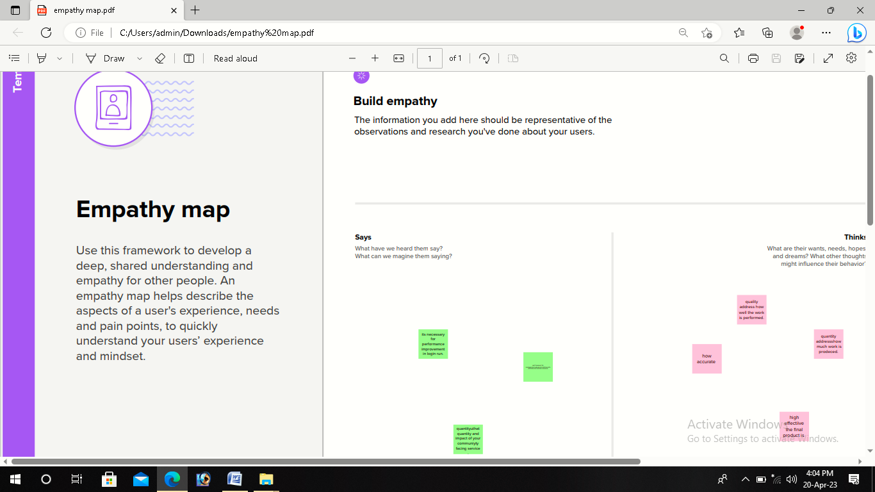



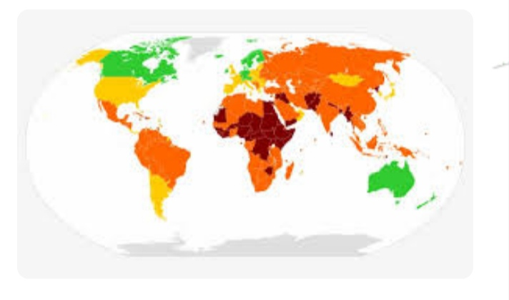

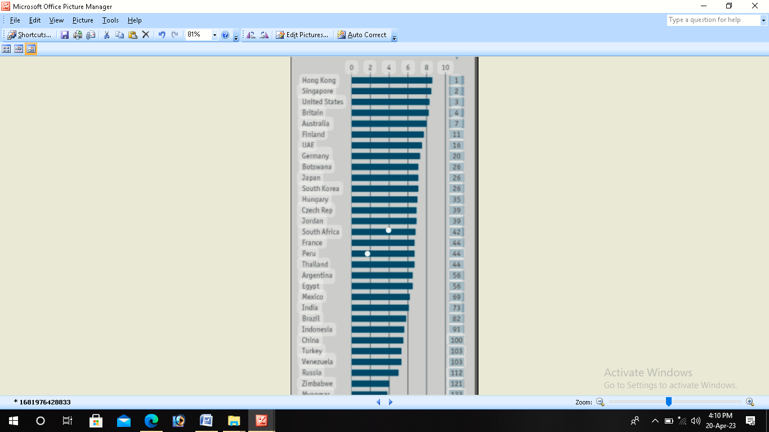

ADVANTAGES AND DISADVANTAGES

Advantages

* Increased efficiency, production and innovation.
* Low or non exsistent unemployment, speed in decision making.
* Equality amongst citizens and a focus on the worker as opposed to profits.
* The fundamental rights of every human to control his or her own labour and property.
* Low unemployment.

Disadvantages

* Monopolies, no government intervention, poor working condition and employment .
* Poor quality .Since profit maximization is the biggest motivation for films , they may try to reduce the cost unethically.
* Excessive power of firms.
* Unemploymernt and inequality

Applications

* Extent of government regulation of financial service.
* Degree of state intervention in banks and other financial firms through direct and indirect ownership.
* Government influence on the allocation of credit.
* Extent of financial and capital market development.
* Openneses to foreign competition.
* India got on overall score of 52.9 on a scale of 100 on the index of economic freedom 2023-equating to a 52.9% achievement on the index. India overall score on the 2023 index is at a 6 years below.
* It depends on the nature of economic growth for example, If economic growth leads to more population and congestion,then living standard fall.
* Economic growth enables consumers to consume more goods and service and enjoy better standard of living.
* Economic growth during the 20th century was a major factor in reducing absolute level of poverty and enabling a rasing in life expectancy.

Conclusion

In reason years the top countries economic freedom have been fairly consistent. Singapore ranked number 1 in 2021 with an overall score of 89.7. It was followed by newzealand (83.9), Australia (82.4), Switzerland (81.9) and Ireland (81.4) to round out the economic rated as free.

Countries on the opposite end of the freedom spectrum include north korea, Venezuela , cuba, sudan and zimbadwe. The united states ranked 20th with an overall score of 74.8, dropping by 1.8 points from 2020. Mostly due to increased trade restrictions

As mentioned,the higher the score in the economic freedom index,the higher the income and viceversa.country ranked as”free’’or’’mostly free’’ had an average per capita GDP that was double the overall average, and morethan average per capita incomes of represed countries .

Future scope

The degree of economic freedom present is influenced by numerous factors. No single statistic will be able to capture fully all of them and their interrelations. The index presented here captures most of the important elements and provides a reasonable good measure of cross-country differences in economic freedom. However , something as complex as economic freedom is difficult to measure with precision. Thus , small differences between countries should not be taken very seriously.