AI Powered Online Recruitment
ABSTRACT
Artificial Intelligence (AI) can play a pivotal role in the company recruiting process, facilitating excellence. This app faces challenges AI faces in the hiring process and the outcomes results of using AI in the hiring process. The benefits of using AI in the hiring process include identifying AI vendors and firms that have adopted AI in the hiring process, analyzing the present state of AI to facilitate the hiring process, and the impact of adopting AI in the hiring process. Through this app different perceptions, ideas, and opinions are presented to modulate the use of AI in human resource management. The findings indicate that AI is adopted mainly in high-tech or large companies. The reports presented by these companies on the use of AI thus do not provide an actual picture of the usage and step by step evaluation as interviews are still a part of the recruitment process providing space for human bias. The aspect of AI to support human resources in decision making, not a threat as AI is considered to take over the human roles in human resource management, should also be studied in detail.
Keywords: Artificial Intelligence (AI), Hiring process, Challenges, Outcomes, Adoption, Human resource management.
STATEMENT ABOUT THE PROBLEM
AI adoption in recruitment faces challenges, including incomplete integration and reliance on human biases in the hiring process. Despite being used in large and high-tech companies, the actual impact of AI is unclear, with interviews still playing a major role. A detailed understanding of AI's role in decision-making and bias reduction is essential.
WHY IS THE PARTICULAR TOPIC CHOSEN?
This topic was chosen to explore the growing role of Artificial Intelligence in transforming recruitment processes. With AI becoming increasingly integrated into hiring practices, it's important to understand its potential benefits and challenges. By examining AI's impact on reducing biases and improving efficiency, this topic aims to provide valuable insights for future advancements in recruitment technology.
SCOPE
This app investigates the use of Artificial Intelligence (AI) in the recruitment process, focusing on its benefits, challenges, and impact on hiring outcomes. It analyses AI adoption by companies, identifies AI vendors, and evaluates how AI affects human resource decisions. The app provides insights into AI's potential role in improving recruitment practices and reducing bias.
OBJECTIVE OF THE PROJECT
The objective of this abstract is to provide a comprehensive overview of the use of AI in the hiring process. It aims to explore the challenges and outcomes associated with AI adoption, while highlighting the benefits it brings to recruitment. The abstract also seeks to present diverse perspectives on AI in human resource management, emphasizing the need for a balanced approach to address biases and support decision-making. It recognizes the prevalent utilization of AI in high-tech or large companies but raises concerns about the limited evaluation due to the continued reliance on interviews. Ultimately, the objective is to foster a deeper understanding of AI's role in recruiting and its potential to drive excellence in human resource management.
EXISTING METHOD
Traditional Recruitment process and selection is a term that is often used to define the process when people apply for jobs using traditional paper applications and resumes. This is in contrast to the digital-only world of today, where job applications and resumes are mostly conducted online. This method of job application is referred to as traditional recruitment and selection. This method of job application is often used by large companies and organizations that have the time, space, and human resource to conduct traditional recruitment and selection.
DISADVANTAGES
PROPOSED SYSTEM:
The reports presented by these companies on the use of AI thus do not provide an actual picture of the usage and step by step evaluation as interviews are still a part of the recruitment process providing space for human bias. The aspect of AI to support human resources in decision making, not a threat as AI is considered to take over the human roles in human resource management, should also be studied in detail. Google ML Kit provided a very good technique which is Google OCR API kit. Which can read the text from pdf using camera v2 vision. Recommendation with text recognition useful to get key technologies from resume this makes useful sort the resumes for different technologies.
ADVANTAGES:
- Google vision API.
- Camera v2 vision.
- Fast and accurate.
Architecture
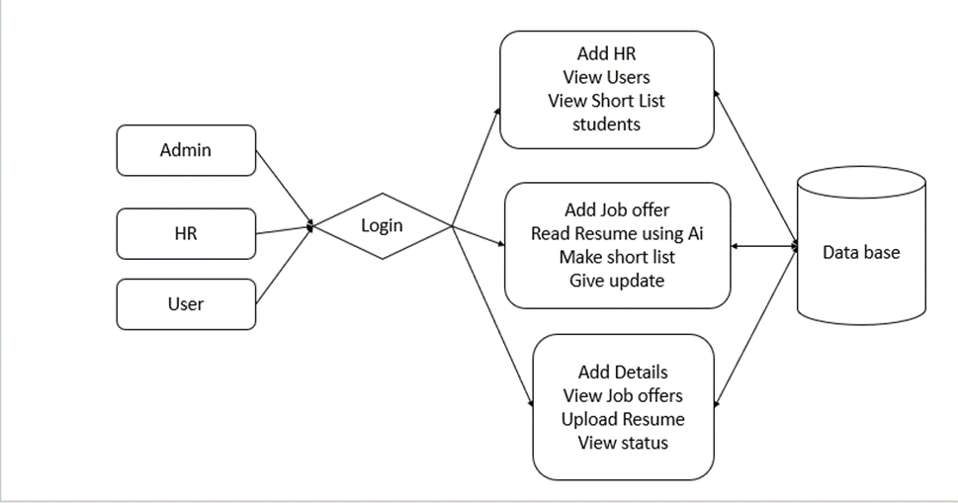

SOFTWARE REQUIREMENTS
Hardware Requirements
- Processor - I3/Intel Processor
- RAM - 8 GB
- Hard Disk - 1TB
Software Requirements
- Operating System - Windows 10
- JDK - java
- Plugin - Kotlin
- SDK - Android
- IDE - Android studio
- Database - server script, MySQL

Modules:
Admin: The admin module allows the addition of HR personnel, viewing user details, and accessing a list of shortlisted students. Admins also have the ability to update records in the database.
HR: HR has access to add job offers, read resumes using AI, and make shortlists of candidates. HR can also update the job status and provide feedback, ensuring the recruitment process is efficient.
User: Users can add personal details, view available job offers, upload resumes, and check their application status. Users can apply to job offers, and the system helps match them to suitable roles based on their profiles.

