CONVERSATIONAL IVR MODERNIZATION FRAMEWORK
Document Title: Milestone 1: Completion of System Analysis and Detailed Documentation of Integration Strategy
Project: Conversational IVR Modernization Framework
Batch: 13
Group: 2
Date: 15.02.2026

- Executive Summary

This report details the system analysis for the modernization of the IRCTC IVR. The current infrastructure, while functional, relies on aging on-premise hardware that lacks the elasticity to handle peak Tatkal congestion. We are proposing a move from a rigid, VXML-based "Press-1" system to an intent-driven architecture using Amazon Connect Streams (ACS) and BAP AI. This shift will replace hardware-capped ports with cloud-native scalability, ensuring that 10:00 AM transaction spikes do not result in system timeouts. [Source 1, 9]

- Assessment of Existing System

  - Baseline Architecture Overview
The "Exit" system is a hardware-dependent environment. It is built on distributed PC consoles using Dialogic telephony cards (4-16 ports). These systems terminate physical E1/PRI lines and run a VXML interpreter to manage calls.

- Languages & Syntax: The system uses VoiceXML (VXML). The code is structured around static tags like <form> and <menu>. This creates a "Static Script" environment where the user’s path is hard-code.

- The Convolutional Loop: The current workflow is a basic state machine. If a user fails to provide a clear DTMF tone, the system triggers a "No-Match" event and simply loops the audio prompt back to the beginning. It has no "memory"—it doesn't realize the user is struggling; it just repeats the loop until the user hangs up.

The Current Technical Flow:

- Telephony: Calls hit the Dialogic card via E1 interfaces. [Source 1]
- Logic Layer: VXML scripts manage the dialogue. This is "Hard Logic"—it cannot adapt to the user's tone or natural speech.
- Backend: The system uses EJB/JSP telephony servers to query the PRS MUX (for PNR) and NTES (for train info) databases via SQL. [Source 4, 5]

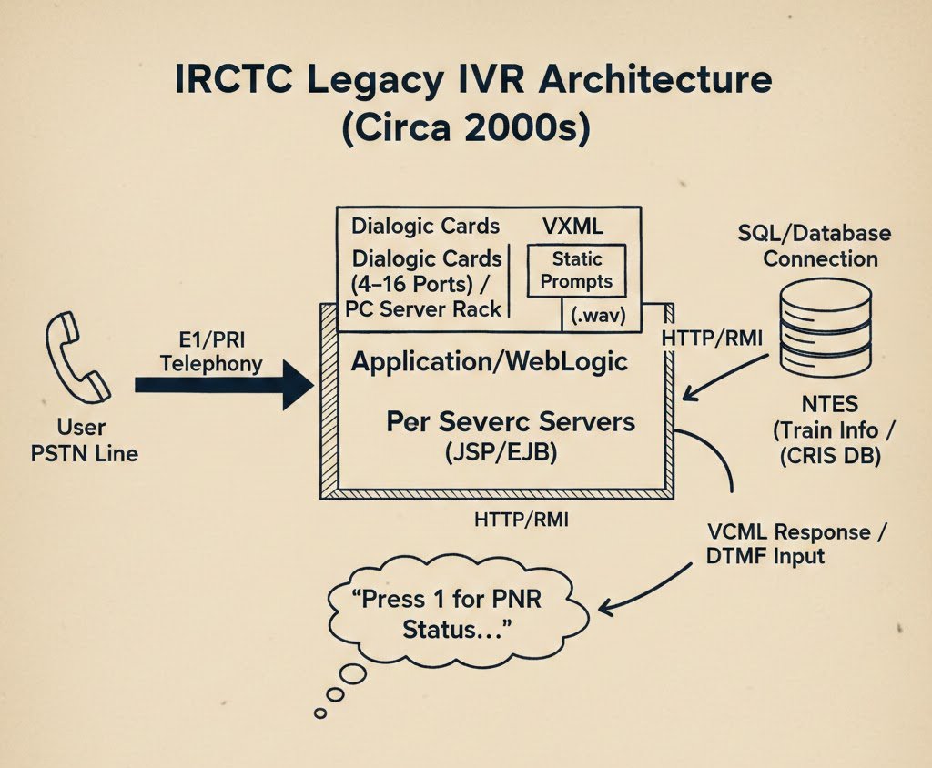
Fig. 2.1 IRCTC Legacy IVR Architecture

  - Capabilities Inventory
The following table outlines the existing feature set and the limitations of their current implementation:
Service | Current Implementation | The Modern Need
PNR Status | SQL queries via PRS Interface | Needs API-led retrieval via AWS Lambda.
Train Info | Live feeds from NTES. | Needs proactive AI alerts for delays.
User Feedback | Post-call ratings (2015 module). [Source 2] | Needs Sentiment Analysis to detect angry callers.
Languages | Static prompts (English and other Regional Languages). | Needs Neural TTS (Text-to-Speech) for natural voices.

- Modern IVR Integration (The "In-Depth" Architecture)

  - ACS and Twilio: The Strategic Shift

Unlike the legacy system, ACS and Twilio provide a "Digital Canvas." You aren't just writing scripts; you are building an Event-Driven system.
- Logic Translation: We move from "VXML Forms" to "Intent Recognition." Instead of waiting for a button, the system understands the Intent (e.g., "Where is my train?").
- Scalability: We replace physical Dialogic ports with virtual cloud capacity. This is necessary because the legacy market cannot handle the Tatkal-hour surges without crashing.

  - The Integration Workflow
In the modernized architecture, the "Loop" is replaced by a Contextual Workflow:
  - Ingress: The Call Arrives at Amazon Connect (ACS)
  - Intelligence: The BAP AI identifies the intent and extracts the PNR number using Natural Language Understanding (NLU).
  - Action: An AWS Lambda function is triggered. This is the "Logic Bridge" that fetches data from the legacy CRIS database.
  - Security: To prevent the Data Leakage mentioned in the requirements, all data is passed through an encrypted VPC PrivateLink tunnel.

- Technical Challenges & Security Concerns

  - Development Challenges
The biggest hazard is Logic Translation. We have to "re-teach" the system how to handle user queries. In the legacy system, everything was hard-coded. In the new system, we have to account for background noise and different Indian dialects, which requires Custom Development of the NLU models..

  - Security & Compatibility

• Data Leakage: Since we are moving PNR data to the cloud, we must implement PII Redaction.
• Feature Gaps: Legacy systems don't have "Sentiment Analysis." Our modern version will include a feature that detects if a passenger is frustrated and escalates them to a human agent automatically—something the existing system [Source 2] can't do.

