J Tables
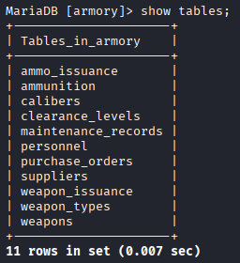

ammo_issuance
ammo_issuance table contains columns namely:
- ammo_issue_id (INT, PK)
- ammo_id (INT, FK)
- person_id (INT, FK)
- quantity (INT, NOT NULL)
- issue_date (DATE, NOT NULL)
This table is for storing the information related to the handing out of ammunition from the armory stock to specific personnel. It records every instance of ammunition withdrawal. This table has 2 many-to-one relationships with personnel(every issuance record belongs to exactly 1 person, but a person can appear in many issuance records) and ammunition(every issuance record is linked to exactly 1 ammunition type. However, a single ammunition type can appear in many issuance records over time. For example, the same 9mm round type may be issued to multiple personnel on different dates and in different quantities) tables.

ammunition
ammunition table contains columns namely:
- ammo_id (INT, PK)
- caliber_id (INT, FK)
- quantity (INT, NOT NULL)
- storage_location (VARCHAR(100))
This table is for storing the information related to current stock of ammunition types. The main aim of this table is to maintain an accurate and up-to-date record of what type of ammunition is available, how much is in stock, and their location. This table has 1 one-to-many relationships with calibers(ensures that every ammunition record must correspond to a valid, defined caliber type) and 1 many-to-one relationship with ammo_issuance (a single unit of ammunition can be issued by many personnels) tables.

calibers
calibers table contains columns namely:
- caliber_id (INT, PK)
- caliber_name (VARCHAR(50), NOT NULL)
This table is for storing the information related to caliber names with their unique ID’s. This table has 1 many-to-one relationship with ammunition(one caliber type can be associated with many different ammunition stock entries) and 1 one-to-many relationship with weapons(one caliber type, such as '5.56mm', can be used by many different weapon records, but each weapon record is linked to only one primary caliber) tables.

clearance_levels
calibers table contains columns namely:
- level_id (INT, PK)
- description (VARCHAR(200), NOT NULL)
This table is for storing the information related to 10 different types of level which as it increases its confidentiality increases and availability decreases. This table has 1 many-to-one relationship with personnel(as one clearance level can be assigned to many different personnel members).

maintenance_records
maintenance_records contains columns namely:
- record_id (INT, PK)
- weapon_id (INT,FK)
- maintenance_date(DATE)
- performed_by(VARCHAR(150))
- notes (TEXT)
This table is weak type as it functionally depends on weapons table, it only can be defined by record_id which is pointless without a relevant weapon. The table is for storing the information related to service, inspection and maintenance activities performed on every weapon in the armory inventory. It has 1 many-to-one relationship with the weapons table(one weapon can have many maintenance records).

personnel
personnel table contains columns namely:
- person_id (INT, PK)
- fullname (VARCHAR(150), NOT NULL)
- clearance_level(INT, FK)
This table is core entity and is for storing the information related to details of various personnels. This table has 1 many-to-one relationship with clearance_levels(as one clearance level can be assigned to many different personnel members) and 2 one-to-many relationships with ammo_issuance(a single personnel member can receive many different types of ammunition over time) and weapon_issuance(as one person can be associated with many different issuance records, but each issuance record belongs to only one person).

purchase_orders
purchase_orders table contains columns namely:
- order_id (INT, PK)
- supplier_id (INT, FK)
- weapon_id(INT, FK)
- order_date (DATE)
This table is for storing the information related to details of various purchases including bought weapons’ ids, order date and supplier ids. This table has 1 many-to-one relationship with suppliers (as one supplier can have many orders) and 1 one-to-many relationship with weapons(as many purchase order records can refer to the same weapon id).

suppliers
suppliers table contains columns namely:
- supplier_id (INT, PK)
- supplier_name(VARCHAR(150), NOT NULL)
- contact_info(VARCHAR(200))
This table is for storing the information related to details of various suppliers, their names and contact information. This table has 1 one-to-many relationships with purchase_orders(as one supplier can have many orders).

weapon_issuance
weapon_issuance table contains columns namely:
- issue_id (INT, PK)
- weapon_id(INT, FK)
- person_id(INT, FK)
- issue_date(DATE, NOT NULL)
- return_date(DATE, OPTIONAL NULL)
This table is for storing the information related to tracking who currently possesses or has previously possessed a specific weapon. It has 2 many-to-one relationships with personnel(as one person can be associated with many different issuance records, but each issuance record belongs to only one person) and weapons(as one specific weapon can be associated with many different issuance records throughout its service history, but each issuance record links to only one weapon)

weapon_types
weapon_types table contains columns namely:
- type_id (INT, PK)
- type_name(VARCHAR, NOT NULL)
This table is for storing the information related to weapons’ names along with their unique ids. It has 1 many-to-one relationship with weapons(as 1 weapon type (e.g., 'Pistol') can apply to many different specific weapon items (weapon_ids), but each individual weapon item can only be classified under one primary type.)

weapons
weapon table contains columns namely:
- weapon_id (INT, PK)
- serial_number (VARCHAR, NOT NULL)
- type_id (INT, FK)
- caliber_id (INT, FK)
- purchase_date(DATE, NOT NULL)
- status(VARCHAR(20), DEFAULT = ‘AVAILABLE’)
The weapons table is the core entity of the database. It is for store information related to individuals, serialized weapon item currently held in the inventory. It is used to track the current status, specifications, and acquisition history of weapons. It has 2 many-to-one relationships with weapon_types and calibers and 3 one-to-many relationships with weapon_issuance, maintenance_records and purchase_orders.

Normalization rules

1NF
Each cell must have atomic value, for example, instead of seperating the names of bought weapons by comma, I created weapon_issuance table.

2NF
Requires 1NF and must have no partial dependicies. In my case, ammo_issuance and weapon_issuance tables have their own primary key, to prevent being dependent on other tables’ composite keys

3NF
Requires 2NF and must have no any transitive dependency. In my case, for example personnel table has also clearance_description, so I separate clearance_levels, and make it another table. Similarly, in weapons table, there were type_id and type_name, to prevent repetition, I created weapon_types table and separate it from weapons table.

Queries

First Query
It identifes which weapons are currently issued and not yet returned:
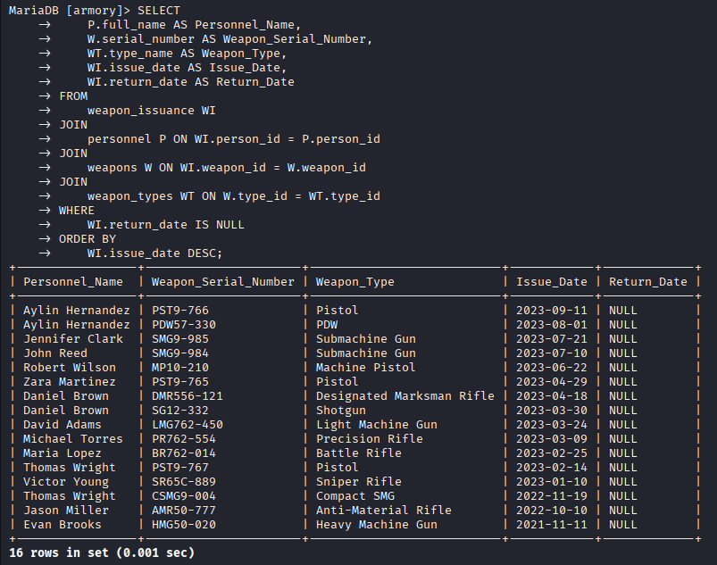

Second query
This query joins the personnel and clearance_levels tables to list all personnel who possess a "Secret Access" or higher clearance level (assuming level_id 4 and above indicates high clearance).
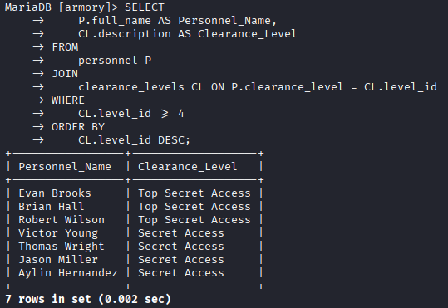

Third query
This query determines which ammunition caliber has been issued the most in terms of total quantity. It joins ammo_issuance, ammunition, and calibers, then uses the aggregate function SUM() and GROUP BY to total the issued quantity per caliber.
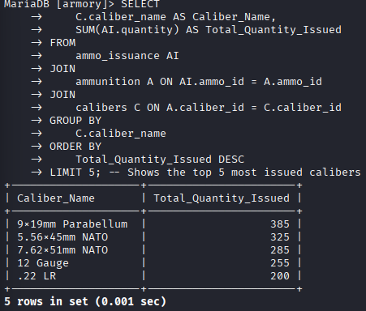

Fourth query
This query lists all weapons whose current status is 'Maintenance' or any weapon for which there is no maintenance record yet (LEFT JOIN combined with IS NULL), along with the date of their last service
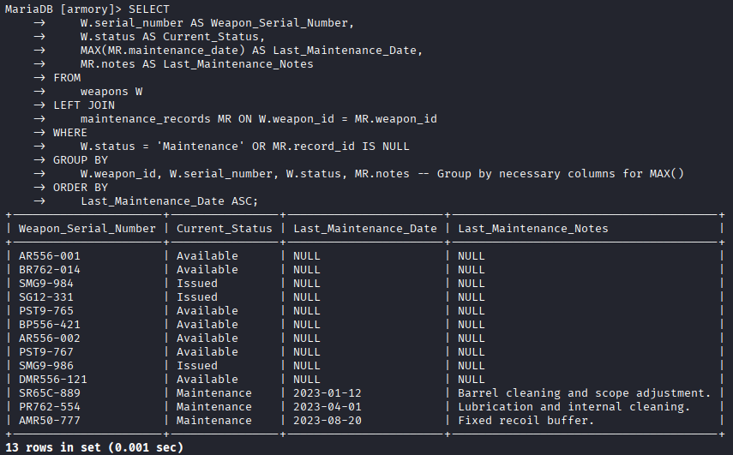

Fifth Query
This query identifies the most recent order date for each supplier. It joins purchase_orders and suppliers and uses the MAX() aggregate function to find the latest date per supplier.
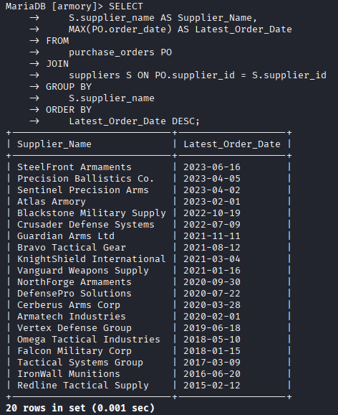

Stored Functions

First Function
GET_WEAPON_TOTAL_ISSUANCE_COUNT
This shows how many the given weapon id is issued
SHOW CREATE FUNCTION armory. GET_WEAPON_TOTAL_ISSUANCE_COUNT\G
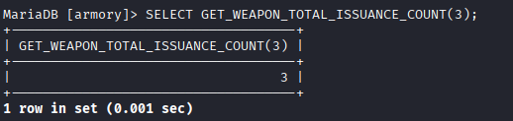

Second Function
GET_DAYS_SINCE_LAST_MAINTENANCE
This function calculates how many days are went since last maintenance, if there is no any note, it returns NULL.
SHOW CREATE FUNCTION armory. GET_DAYS_SINCE_LAST_MAINTENANCE\G
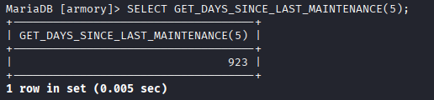

Third Function
GET_PERSONNEL_CLEARANCE_DESCRIPTION
This function returns clearance desription based on personnel id.
SHOW CREATE FUNCTION armory. GET_PERSONNEL_CLEARANCE_DESCRIPTION\G
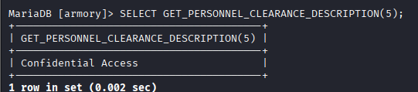

Stored Procedures
SHOW PROCEDURE STATUS WHERE Db = 'armory’;

First Procedure
ISSUE_WEAPON
Manages the personal weapon cleaning process and automatically changes the weapon's status to Issued.
SHOW CREATE PROCEDURE armory.ISSUE_WEAPON\G
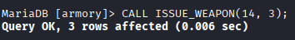

Second Procedure
RETURN_WEAPON
Records the return of the weapon and changes the weapon's status to 'Available'.
SHOW CREATE PROCEDURE armory.RETURN_WEAPON\G
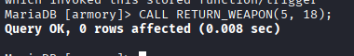

Third Procedure
SEARCH_PERSONNEL_BY_LEVEL
Lists all personnel with a given authority level (e.g., 4).
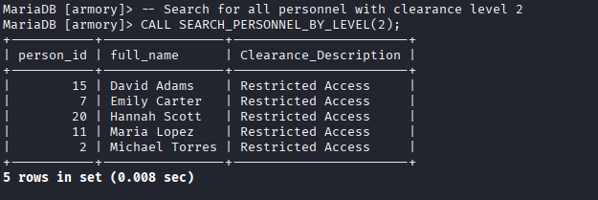

Fourth Procedure
ADD_MAINTENANCE_RECORD
Inserts a new maintenance record for the weapon and sets the weapon's status to 'Available'.
SHOW CREATE PROCEDURE armory.ADD_MAINTENANCE_RECORD\G

Fifth Procedure
ISSUE_AMMUNITION
SHOW CREATE PROCEDURE armory.ISSUE_AMMUNITION\G
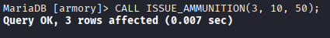
Keeps a record of personnel ammunition distribution and withdraws that amount from the available ammunition stock.

Triggers

First Trigger
SHOW CREATE TRIGGER armory.UPDATE_WEAPON_STATUS_ON_MAINTENANCE_INSERT\G
Before a new maintenance record is inserted into the maintenance_records table (BEFORE INSERT), it changes the status of that weapon to 'Maintenance'.
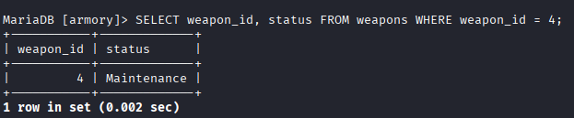

Second Trigger
SHOW CREATE TRIGGER armory.CHECK_AMMUNITION_STOCK\G
Before inserting a new ammunition distribution record (BEFORE INSERT), it checks whether there is enough ammunition in the warehouse. If not, it prevents the operation (or returns an error).
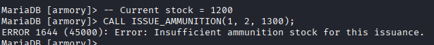

Third Trigger
SHOW CREATE TRIGGER armory.PREVENT_WEAPON_STATUS_UPDATE\G
Warns when trying to change the status of a weapon issued to a person to Available after the status has been changed in the weapons table (AFTER UPDATE) (this trigger will run if return_date is NULL in the weapon_issuance table).
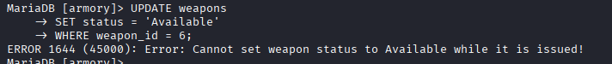

CTEs

First CTE
CTE: ISSUED_WEAPON_SUMMARY
This CTE cleanly integrates the weapon_issuance table, maintenance records, and personnel.
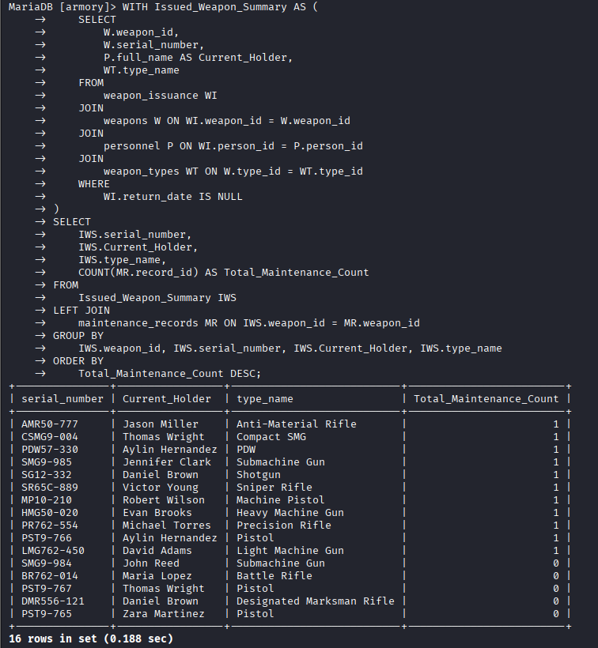

Second CTE
CTE: TOP_ISSUED_AMMO_BY_LEVEL
Calculates the total amount of ammunition distributed for each Clearance Level and ranks these levels by the amount of ammunition distributed the most.
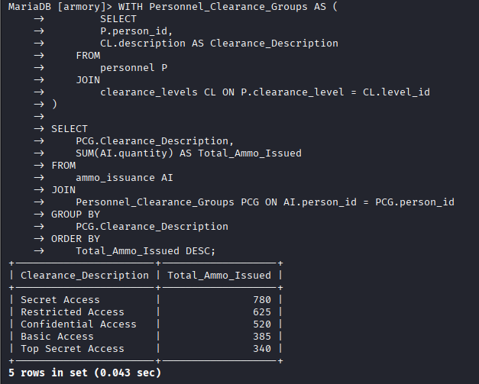

Third CTE
CTE: WEAPON_AGE_RANKING
This CTE uses a Window Function to assign a rank to each weapon based on its age.


