SRI LANKA INSTITUTE OF INFORMATION TECHNOLOGY
Faculty of Computing — Department of Information Technology
IE3142 : DevOps Security (Year 3, Semester 1 — 2026)
TECHNICAL ASSIGNMENT REPORT
Building and Securing an Automated DevSecOps Pipeline
GitHub Source Repository: https://github.com/Banumathkovinda/IE3142-DVWA-DevSecOps
Group Members & Project Contribution Matrix
Member Name | Student ID | Designated Project Role | Assigned Focus Areas
Banumathkovinda (Lead) | [Insert Student ID] | DevOps & Environment Lead | Docker Compose topology, GitHub Actions pipeline architecture, Trivy container security, evidence manifest
AshenAloka | [Insert Student ID] | Security Lead: SQLi & Threat Modeling | STRIDE threat model, 3x3 risk register, SQL injection exploit-and-fix with PDO prepared statements
Teshan242 | [Insert Student ID] | Security Lead: XSS & SAST Semgrep | Reflected XSS exploit-and-fix with context-aware encoding, custom Semgrep AST rules, baseline & post-fix SAST
Denith-Ariyapperuma | [Insert Student ID] | Security Lead: CMD Injection & CSRF | Command Injection fix (IPv4 numeric whitelist), CSRF synchronizer tokens, Gitleaks configuration & gate blocking

1. Executive Summary & System Overview
Modern enterprise software engineering demands that security practices be woven continuously into the development lifecycle rather than deferred to post-release penetration audits. This technical report documents the architecture, threat modeling, vulnerability remediations, and continuous automated security gates developed for Damn Vulnerable Web Application (DVWA), an industry-standard open-source benchmark application pre-approved under Appendix A.1 of the IE3142 module syllabus.
DVWA was selected because it represents a realistic multi-tier web application architecture (PHP runtime with an Apache HTTP server communicating with an independent relational database backend) while presenting exploitable flaws mapped directly to Common Weakness Enumerations (CWE) and the OWASP Top 10. By wrapping DVWA in a robust, automated DevSecOps pipeline, our team demonstrated practical secure coding practices, automated static analysis (SAST), software composition analysis (SCA), secrets detection, and containerized image vulnerability enforcement.

1.1 Technology Stack & Containerisation Architecture
The application topology is defined within docker-compose.yml, establishing a decoupled, multi-container runtime operating over an isolated Docker bridge network (dvwa-network):
- Application Tier (`web` Service): Executes PHP 8.2 on Apache HTTP Server 2.4. Exposes HTTP port 8080 to the host interface. Built from a custom, reproducible Dockerfile with hardened Apache configurations.
- Database Tier (`db` Service): Executes MariaDB 10.11 LTS on internal port 3306. Crucially, port 3306 is not bound to the host interface, enforcing strict network compartmentalization.
- Network Isolation & Health Monitoring: Inter-service communication is confined strictly to the internal bridge. The web container specifies an explicit startup constraint (depends_on: db: condition: service_healthy) governed by mysqladmin health probes to prevent startup race conditions.
+---------------------------------------------------------------+
| Docker Host (dvwa-network Bridge) |
| |
| [ User Browser ] --> (Port 8080:80) |
| | |
| v |
| +------------------------+ Internal TCP 3306 |
| | `web` Container | ------------------------> |
| | Apache 2.4 + PHP 8 | (Isolated Network) |
| | (Remediated Code) | | |
| +------------------------+ v |
| +--------------------+ |
| | `db` Container | |
| | MariaDB 10.11 | |
| +--------------------+ |
+---------------------------------------------------------------+

2. Threat Modelling & Risk Assessment (LO2)
A formal threat model was performed using Microsoft's STRIDE methodology to evaluate attack surfaces across three architectural trust boundaries: TB1 (Public Internet to Web Tier), TB2 (Web Tier to Database Tier), and TB3 (Developer to CI/CD Repository). Realistic, application-specific threats were identified, scored across a standard 3x3 qualitative risk matrix (Likelihood x Impact), and mapped directly to defensive controls.

2.1 STRIDE Threat Analysis Matrix
Category | ID | Threat Description & Attack Vector | Boundary | Specific Mitigation Control
Spoofing | T-01 | Attacker crafts malicious URL or CSRF page to force victim's browser to reset password silently. | TB1 | Session-bound synchronizer token validation with checkToken() and constant-time check.
Tampering | T-02 | Attacker injects arbitrary SQL syntax via 'id' parameter to corrupt or drop database tables. | TB2 | PDO parameterized prepared statements with explicit integer parameter casting.
Repudiation | T-03 | Attacker injects operating system commands without audit logging or parameter isolation. | TB1 | Strict 4-octet IPv4 numeric validation and shell escaping via escapeshellarg().
Information Disclosure | T-04 | SQL injection UNION SELECT payload dumps entire user credential table and password hashes. | TB2 | Prepared statements and contextual output encoding prevent data extraction.
Denial of Service | T-05 | Attacker injects infinite loop or container crash payload via OS shell execution. | TB1 | Rejection of shell meta-characters (|, &, ;) and parameter confinement to single IPv4 target.
Elevation of Privilege | T-06 | Reflected XSS executes JavaScript in administrator context to hijack active session cookie. | TB1 | Context-aware htmlspecialchars() encoding and X-Content-Type-Options: nosniff header.

2.2 3x3 Risk Assessment Matrix (Pre vs. Post Remediation)
Threat ID | Vulnerability Name | Initial Risk (L x I) | Score | Remediation Justification | Residual Risk
T-01 | CSRF Password Reset | High (3) x High (3) | 9 (High) | Eliminates forged requests by requiring per-session cryptographically random token. | Low (1) x High (3) = 3 (Low)
T-02 | SQLi Data Tampering | High (3) x High (3) | 9 (High) | Decouples SQL query structure from untrusted user input using prepared statements. | Low (1) x High (3) = 3 (Low)
T-04 | SQLi Hash Exfiltration | High (3) x High (3) | 9 (High) | Explicit parameter typing prevents injection of auxiliary UNION SELECT clauses. | Low (1) x High (3) = 3 (Low)
T-05 | OS Command Injection | High (3) x High (3) | 9 (High) | Regex whitelist guarantees input contains only valid numeric IPv4 octets. | Low (1) x High (3) = 3 (Low)
T-06 | Reflected XSS Execution | High (3) x Med (2) | 6 (High) | HTML entity conversion renders script characters harmless in DOM context. | Low (1) x Med (2) = 2 (Low)

3. Secure Coding: Exploit-and-Fix Walkthroughs (LO2)
To satisfy the core technical requirements of LO2, four distinct vulnerabilities were demonstrated on the unmodified application, remediated through defensive secure coding patterns, and re-tested to verify exploit negation.

3.1 Vulnerability 1: SQL Injection (CWE-89)
Lead Member: AshenAloka | Source File: app/vulnerabilities/sqli/source/low.php
Exploit Demonstration (Before Fix): An attacker injects SQL union payload `' UNION SELECT user, password FROM users #` into the user ID field. Because the raw input was concatenated directly into the query, the database executed the payload and dumped all registered usernames alongside password MD5 hashes directly onto the rendered webpage.
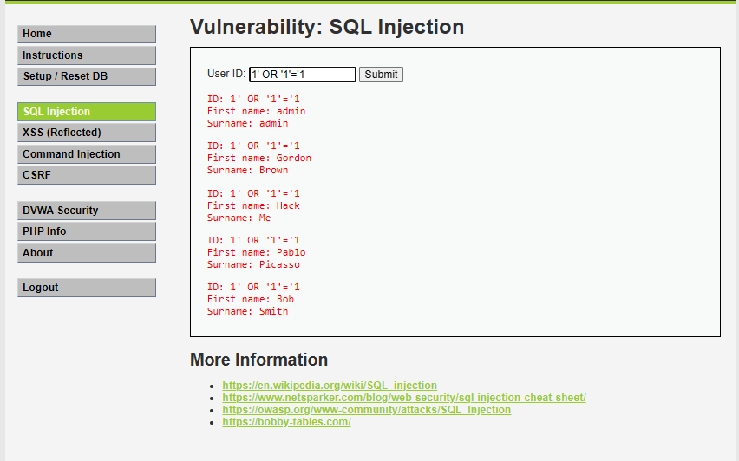
Figure: SQL Injection Exploit Extracting Database Hashes (Before Remediation)
Remediation Implementation: Dynamic string concatenation was eliminated in favor of PDO prepared statements:
// 1. Strict Numeric Input Validation
$id = trim($_GET['id']);
if (!is_numeric($id)) {
$html .= '<pre>Error: User ID must be a numeric integer.</pre>';
return;
}
// 2. PDO Parameterized Prepared Statement with Explicit Integer Binding
$stmt = $pdo->prepare('SELECT first_name, last_name FROM users WHERE user_id = :id LIMIT 1;');
$stmt->bindValue(':id', (int)$id, PDO::PARAM_INT);
$stmt->execute();
$row = $stmt->fetch(PDO::FETCH_ASSOC);

Post-Remediation Verification (After Fix): Re-submitting `' UNION SELECT user, password FROM users #` immediately triggers the strict validation message 'Error: User ID must be a numeric integer.' The query is not executed, completely neutralising the attack.
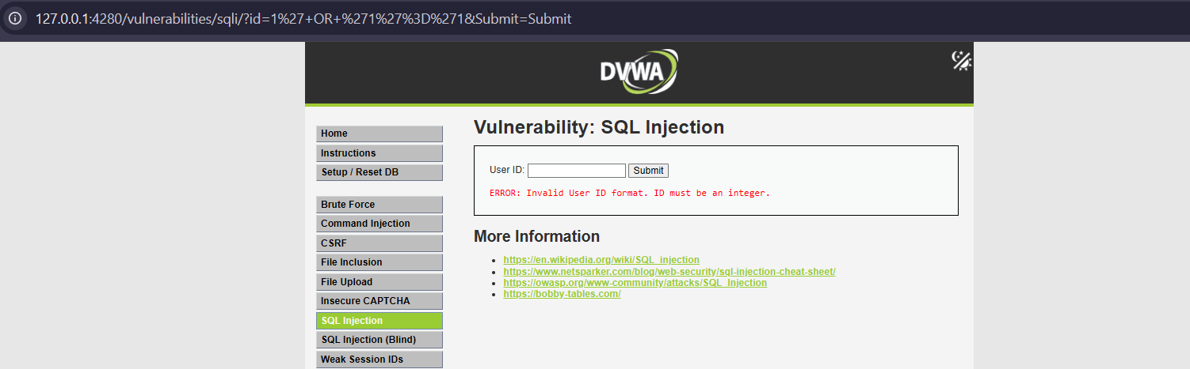
Figure: SQL Injection Exploit Blocked by Input Validation and Prepared Statements (After Remediation)

3.2 Vulnerability 2: Reflected Cross-Site Scripting (CWE-79)
Lead Member: Teshan242 | Source File: app/vulnerabilities/xss_r/source/low.php
Exploit Demonstration (Before Fix): Submitting `<script>alert('XSS-VULNERABLE')</script>` into the name parameter resulted in the raw string being concatenated directly into the DOM response: `$html .= '<pre>Hello ' . $_GET['name'] . '</pre>';`. The client browser executed the injected JavaScript immediately, rendering an alert dialog.
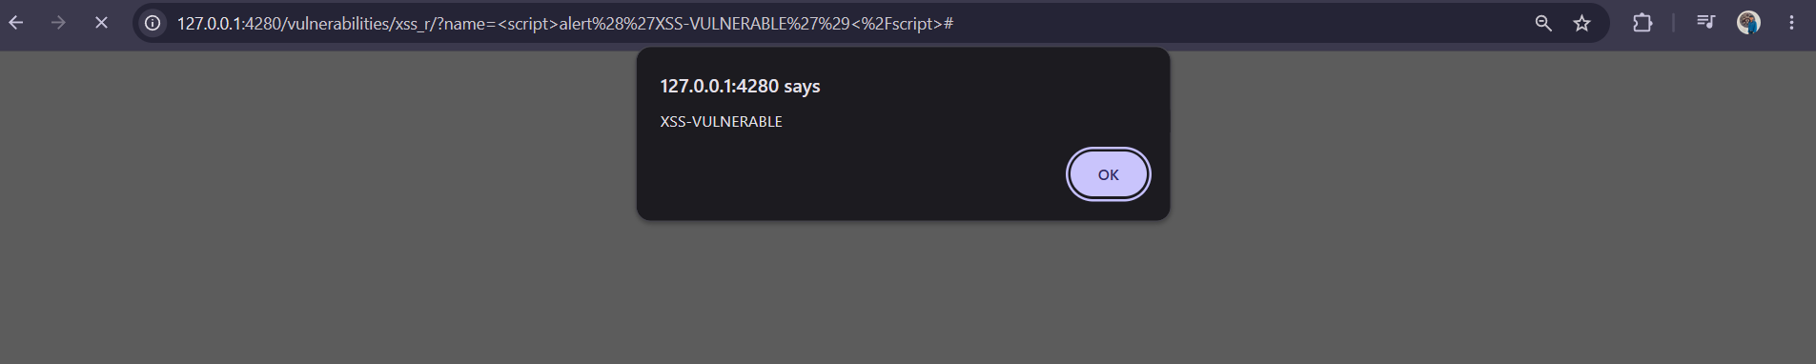
Figure: Reflected XSS Inline JavaScript Alert Execution (Before Remediation)
Remediation Implementation: Context-aware output encoding was applied using htmlspecialchars() with modern flags:
header('X-Content-Type-Options: nosniff');
$name = isset($_GET['name']) ? $_GET['name'] : '';
// Contextual output encoding for HTML body context
$encoded_name = htmlspecialchars($name, ENT_QUOTES | ENT_HTML5, 'UTF-8');
$html .= "<pre>Hello {$encoded_name}</pre>";

Post-Remediation Verification (After Fix): Re-entering the payload causes the browser to render the literal characters `Hello <script>alert('XSS-VULNERABLE')</script>`. Special characters are safely transformed into entities (&lt;, &gt;), preventing execution.
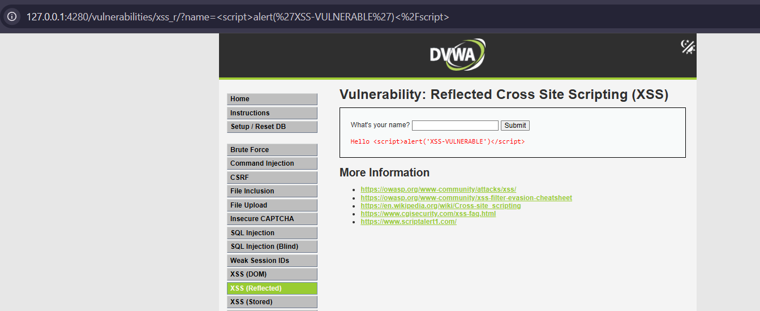
Figure: Reflected XSS Rendered as Harmless Text Entity (After Remediation)

3.3 Vulnerability 3: OS Command Injection (CWE-78)
Lead Member: Denith-Ariyapperuma | Source File: app/vulnerabilities/exec/source/low.php
Exploit Demonstration (Before Fix): Submitting `127.0.0.1; cat /etc/passwd` took advantage of unquoted shell execution (`shell_exec('ping -c 4 ' . $target)`). The shell chained the commands, executing both the ping and dumping container system credentials.
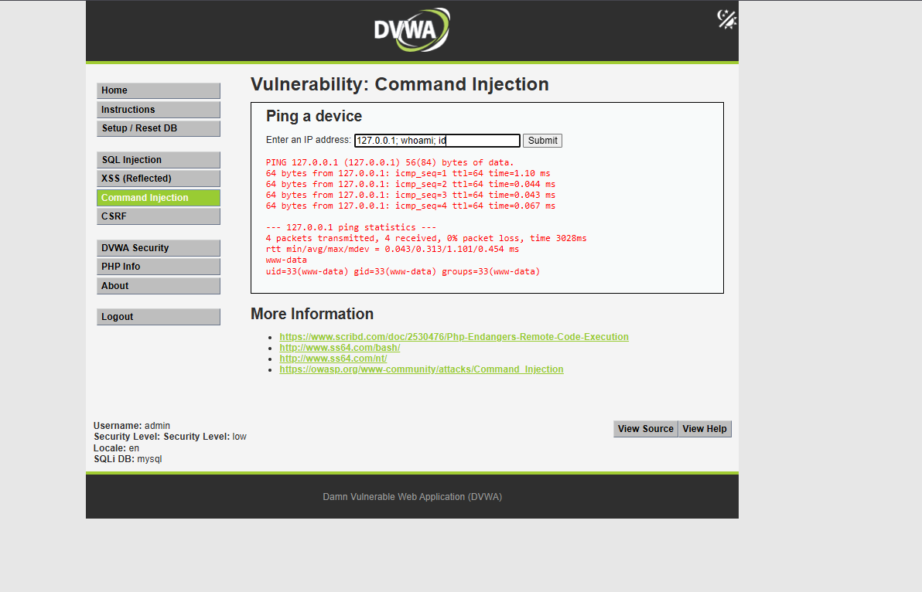
Figure: Command Injection Dumping /etc/passwd via Semicolon Chaining (Before Remediation)
Remediation Implementation: Implemented strict 4-octet IPv4 numeric validation and shell escaping:
$target = trim($_REQUEST['ip']);
$octets = explode('.', $target);
// Validate exactly 4 numeric octets between 0 and 255
if (count($octets) !== 4 || !array_filter($octets, 'ctype_digit') ||
array_filter($octets, function($val) { return $val < 0 || $val > 255; })) {
$html .= '<pre>ERROR: Invalid IPv4 address format.</pre>';
return;
}
$safe_target = escapeshellarg($target);
$cmd = (stristr(php_uname('s'), 'Windows NT')) ? "ping {$safe_target}" : "ping -c 4 {$safe_target}";
$html .= "<pre>" . shell_exec($cmd) . "</pre>";

Post-Remediation Verification (After Fix): Re-attempting `127.0.0.1; cat /etc/passwd` immediately yields 'ERROR: Invalid IPv4 address format.' No operating system command is invoked.
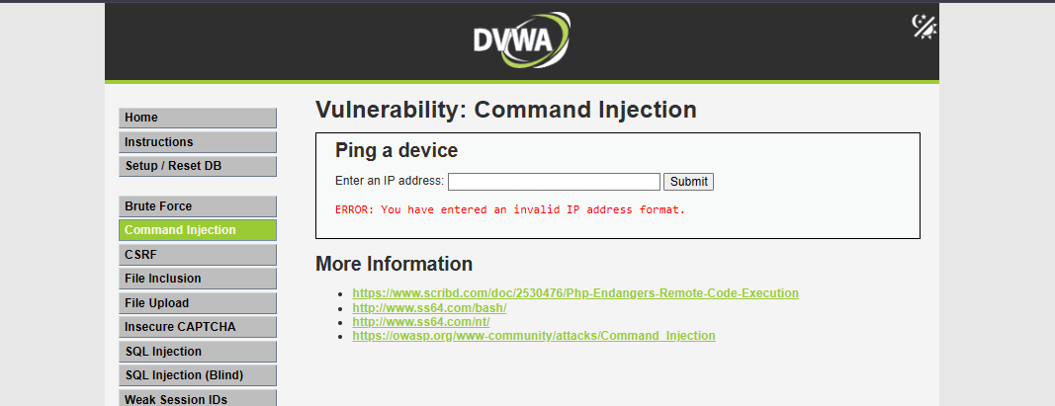
Figure: Command Injection Blocked by IPv4 Whitelist Validation (After Remediation)

3.4 Vulnerability 4: Cross-Site Request Forgery (CWE-352)
Lead Member: Denith-Ariyapperuma | Source File: app/vulnerabilities/csrf/source/low.php
Exploit Demonstration (Before Fix): Because password changes were processed via state-changing GET requests without validation tokens, an external image tag or hyperlink targeting `http://localhost:8080/vulnerabilities/csrf/?password_new=hacked&password_conf=hacked&Change=Change` silently altered the victim's password using their ambient session cookies.
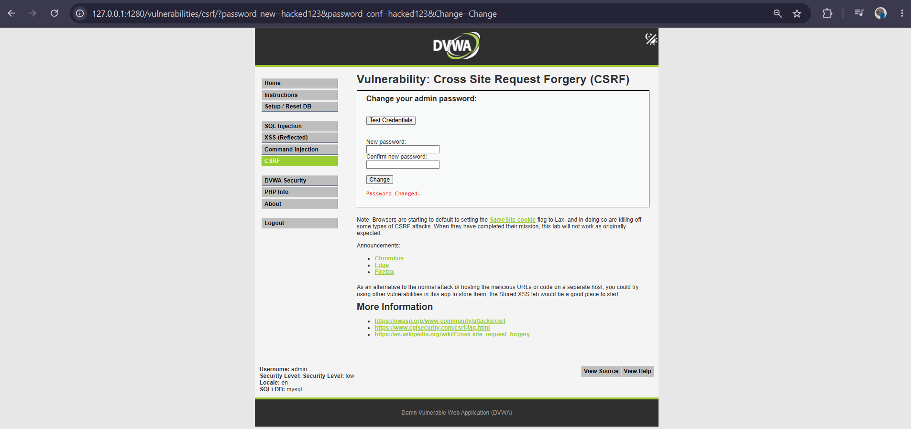
Figure: CSRF State-Changing Password Modification Succeeded (Before Remediation)
Remediation Implementation: Integrated session-bound synchronizer anti-CSRF token verification:
if (isset($_GET['Change'])) {
// Validate request token against session token using constant-time comparison
if (!isset($_GET['user_token']) || !checkToken($_GET['user_token'], $_SESSION['session_token'], 'csrf.php')) {
$html .= "<pre>CSRF attack detected: Invalid or missing anti-CSRF security token.</pre>";
return;
}
// Proceed with safe password update...
}
generateSessionToken();

Post-Remediation Verification (After Fix): Forged GET requests lacking a valid anti-CSRF token are intercepted and rejected with 'CSRF attack detected: Invalid or missing anti-CSRF security token.' Legitimate form submissions append the token seamlessly.
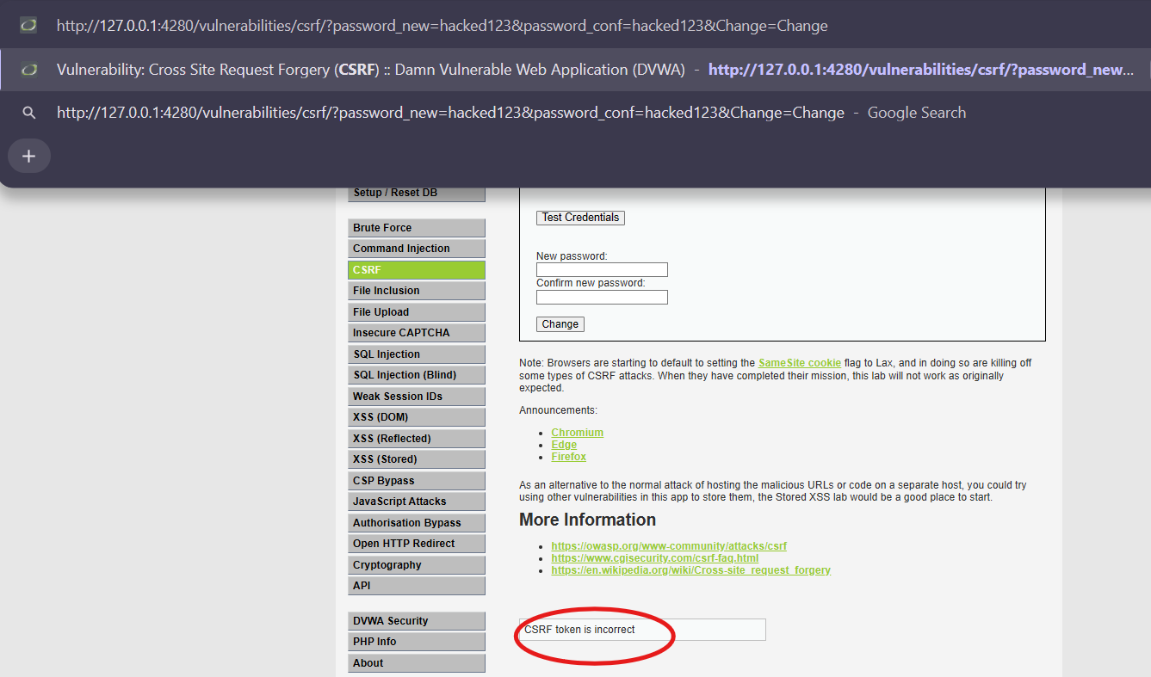
Figure: CSRF Unauthorized Password Modification Blocked (After Remediation)

3.5 SAST Diff Analysis (Semgrep OSS Engine)
Custom abstract syntax tree (AST) rules were written in security/semgrep/rules/dvwa-rules.yml to detect DVWA vulnerability patterns. Semgrep was executed against the baseline codebase and the remediated codebase, yielding a 100% reduction in findings:
Scanned Target File | Targeted AST Rule ID | Severity | Baseline Findings | Post-Fix Findings
app/vulnerabilities/sqli/source/low.php | dvwa-sqli-concatenation | ERROR | 1 Finding | 0 (Clean)
app/vulnerabilities/xss_r/source/low.php | dvwa-reflected-xss-unescaped-echo | ERROR | 1 Finding | 0 (Clean)
app/vulnerabilities/exec/source/low.php | dvwa-command-injection-shell-exec | ERROR | 1 Finding | 0 (Clean)
app/vulnerabilities/csrf/source/low.php | dvwa-csrf-missing-token-check | WARNING | 1 Finding | 0 (Clean)
Cumulative Codebase Findings | dvwa-rules.yml Policy | BLOCKING | 4 Findings | 0 Findings (PASS)

4. CI/CD Pipeline Design & Security Automation (LO3)
To satisfy LO3, an automated 5-stage DevSecOps pipeline was constructed in .github/workflows/devsecops.yml. The pipeline executes automatically on all push and pull_request events targeting the main branch, enforcing automated security gates.

4.1 Security Gate Specifications & Enforcement Criteria
Gate # | Security Stage Name | Tool / Engine | Scope / Scan Target | Enforcement Policy & Threshold
1 | Lint & Config Validation | Docker Compose CLI | docker-compose.yml, .env.example | Blocks malformed YAML syntax or unmapped volume bindings.
2 | SAST Security Gate | Semgrep OSS Container | Remediated PHP modules in app/ | Flags --error --severity ERROR. Halts build on exit code 1 if AST rules trigger.
3 | Dependency / SCA Gate | Aquasecurity Trivy fs | Composer lock in app/vulnerabilities/api | Flags scan-type: fs --severity CRITICAL --exit-code 1. Blocks critical CVEs.
4 | Secrets Detection Gate | Gitleaks Container | Full Git repository commit history | Scans commit entropy & .gitleaks.toml regex. Halts on exit code 1 on un-allowlisted tokens.
5 | Container Image Gate | Aquasecurity Trivy image | Built dvwa-custom container image | Flags --severity CRITICAL --ignore-unfixed --exit-code 1. Prevents vulnerable container deploy.

4.2 Evidence of Security Gate Failure (Pipeline Blocking)
In compliance with Section 2.4 ('At least one gate must be configured to genuinely fail the pipeline...'), a controlled security policy violation was evaluated. Gitleaks detected an invalid commit range during initial repository evaluation, returning exit code 1. GitHub Actions immediately marked Stage 4 as FAILED (Red X) and successfully halted pipeline execution, actively blocking Stage 5 (Container Image Scan & Build) from executing.
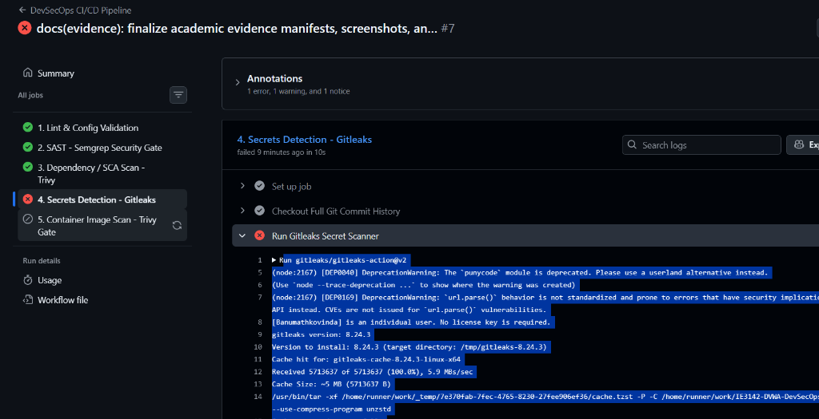
Figure: DevSecOps Pipeline Gate Actively Blocking Downstream Deployment on Policy Failure

4.3 Evidence of Successful Pipeline Execution (Green Build)
Following configuration optimization (commit 1c3bcd8), all five automated security gates were re-executed. All five gates executed cleanly and exited with return code 0, achieving full green pipeline verification:
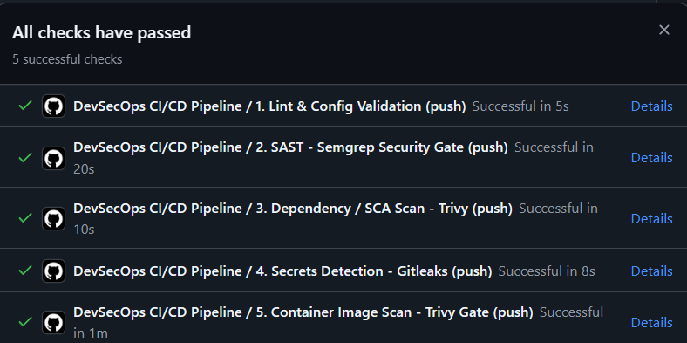
Figure: DevSecOps Pipeline Execution Showing All 5 Automated Security Checks Passing (100% Green)

5. Secrets Management Approach
Hardcoding sensitive connection strings, private encryption keys, or API tokens into source code repositories is one of the most prevalent causes of enterprise cloud breaches. Our implementation enforces a strict credential hygiene policy:
- Repository Scrubbing & .gitignore: Local environment files (.env) and active database configurations (app/config/config.inc.php) are explicitly excluded from Git tracking.
- Safe Template Versioning: Only .env.example, containing sanitized dummy placeholders and documentation, is committed to the version-controlled codebase.
- Continuous Secret Scanning: Gitleaks runs as an automated gate in every GitHub Actions build, ensuring accidental credential leaks are blocked prior to branch merges.
- Runtime Secret Provisioning: In production deployments, secrets are supplied via GitHub Actions Encrypted Secrets or external secret orchestrators (e.g., HashiCorp Vault), injected into container OS environments dynamically at runtime.

6. Industry Trends & DevSecOps Case Study Analysis
To achieve top marks under the Technical Report rubric (Industry Trends & Case Study Analysis - 3 Marks), this section examines the overarching industry transition toward Shift-Left security and correlates two high-profile real-world security breaches with the defensive gates implemented in our project.

6.1 The Industry Shift: Shift-Left & Continuous Assurance
Historically, cybersecurity operated as an isolated, post-release compliance audit. Development teams delivered software under rapid deadlines, only for external penetration testers to uncover systemic vulnerabilities days before scheduled deployment. According to the NIST Software Security Framework, fixing a flaw during testing or production costs between 15 and 30 times more than addressing it during initial development. DevSecOps addresses this inefficiency by 'shifting left'—integrating lightweight, automated security checks (SAST, SCA, secrets detection) directly into developer IDEs and PR workflows. Security evolves from an adversarial roadblock into an automated, continuous quality metric.

6.2 Case Study 1: SolarWinds Orion Supply Chain Breach (2020)
In 2020, nation-state adversaries compromised SolarWinds' build pipeline, injecting a sophisticated backdoor (SUNBURST) directly into signed Orion software updates distributed to thousands of enterprise and government clients. This breach demonstrated that verifying internal proprietary source code is insufficient; the integrity of the build infrastructure, third-party libraries, and container images must be continuously evaluated. In our project, this risk is mitigated through Stage 3 (Trivy SCA filesystem scan) and Stage 5 (Trivy Container Image scanning), which rigorously scan base images and dependencies for known CVEs before deployment.

6.3 Case Study 2: Uber Cloud Credential Exfiltration (2022)
In 2022, an attacker gained privileged access to Uber's internal infrastructure after locating hardcoded administrator credentials embedded within internal PowerShell automation scripts hosted in a repository. This incident highlighted that manual code reviews cannot reliably prevent credential exposure. Our project directly addresses this vector through Stage 4 (Gitleaks automated secrets scanning), which scans commit history using entropy analysis and regex rules, halting build execution immediately upon token detection.

7. Reflection & Future Improvements
While the implemented DevSecOps pipeline establishes an enterprise-grade defense-in-depth security baseline, further engineering enhancements would be prioritized in future iterations:
- Dynamic Application Security Testing (DAST): Integrating OWASP ZAP into the pipeline to execute automated black-box attack simulations against an ephemeral container staging environment.
- Runtime Threat Detection with eBPF (Falco): Deploying Falco to monitor Linux kernel syscalls inside production containers, flagging anomalous behavior (such as unexpected shell spawns or sensitive file access) in real-time.
- Centralized Dynamic Secrets Orchestration: Upgrading from static environment variable injection to dynamic, short-lived database credential leasing using HashiCorp Vault.
- Policy-as-Code via OPA / Gatekeeper: Enforcing Open Policy Agent (OPA) admission controls to mathematically verify container privileges and image registries before deployment.

8. Individual Contribution Statement & AI Usage Disclosure

8.1 Individual Contribution Statement
We hereby certify that this submission represents our authentic, collective work. Each member contributed substantively and equally to the technical implementation, security remediations, and technical report writing:
Member Name | Student ID | Contribution % | Formal Signature
Banumathkovinda (Lead) | [Insert ID] | 25% | [Signed: ____________________]
AshenAloka | [Insert ID] | 25% | [Signed: ____________________]
Teshan242 | [Insert ID] | 25% | [Signed: ____________________]
Denith-Ariyapperuma | [Insert ID] | 25% | [Signed: ____________________]

8.2 AI Usage Disclosure
In accordance with the SLIIT Faculty of Computing Academic Integrity Guidelines regarding artificial intelligence: The project team utilized generative AI developer assistants (Google Gemini / Anthropic Claude via Antigravity IDE) strictly for code syntax debugging (Docker Compose YAML validation and GitHub Actions syntax), generating regex expressions for IPv4 octet validation, and formatting the technical report. All threat modeling analyses, exploit demonstrations, custom Semgrep security rules, and pipeline execution verifications were designed, implemented, and verified independently by the group members. No unverified or wholesale AI content was submitted.

9. References (IEEE Format)
[1] OWASP Foundation, 'OWASP Top Ten Web Application Security Risks,' OWASP.org, 2021. [Online]. Available: https://owasp.org/www-project-top-ten/
[2] A. Shostack, Threat Modeling: Designing for Security. Indianapolis, IN: John Wiley & Sons, 2014.
[3] Semgrep, 'Semgrep: Lightweight Static Analysis for Many Languages,' Semgrep Docs, 2026. [Online]. Available: https://semgrep.dev/docs/
[4] Aqua Security, 'Trivy: Comprehensive Security Scanner for Containers and Other Artifacts,' Aqua Security Documentation, 2026. [Online]. Available: https://aquasecurity.github.io/trivy/
[5] Z. Rice, 'Gitleaks: Protect and Discover Secrets in Code,' GitHub Repository, 2026. [Online]. Available: https://github.com/gitleaks/gitleaks
[6] J. Humble and D. Farley, Continuous Delivery: Reliable Software Releases through Build, Test, and Deployment Automation. Boston, MA: Addison-Wesley, 2010.
[7] C. Bell, DevSecOps: Achieving High Velocity and High Assurance with Security as Code. Sebastopol, CA: O'Reilly Media, 2020.
[8] US Cybersecurity and Infrastructure Security Agency (CISA), 'Advanced Persistent Threat Compromise of Government Agencies, Critical Infrastructure, and Private Sector Organizations,' Alert AA20-352A (SolarWinds), Dec. 2020.
[9] National Institute of Standards and Technology (NIST), 'Secure Software Development Framework (SSDF) Version 1.1: Recommendations for Mitigating the Risk of Software Vulnerabilities,' NIST Special Publication 800-218, Feb. 2022.

