**SQL Test Assessment:**

**Question No.1**

[SELECT](http://localhost/phpmyadmin/url.php?url=https://dev.mysql.com/doc/refman/5.5/en/select.html) orderdetails.orderNumber, products.productName,customers.customerName,payments.amount,payments.checkNumber FROM orderdetails INNER JOIN products ONproducts.productCode=orderdetails.productCode INNER JOIN payments ON payments.customerNumber=([SELECT](http://localhost/phpmyadmin/url.php?url=https://dev.mysql.com/doc/refman/5.5/en/select.html) customerNumber FROM orders WHERE orders.orderNumber=orderdetails.orderNumber)INNER JOIN customers ON customers.customerNumber=payments.customerNumber

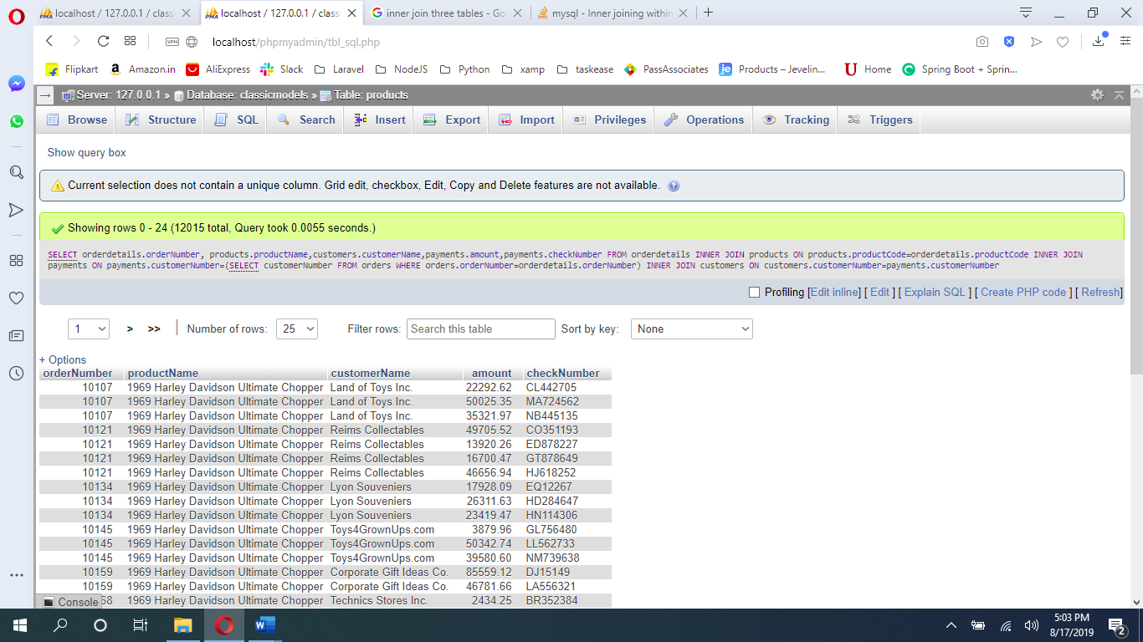

**Question No. 2**

[SELECT](http://localhost/phpmyadmin/url.php?url=https://dev.mysql.com/doc/refman/5.5/en/select.html) orders.orderNumber,

([SELECT](http://localhost/phpmyadmin/url.php?url=https://dev.mysql.com/doc/refman/5.5/en/select.html) [SUM](http://localhost/phpmyadmin/url.php?url=https://dev.mysql.com/doc/refman/5.5/en/group-by-functions.html#function_sum)(amount) FROM payments

WHERE customerNumber=orders.customerNumber)

as total_paid_amount_for_the_order_10100

FROM orders WHERE orderNumber =10100

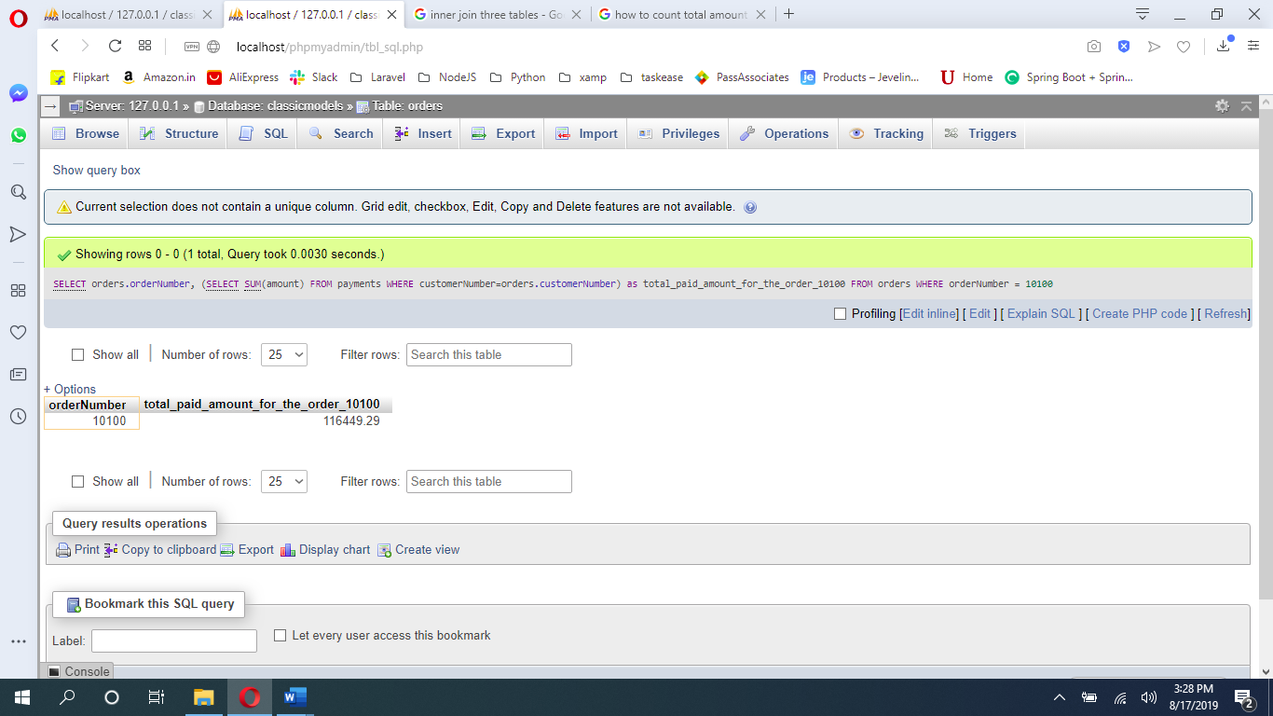

Question No 3

[SELECT](http://localhost/phpmyadmin/url.php?url=https://dev.mysql.com/doc/refman/5.5/en/select.html) ([SELECT](http://localhost/phpmyadmin/url.php?url=https://dev.mysql.com/doc/refman/5.5/en/select.html) orderNumber FROM orders WHERE orderNumber=10100) as orderNumber, checkNumber from payments WHERE customerNumber = ([SELECT](http://localhost/phpmyadmin/url.php?url=https://dev.mysql.com/doc/refman/5.5/en/select.html) customerNumber FROM orders WHERE orderNumber=10100)

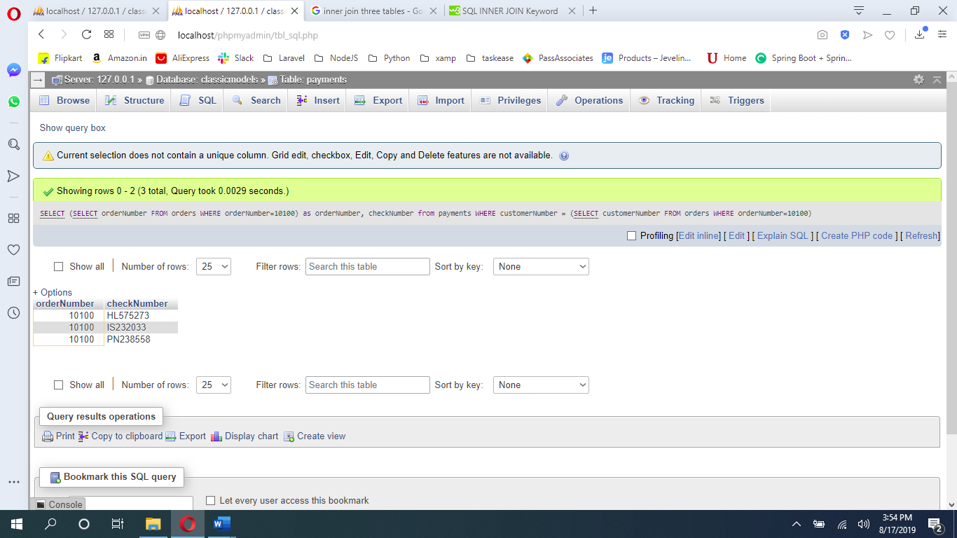

Question No 4

[SELECT](http://localhost/phpmyadmin/url.php?url=https://dev.mysql.com/doc/refman/5.5/en/select.html) [MIN](http://localhost/phpmyadmin/url.php?url=https://dev.mysql.com/doc/refman/5.5/en/group-by-functions.html#function_min)(quantityInStock) as lease_value_in_quantityInStock, [MAX](http://localhost/phpmyadmin/url.php?url=https://dev.mysql.com/doc/refman/5.5/en/group-by-functions.html#function_max)(quantityInStock) as max_value_in_quantityInStock FROM `products`

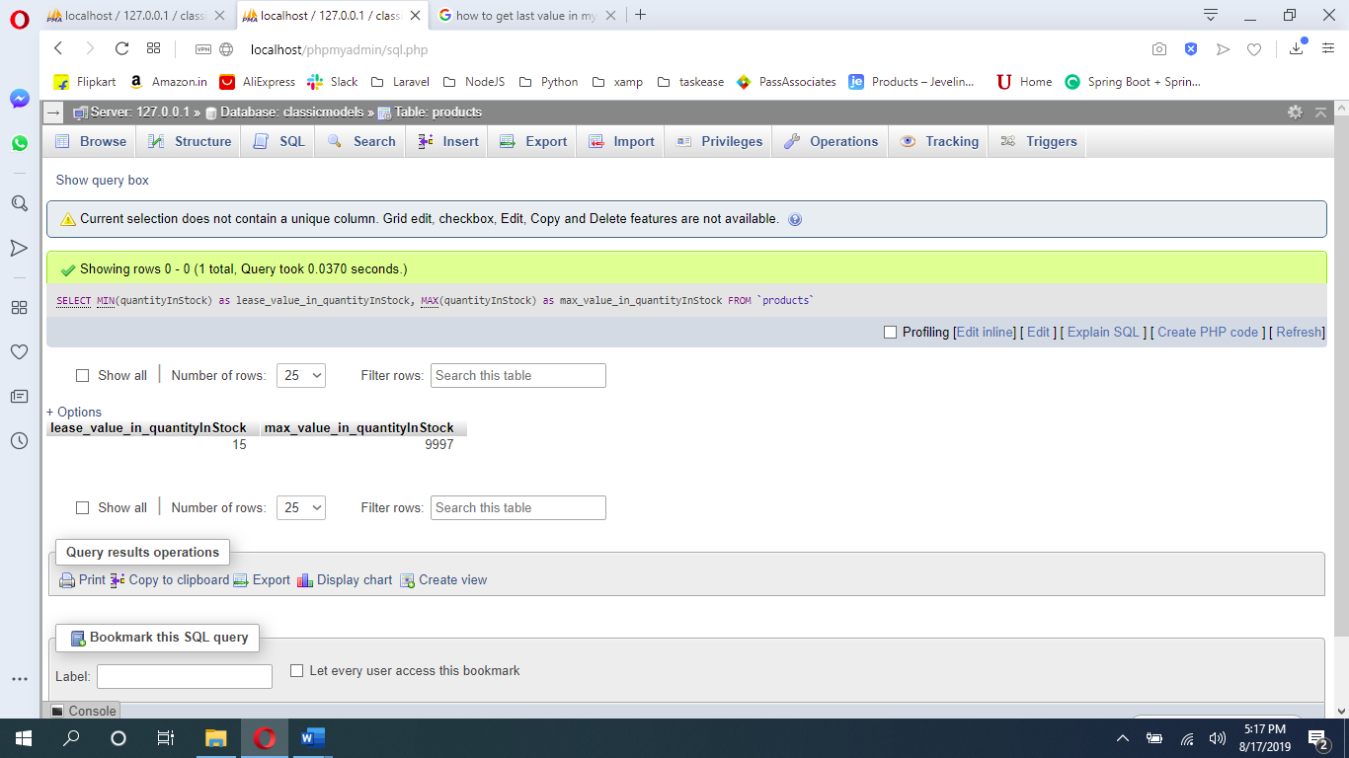

Question No 5

[SELECT](http://localhost/phpmyadmin/url.php?url=https://dev.mysql.com/doc/refman/5.5/en/select.html) products.productCode, products.productLine, ([SELECT](http://localhost/phpmyadmin/url.php?url=https://dev.mysql.com/doc/refman/5.5/en/select.html) IFNULL(htmlDescription, (CONCAT("<",products.productLine,">"))) FROM productlines WHERE productLine = products.productLine) as htmlDescription FROM products

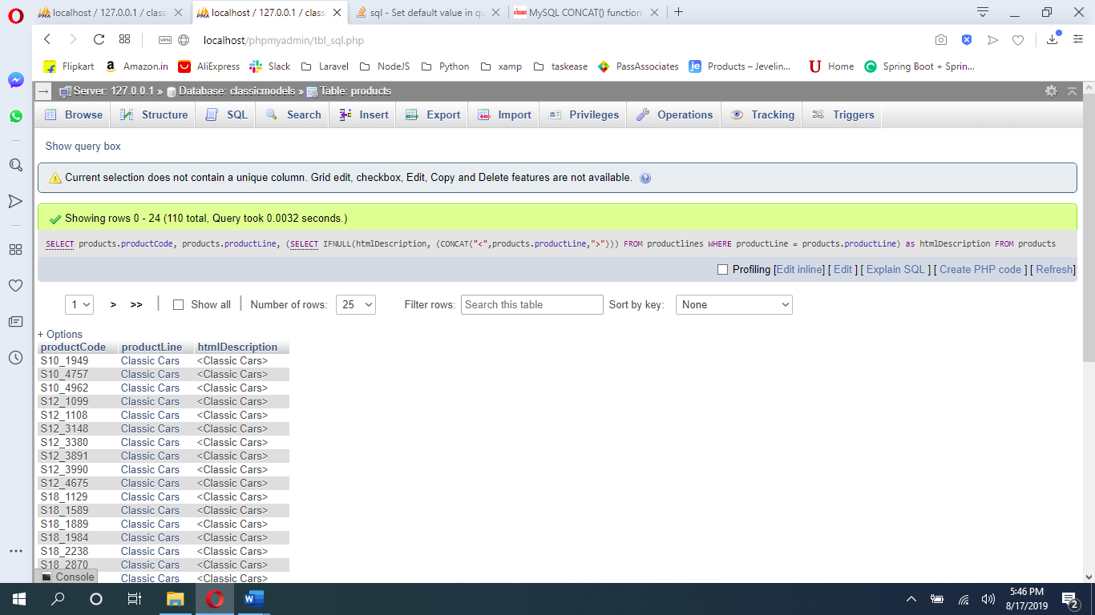

Question 6

[SELECT](http://localhost/phpmyadmin/url.php?url=https://dev.mysql.com/doc/refman/5.5/en/select.html) [COUNT](http://localhost/phpmyadmin/url.php?url=https://dev.mysql.com/doc/refman/5.5/en/group-by-functions.html#function_count)(1) - [COUNT](http://localhost/phpmyadmin/url.php?url=https://dev.mysql.com/doc/refman/5.5/en/group-by-functions.html#function_count)(htmlDescription) as NULL_COUNT FROM productlines

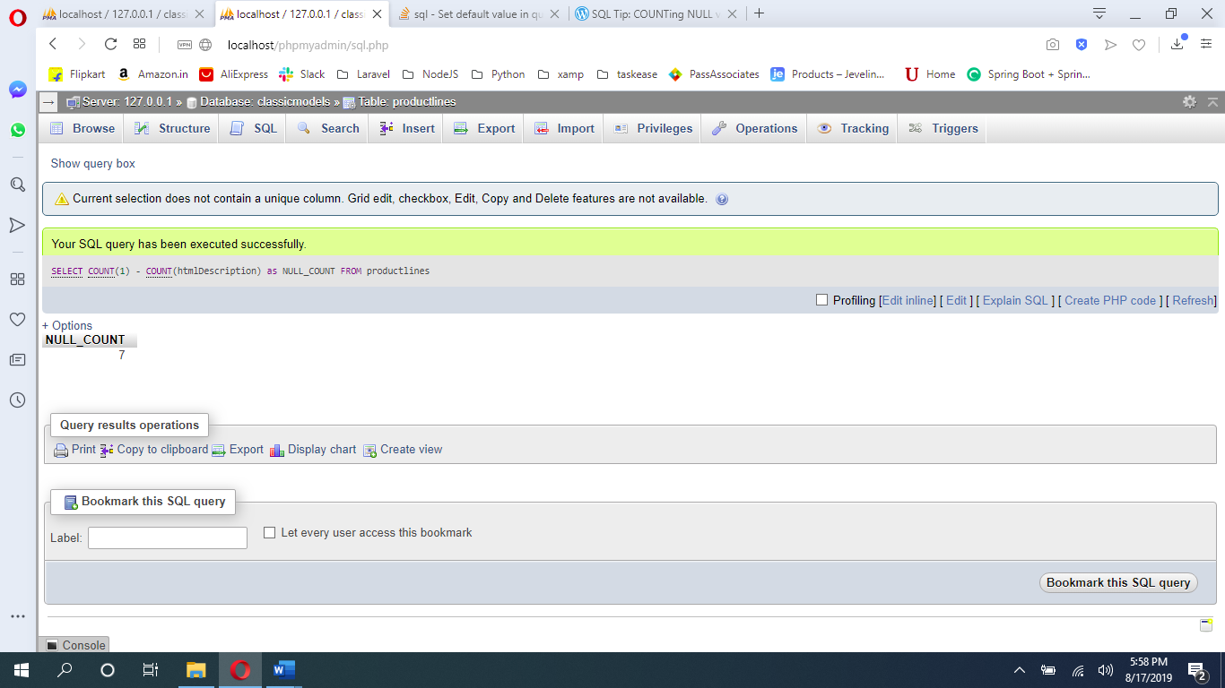

Question No. 7

[SELECT](http://localhost/phpmyadmin/url.php?url=https://dev.mysql.com/doc/refman/5.5/en/select.html) DATE_FORMAT('2019-07-18 12:49:24', '%d-%M-%a')

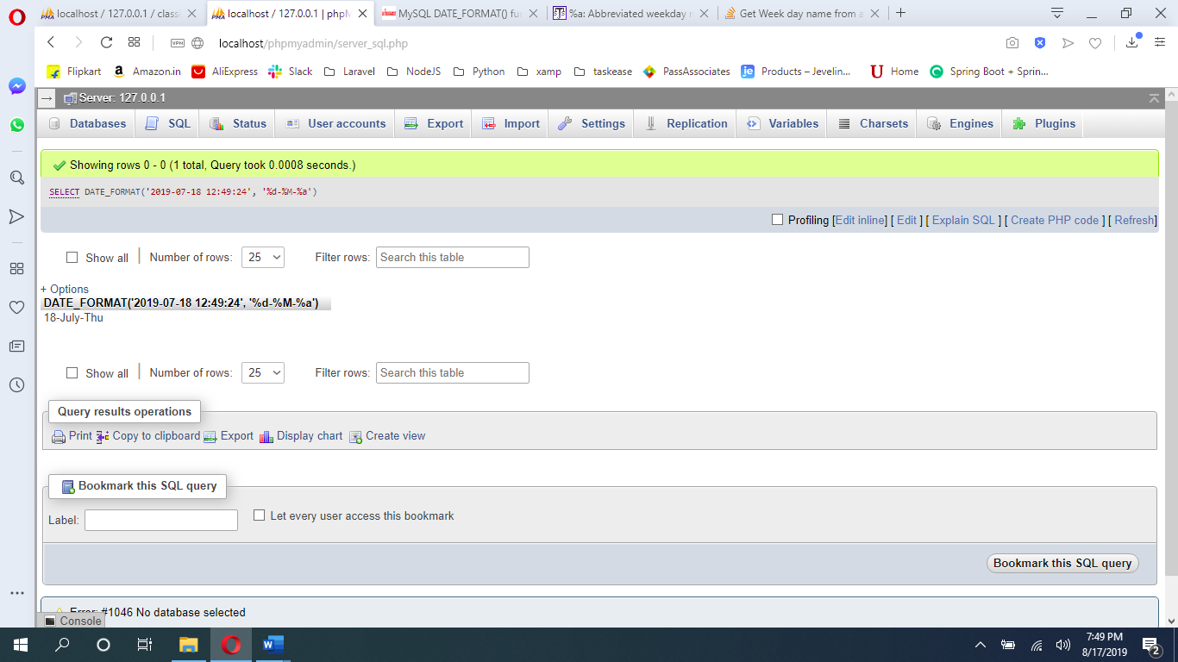

Question No 8

[SELECT](http://localhost/phpmyadmin/url.php?url=https://dev.mysql.com/doc/refman/5.5/en/select.html) amount FROM payments one1 WHERE ( 3 ) = ( [SELECT](http://localhost/phpmyadmin/url.php?url=https://dev.mysql.com/doc/refman/5.5/en/select.html) [COUNT](http://localhost/phpmyadmin/url.php?url=https://dev.mysql.com/doc/refman/5.5/en/group-by-functions.html#function_count)( one2.amount ) FROM payments one2 WHERE one2.amount >= one1.amount )

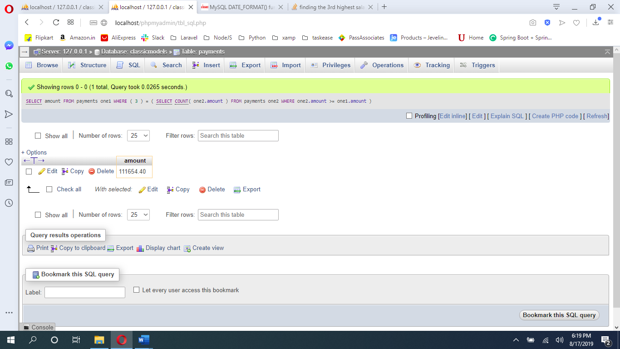

Question No 9

[SELECT](http://localhost/phpmyadmin/url.php?url=https://dev.mysql.com/doc/refman/5.5/en/select.html) contactFirstName FROM `customers` WHERE contactFirstName [LIKE](http://localhost/phpmyadmin/url.php?url=https://dev.mysql.com/doc/refman/5.5/en/string-comparison-functions.html#operator_like) 'C%a'

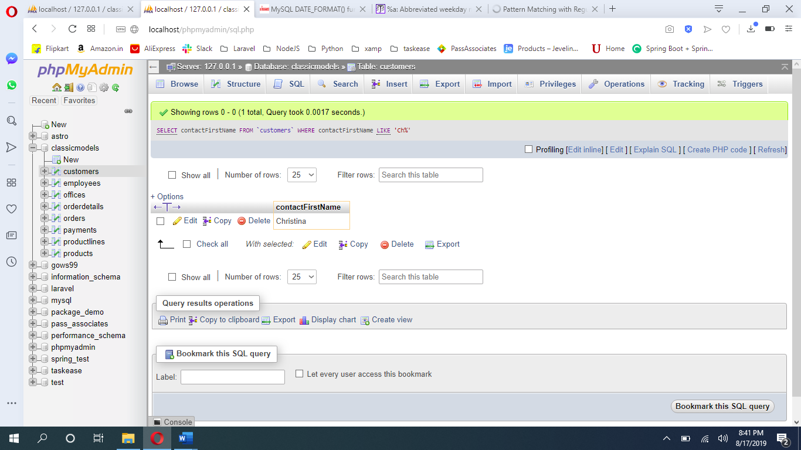

Question No 10

[SELECT](http://localhost/phpmyadmin/url.php?url=https://dev.mysql.com/doc/refman/5.5/en/select.html) * FROM productlines WHERE productLine [NOT](http://localhost/phpmyadmin/url.php?url=https://dev.mysql.com/doc/refman/5.5/en/logical-operators.html#operator_not) [IN](http://localhost/phpmyadmin/url.php?url=https://dev.mysql.com/doc/refman/5.5/en/comparison-operators.html#function_in) ([SELECT](http://localhost/phpmyadmin/url.php?url=https://dev.mysql.com/doc/refman/5.5/en/select.html) productLine FROM products)

