**Create the below tables with appropriate data types and constraints. Then Solve the queries.**

**Note : The queries and its output needs to be saved and pushed to the git link**

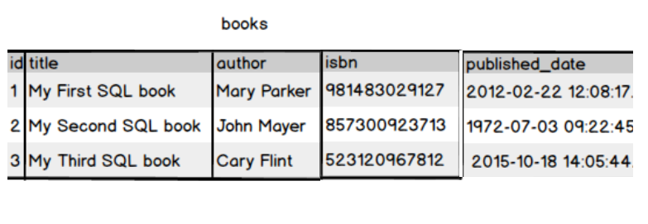

Create a book table with id as primary key and provide the appropriate data type to other attributes .isbn no should be unique for each book

Write a query to fetch the details of the books written by author whose name ends with er.



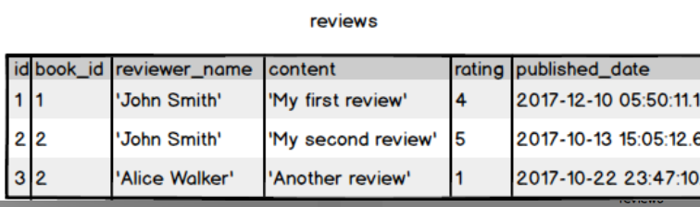

Display the Title ,Author and ReviewerName for all the books from the above table





Display the reviewer name who reviewed more than one book.

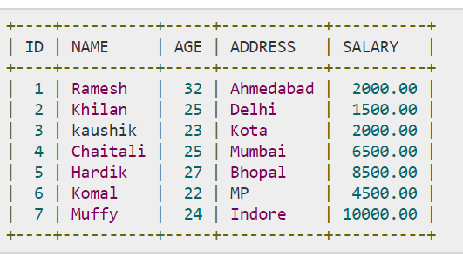

Display the Name for the customer from above customer table who live in same address which has character o anywhere in address

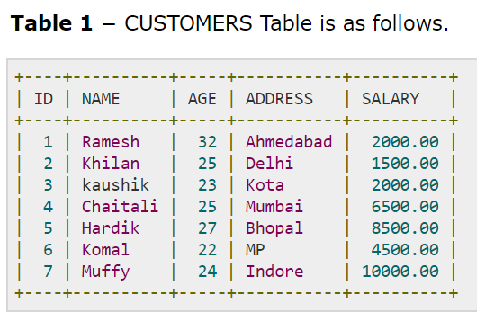 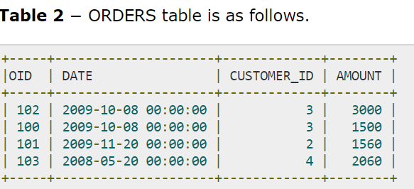

Write a query to display the Date,Total no of customer placed order on same Date

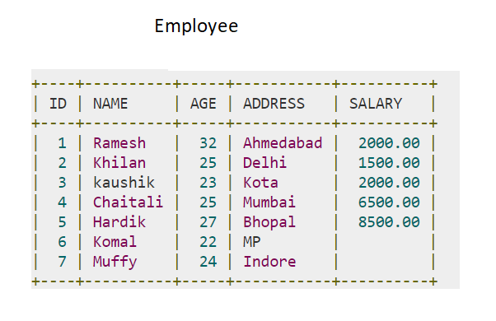

Display the Names of the Employee in lower case, whose salary is null

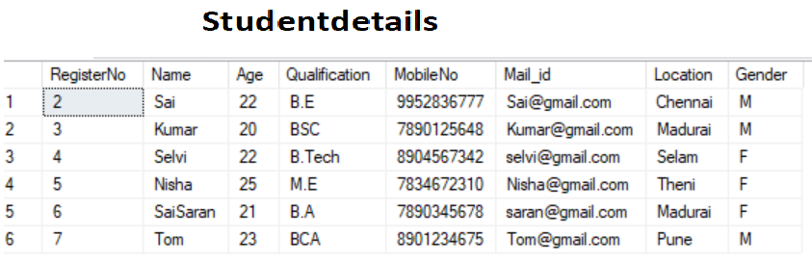

Write a sql server query to display the Gender,Total no of male and female from the above

relation

C Sharp Question

1. Create a Generic List Collection empList and populate it with the following records.

|  |  |  |  |  |  |  |
| --- | --- | --- | --- | --- | --- | --- |
| EmployeeID | FirstName | LastName | Title | DOB | DOJ | City |
| 1001 | Malcolm | Daruwalla | Manager | 16-11-1984 | 08-06-2011 | Mumbai |
| 1002 | Asdin | Dhalla | AsstManager | 20-08-1994 | 07-07-2012 | Mumbai |
| 1003 | Madhavi | Oza | Consultant | 14-11-1987 | 12-04-2015 | Pune |
| 1004 | Saba | Shaikh | SE | 03-06-1990 | 02-02-2016 | Pune |
| 1005 | Nazia | Shaikh | SE | 08-03-1991 | 02-02-2016 | Mumbai |
| 1006 | Amit | Pathak | Consultant | 07-11-1989 | 08-08-2014 | Chennai |
| 1007 | Vijay | Natrajan | Consultant | 02-12-1989 | 01-06-2015 | Mumbai |
| 1008 | Rahul | Dubey | Associate | 11-11-1993 | 06-11-2014 | Chennai |
| 1009 | Suresh | Mistry | Associate | 12-08-1992 | 03-12-2014 | Chennai |
| 1010 | Sumit | Shah | Manager | 12-04-1991 | 02-01-2016 | Pune |
|  |  |  |  |  |  |  |

Now once the collection is created write down and execute the LINQ queries for collection

as follows :

a. Display detail of all the employee

b. Display details of all the employee whose location is not Mumbai

c. Display details of all the employee whose title is AsstManager

d. Display details of all the employee whose Last Name start with S