1.Write the following application. The initial page is called Validator.aspx and it has 7 text boxes representing (Name, Family Name, Address, City, Zip Code, Phone and e-mail address) and a Check button.

User gets the following page after clicking on Check button:

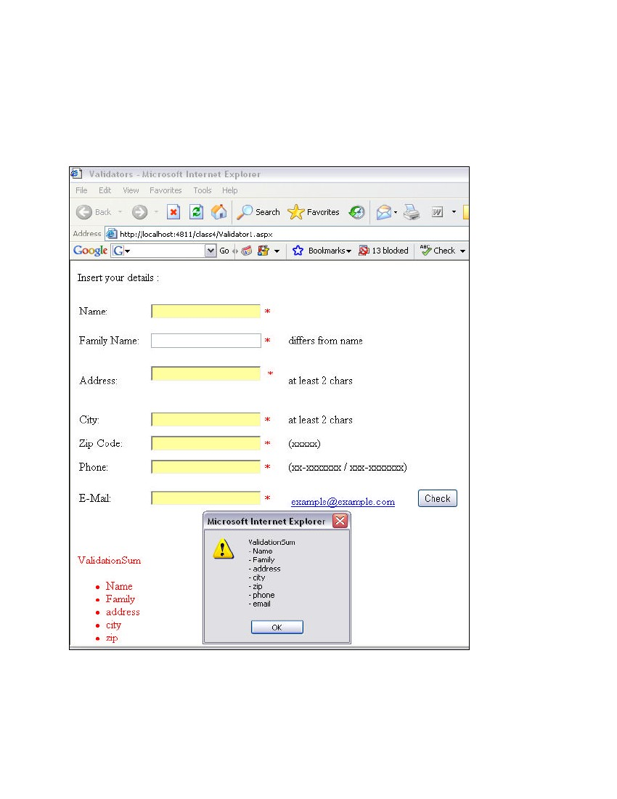

The required validation actions are:

* name different from family name,
* address at least 2 letters,
* city at least 2 letters,
* zip-code 5 digits,
* phone according to the format XX-XXXXXXX or XXX-XXXXXXX,

e-mail is a valid email.

2. Write a program containing the following controls:

• A Dropdown list

• A Button

• An Image

• A Label

Dropdown list is used to list items available in a store. When the user clicks on an item in the Dropdown list, its image is displayed in the Image control. When the user clicks the button, the cost of the selected item is displayed in the Label control.