1. Write a JavaScript program to calculate multiplication and division of two numbers (input from user).

Sample Form:

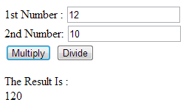

1. Write a JavaScript program to compute the sum of the given two integers. If the two values are same, then returns triple their sum.
2. Write a JavaScript program to check whether two given integer values are in the range 50..99 (inclusive). Return true if both of them are in the said range, else false.