# IPAN Scenario Background (DRAFT)

You are an Intelligence Analyst assigned to the Intelligence Staff of the Brickland Army Brigade Headquarters. You are located in the Intelligence Cell of the Operations Center on a large Gordanian Army base. Brickland and Gordania are two countries with a common border and shared political interests. A week ago, a powerful earthquake struck Gordania causing widespread devastation to the country’s infrastructure and leaving over 15,000 dead and over 60,000 injured. The UN has requested global assistance to launch the largest humanitarian relief operation ever executed. Brickland, with its extensive and modern military force and airlift capability, is leading the effort and coordinating the international response. The Gordanian government has also asked Brickland to provide military resources to augment national security forces. There are militia groups within Gordania that may take advantage of the disaster and seize the opportunity to disrupt relief operations in order to gain credibility and shift popular support away from the Gordanian government.

Today is June 6th, 2013. You are at your desk in the Operations Center of the main Forward Operating Base (FOB) in Tapel, monitoring the flow of data and reports coming in related to conditions, casualties and relief requirements. The Brickland Army Task Force Commander wants to determine appropriate actions to ensure timely relief operations, mitigate further loss of life due to stalled or poorly prepared search and rescue operations, protect relief assets and personnel including UN and NGO resources, protect vital remaining infrastructure and key buildings, and reestablish the security of the Gordanian population from looters and militia forces.

You have direct communications with two other FOB locations in Waga and Sligo, which were likewise affected by the earthquake. These FOBs are monitoring activities and coordinating specific humanitarian relief operations in their respective cities.

There are three insurgent cells operating in the region: Reds, Dragons, and Lions. Each one is vying for power with the population, local and national politicians. Each one is seeking to take advantage of the situation to consolidate their political positions and establish local control with their militia forces. The militia forces have access to small arms weapons and limited explosives. The militia’s are stirring up the local population to protest the presence of Brickland forces and the incompetence of the Gordanian government.

The UN and other nongovernment agencies are supporting large food and water distribution operations to prevent mass starvation and cholera outbreaks. UN and NGO medical and Gordanian Red Cross assets are operating in each locale to provide medical support to injured civilians.

The G-2, your Intelligence Section Chief, just brought a list of Commander’s Critical Information Requirements (CCIR) approved by the Brickland Army Commander. The Commander has directed the G-2 to get answers to the CCIR in order to develop possible Courses of Action to ensure effective, responsive relief operations and robust security.

The CCIR’s include the following Priority Intelligence Requirements (PIR):

1. Which insurgent/militia cell is encouraging the most violence against Brickland and the Gordanian government?
2. Of the three cities, where are search and rescue efforts most needed?
3. Where will protests against Brickland and Gordania most likely occur to disrupt relief operations?
4. What degree of risk exists to NGO elements operating in the cities and towns around the cities?

Your task is to answer the above questions based on information from Twitter feeds of text, images and other information found in the FLUO tool. By manipulating the filters in the tool, text and images from sources in specific locations are displayed. The accompanying excel spreadsheet gives a detailed list of information that is arriving in the FLUO tool.

# Trust Network

I trust the following information sources with decreasing confidence levels:

1. Brickland Military: 1.0 Trust Level
2. Brickland Department of State: 1.0 Trust Level
3. Gordanian Military: 1.0 Trust Level
4. Gordanian First Responder: 0.9 Trust Level
5. NGO: 0.8 Trust Level
6. Open Media: 0.7 Trust Level
7. Gordanian Official: 0.6 Trust Level
8. Twitter: 0.4 Trust Level
9. International Civilian: 0.3 Trust Level
10. Gordanian Civilian: 0.3 Trust Level

# CCIR: Militia Inciting Most Violence

## Version 0: Militia Inciting Most Violence

The first 145 lines of the excel spreadsheet lists the information received regarding Red, Lion, and Dragon militia activity. Each piece of information is classified based on its source and is counted against one the following three categories: *Red_Incidents, Lion_Incidents,* and *Dragon_Incidents*. For each source, after counting the number of Red_Incidents, Lion_Incidents, and Dragon_Incidents, the count against each militia is then mapped to one of *FewIncidents, SomeIncidents* or *ManyIncidents*. The following table is generated:

|  |  |  |  |
| --- | --- | --- | --- |
|  | Red_Incidents | Lion_Incidents | Dragon_Incidents |
| Brickland Military | 19 (Many Incidents) | 12 (Some Incidents) | 9 (Some Incidents) |
| Twitter | 30 (Many Incidents) | 13 (Some Incidents) | 11 (Some Incidents) |
| Gordanian First Responder | 3 (Some Incidents) | 2 (Few Incidents) | 1 (Few Incidents) |
| Gordanian Official | 2 (Few Incidents) | 1 (Few Incidents) |  |
| International Civilian | 6 (Some Incidents) |  |  |
| Gordanian Civilian | 3 (Some Incidents) | 1 (Few Incidents) | 2 (Few Incidents) |
| NGO | 2 (Few Incidents) | 2 (Few Incidents) | 2 (Few Incidents) |
| Brickland Dept. of State | 2 (Few Incidents) | 1 (Few Incidents) |  |
| Open Media | 4 (Some Incidents) | 2 (Few Incidents) | 3 (Some Incidents) |
| Gordanian Military |  | 1 (Few Incidents) |  |

Rules to combine incidents are as follows:

* FewIncidents(X) ==> LittleViolence(X)
* SomeIncidents(X) ==> SomeViolence(X)
* ManyIncidents(X) ==> MuchViolence(X)
* MuchViolence(X) ^ SomeViolence(Y) ^ SomeViolence(Z) ==> MostViolent(X)
* MuchViolence(X) ^ SomeViolence(Y) ^ LittleViolence(Z) ==> MostViolent(X)
* MuchViolence(X) ^ LittleViolence(Y) ^ SomeViolence(Z) ==> MostViolent(X)
* MuchViolence(X) ^ LittleViolence(Y) ^ LittleViolence(Z) ==> MostViolent(X)
* SomeViolence(X) ^ LittleViolence(Y) ^ LittleViolence(Z) ==> MostViolent(X)
* MuchViolence(X) ^ SomeViolence(Y) ^ SomeViolence(Z) ==> NOT MostViolent(Y or Z)
* MuchViolence(X) ^ SomeViolence(Y) ^ LittleViolence(Z) ==> NOT MostViolent(Y or Z)
* MuchViolence(X) ^ LittleViolence(Y) ^ SomeViolence(Z) ==> NOT MostViolent(Y or Z)
* MuchViolence(X) ^ LittleViolence(Y) ^ LittleViolence(Z) ==> NOT MostViolent(Y or Z)
* SomeViolence(X) ^ LittleViolence(Y) ^ LittleViolence(Z) ==> NOT MostViolent(Y or Z)

The question asked is: ‘MostViolent(Red)’. The following trust-extended belief network is generated by argtrust:

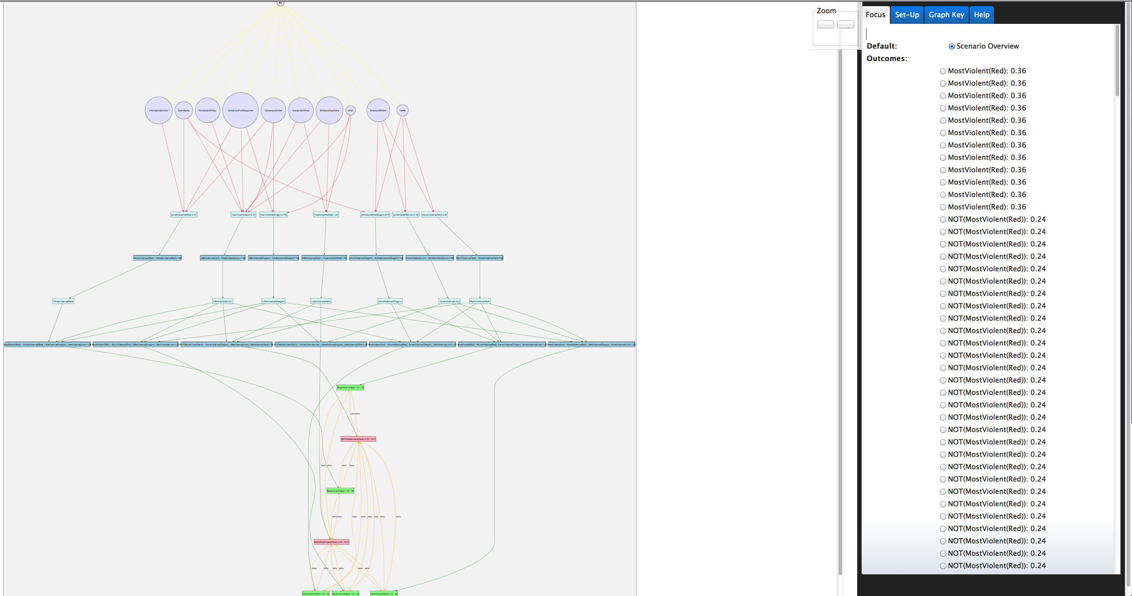

## Version 1: Militia Inciting Most Violence

The previous version (version 0) suffered from too many sources of information, which resulted in the graph blowing up in size. Despite this, the scenario is pretty simple (not too many levels of reasoning) and does not have lend itself to uncertain interpretation. Hence a refinement of the scenario was needed and this leads to version 1.

The intelligence analyst has the following information:

* Brickland Military reports that they have encountered many incidents of violence involving Red militia (19 separate incidents), some incidents of violence involving Lion militia (12 separate incidents) as well as some incidents of violence involving Dragon militia (9 separate incidents)
* Twitter feeds have around 30 posts regarding incidents by Red militia (many incidents), 13 posts regarding incidents by Lion militia (some incidents) and 11 posts involving incidents by Dragon militia (some incidents)
* Twitter feeds are not considered very reliable
* Other sources of information include: Brickland Department of State, Gordanian Military, Gordanian First Responders, Gordanian Officials, Gordanian Civilians, International Civilians, NGO, and Open Media
  + All these sources of information reports only few incidents each which makes information from them incomplete
* The Gordanian Military reports that they have seen lots of vehicles outside the Lion Headquarters both in Sligo and Waga
* The presence of large number of vehicles outside a militia headquarters can indicate that the militia is planning many attacks on relief personnel
* Paid Lion militia members indicate that they have been directed to increase violence and use small arms against the military

Facts in the scenario are as follows:

* BricklandMilitary 🡪 ManyIncidents(Red); BricklandMilitary 🡪 SomeIncidents(Lion); BricklandMilitary 🡪 SomeIncidents(Dragon)
* Twitter 🡪 ManyIncidents(Red); Twitter 🡪 SomeIncidents(Lion); Twitter 🡪 SomeIncidents(Dragon)
* GordanianMilitary 🡪 ManyVehiclesHQ(Lion)
* Informants 🡪 IncrViolence(Lion)

Intelligence Analyst Trust Levels:

* BricklandMilitary: 1.00
* GordanianMilitary: 1.00
* Twitter: 0.6
* Informants: 0.3

Rules that the intelligence analyst believes in are as follows:

* ManyIncidents(Red)🡪MuchViolence(Red)
* SomeIncidents(Lion)🡪SomeViolence(Lion)
* SomeIncidents(Dragon)🡪SomeViolence(Dragon)
* ManyVehiclesHQ(Lion)^IncViolence(Lion)🡪MuchViolence(Lion)
* MuchViolence(Red)^ SomeViolence(Lion)^ SomeViolence(Dragon)🡪MostViolent(Red)
* MuchViolence(Red)^ MuchViolence(Lion)🡪NOT MostViolent(Red)

The question asked is: ‘MostViolent(Red)’. The following trust-extended belief network is generated by ArgTrust:

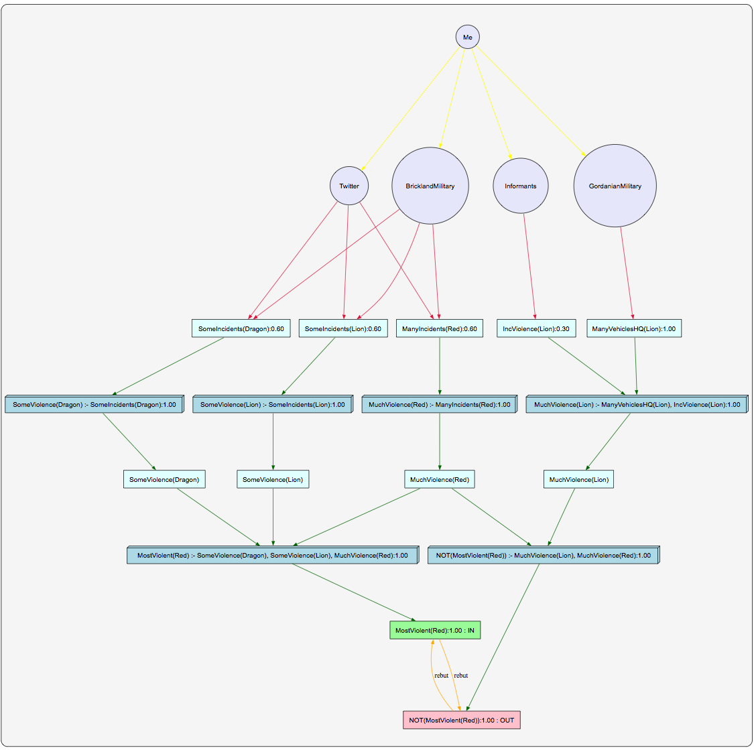

## Version 2: Militia Inciting Most Violence

The version 1 scenario is still pretty simple (not too many levels of reasoning) and does not have arguments undermining other arguments. In Version 2, the predicate ‘SomeViolence’ is replaced by ‘NOT MuchViolence’ which gives us arguments capable of undermining other arguments (i.e., arguments using ‘MuchViolence’). Also an additional rule of ‘ManyVehiclesHQ’ implying ‘PlanViolence’ with level 0.7 has been added. The scenario description and rules are very similar to version 1 but are described below for completeness.

The intelligence analyst has the following information:

* Brickland Military reports that they have encountered many incidents of violence involving Red militia (19 separate incidents), some incidents of violence involving Lion militia (12 separate incidents) as well as some incidents of violence involving Dragon militia (9 separate incidents)
* Twitter feeds have around 30 posts regarding incidents by Red militia (many incidents), 13 posts regarding incidents by Lion militia (some incidents) and 11 posts involving incidents by Dragon militia (some incidents)
* Twitter feeds are not considered very reliable
* Other sources of information include: Brickland Department of State, Gordanian Military, Gordanian First Responders, Gordanian Officials, Gordanian Civilians, International Civilians, NGO, and Open Media
  + All these sources of information reports only few incidents each which makes information from them incomplete
* The Gordanian Military reports that they have seen lots of vehicles outside the Lion Headquarters both in Sligo and Waga
* The presence of large number of vehicles outside a militia headquarters can indicate that the militia is planning many attacks on relief personnel
* Paid Lion militia members indicate that they have been directed to increase violence and use small arms against the military

Facts in the scenario are as follows:

* BricklandMilitary 🡪 ManyIncidents(Red); BricklandMilitary 🡪 SomeIncidents(Lion); BricklandMilitary 🡪 SomeIncidents(Dragon)
* Twitter 🡪 ManyIncidents(Red); Twitter 🡪 SomeIncidents(Lion); Twitter 🡪 SomeIncidents(Dragon)
* GordanianMilitary 🡪 ManyVehiclesHQ(Lion)
* Informants 🡪 IncrViolence(Lion)

Intelligence Analyst Trust Levels:

* BricklandMilitary: 1.00
* GordanianMilitary: 1.00
* Twitter: 0.6
* Informants: 0.3

Rules that the intelligence analyst believes in are as follows:

* ManyIncidents(Red)🡪MuchViolence(Red)
* SomeIncidents(Lion)🡪NOT MuchViolence(Lion)
* SomeIncidents(Dragon)🡪NOT MuchViolence(Dragon)
* ManyVehiclesHQ(Lion)🡪PlanViolence(Lion) with level 0.7
* PlanViolence(Lion)^IncrViolence(Lion)🡪MuchViolence(Lion)
* MuchViolence(Red)^ NOT MuchViolence(Lion)^ NOT MuchViolence(Dragon)🡪MostViolent(Red)
* MuchViolence(Red)^ MuchViolence(Lion)🡪NOT MostViolent(Red)

The question asked is: ‘MostViolent(Red)’. The following trust-extended belief network is generated by ArgTrust:

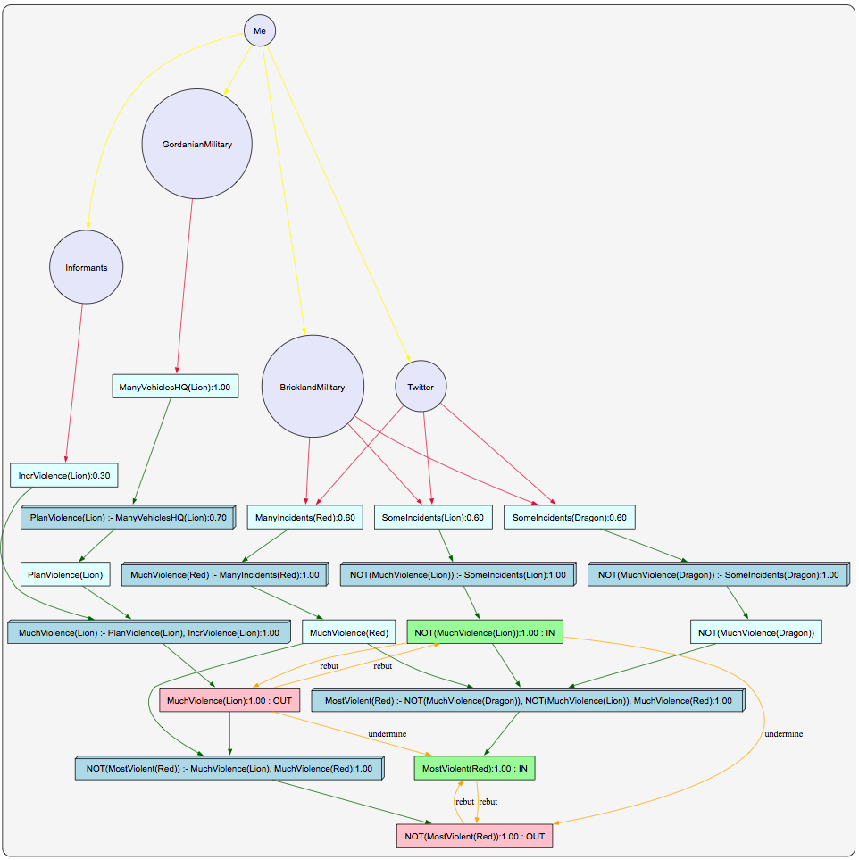

## Version 3: Militia Inciting Most Violence

The version 2 scenario is still pretty simple (not too many levels of reasoning) and is not that amenable to uncertain interpretation. In Version 3, we add to the scenario with a new agent ‘GordanianGovt’. The scenario is appended to as follows: The Gordanian Government has been approached by the leader of the Red militia faction promising to cooperate with the relief operations in exchange for an increased role in the political arena which has been agreed to in principle by the Gordanian Government. The promise of cooperation with relief operations may indicate that the Red militia will suspend violence.

The scenario description and rules are very similar to version 2 but are described below for completeness.

The intelligence analyst has the following information:

* Brickland Military reports that they have encountered many incidents of violence involving Red militia (19 separate incidents), some incidents of violence involving Lion militia (12 separate incidents) as well as some incidents of violence involving Dragon militia (9 separate incidents)
* Twitter feeds have around 30 posts regarding incidents by Red militia (many incidents), 13 posts regarding incidents by Lion militia (some incidents) and 11 posts involving incidents by Dragon militia (some incidents)
* Twitter feeds are not considered very reliable
* Other sources of information include: Brickland Department of State, Gordanian Military, Gordanian First Responders, Gordanian Officials, Gordanian Civilians, International Civilians, NGO, and Open Media
  + All these sources of information reports only few incidents each which makes information from them incomplete
* The Gordanian Military reports that they have seen lots of vehicles outside the Lion Headquarters both in Sligo and Waga
* The presence of large number of vehicles outside a militia headquarters can indicate that the militia is planning many attacks on relief personnel
* Paid Lion militia members indicate that they have been directed to increase violence and use small arms against the military
* The Gordanian Government has been approached by the leader of the Red militia faction promising to cooperate with the relief operations in an increased future role in the political arena, which has been agreed to by the Gordanian Government.
* The promise of cooperation with relief operations may indicate that the Red militia will suspend violence.

Facts in the scenario are as follows:

* BricklandMilitary 🡪 ManyIncidents(Red); BricklandMilitary 🡪 SomeIncidents(Lion); BricklandMilitary 🡪 SomeIncidents(Dragon)
* Twitter 🡪 ManyIncidents(Red); Twitter 🡪 SomeIncidents(Lion); Twitter 🡪 SomeIncidents(Dragon)
* GordanianMilitary 🡪 ManyVehiclesHQ(Lion)
* Informants 🡪 IncrViolence(Lion)
* GordanianGovt 🡪CoopReliefOperations(Red)

Intelligence Analyst Trust Levels:

* BricklandMilitary: 1.00
* GordanianMilitary: 1.00
* GordanianGovt: 1.00
* Twitter: 0.6
* Informants: 0.3

Rules that the intelligence analyst believes in are as follows (the default belief level is 1):

* ManyIncidents(Red)🡪MuchViolence(Red)
* SomeIncidents(Lion)🡪NOT MuchViolence(Lion)
* SomeIncidents(Dragon)🡪NOT MuchViolence(Dragon)
* ManyVehiclesHQ(Lion)🡪PlanViolence(Lion) *with level 0.7*
* PlanViolence(Lion)^IncrViolence(Lion)🡪MuchViolence(Lion)
* CoopReliefOperations(Red)🡪SuspendViolence(Red) *with level 0.5*
* SuspendViolence(Red)🡪NOT MostViolent(Red)
* MuchViolence(Red)^ NOT MuchViolence(Lion)^ NOT MuchViolence(Dragon)🡪MostViolent(Red)
* MuchViolence(Red)^ MuchViolence(Lion)🡪NOT MostViolent(Red)

The question asked is: ‘MostViolent(Red)’. The following trust-extended belief network is generated by ArgTrust:

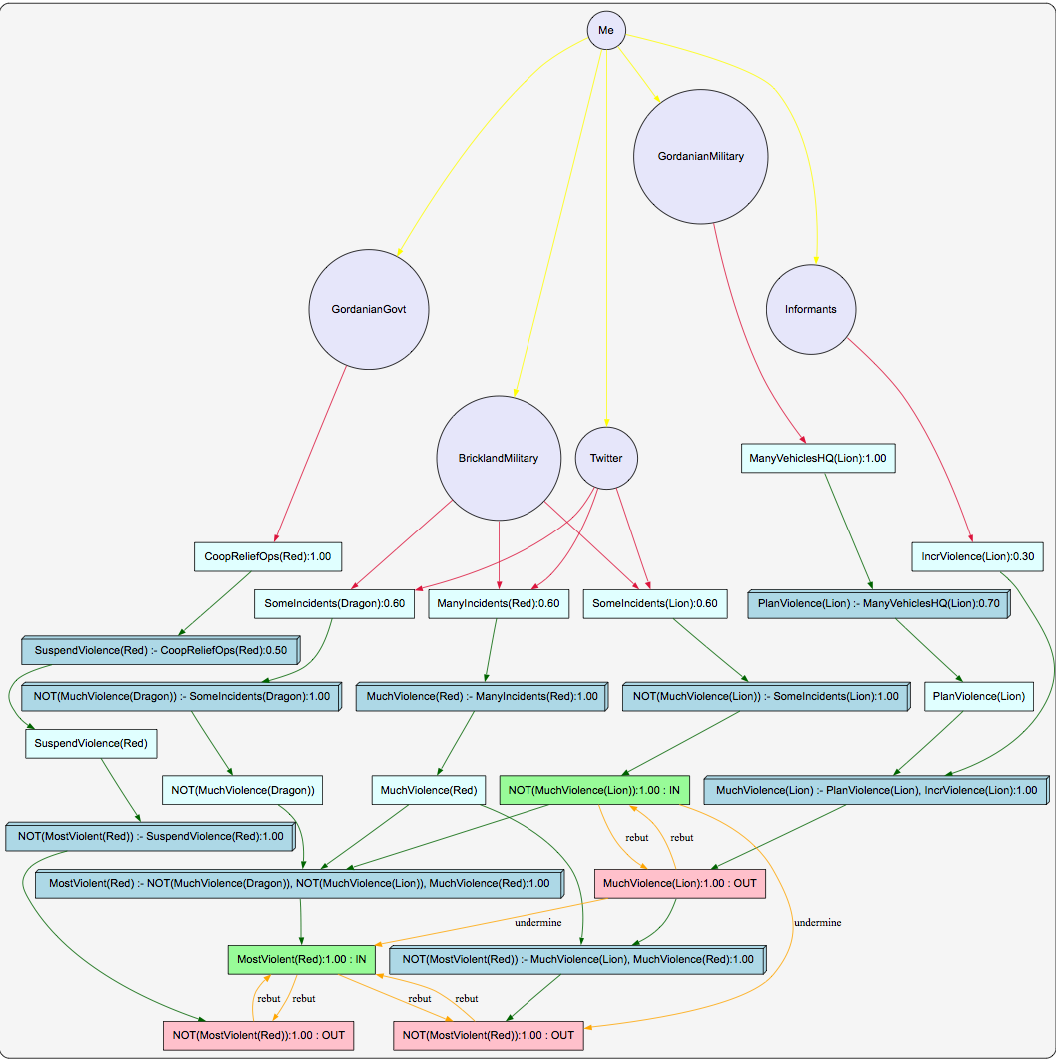

### Version 3 with No Dragon Militia group:

If the above Version 3 graph seems too complicated, we can remove the Dragon militia group from our narration and ask the same question: ‘MostViolent(Red)’. The following trust-extended belief network is generated by ArgTrust:

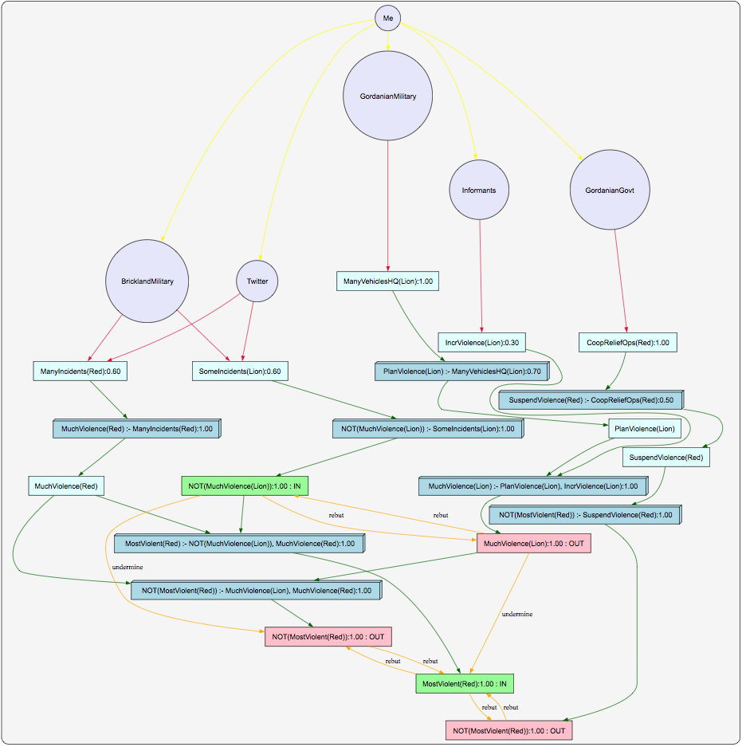

# CCIR: City Where Protests Most Likely to Disrupt Relief Ops

## Version 0: City Where Protests Most Likely to Disrupt Relief Ops

Row 249-352 of the excel spreadsheet lists the information received regarding protests in the three towns of Tapel, Sligo and Waga. Each piece of information is classified based on its source and is counted against one the following three categories: *Tapel_Protests, Sligo_Protests,* and *Waga_Protests*. For each source, after counting the number of Tapel_Protests, Sligo_Protests, and Waga_Protests, the count against each city is then mapped to one of *LittleDisruption, SomeDisruption* or *MuchDisruption*. The following table is generated:

|  |  |  |  |
| --- | --- | --- | --- |
|  | Tapel_Protests | Sligo_Protests | Waga_Protests |
| Brickland Military | 24 (Many Protests) | 4 (Some Protests) | 1 (Few Protests) |
| Twitter | 10 (Many Protests) | 4 (Few Protests) | 6 (Some Protests) |
| Gordanian First Responder | 8 (Many Protests) |  | 1 (Few Protests) |
| Gordanian Official |  |  |  |
| International Civilian |  |  |  |
| Gordanian Civilian | 2 (Few Protests) | 1 (Few Protests) | 1 (Few Protests) |
| NGO |  | 1(Few Protests) | 1 (Few Protests) |
| Brickland Dept. of State |  |  |  |
| Open Media | 3 (Few Protests) | 1 (Few Protests) | 2 (Few Protests) |
| Gordanian Military |  | 1 (Few Protests) | 1 (Few Protests) |

Rules to combine protests are as follows:

* FewProtests(X) ==> LittleDisruption(X)
* SomeProtests(X) ==> SomeDisruption(X)
* ManyProtests(X) ==> MuchDisruption(X)
* MuchDisruption(X) ^ SomeDisruption(Y) ^ SomeDisruption(Z) ==> MostReliefDisruptions(X)
* MuchDisruption(X) ^ SomeDisruption(Y) ^ LittleDisruption(Z) ==> MostReliefDisruptions(X)
* MuchDisruption(X) ^ LittleDisruption(Y) ^ SomeDisruption(Z) ==> MostReliefDisruptions(X)
* MuchDisruption(X) ^ LittleDisruption(Y) ^ LittleDisruption(Z) ==> MostReliefDisruptions(X)
* SomeDisruption(X) ^ LittleDisruption(Y) ^ LittleDisruption(Z) ==> MostReliefDisruptions(X)

Only ‘Brickland Military’, ‘Twitter’ and ‘Gordanian First Responder’ are modeled. The question asked is: ‘MostReliefDisruptions(Tapel)’. The following trust-extended belief network is generated by argtrust (Note that there are no arguments that rebut or undermine the question).

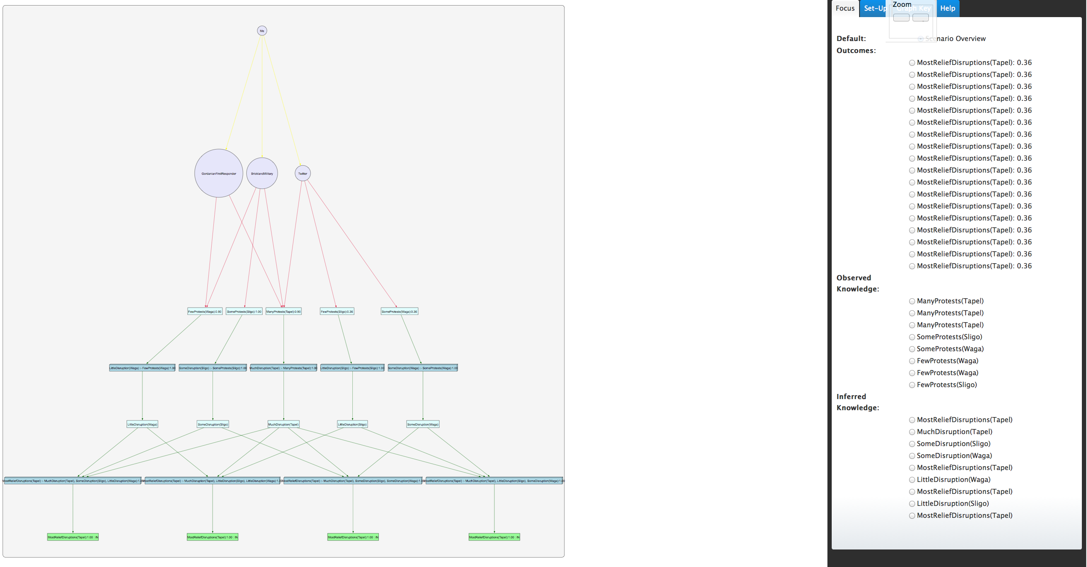

## Version 1: City Where Protests Most Likely to Disrupt Relief Ops

The previous version (version 0) suffered being too simple (not too many levels of reasoning) and does not have any conflicts. Hence a refinement of the scenario was needed and this leads to version 1.

The intelligence analyst has the following information:

* Brickland Military reports that they have encountered many protest incidents in the town of Tapel (24 separate incidents), few protest incidents in the town of Sligo (4 separate incidents) as well as few protest incidents in the town of Waga (1 incident)
* Twitter feeds have around 10 posts regarding protest incidents in the town of Tapel (many incidents), 4 posts involving protest incidents in the town of Sligo (some incidents) and 6 posts involving protest incidents in the town of Waga (some incidents)
* Twitter feeds are not considered very reliable
* The Gordanian First Responders report many protests (8 incidents) in the town of Tapel, few protests (1 incident) in the town of Sligo and few protests (1 incident) in the town of Waga
* Other sources of information include: Gordanian Military, Gordanian Civilians, NGO, and Open Media
  + All these sources of information reports only few incidents each which makes information from them incomplete
* The Gordanian Military reports that they have seen lots of vehicles outside the Lion Headquarters both in Sligo and Waga
* The presence of large number of vehicles outside a militia headquarters can indicate that the militia is planning many attacks on relief personnel
* Paid Lion militia members in Waga indicate that they have been directed to increase violence and use small arms against the military

Facts in the scenario are as follows:

* BricklandMilitary 🡪 ManyProtests(Tapel); BricklandMilitary 🡪 FewProtests(Sligo); BricklandMilitary 🡪 FewProtests(Waga)
* Twitter 🡪 ManyProtests(Tapel); Twitter 🡪 SomeProtests(Sligo); Twitter 🡪 SomeProtests(Waga)
* GordanianFirstResponder 🡪 ManyProtests(Tapel); GordanianFirstResponder 🡪 FewProtests(Sligo); GordanianFirstResponder 🡪 FewProtests(Waga)
* GordanianMilitary 🡪 ManyVehiclesHQ(Sligo); GordanianMilitary 🡪 ManyVehiclesHQ(Waga)
* Informants 🡪 IncrViolence(Waga)

Intelligence Analyst Trust Levels:

* BricklandMilitary: 1.00
* GordanianMilitary: 1.00
* GordanianFirstResponder: 0.9
* Twitter: 0.6
* Informants: 0.3

Rules that the intelligence analyst believes in are as follows:

* ManyProtests(Tapel)🡪MuchDisruption(Tapel)
* FewProtests(Sligo)🡪LittleDisruption(Sligo); SomeProtests(Sligo)🡪SomeDisruption(Sligo)
* FewProtests(Waga)🡪LittleDisruption(Waga); SomeProtests(Waga)🡪SomeDisruption(Waga)
* ManyVehiclesHQ(Waga)^IncViolence(Waga)🡪MuchDisruption(Waga)
* MuchDisruption(Tapel)^SomeDisruption(Waga)^SomeDisruption(Sligo)🡪MostReliefDisruptions(Tapel)
* MuchDisruption(Tapel)^SomeDisruption(Waga)^LittleDisruption(Sligo)🡪MostReliefDisruptions(Tapel)
* MuchDisruption(Tapel)^LittleDisruption(Waga)^SomeDisruption(Sligo)🡪MostReliefDisruptions(Tapel)
* MuchDisruption(Tapel)^LittleDisruption(Waga)^LittleDisruption(Sligo)🡪MostReliefDisruptions(Tapel)
* MuchDisruption(Tapel)^MuchDisruption(Waga)🡪NOT MostReliefDisruptions(Tapel)

The question asked is: ‘MostReliefDisruptions(Tapel)’. The following trust-extended belief network is generated by ArgTrust:

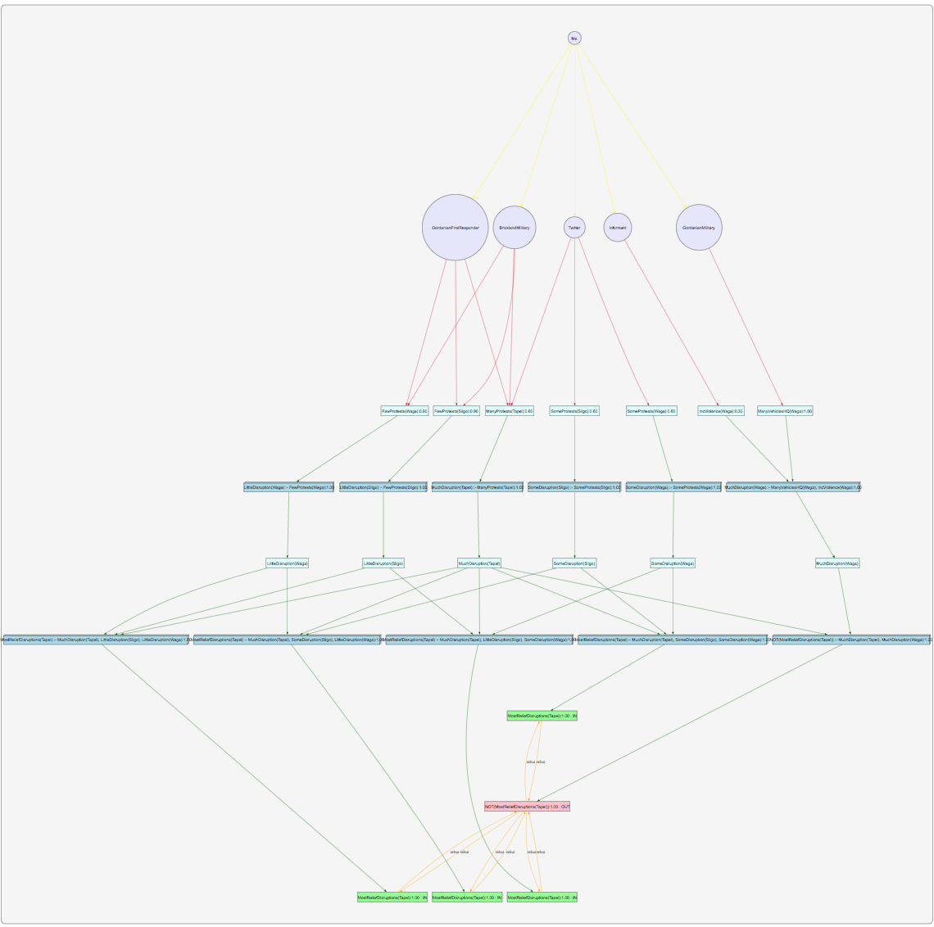

## Version 2: City Where Protests Most Likely to Disrupt Relief Ops

The version 1 scenario is still pretty simple (not too many levels of reasoning) and does not have arguments undermining other arguments. In Version 2, the predicate ‘LittleDisruption’ and ‘SomeDisruption’ are replaced by ‘NOT MuchDisruption’ which gives us arguments capable of undermining other arguments (i.e., arguments using ‘MuchDisruption’). Also an additional rule of ‘ManyVehiclesHQ’ implying ‘PlanViolence’ with level 0.7 has been added. The scenario description and rules are very similar to version 1 but are described below for completeness.

The intelligence analyst has the following information:

* Brickland Military reports that they have encountered many protest incidents in the town of Tapel (24 separate incidents), few protest incidents in the town of Sligo (4 separate incidents) as well as few protest incidents in the town of Waga (1 incident)
* Twitter feeds have around 10 posts regarding protest incidents in the town of Tapel (many incidents), 4 posts involving protest incidents in the town of Sligo (some incidents) and 6 posts involving protest incidents in the town of Waga (some incidents)
* Twitter feeds are not considered very reliable
* The Gordanian First Responders report many protests (8 incidents) in the town of Tapel, few protests (1 incident) in the town of Sligo and few protests (1 incident) in the town of Waga
* Other sources of information include: Gordanian Military, Gordanian Civilians, NGO, and Open Media
  + All these sources of information reports only few incidents each which makes information from them incomplete
* The Gordanian Military reports that they have seen lots of vehicles outside the Lion Headquarters both in Sligo and Waga
* The presence of large number of vehicles outside a militia headquarters can indicate that the militia is planning many attacks on relief personnel
* Paid Lion militia members in Waga indicate that they have been directed to increase violence and use small arms against the military

Facts in the scenario are as follows:

* BricklandMilitary 🡪 ManyProtests(Tapel); BricklandMilitary 🡪 FewProtests(Sligo); BricklandMilitary 🡪 FewProtests(Waga)
* Twitter 🡪 ManyProtests(Tapel); Twitter 🡪 SomeProtests(Sligo); Twitter 🡪 SomeProtests(Waga)
* GordanianFirstResponder 🡪 ManyProtests(Tapel); GordanianFirstResponder 🡪 FewProtests(Sligo); GordanianFirstResponder 🡪 FewProtests(Waga)
* GordanianMilitary 🡪 ManyVehiclesHQ(Sligo); GordanianMilitary 🡪 ManyVehiclesHQ(Waga)
* Informants 🡪 IncrViolence(Waga)

Intelligence Analyst Trust Levels:

* BricklandMilitary: 1.00
* GordanianMilitary: 1.00
* GordanianFirstResponder: 0.9
* Twitter: 0.6
* Informants: 0.3

Rules that the intelligence analyst believes in are as follows:

* ManyProtests(Tapel)🡪MuchDisruption(Tapel)
* FewProtests(Sligo)🡪NOT MuchDisruption(Sligo); SomeProtests(Sligo)🡪NOT MuchDisruption(Sligo)
* FewProtests(Waga)🡪NOT MuchDisruption(Waga); SomeProtests(Waga)🡪NOT MuchDisruption(Waga)
* ManyVehiclesHQ(Waga)🡪PlanViolence(Waga) with level 0.7
* PlanViolence(Waga)^IncrViolence(Waga)🡪MuchDisruption(Waga)
* MuchDisruption(Tapel)^NOT MuchDisruption(Waga)^NOT MuchDisruption(Sligo)🡪MostReliefDisruptions(Tapel)
* MuchDisruption(Tapel)^MuchDisruption(Waga)🡪NOT MostReliefDisruptions(Tapel)

The question asked is: ‘MostReliefDisruptions(Tapel)’. The following trust-extended belief network is generated by ArgTrust:

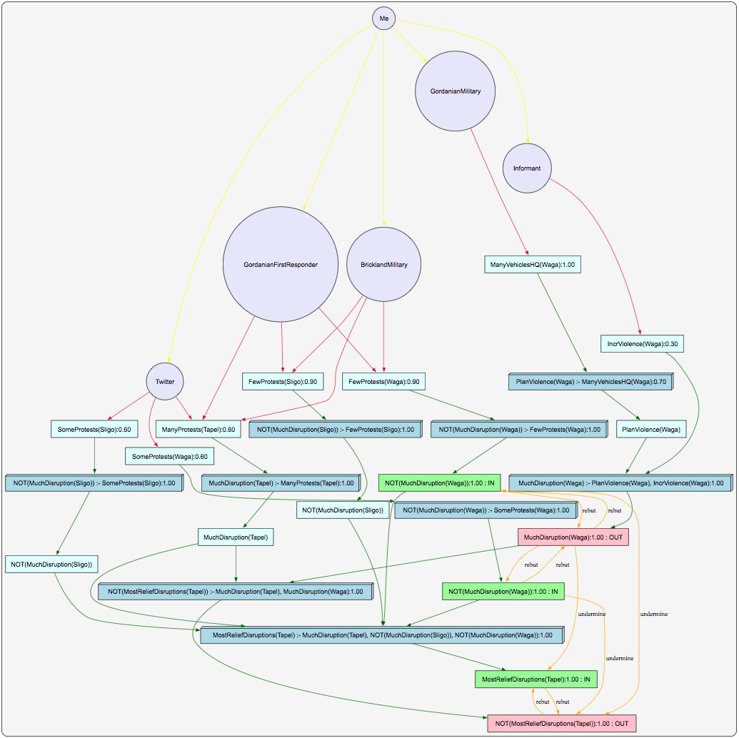

## Version 3: City Where Protests Most Likely to Disrupt Relief Ops

The version 2 scenario is still pretty simple (not too many levels of reasoning) and is not that amenable to uncertain interpretation. In Version 3, we add to the scenario with a new agent ‘GordanianGovt’. The scenario is appended to as follows: The Gordanian Government has been approached by the leader of a prominent militia group called Red promising to cooperate with the relief operations in exchange for an increased role in the political arena which has been agreed to in principle by the Gordanian Government. The promise of cooperation with relief operations may indicate that the Red militia will suspend violence. The Red militia mostly operate in the city of Tapel.

The scenario description and rules are very similar to version 2 but are described below for completeness.

The intelligence analyst has the following information:

* Brickland Military reports that they have encountered many protest incidents in the town of Tapel (24 separate incidents), few protest incidents in the town of Sligo (4 separate incidents) as well as few protest incidents in the town of Waga (1 incident)
* Twitter feeds have around 10 posts regarding protest incidents in the town of Tapel (many incidents), 4 posts involving protest incidents in the town of Sligo (some incidents) and 6 posts involving protest incidents in the town of Waga (some incidents)
* Twitter feeds are not considered very reliable
* The Gordanian First Responders report many protests (8 incidents) in the town of Tapel, few protests (1 incident) in the town of Sligo and few protests (1 incident) in the town of Waga
* Other sources of information include: Gordanian Military, Gordanian Civilians, NGO, and Open Media
  + All these sources of information reports only few incidents each which makes information from them incomplete
* The Gordanian Military reports that they have seen lots of vehicles outside the Lion Headquarters both in Sligo and Waga
* The presence of large number of vehicles outside a militia headquarters can indicate that the militia is planning many attacks on relief personnel
* Paid Lion militia members in Waga indicate that they have been directed to increase violence and use small arms against the military
* The Gordanian Government has been approached by the leader of a prominent militia group called Red promising to cooperate with the relief operations in exchange for an increased role in the political arena which has been agreed to in principle by the Gordanian Government
  + The Red militia mostly operate in the city of Tapel
* The promise of cooperation with relief operations may indicate that the Red militia will suspend violence

Facts in the scenario are as follows:

* BricklandMilitary 🡪 ManyProtests(Tapel); BricklandMilitary 🡪 FewProtests(Sligo); BricklandMilitary 🡪 FewProtests(Waga)
* Twitter 🡪 ManyProtests(Tapel); Twitter 🡪 SomeProtests(Sligo); Twitter 🡪 SomeProtests(Waga)
* GordanianFirstResponder 🡪 ManyProtests(Tapel); GordanianFirstResponder 🡪 FewProtests(Sligo); GordanianFirstResponder 🡪 FewProtests(Waga)
* GordanianMilitary 🡪 ManyVehiclesHQ(Sligo); GordanianMilitary 🡪 ManyVehiclesHQ(Waga)
* Informants 🡪 IncrViolence(Waga)
* GordanianGovt 🡪 MilitiaCoopReliefOps(Tapel)

Intelligence Analyst Trust Levels:

* BricklandMilitary: 1.00
* GordanianMilitary: 1.00
* GordanianFirstResponder: 0.9
* Twitter: 0.6
* Informants: 0.3
* GordanianGovt: 1.00

Rules that the intelligence analyst believes in are as follows:

* ManyProtests(Tapel)🡪MuchDisruption(Tapel)
* FewProtests(Sligo)🡪NOT MuchDisruption(Sligo); SomeProtests(Sligo)🡪NOT MuchDisruption(Sligo)
* FewProtests(Waga)🡪NOT MuchDisruption(Waga); SomeProtests(Waga)🡪NOT MuchDisruption(Waga)
* ManyVehiclesHQ(Waga)🡪PlanViolence(Waga) *with level 0.7*
* PlanViolence(Waga)^IncrViolence(Waga)🡪MuchDisruption(Waga)
* MilitiaCoopReliefOps(Tapel)🡪 SuspendViolence(Tapel) *with level 0.5*
* SuspendViolence(Tapel)🡪 NOT MostReliefDisruptions(Tapel)
* MuchDisruption(Tapel)^NOT MuchDisruption(Waga)^NOT MuchDisruption(Sligo)🡪MostReliefDisruptions(Tapel)
* MuchDisruption(Tapel)^MuchDisruption(Waga)🡪NOT MostReliefDisruptions(Tapel)

The question asked is: ‘MostReliefDisruptions(Tapel)’. The following trust-extended belief network is generated by ArgTrust:

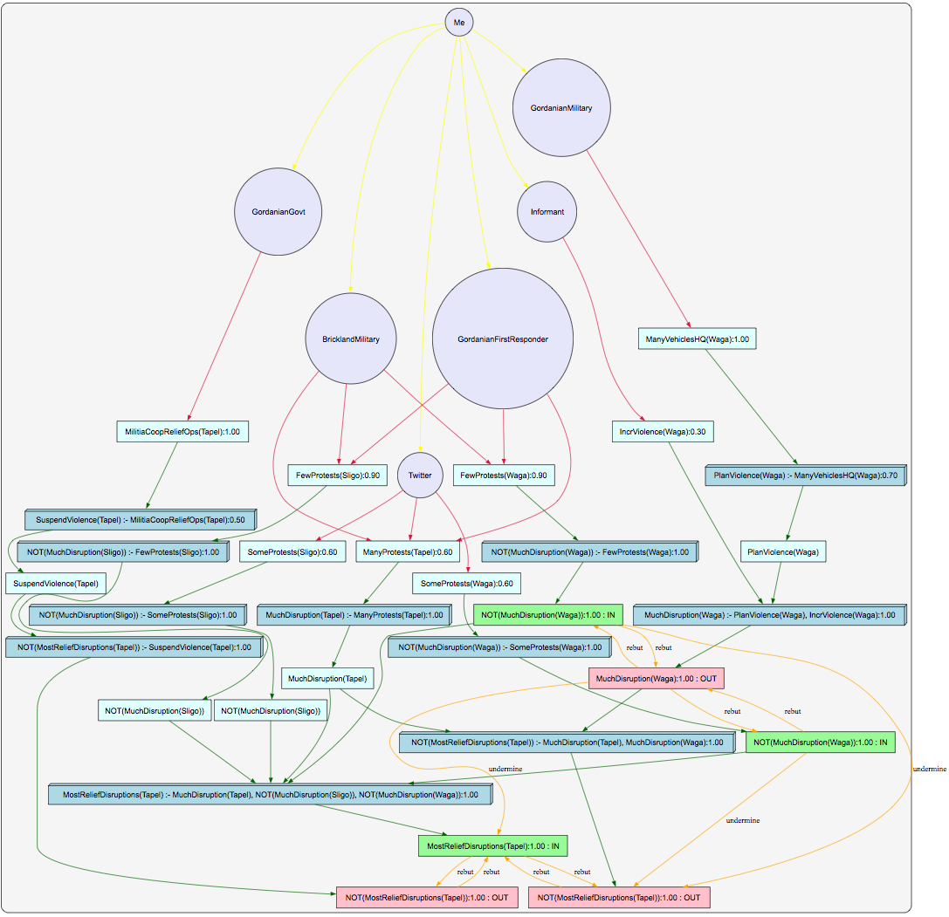

## Version 4: City Where Protests Most Likely to Disrupt Relief Ops

The version 3 graph seems too complicated. So we remove the agent ‘GordanianFirstResponder’. The question asked is: ‘MostReliefDisruptions(Tapel)’. The following trust-extended belief network is generated by ArgTrust:

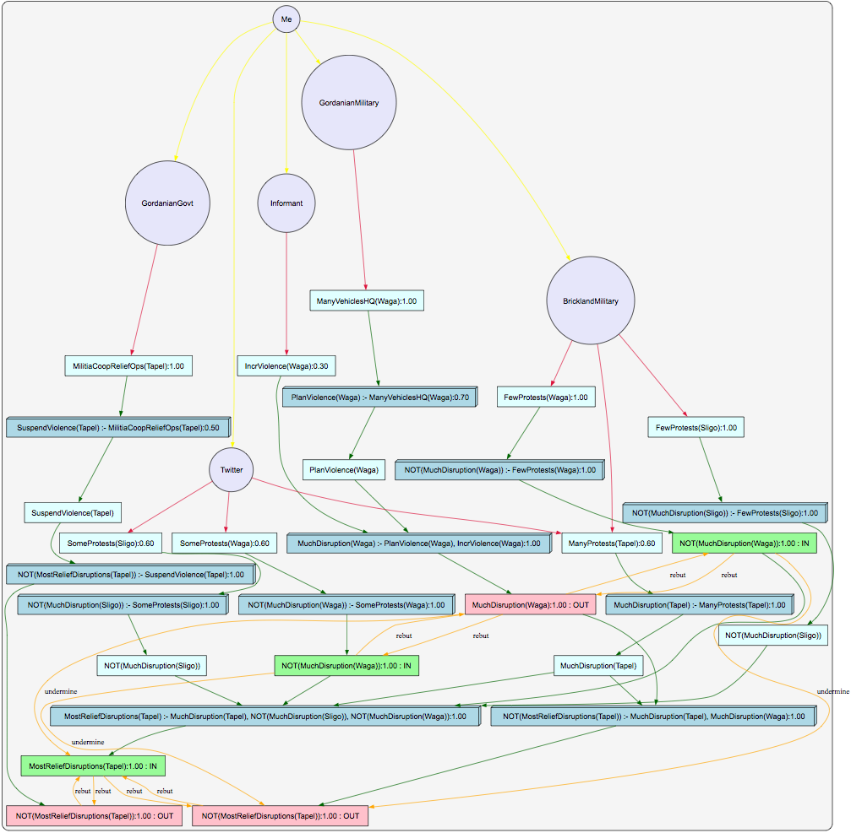

### Version 4 with no city Sligo removed

The version 4 graph above seems too complicated and we can remove the city Sligo. The question asked is: ‘MostReliefDisruptions(Tapel)’. The following trust-extended belief network is generated by ArgTrust:

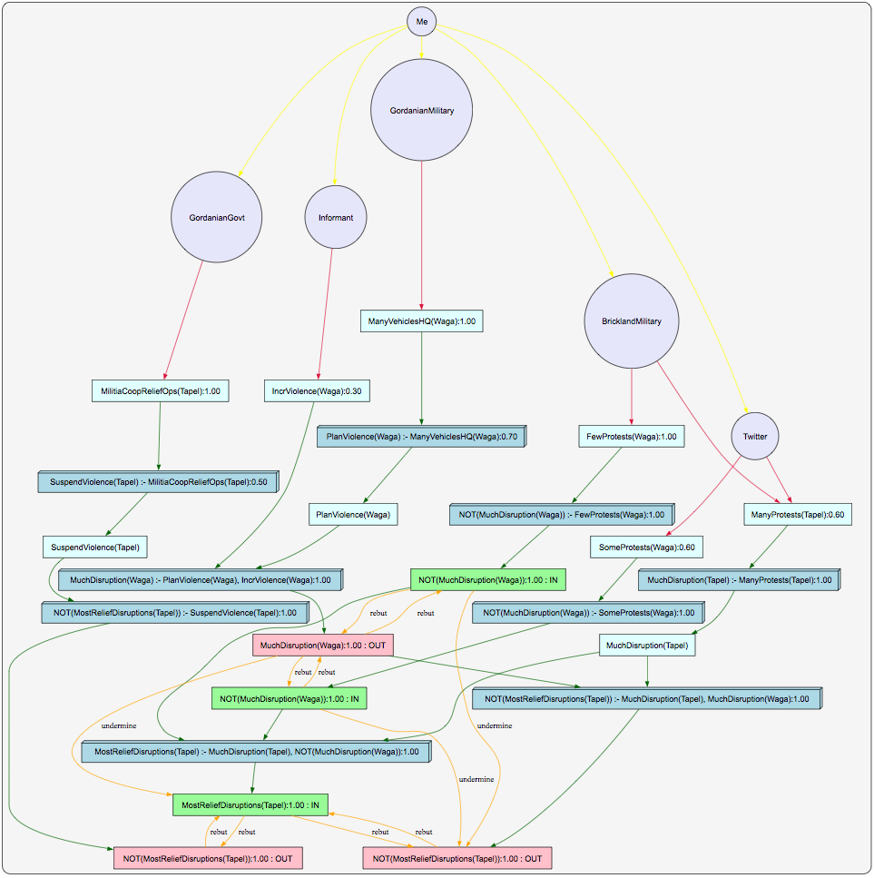

# CCIR: City Where Search and Rescue Efforts Most Needed

## Version 0: City Where Search and Rescue Efforts Most Needed

Row 353-448(end) of the excel spreadsheet lists the information received regarding search and rescue efforts and requests in the three towns of Tapel, Sligo and Waga. Each piece of information is classified based on its source and is (mostly) counted against one the following six categories: *Tapel_SR_Requests, Tapel_SR_Ops, Sligo_SR_Requests, Sligo_SR_Ops, Waga_SR_Requests* and *Waga_Ops*. There is also information that is of the following three categories: *HardlySearched, Abt50percSearched,* and *MostlySearched*. For each source, after counting the number of Tapel_SR_Requests, Sligo_SR_Requests, and Waga_SR_Requests, the count against each city is then mapped to one of *FewSRreq, SomeSRreq* or *ManySRreq*. The following table is generated:

|  |  |  |  |  |  |  |
| --- | --- | --- | --- | --- | --- | --- |
|  | Tapel_Req | Tapel_Ops | Sligo_Req | Sligo_Ops | Waga_Req | Waga_Ops |
| Brickland Military | 14 (Many) | 6 |  | 4 | 3 (Few) | 4 |
| Twitter | 4 (Some) | 1 |  |  | 1 |  |
| Gordanian First Responder | 5 (Many) |  |  |  | 1 | 1 |
| Gordanian Official |  |  |  | 1 |  |  |
| International Civilian | 1 |  |  |  |  |  |
| Gordanian Civilian | 2 |  |  | 1 |  | 1 |
| NGO | 1 (Few) | 1 | 2 (Few) |  |  |  |
| Brickland State Dept. |  |  |  |  |  |  |
| Open Media |  |  |  |  |  |  |
| Gordanian Military | 1 (Few) | 2 | 1 (Few) |  | 2 (Some) |  |

Gordanian First Responder reports that Waga is about 50% searched (i.e., *Abt50percSearched(Waga)*). The Brickland Military reports that Sligo is mostly searched (i.e., *MostlySearched(Sligo)*) and that Tapel has been hardly searched (i.e., *HardlySearched(Tapel)*).

Rules to combine S&R requests are as follows:

* HardlySearched(X) ==> MoreSRneeded(X)
* Abt50percSearched(X) ^ ManySRreq(X) ==> MoreSRneeded(X)
* Abt50percSearched(X) ^ SomeSRreq(X) ==> MoreSRneeded(X)
* Abt50percSearched(X) ^ FewSRreq(X) ==> SomeSRneeded(X)
* MostlySearched(X) ^ FewSRreq(X) ==> LessSRneeded(X)
* MostlySearched(X) ^ SomeSRreq(X) ==> LessSRneeded(X)
* MostlySearched(X) ^ ManySRreq(X) ==> SomeSRneeded(X)
* MoreSRneeded(X) ^ SomeSRneeded(Y) ^ SomeSRneeded(Z) ==> MostSRneeded(X)
* MoreSRneeded(X) ^ SomeSRneeded(Y) ^ LessSRneeded(Z) ==> MostSRneeded(X)
* MoreSRneeded(X) ^ LessSRneeded(Y) ^ SomeSRneeded(Z) ==> MostSRneeded(X)
* MoreSRneeded(X) ^ LessSRneeded(Y) ^ LessSRneeded(Z) ==> MostSRneeded(X)
* SomeSRneeded(X) ^ LessSRneeded(Y) ^ LessSRneeded(Z) ==> MostSRneeded(X)
* MoreSRneeded(X) ^ SomeSRneeded(Y) ^ SomeSRneeded(Z) ==> NOT MostSRneeded(Y or Z)
* MoreSRneeded(X) ^ SomeSRneeded(Y) ^ LessSRneeded(Z) ==> NOT MostSRneeded(Y or Z)
* MoreSRneeded(X) ^ LessSRneeded(Y) ^ SomeSRneeded(Z) ==> NOT MostSRneeded(Y or Z)
* MoreSRneeded(X) ^ LessSRneeded(Y) ^ LessSRneeded(Z) ==> NOT MostSRneeded(Y or Z)
* SomeSRneeded(X) ^ LessSRneeded(Y) ^ LessSRneeded(Z) ==> NOT MostSRneeded(Y or Z)
* MoreSRneeded(X) ^ MoreSRneeded(Y) ^ SomeSRneeded(Z) ==> NOT MostSRneeded(X)

Only the following sources of information are modeled: ‘Brickland Military’, ‘Twitter’, ‘Gordanian First Responder’, ‘NGO’, ‘Gordanian Military’. The question asked is: ‘MostSRneeded(Tapel)’. The following trust-extended belief network is generated by argtrust:

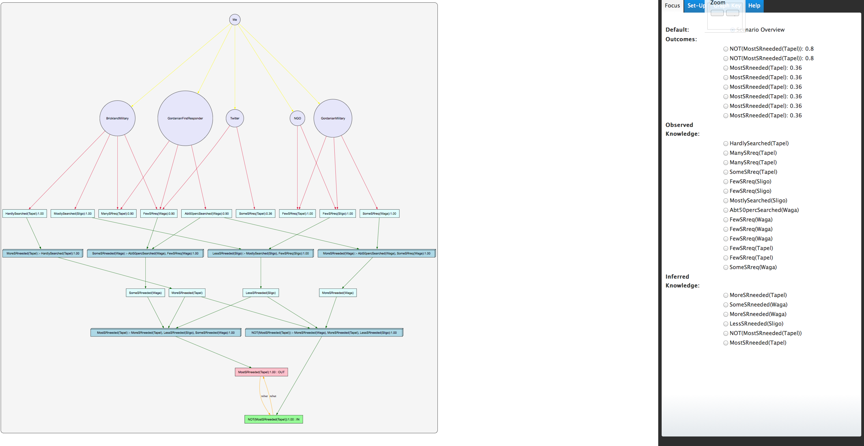

## Version 1: City Where Search and Rescue Efforts Most Needed

The previous version (version 0) suffered from too many sources of information. In version 1, we simplify the number of sources and remove some of the rules.

The intelligence analyst has the following information:

* Brickland Military reports that they have had many requests for search and rescue (SR) efforts in the town of Tapel (14 separate requests) and few SR requests in the town of Waga (3 separate requests)
* The Gordanian First Responders report some SR requests (4 requests) in the town of Tapel and a single SR request in the town of Waga
* The Gordanian Military reports a single SR request in the town of Tapel, a single SR request in the town of Sligo and some SR requests (5 requests) in the town of Waga
* Other sources of information include: Twitter, Gordanian Civilians, NGO, and International Civilians
  + All these sources of information reports only very few incidents each which makes information from them incomplete
* The Gordanian First Responders report that about 50 percent of Waga has been searched
* The Brickland Military reports that the mountainous region of Sligo has been mostly searched
* The Brickland Military also reports that the widespread destruction to infrastructure in the town of Tapel makes it very hard for them to carry out any search and rescue operations

Facts in the scenario are as follows:

* BricklandMilitary 🡪 ManySRrequests(Tapel); BricklandMilitary 🡪 FewSRrequests(Waga)
* GordanianFirstResponder 🡪 SomeSRrequests(Tapel); GordanianFirstResponder 🡪 FewSRrequests(Waga)
* GordanianMilitary 🡪FewSRrequests(Tapel); GordanianMilitary 🡪FewSRrequests(Sligo); GordanianMilitary 🡪SomeSRrequests(Waga)
* GordanianFirstResponders🡪Abt50percSearched(Waga)
* BricklandMilitary 🡪MostlySearched(Sligo)
* BricklandMilitary 🡪HardlySearched(Tapel)

Intelligence Analyst Trust Levels:

* BricklandMilitary: 1.00
* GordanianMilitary: 1.00
* GordanianFirstResponder: 0.9

Rules that the intelligence analyst believes in are as follows:

* HardlySearched(Tapel)🡪MoreSRneeded(Tapel)
* Abt50percSearched(Waga)^SomeSRreq(Waga)🡪MoreSRneeded(Waga)
* Abt50percSearched(Waga)^ FewSRrequests(Waga)🡪SomeSRneeded(Waga)
* MostlySearched(Sligo)^ FewSRrequests(Sligo)🡪LessSRneeded(Sligo)
* MoreSRneeded(Tapel)^ SomeSRneeded(Waga)^LessSRneeded(Sligo)🡪MostSRneeded(Tapel)
* MoreSRneeded(Tapel)^ MoreSRneeded(Waga)🡪NOT MostSRneeded(Tapel)

The question asked is: ‘MostSRneeded(Tapel)’. The following trust-extended belief network is generated by ArgTrust:

