FIRE ON WALNUT STREET

# Scenario

You are in charge of a police precinct. You receive a report that a group of kids has set a fire in a garbage can in an empty lot on Walnut Street. It is 10pm. Standard operating procedure is to send out a patrol car and have the officers in the patrol car warn the kids off and to call the fire department to put out the fire. You have to decide if:

1. you should follow standard operating procedure, or
2. you should not follow standard operating procedure and respond in some other way.

Here are the details. Several recent incidents have occurred that cause you to question whether standard operating procedure is the right action in this case. First, there have been cases where the patrol car finds that there is not just a bunch of kids in the empty lot, but also there are members of a local gang (called the Pelts) that harass the police and stone the squad car and fire truck. Second, there have been several crank phone calls in which the patrol car has gone to the lot and found it deserted, with no sign of a fire. Finally, you know that the fire department is short staffed and you are wary of sending them to a call that might be phony.

You decide to look at information from CCTVs (closed circuit television cameras). It is a dark night with no moon, and the CCTV footage is a bit unreliable at night since the images are hard to see well. You think you can see that there are some people around on Walnut Street, but the pictures are far too indistinct to tell you if they are wearing gang insignia. You have information from an informant, Tony, who is a former member of the Pelts, who says that he has heard rumors that the Pelts have something planned for tonight, but he doesn’t know what it is, or where or what time it might occur. You have external confirmation that Tony is a reliable source. More information comes in from beat officers who have been patrolling Oak Street to say that many members of the Pelts are currently gathered at Alice’s, their favorite diner, on the corner of Oak and Pecan Streets (which is about 2 miles from the empty lot on Walnut Street). You also got a phone call from a local resident who says that a gang is near the empty lot on Walnut Street. You call Manny, the manager of an all-night convenience store on Walnut Street, who regularly cooperates with the police (because the police are responsive when he has had trouble with robberies in the past). Manny says there are kids hanging around on Walnut Street, but he doesn’t think they are members of the Pelts.

# Argumentation Graphs

## Version 0:

Agents along with their direct beliefs (facts) and belief levels are listed below:

* *Me🡪Phony(PhoneCalls)* with level 0.3; *Me🡪NOT Phony(PhoneCalls)* with level 0.7
* *Report🡪AtLocation(WalnutStLot_Fire)* with level 1.0
* *CCTV🡪AtLocation(WalnutSt_People)* with level 0.8; *CCTV🡪Membership(People_Pelts)* with level 0.3; *CCTV🡪NOT Membership(People_Pelts)* with level 0.7
* *Tony🡪TonightPlan(Pelts)* with level 0.6
* *BeatPatrol🡪AtLocation(AliceOnOakSt_Pelts)* with level 1.0
* *Resident🡪AtLocation(WalnutSt_Gang)* with level 1.0
* *Manny🡪AtLocation(WalnutSt_Kids)* with level 1.0; *Manny🡪NOT Membership(Kids_Pelts)* with level 1.0

My trust levels are as follows:

* Report: 0.7
* CCTV: 0.7
* Tony: 1.0
* BeatPatrol: 1.0
* Resident: 0.8
* Manny: 1.0

Rules that I believe in are as follows (belief levels are set to 1 by default):

* AtLocation(WalnutStLot_Fire)^Phony(PhoneCalls)🡪NOT Follow(StdOpProc)
* AtLocation(WalnutSt_People)^Membership(People_Pelts)🡪AtLocation(WalnutSt_Pelts)
* AtLocation(WalnutSt_People)^NOT Membership(People_Pelts) 🡪 NOT AtLocation(WalnutSt_Pelts)
* AtLocation(WalnutStLot_Fire)^AtLocation(WalnutSt_Pelts)🡪NOT Follow(StdOpProc)
* AtLocation(WalnutStLot_Fire)^NOT AtLocation(WalnutSt_Pelts)^NOT Phony(PhoneCalls)🡪Follow(StdOpProc)
* TonightPlan(Pelts)^AtLocation(WalnutStLot_Fire)🡪AtLocation(WalnutSt_Pelts) *with level 0.5*
* AtLocation(AliceOnOakSt_Pelts)🡪 NOT AtLocation(WalnutSt_Pelts)
* AtLocation(WalnutSt_Gang)🡪 AtLocation(WalnutSt_Pelts) *with level 0.9*
* AtLocation(WalnutSt_Kids)^NOT Membership(Kids_Pelts) 🡪NOT AtLocation(WalnutSt_Pelts)

The question asked by ‘Me’ is: ‘Follow(StdOpProc)’. The following trust-extended belief network is generated by ArgTrust:

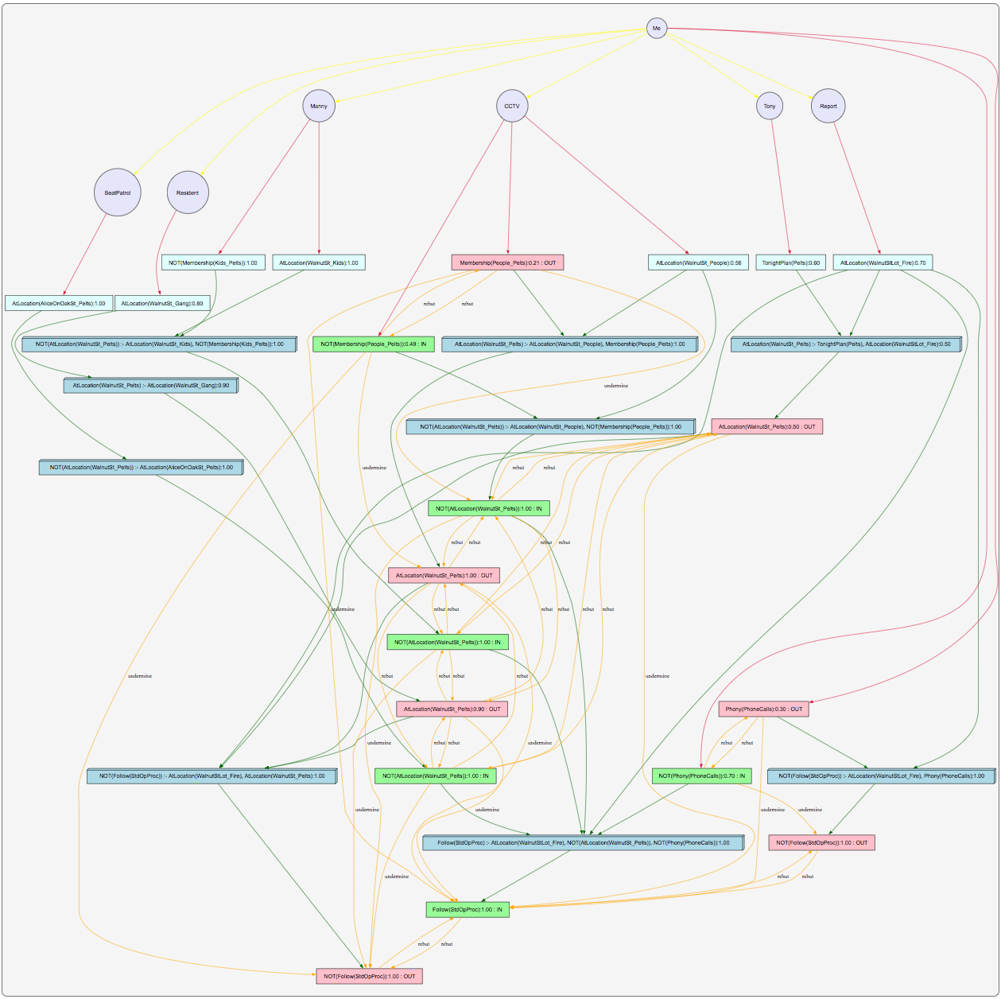

## Version 1:

Version 0 as drawn is too complicated: too many rebuts and undermines. Hence version 1 has the following changes:

* Removed the 3 CCTV facts 'AtLocation(WalnutSt_People)', 'Membership(People_Pelts)' and 'NOT Membership(People_Pelts)'.
* Replaced the 3 facts with the following 2 CCTV facts: 'AtLocation(WalnutSt_Pelts)' and 'NOT AtLocation(WaltnutSt_Pelts)'. This simplifies the overview diagram as there is one less level of inference. Previously 'AtLocation(WalnutSt_Pelts)' and 'NOT AtLocation(WaltnutSt_Pelts)' were inferred from the facts 'AtLocation(WalnutSt_People)', 'Membership(People_Pelts)' and 'NOT Membership(People_Pelts)'.

Agents along with their direct beliefs (facts) and belief levels are listed below:

* *Me🡪Phony(PhoneCalls)* with level 0.3; *Me🡪NOT Phony(PhoneCalls)* with level 0.7
* *Report🡪AtLocation(WalnutStLot_Fire)* with level 1.0
* *CCTV🡪AtLocation(WalnutSt_Pelts)* with level 0.3; *CCTV🡪NOT AtLocation(WalnutSt_Pelts)* with level 0.7
* *Tony🡪TonightPlan(Pelts)* with level 0.6
* *BeatPatrol🡪AtLocation(AliceOnOakSt_Pelts)* with level 1.0
* *Resident🡪AtLocation(WalnutSt_Gang)* with level 1.0
* *Manny🡪AtLocation(WalnutSt_Kids)* with level 1.0; *Manny🡪NOT Membership(Kids_Pelts)* with level 1.0

My trust levels are as follows:

* Report: 0.7
* CCTV: 0.7
* Tony: 1.0
* BeatPatrol: 1.0
* Resident: 0.8
* Manny: 1.0

Rules that I believe in are as follows (belief levels are set to 1 by default):

* AtLocation(WalnutStLot_Fire)^Phony(PhoneCalls)🡪NOT Follow(StdOpProc)
* AtLocation(WalnutStLot_Fire)^AtLocation(WalnutSt_Pelts)🡪NOT Follow(StdOpProc)
* AtLocation(WalnutStLot_Fire)^NOT AtLocation(WalnutSt_Pelts)^NOT Phony(PhoneCalls)🡪Follow(StdOpProc)
* TonightPlan(Pelts)^AtLocation(WalnutStLot_Fire)🡪AtLocation(WalnutSt_Pelts) *with level 0.5*
* AtLocation(AliceOnOakSt_Pelts)🡪 NOT AtLocation(WalnutSt_Pelts)
* AtLocation(WalnutSt_Gang)🡪 AtLocation(WalnutSt_Pelts) *with level 0.9*
* AtLocation(WalnutSt_Kids)^NOT Membership(Kids_Pelts) 🡪NOT AtLocation(WalnutSt_Pelts)

The question asked by ‘Me’ is: ‘Follow(StdOpProc)’. The following trust-extended belief network is generated by ArgTrust:

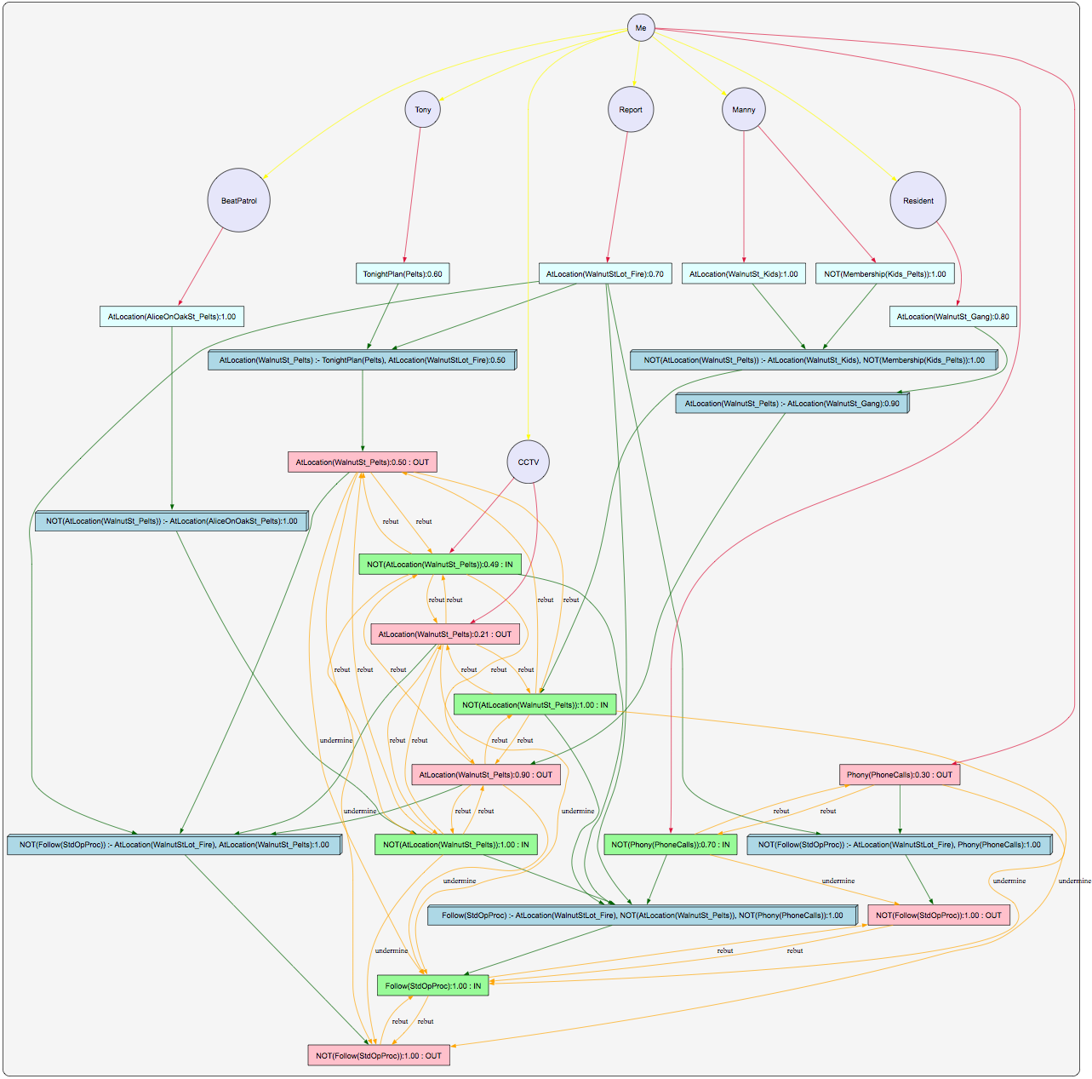

## Version 2:

Version 1 is still too complicated: too many rebuts and undermines. Hence version 2 has the following changes:

* Removed agent ‘CCTV’ and its corresponding facts. Either remove CCTV facts from the scenario or assume that we do not trust (level=0) the CCTV footage.

Agents along with their direct beliefs (facts) and belief levels are listed below:

* *Me🡪Phony(PhoneCalls)* with level 0.3; *Me🡪NOT Phony(PhoneCalls)* with level 0.7
* *Report🡪AtLocation(WalnutStLot_Fire)* with level 1.0
* *Tony🡪TonightPlan(Pelts)* with level 0.6
* *BeatPatrol🡪AtLocation(AliceOnOakSt_Pelts)* with level 1.0
* *Resident🡪AtLocation(WalnutSt_Gang)* with level 1.0
* *Manny🡪AtLocation(WalnutSt_Kids)* with level 1.0; *Manny🡪NOT Membership(Kids_Pelts)* with level 1.0

My trust levels are as follows:

* Report: 0.7
* Tony: 1.0
* BeatPatrol: 1.0
* Resident: 0.8
* Manny: 1.0

Rules that I believe in are as follows (belief levels are set to 1 by default):

* AtLocation(WalnutStLot_Fire)^Phony(PhoneCalls)🡪NOT Follow(StdOpProc)
* AtLocation(WalnutStLot_Fire)^AtLocation(WalnutSt_Pelts)🡪NOT Follow(StdOpProc)
* AtLocation(WalnutStLot_Fire)^NOT AtLocation(WalnutSt_Pelts)^NOT Phony(PhoneCalls)🡪Follow(StdOpProc)
* TonightPlan(Pelts)^AtLocation(WalnutStLot_Fire)🡪AtLocation(WalnutSt_Pelts) *with level 0.5*
* AtLocation(AliceOnOakSt_Pelts)🡪 NOT AtLocation(WalnutSt_Pelts)
* AtLocation(WalnutSt_Gang)🡪 AtLocation(WalnutSt_Pelts) *with level 0.9*
* AtLocation(WalnutSt_Kids)^NOT Membership(Kids_Pelts) 🡪NOT AtLocation(WalnutSt_Pelts)

The question asked by ‘Me’ is: ‘Follow(StdOpProc)’. The following trust-extended belief network is generated by ArgTrust:

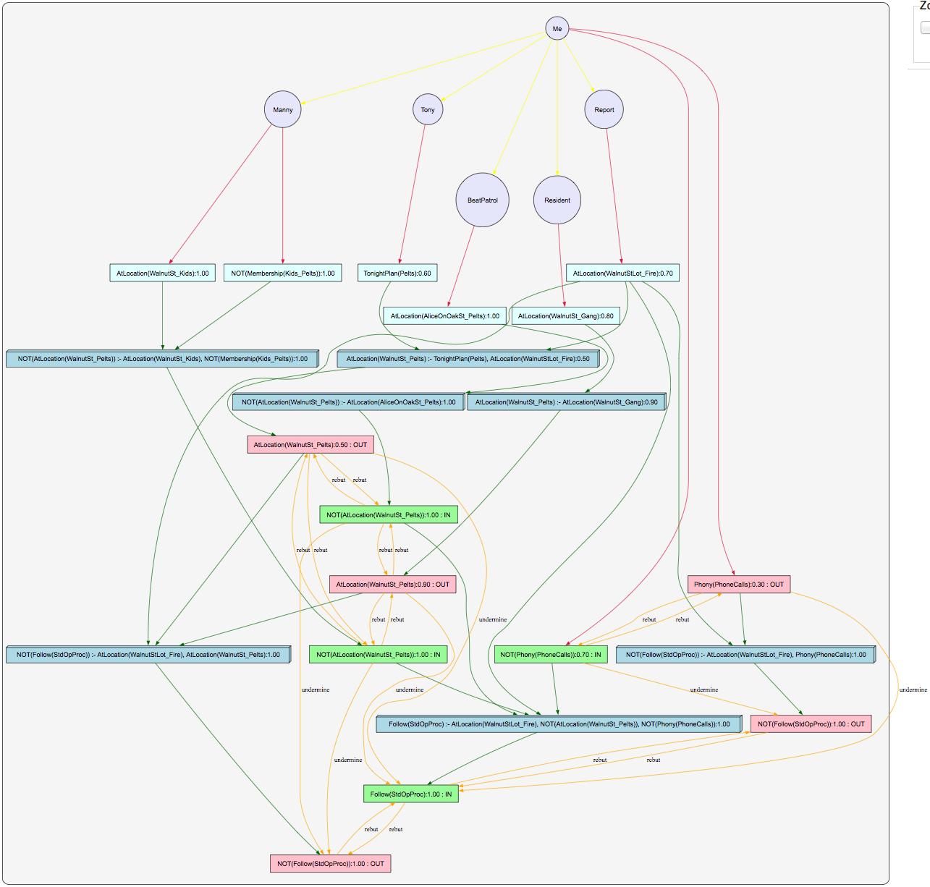

## Version 3:

Version 2 is still too complicated: too many rebuts and undermines. Hence version 3 has the following changes:

* Removed direct belief ‘NOT Phony(PhoneCalls)’ from agent ‘Me’.

Agents along with their direct beliefs (facts) and belief levels are listed below:

* *Me🡪Phony(PhoneCalls)* with level 0.3
* *Report🡪AtLocation(WalnutStLot_Fire)* with level 1.0
* *Tony🡪TonightPlan(Pelts)* with level 0.6
* *BeatPatrol🡪AtLocation(AliceOnOakSt_Pelts)* with level 1.0
* *Resident🡪AtLocation(WalnutSt_Gang)* with level 1.0
* *Manny🡪AtLocation(WalnutSt_Kids)* with level 1.0; *Manny🡪NOT Membership(Kids_Pelts)* with level 1.0

My trust levels are as follows:

* Report: 0.7
* Tony: 1.0
* BeatPatrol: 1.0
* Resident: 0.8
* Manny: 1.0

Rules that I believe in are as follows (belief levels are set to 1 by default):

* AtLocation(WalnutStLot_Fire)^Phony(PhoneCalls)🡪NOT Follow(StdOpProc)
* AtLocation(WalnutStLot_Fire)^AtLocation(WalnutSt_Pelts)🡪NOT Follow(StdOpProc)
* AtLocation(WalnutStLot_Fire)^NOT AtLocation(WalnutSt_Pelts) 🡪 Follow(StdOpProc)
* TonightPlan(Pelts)^AtLocation(WalnutStLot_Fire)🡪AtLocation(WalnutSt_Pelts) *with level 0.5*
* AtLocation(AliceOnOakSt_Pelts)🡪 NOT AtLocation(WalnutSt_Pelts)
* AtLocation(WalnutSt_Gang)🡪 AtLocation(WalnutSt_Pelts) *with level 0.9*
* AtLocation(WalnutSt_Kids)^NOT Membership(Kids_Pelts) 🡪NOT AtLocation(WalnutSt_Pelts)

The question asked by ‘Me’ is: ‘Follow(StdOpProc)’. The following trust-extended belief network is generated by ArgTrust:

