

**NGUYEN NHU BAO**

*JAVA ANDROID PROGRAMMER*

Hard working, honestly, highly motivated, smart

and hungry to learn new technologies

Constantly learning to cultivate knowledge about programming to develop professional skills.

In the next 1 year, I will become a professional java and android programmer and learn more IOS

programming.

**SKILL**

English read and write

Independent - teamwork working skills

Problem solving skill

Withstanding high pressure in ensuring work

progress.

**CARRIER OBJECTIVES**

21/05/1999

Male 0396940321

[Nguyennhubao999@gmail.com](mailto:Nguyennhubao999@gmail.com) TPHCM

[https://www.facebook.com/nguyenhubao](http://www.facebook.com/nguyenhubao)

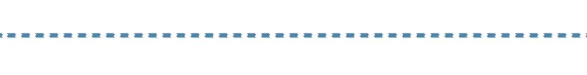

**EDUCATIONAL BACKGROUND**

# NONGLAM UNIVERSITY

## From otc 2017 to otc 2021

Major: Software Engineer



**ACTIVITY**

# JOIN "KETNOITHANHCONG" CLUB

## Member

Learn presentation skills before the crowd, teamwork skills ...

# CHALLENGE THE PROGRAMMER

## Participants

The famous contest of the Faculty Information Technology of Nong Lam University in Ho Chi Minh City

# JOIN GREENTEA

## Participants

academic and skill groups

**Working on startup Vinsen company**

From jul 2019 to sep 2019

Fontend dev (html,css ,js) and android dev (java)



INVOLVED PROJECT

# +/ BACK PROTECTION

## This is a project to build an application for back protection.

Language used: Java: https://github.com/Special4599/BackProtection.git

# +/ GAME

## this is project game in subjects OOD. I and team build for report

Language used: Java,

<https://github.com/Special4599/game.git>

**+/ Web Sell Book**

This is project in subject Web Develop. Project works is great

Technology: Java, Jsp, Servlet

**+/ GreenTea (Mobile application)**

**HOBBY**

This is the application that uses QR code and barcode scanner to to take attendance at meetings. The app has been used successfully in the Communist Youth Union Congress of Ho Chi Minh City University of Agriculture and Forestry

* CODE is passionate
* Learning new technology
* Listening to music
* Playing soccer and volleyball

Language used : JAVA,

Technology: Rest api

**+ SleepTime (Mobile application)**

Sleep calculation application and scheduled alarms.

Language: java

<https://github.com/Special4599/TimeSleep>

**- Operating systems: Windows, Linux**



TECHNICAL SKILLS

**- IDE Tools: Eclipse, IntelliJ, Visual Studio Code**

**- Multil Threads, Process principle and programming**

**- Programming Languages: Java, HTML, JavaScript**

**- Database: SQL, MySQL**