Team Charter
Team Number: | 12

Please list full names and MacID’s of all Team Members.
Full Name: | MacID:
Seaya Liu | liu1150
Kyle Hagerman | hagermak
Baoze Lin | linb44
Ursula Chui | chuiu

Roles and Responsibilities
In this section, you can identify who will be responsible for what roles in a team. At this stage, you should focus on the high-level administrative tasks (e.g., taking meeting minutes, submitting documents to Avenue, scheduling meetings, communicating with instructors, etc.). However, as the project progress roles may expand and become more specific. As needed, you can attach an addendum to this charter and submit with future deliverables (important: the original team charter should never be changed once all team members have signed it.

Manager: Ursula
- Assemble an agenda/list of goals for each meeting, considering input from team members
- Lead meetings, ensuring team members stay on topic and reach decisions on meeting goals

Administrator: Kyle
- Take meeting notes
- Ensure DHF is organized and keep records of action items and completion

Coordinator: Baoze
- Lead and delegate external communications with stakeholders and supervisor(s)
- Schedule and coordinate meetings

Deliverable Manager: Seaya
- Keep track of deadlines
- Submit documents on Avenue

Expectations of Behaviour, Work Ethic, and Professionalism
Summarize what will be expected of all team members.
- Examples can be found in Breakout Box 2.2 of Chapter 2 excerpt from Biomedical Engineering Design.

All team members are expected to:
- Deliver assigned deliverables on schedule and communicate unforeseen scheduling conflicts or constraints with adequate advance notice.
- Take ownership of project objectives by executing tasks thoroughly, maintaining work quality, and offering additional support across deliverables when team needs arise.
- Attend scheduled group meetings consistently, contribute substantive ideas, and listen attentively to teammates' perspectives.
- Maintain a supportive group climate by recognizing peers' contributions, valuing different skill sets, and treating all members with professionalism.
- Provide thoughtful, actionable critique on project components and integrate peer feedback with a receptive, growth-oriented mindset.

Communication and Documentation Management
This section is intended to outline the frequency of meetings, who is expected to attend each meeting, and the expected format for meetings (e.g., in-person vs. virtual). You should also describe where documents will be stored (e.g., OneDrive, Google Drive, MS Teams, etc.).

- Meetings will occur at least once a week.
- Members who are able to attend meetings should attend. Meetings must occur with at least 2/4 members present.
- Meetings in regards to a project feature that one person has ownership of must have that person attending.
- Meetings will be conducted in person or virtually as needed by the group.
- Documents will be stored in GitHub for clear version control and industry standard software collaboration techniques.

Other Commitments
List anything team members should be considerate of when scheduling meetings, assigning tasks, or working towards deadlines. Examples include, but are not limited to, midterm schedules, work schedules, availability limitations due to weekend availability (e.g., due to commuting), scheduled time out of town, religious observances, etc.).

- Team members must give heads up at the beginning of each term to their expected commitments so everyone can accordingly adjust their expectations.
- Team members will share their busy/free calendar blocks together to facilitate planning, while also giving at least 3 days notice for any plans made, unforeseen circumstances aside.
- Team members must adequately plan their own work around midterm and exam schedules and other work/school commitments to ensure their deliverables do not need to be taken over by another team member for the sake of meeting a deadline.

Conflict Management and Accountability
Explain how you are going to manage conflict should it arise. The focus here should be on resolution rather than punitive measures. Section 2.5 from the Biomedical Engineering Design textbook is an excellent resource that you are encouraged to review.

Meeting Time Conflicts: Communicate any time conflicts as early as possible (or as specified in the ground rules and expectations for tutorial meetings) in person or via the primary communication channel(s). Tools like When2Meet and Google Calendar should be used to find optimal times for all team members. In the event that a person cannot attend a mandatory meeting, they are responsible for sending their assigned task(s) beforehand and catching up on the meeting events independently. The rest of the team will support this by adding notes to shared documents and writing meeting minutes to note discussion points.

Workload Management: Establish weekly capacity check-ins during meetings where team members can report on active hours/tasks and flag if anyone feels or is overloaded due to their assigned workload. If so, the team can discuss the existing distribution and re-assign at least two of their deliverables or sub-deliverables to available members within 24 hours if the division is found to be unequal.

Workload Issues (external): Require all members to communicate major external deadlines, exams, or personal busy periods into a shared communication channel or calendar tool at least 14 days in advance. When a teammate enters a high-stress period, the team can reduce their project task allocation by up to 50% for that week, shifting their assigned deliverables to other members and rotating lead responsibilities for the subsequent milestone/sprint.

Quality of Work Expectations: Establish explicit scoring criteria using the project rubrics on Avenue, defining specific benchmarks for reaching a desired product or grade goal. Review these rubrics and benchmarks collectively and log the agreed-upon standards to eliminate ambiguity upon quality of work discussions.

By signing below, all team members certify agreement with the team charter as outlined below.
Full Name: | Signature: | Date
Baoze Lin | 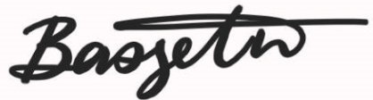 | 2026-09-18
Ursula Chui | Ursula Chui | 2026-09-18
Seaya Liu | 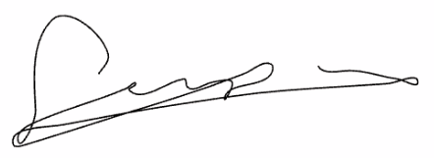 | 2026-09-18
Kyle Hagerman | 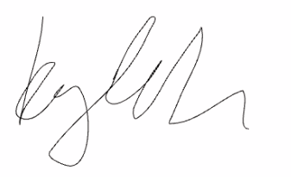 | 2026-09-18

