Group Project Documentation
MICROSERVICES WITH SPRING BOOT

Clinic Appointment System
MediSync Clinic

Prepared by Group 05
Nguyễn Mạnh Quân
Lê Hoài Nam
Nguyễn Hải Long
Tạ Tương Mười
Đào Nguyễn Duy Vũ

Ha Noi City, November 2026
Table of Contents

1.Project Introduction 1
1.1 Product Perspective 1
1.2 User Classes and Characteristics 1
2.Database Design 3
2.1 User Service 3
2.2 Patient Service 4
2.3 Doctor Service 5
2.4 Appointment Service 6
2.5 Notification Service 7
3.System Architecture (Microservices Architecture) 8
4.Implementation 8
1.1. Deployment Considerations 8
1.2. Screenshots and explanations 9
1.3. Communication Diagram 9
4.3.1. Create Appointment 9
4.3.2 Cancel Appointment 9
4.3.3. Send Failed Booking Notification 10
4.3.4. Medical Record Service 11
2. References 12

Revision History
Name | Date | Reason For Changes | Version
Group 05 | 01 Nov 2026 | Initial requirements & monolith decomposition | 1.0 draft 1
Group 05 | 05 Nov 2026 | Architecture design, SAGA pattern & database design | 1.0 draft 2
Group 05 | 11 Nov 2026 | Final submission for Group 05 presentation | 1.0 Final

1.Project Introduction

1.1 Product Perspective
MediSync Clinic is a distributed, enterprise-grade healthcare management application designed to automate, streamline, and scale the clinical consultation lifecycle between patients, medical practitioners, and clinic administrators. In modern healthcare environments, legacy monolithic applications experience critical architectural bottlenecks during peak scheduling hours (such as 07:00 - 08:30 AM), resulting in database table contention, appointment collision (double-booking the same physician time slot), and severe thread-pool exhaustion caused by synchronous blocking I/O with third-party payment gateways and SMS/Email providers.
The application consists of six independent business microservices: User Service, Patient Service, Doctor Service, Appointment Service, Payment Service, and Notification Service. Each service owns its own PostgreSQL database following the Database-per-Service pattern and communicates with other services through synchronous OpenFeign REST clients or asynchronous RabbitMQ events where eventual consistency is acceptable.
The primary purpose of the system is to improve appointment management efficiency, eliminate scheduling conflicts, prevent double-booking of doctor time slots, and ensure strict HIPAA data privacy for patient medical records. The current implementation leverages Spring Cloud Gateway (Port 8080), Eureka Service Discovery (Port 8761), Spring Cloud Config Server (Port 8889), isolated Docker PostgreSQL databases (Ports 55432-55437), Flyway migrations, RabbitMQ message broker (Port 5672/15672), and JWT authentication with edge security filtering.

1.2 User Classes and Characteristics
Patient
# | Function Name | Function Description
1 | Register / Login | Create an account and authenticate with local email/password. User Service issues HMAC256/RSA JWT access tokens and refresh tokens; the API Gateway validates JWTs and injects sanitized X-User-Id / X-User-Roles headers.
2 | Browse doctors / specialties | Search doctors by specialty (Cardiology, Internal Medicine, Pediatrics, Dermatology), view room number, consultation fee, and bio.
3 | View doctor's available slots | View open 45-minute consultation time slots for a doctor (status = AVAILABLE).
4 | Book an appointment | Select a slot and initiate appointment booking. The system coordinates slot reservation via SAGA and triggers asynchronous confirmation notifications.
5 | View / cancel / reschedule appointment | View personal appointments (strictly scoped to own identity), cancel pending appointments.
6 | View medical records & prescriptions | View personal medical history, allergy profile, blood type, and past prescriptions (guaranteed under HIPAA privacy rules).
7 | Receive notifications | Pay consultation fee via simulated VNPay QR code (PAY_NOW) or choose pay later at clinic (PAY_LATER), updating payment status in real-time.
Doctor
# | Function Name | Function Description
1 | Login | Authenticate via local email/password with the DOCTOR role.
2 | Manage work schedule (slots) | Create/activate/block 45-minute consultation time slots across weekly schedules (doctor_slots with optimistic locking).
3 | View appointment list | View daily/weekly appointment queues assigned to the doctor and inspect consultation contexts.
4 | Update visit status | Confirm pending appointments (emitting RabbitMQ confirmation events) and complete consultations; all transitions recorded in appointment_logs.
5 | Manage medical records | Record clinical diagnosis, treatment plan, and prescriptions into the patient's electronic health record (EHR).
Admin
# | Function Name | Function Description
1 | Manage user accounts | Assign roles (ROLE_ADMIN/ROLE_DOCTOR/ROLE_PATIENT) and monitor user statuses via user-service.
2 | Manage doctor directory | Manage doctor directory, medical specialties, room numbers, and consultation pricing.
3 | Monitor system | Monitor hospital-wide appointment metrics, payment revenue, and inspect RabbitMQ message delivery logs.

2.Database Design

2.1 User Service
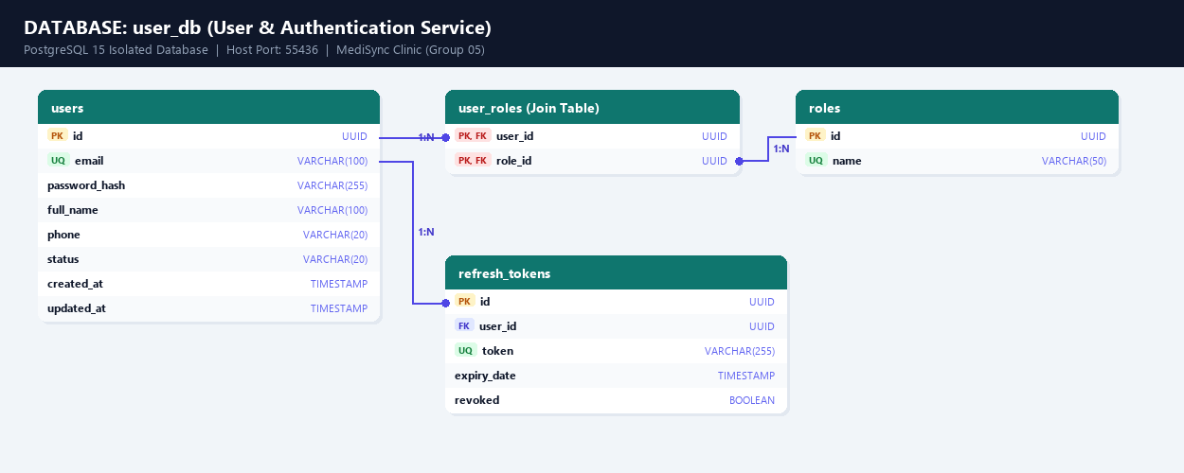

2.2 Patient Service
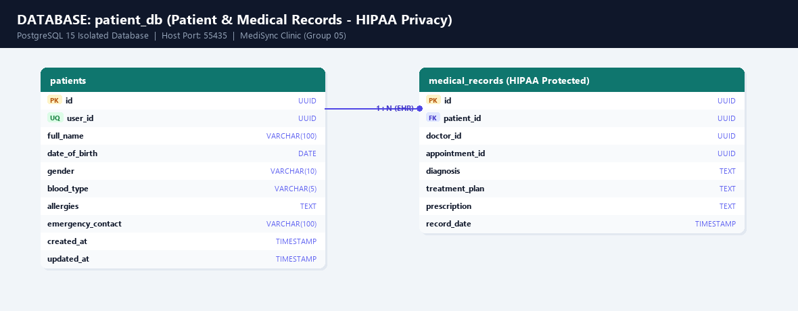

2.3 Doctor Service
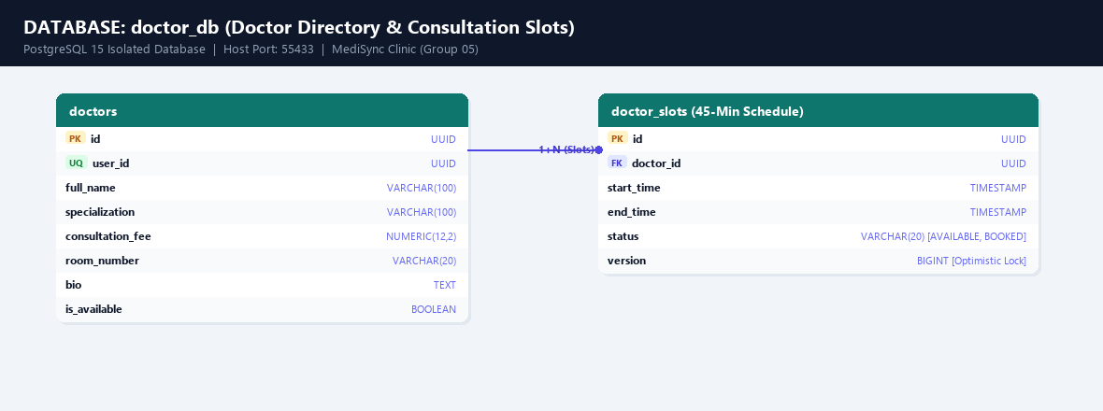

2.4 Appointment Service
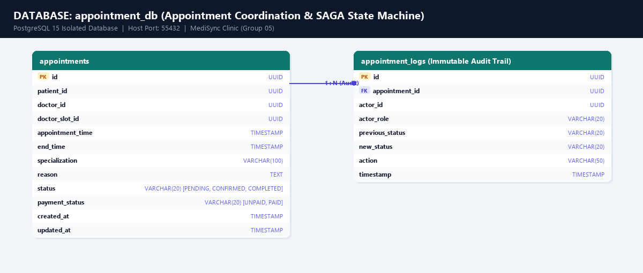

2.5 Notification Service
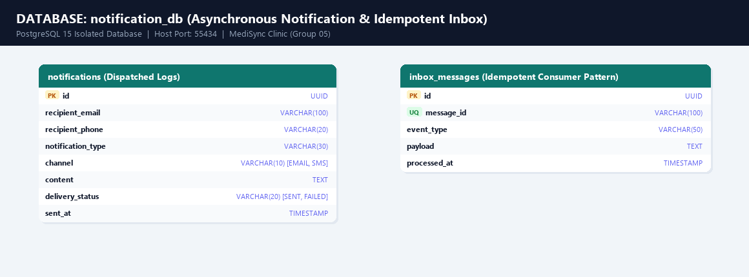

2.6 Payment Service
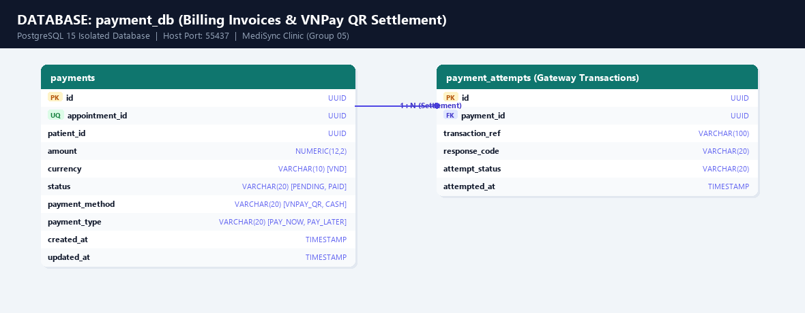

3.System Architecture (Microservices Architecture)
The system is deployed via Docker Compose and native execution, consisting of: an API Gateway (Port 8080), a Eureka Server (Port 8761 - dynamic service registry), a Config Server (Port 8889 - centralized configuration repository), 6 business microservices (user-service, patient-service, doctor-service, appointment-service, payment-service, notification-service) each with its own isolated PostgreSQL database (Ports 55432-55437), RabbitMQ Message Broker (Ports 5672/15672) for asynchronous messaging, and a React 19 Frontend Web Client (Port 5173).
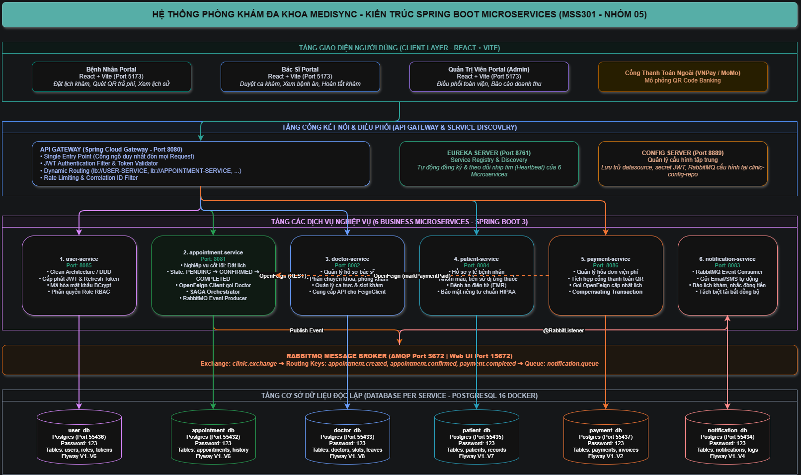

3.1 Detailed Architecture
The client (React frontend) calls the API Gateway over HTTP/HTTPS with a self-issued JWT Bearer token (issued by User Service; no third-party identity server is required). The gateway validates the token signature, strips any untrusted client headers (headers.remove(USER_ID)), extracts the claims, injects verified X-User-Id and X-User-Roles headers, and routes the request to the target service via Eureka dynamic resolution (lb://service-name). Each service follows Clean Architecture / Hexagonal Architecture (api / application / domain / infrastructure) and only accesses its own database. Synchronous communication (OpenFeign) is used for operations requiring immediate consistency — such as the Appointment Service reserving a slot in Doctor Service, or calling Patient Service to resolve patient profile ID. In case of failure, automated SAGA compensating actions cancel the slot reservation. Asynchronous communication (RabbitMQ) is used for events requiring eventual processing, such as dispatching appointment confirmation emails and SMS alerts.
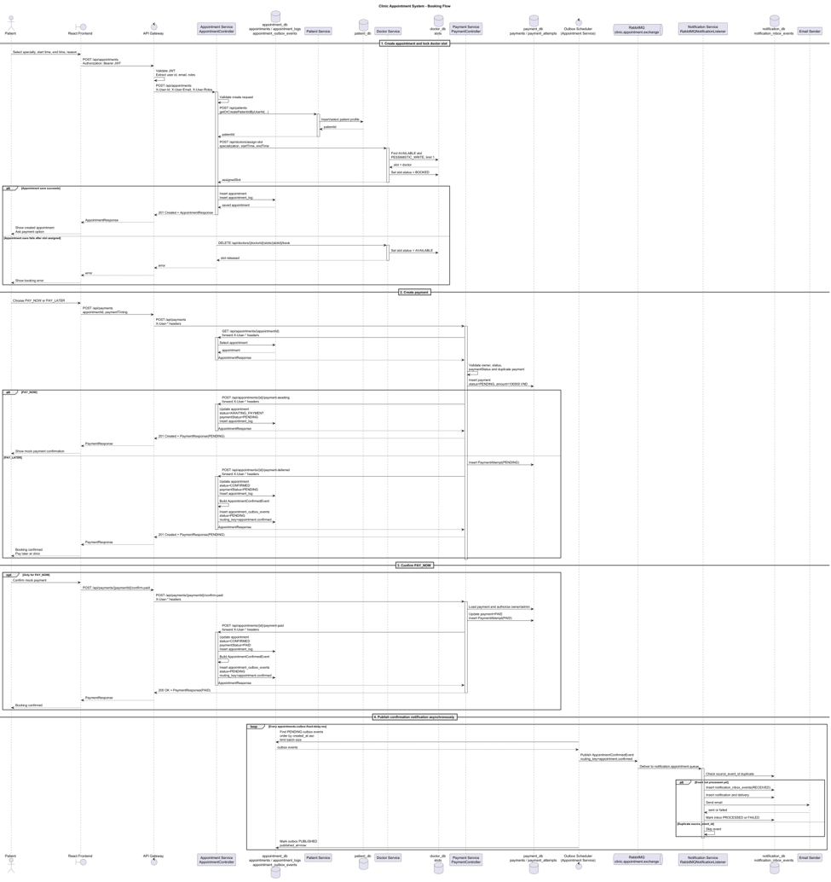

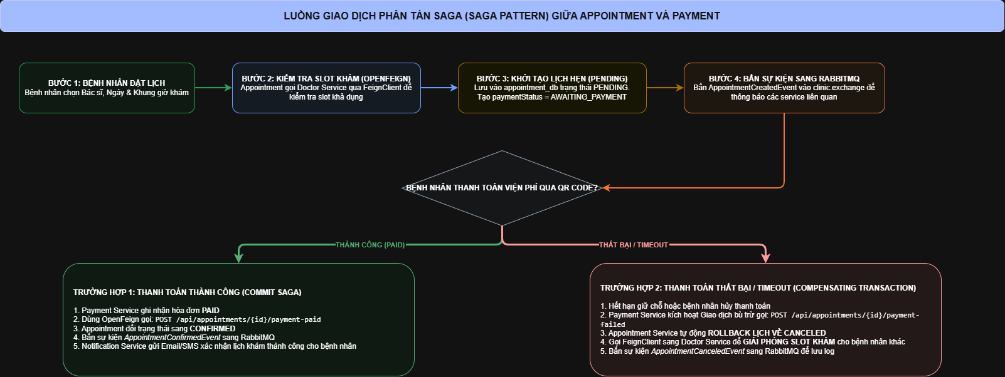
Once an appointment is created, the patient initiates payment via POST /api/payments, choosing either PAY_NOW (pay upfront) or PAY_LATER (pay at the clinic). The Payment Service validates the appointment synchronously against the Appointment Service (must not be canceled, completed, or payment-expired, must not already be paid, and must belong to the requesting patient), checks for a duplicate payment, then creates a Payment record in status PENDING with a fixed consultation fee (100,000 VND). Depending on the timing chosen, it calls back to the Appointment Service to mark the appointment as AWAITING_PAYMENT (PAY_NOW) or PAYMENT_DEFERRED (PAY_LATER, skipping the confirmation step below).

For the PAY_NOW path, the patient confirms payment via POST /api/payments/{paymentId}/confirm-paid — this is a mock payment step with no real payment gateway integration. The Payment Service authorizes the caller as the payment owner or an admin, marks the payment PAID, logs a PaymentAttempt, and notifies the Appointment Service to update paymentStatus to PAID.

A background scheduled job (ExpirePendingPayNowPaymentsUseCase) periodically expires PAY_NOW payments leave PENDING for more than 15 minutes. Note that this job does not call back to the Appointment Service, so appointments.payment_status can become out of sync with the expired payment record — a known limitation worth flagging in the report.

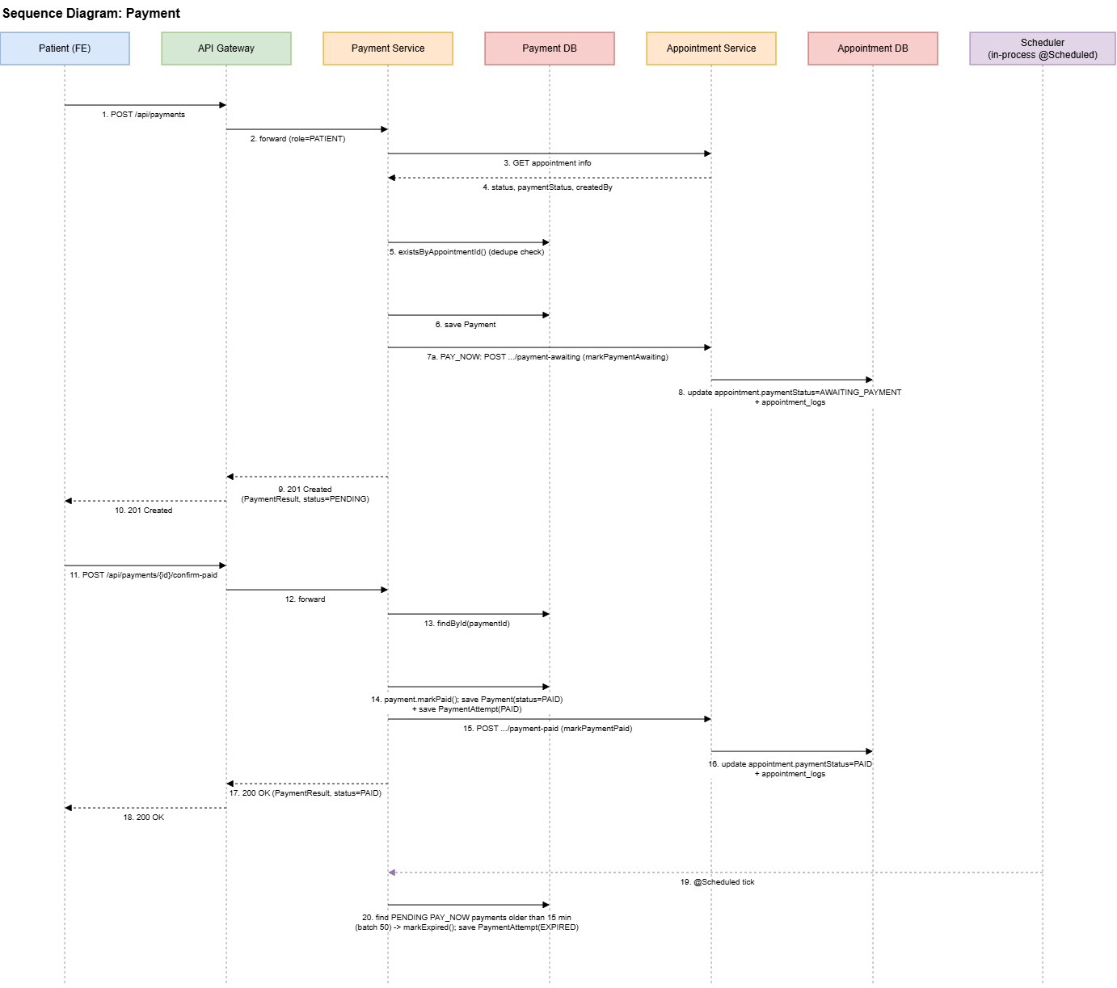

3.2 Technologies Used
- Spring Boot 3.5.14 / Spring Cloud 2025 (Eureka Server, Config Server, Spring Cloud Gateway WebFlux)
- JWT Authentication & BCrypt Password Hashing (Local User Service, Gateway Edge Header Sanitization)
- RabbitMQ 3.13 Topic Exchange (clinic.exchange) for asynchronous, event-driven communication (Inbox Pattern)
- React 19 + Vite + Tailwind CSS 4 + Lucide Icons (frontend Single Page Application with instant multi-role switching)

4.Implementation

4.1 Deployment Considerations
- The system is designed to run in a local development environment.
- All infrastructure components (RabbitMQ message broker, 6 PostgreSQL databases) are containerized using Docker Compose.
- Spring Boot microservices are executed locally through an IDE (such as IntelliJ IDEA) or by using Maven/Gradle commands.
- Spring Cloud Config Server provides centralized configuration for all services.
- Service discovery is handled by Eureka Server, allowing services to register and communicate dynamically.
- Environment-specific settings are managed through configuration files and environment variables.
- Database schema is automatically initialized and versioned using Flyway migrations.
- Developers should start infrastructure services before launching the microservices.

4.2. Screenshots and explanations
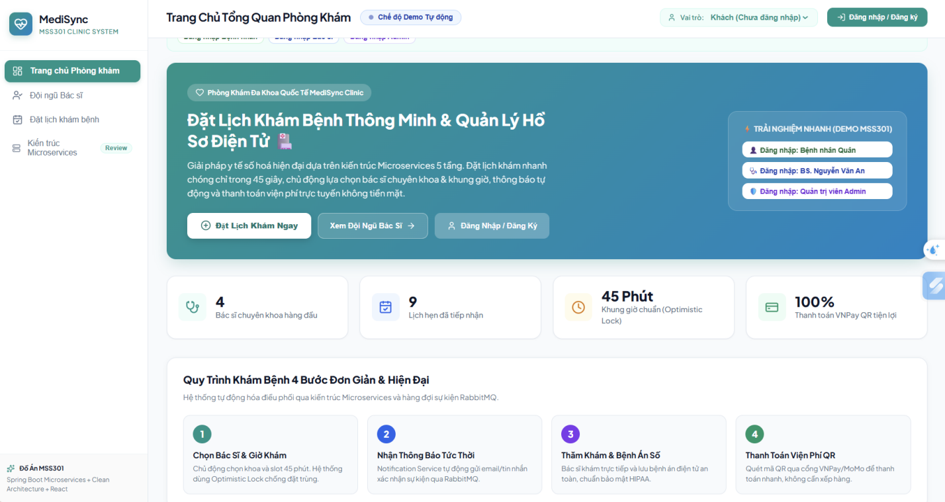

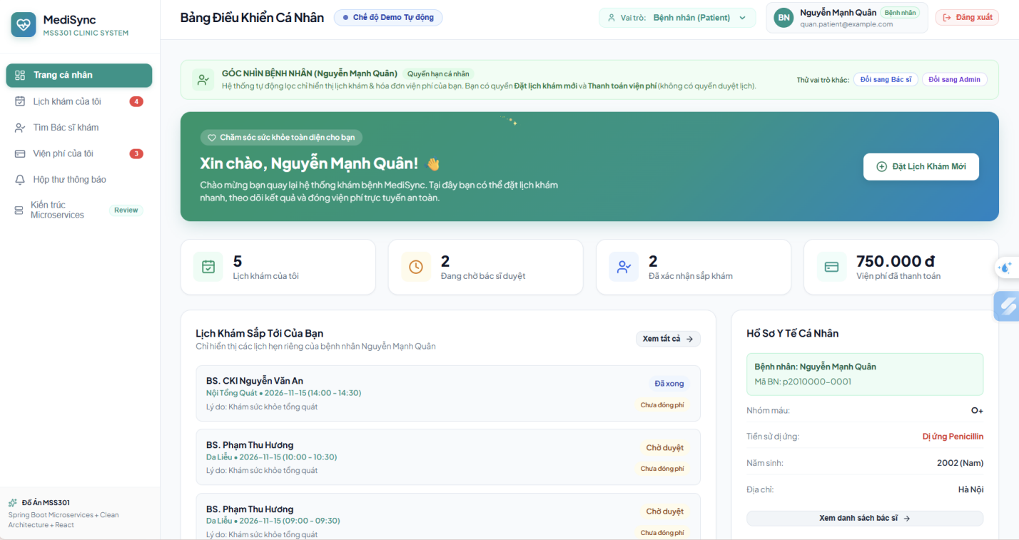

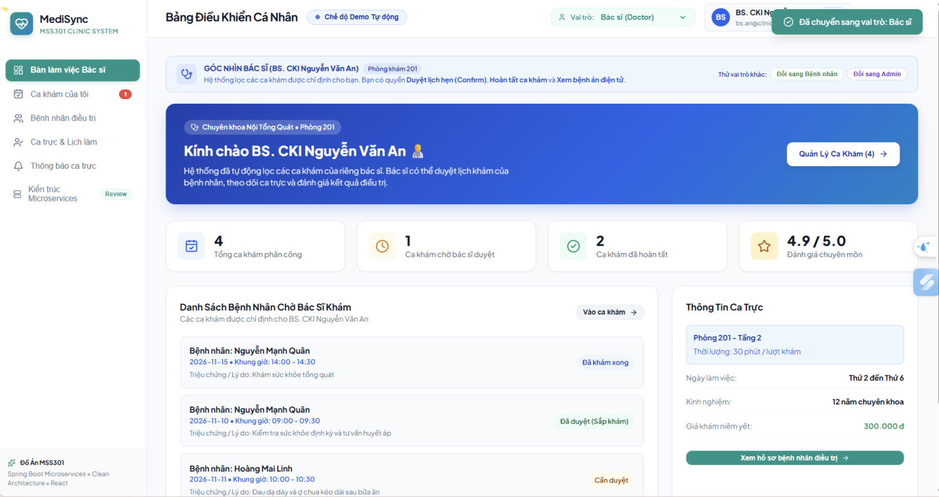

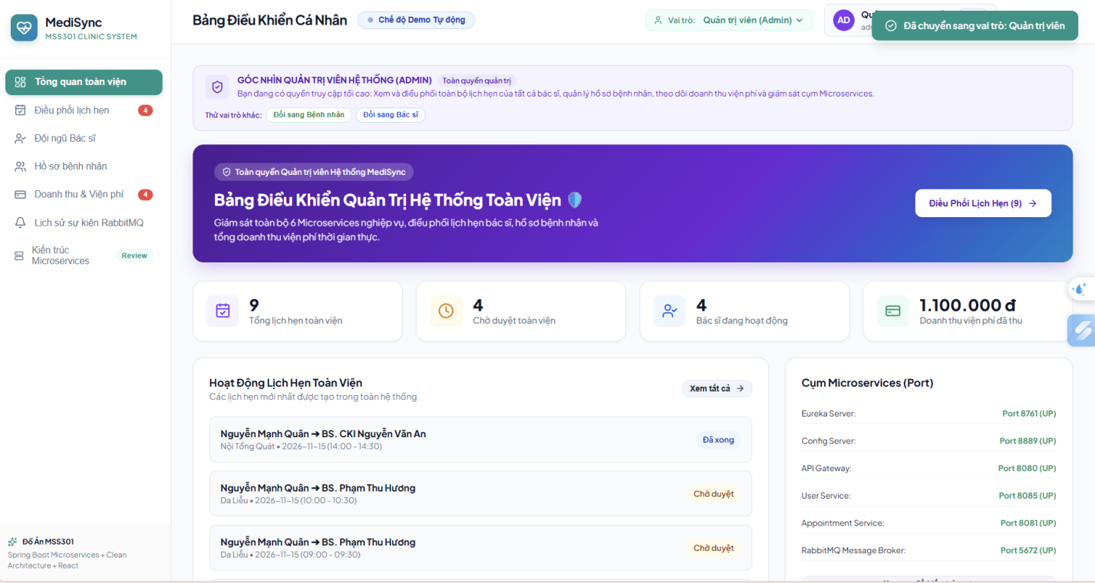

Figure 1. Dashboard Page

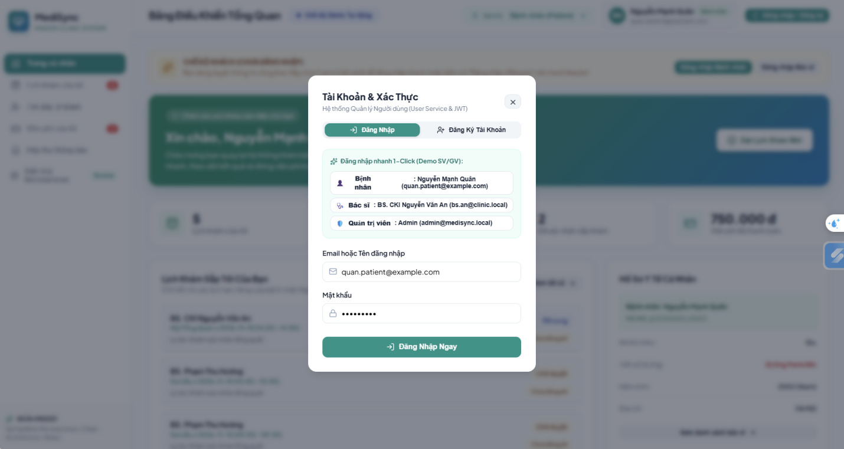
Figure 2. Login Page
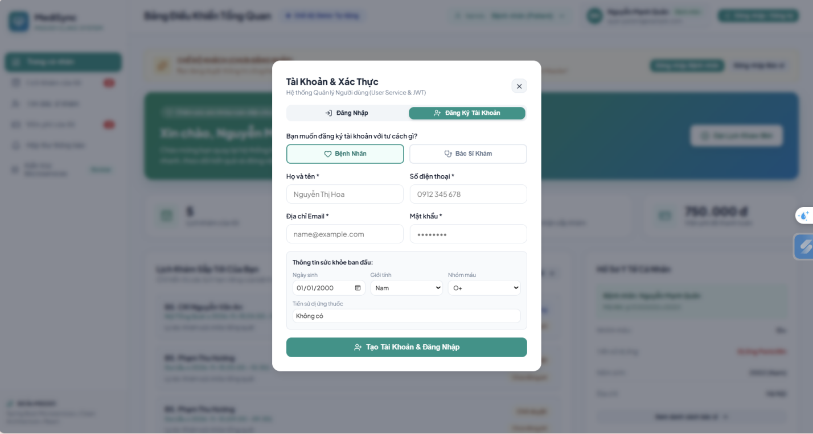

Figure 3. Register Page
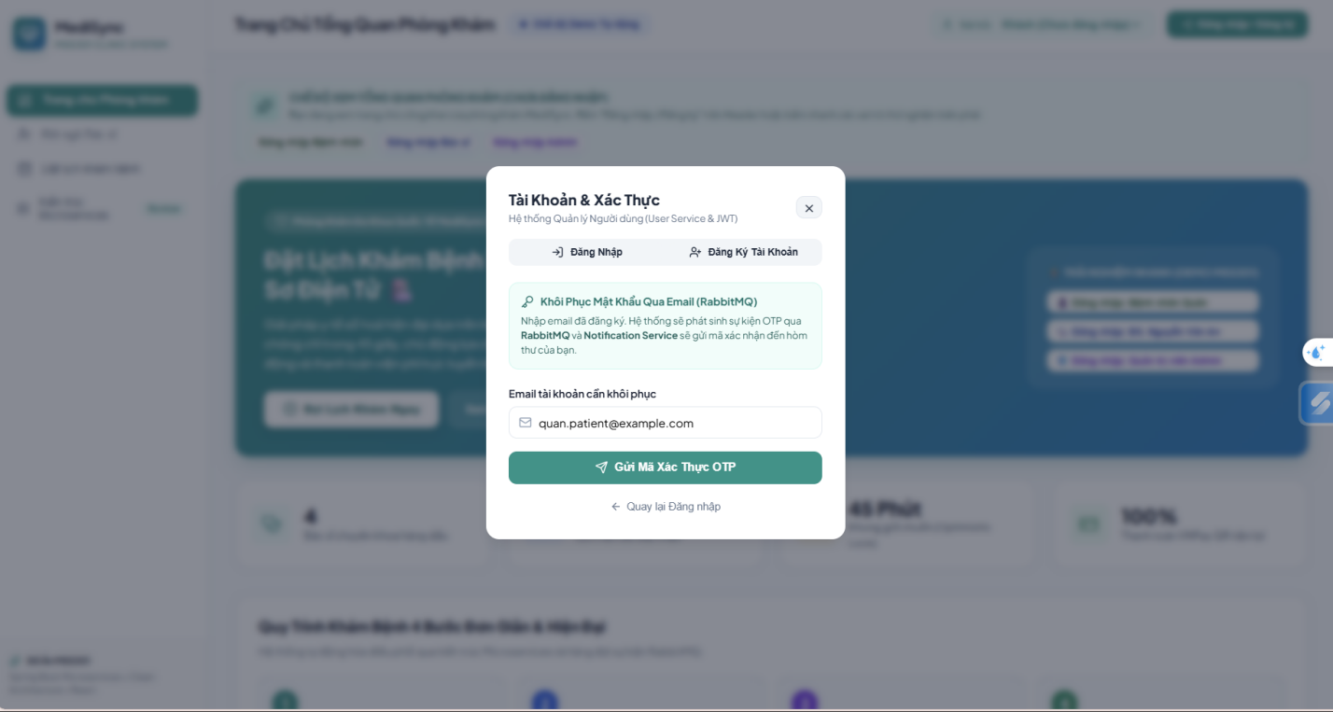
Figure 4. Doctor Schedule & Slots Management Page

4.3. Communication Diagram

4.3.1. Authentication & User Context Loading
Luồng xác thực & truyền danh tính: Client gửi email & password tới POST /api/users/login qua API Gateway. User Service kiểm tra BCrypt hash trong user_db, ký và trả về JWT Access Token (1 giờ) cùng Refresh Token (7 ngày). Trên các request tiếp theo, API Gateway giải mã JWT, chủ động xóa các header rác chống giả mạo, rồi bơm header chuẩn X-User-Id, X-User-Roles xuống các microservice.
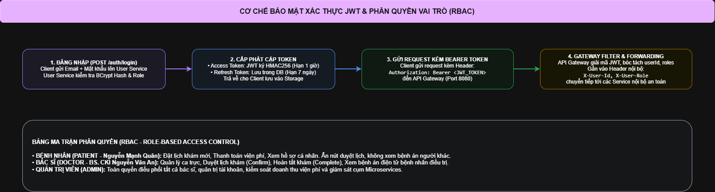

4.3.2. Sign Up & Auto-create Profile
Luồng đăng ký & tự động tạo hồ sơ: Khi người dùng đăng ký tại POST /api/users/register, User Service lưu tài khoản đồng thời phát lệnh REST Client tự động khởi tạo bản ghi hồ sơ trống bên patient-service hoặc doctor-service (Profile Provisioning).
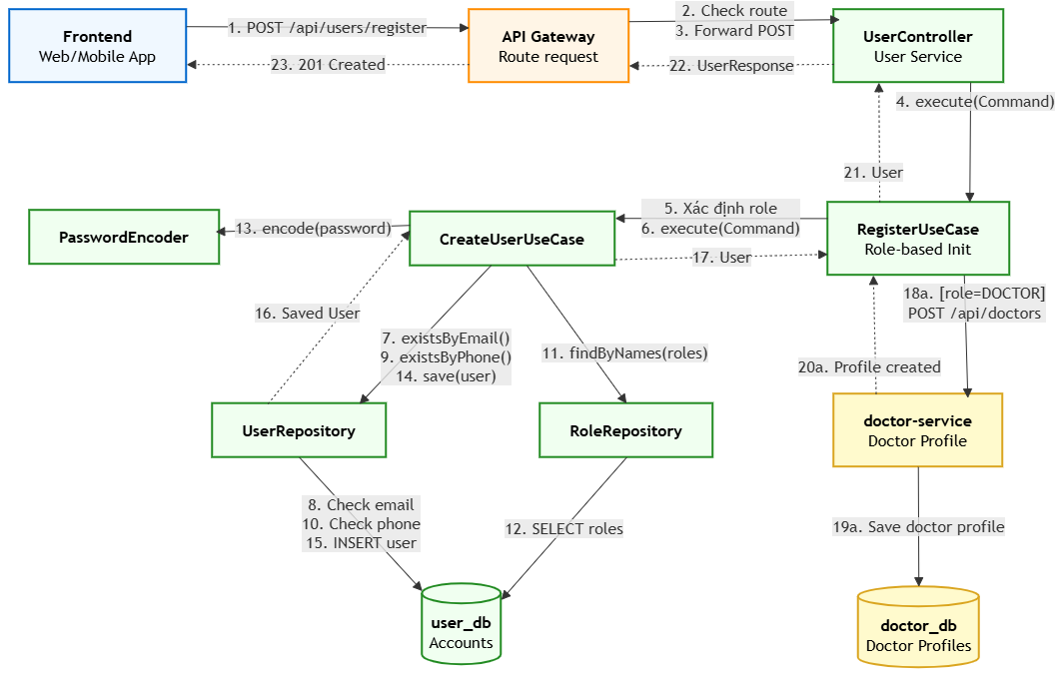

4.3.3. Create Appointment & Lock Slot (Booking)
Luồng đặt lịch khám & SAGA bù trừ: Bệnh nhân gửi yêu cầu đặt lịch tới POST /api/appointments. Appointment Service gọi OpenFeign sang Doctor Service để giữ chỗ (Book Slot). Sau đó, nó lưu lịch hẹn vào appointment_db ở trạng thái PENDING. Nếu việc lưu DB thất bại hoặc timeout, khối catch kích hoạt giao dịch bù trừ (Compensating Transaction) gọi cancelSlotBooking để nhả slot khám của bác sĩ ngay lập tức. Khi bác sĩ duyệt lịch (CONFIRMED), Appointment Service bắn sự kiện AppointmentConfirmedEvent vào RabbitMQ để Notification Service gửi SMS/Email.

4.3.4. Cancel Appointment & Send Notification (Event-Driven)
Luồng hủy lịch & thông báo bất đồng bộ: Khi lịch hẹn bị hủy (qua POST /api/appointments/{id}/cancel), Appointment Service phát sinh sự kiện AppointmentCanceledEvent lên RabbitMQ topic exchange (clinic.exchange). Notification Service lắng nghe hàng đợi và tự động gửi email thông báo hủy lịch cho bệnh nhân mà không gây nghẽn luồng xử lý chính.

5. References

