Ha Long Fish simulation
NGUYEN Vu Bao Hung

Introduction
In this report, I will describe the process of making the fish simulation in Ha Long area using visual work and occam code.

Quickmap and Pickcell
I used the tool quickmap and pickcell in Visualworks to generate a cell system.
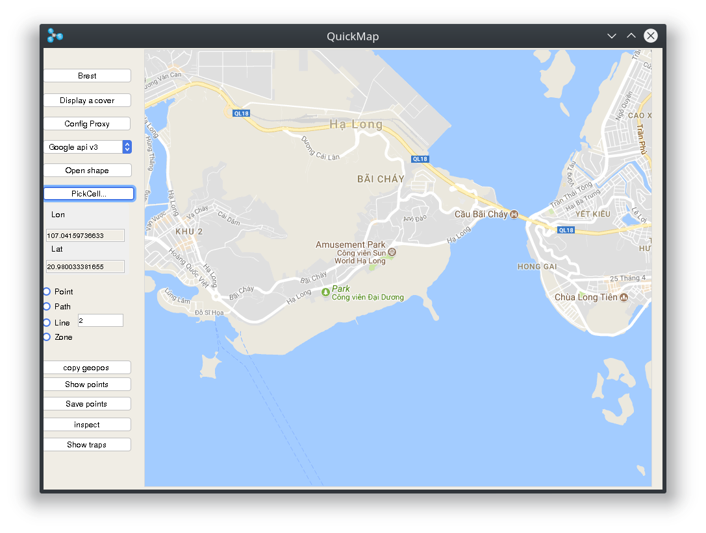
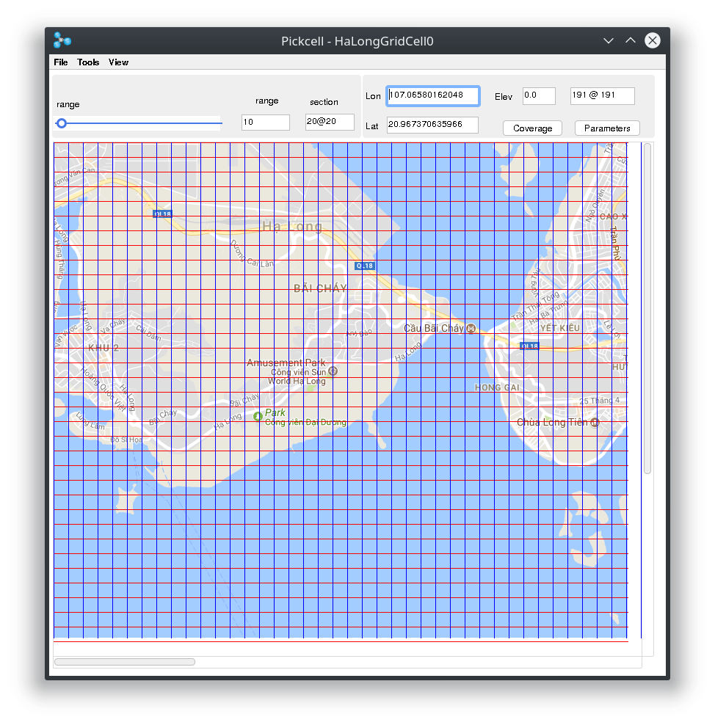
After that, I have the generated cell nodes and save it to occam code.

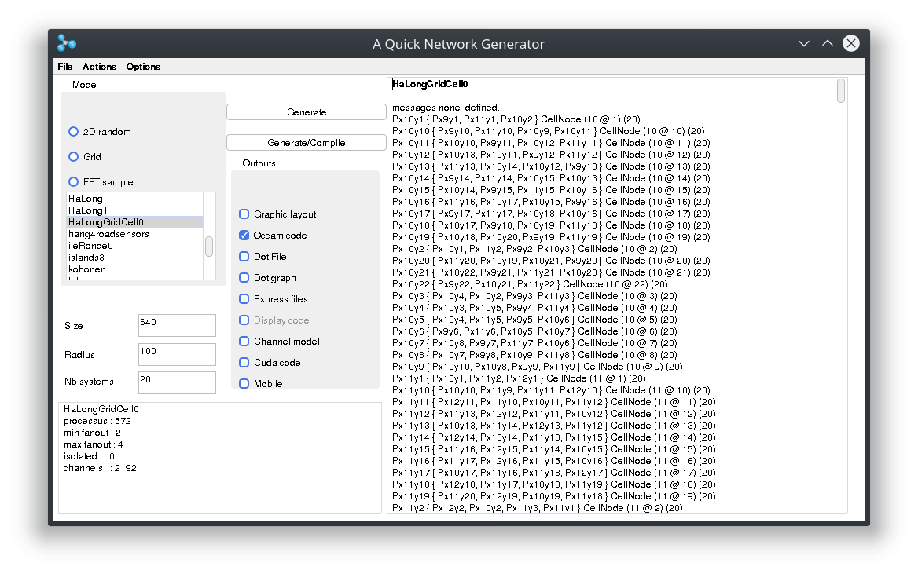
The moving fishes
The fishes suppose to move from one cell to another if the cells are water. The condition to determine that a cell is water is its elevation is less than 0.5.
The number of fishes in a cell is a random number from 0 to 10.
If elevation is greater than 0.5, the number of fish is 0.
The number of fishes that go out of a cell is randomized with a maximum of half the number of fishes in that cell over the number of possible neighbor cells that fishes could live.

The movie
To visualize the process of moving fishes, I have followed your tutorial and was able to make a short movie that shows the changes in each cells.
The elevation information may not be accurate enough since some land cell still contain fishes, but this is a small and acceptable error of input data.
The following shows a few first steps that was generated.
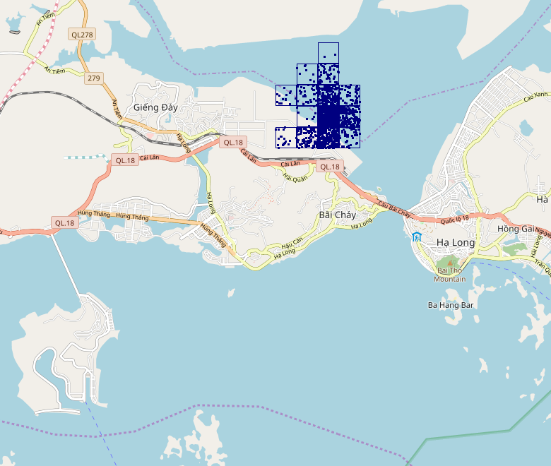
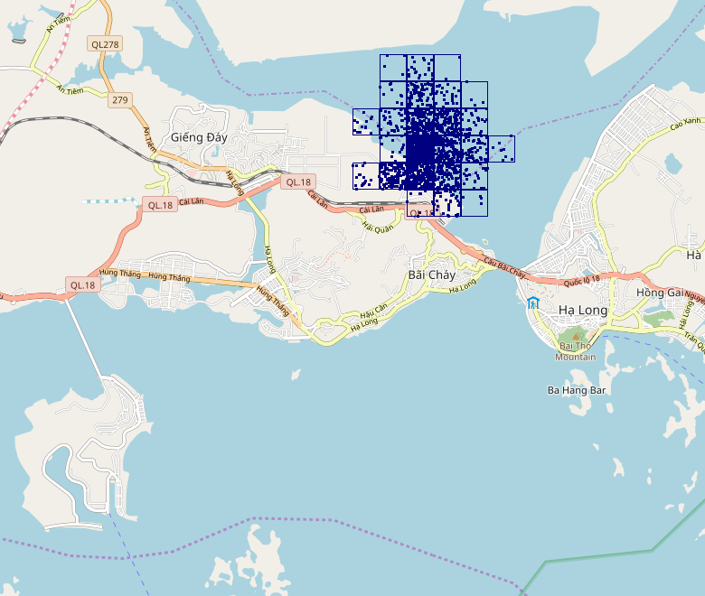
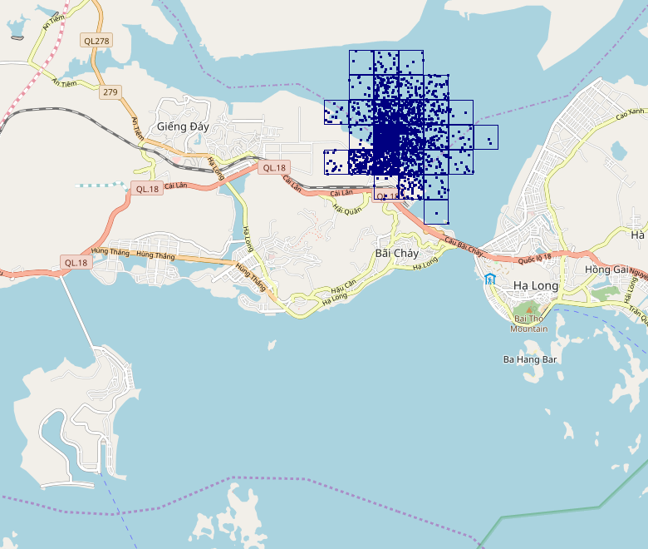

Remarks
Most of my codes for the course is uploaded to https://github.com/BaoHung/OccamCourse.
It includes the moving fishes sample, and the computation of bounding box and max elevation which were not mentioned in this report.

