Họ Tên: Nguyễn Hữu Bảo
MSSV: 1250080016
Lớp: 12_ĐH_CNPM1

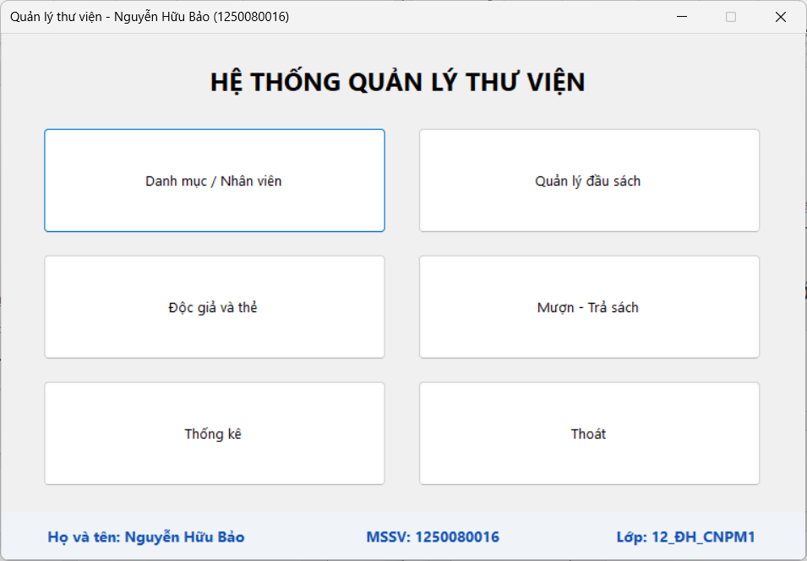
FrmMain.cs:
using System;
using System.Windows.Forms;
namespace QuanLyThuVien.Forms
{
public partial class FrmMain : Form
{
public FrmMain() { InitializeComponent(); }
private void btnDanhMuc_Click(object sender, EventArgs e) { using (FrmDanhMuc f = new FrmDanhMuc()) f.ShowDialog(this); }
private void btnSach_Click(object sender, EventArgs e) { using (FrmSach f = new FrmSach()) f.ShowDialog(this); }
private void btnDocGia_Click(object sender, EventArgs e) { using (FrmDocGia f = new FrmDocGia()) f.ShowDialog(this); }
private void btnMuonTra_Click(object sender, EventArgs e) { using (FrmMuonTra f = new FrmMuonTra()) f.ShowDialog(this); }
private void btnThongKe_Click(object sender, EventArgs e) { using (FrmThongKe f = new FrmThongKe()) f.ShowDialog(this); }
private void btnThoat_Click(object sender, EventArgs e)
{
if (MessageBox.Show("Bạn có thực sự muốn thoát chương trình?", "Xác nhận",
MessageBoxButtons.YesNo, MessageBoxIcon.Question) == DialogResult.Yes) Close();
}
}
}
Danh mục / Nhân viên
Nhân viên
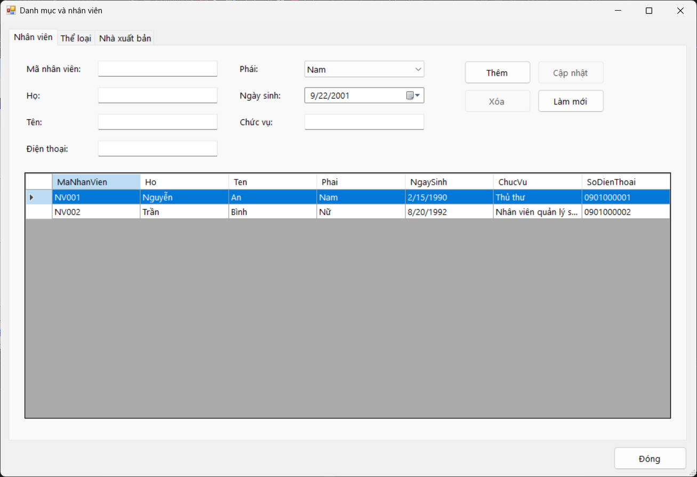

Thể loại
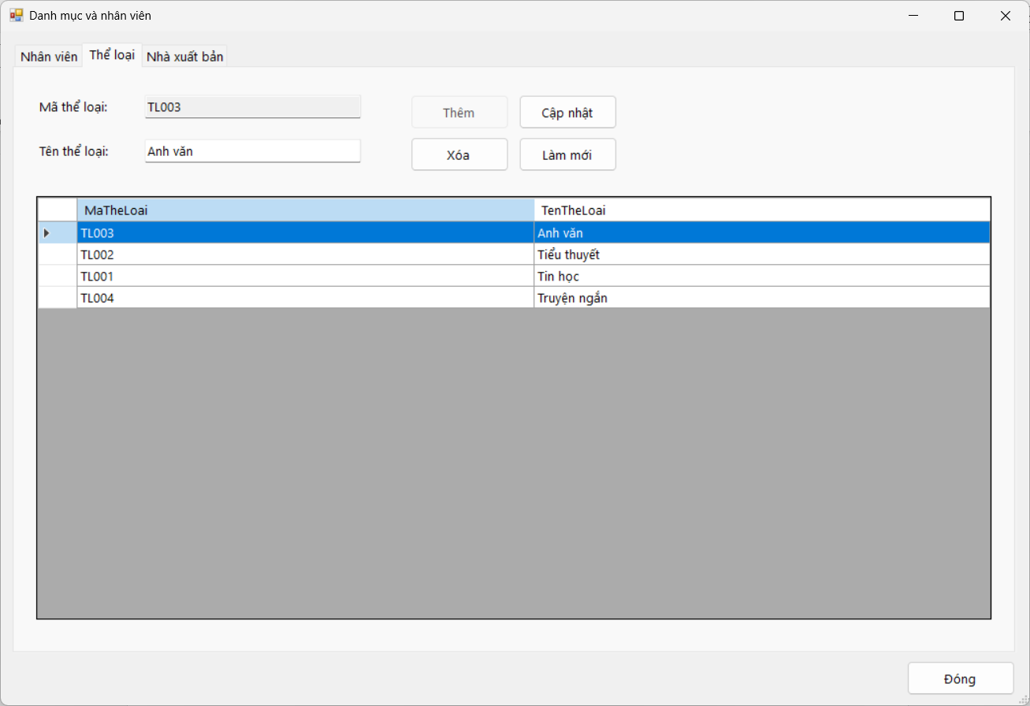

Nhà xuất bản
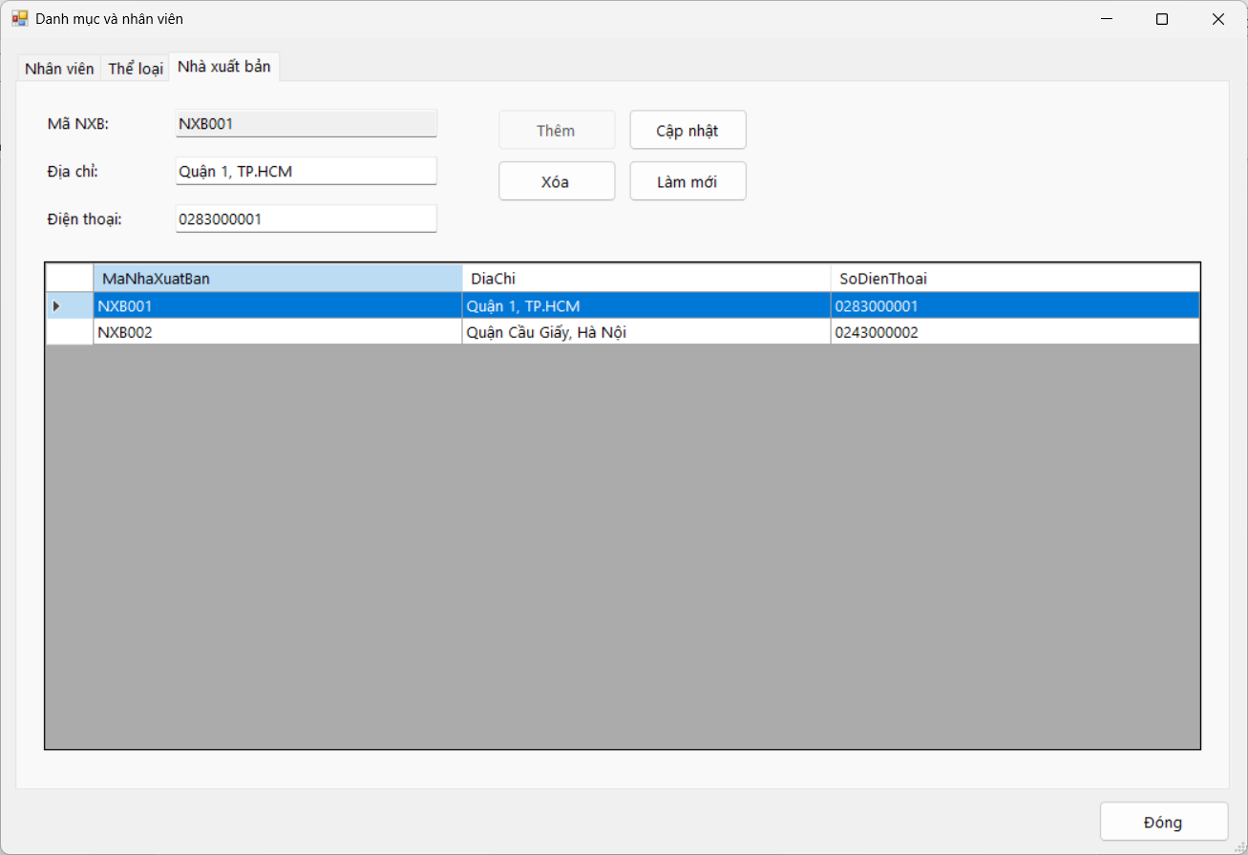

FrmDanhMuc.cs:
using System;
using System.Data;
using System.Windows.Forms;
using QuanLyThuVien.Services;
namespace QuanLyThuVien.Forms
{
public partial class FrmDanhMuc : Form
{
private readonly DanhMucService service = new DanhMucService();
public FrmDanhMuc() { InitializeComponent(); }
private void FrmDanhMuc_Load(object sender, EventArgs e)
{
cboNVPhai.Items.AddRange(new object[] { "Nam", "Nữ", "Khác" });
if (cboNVPhai.Items.Count > 0) cboNVPhai.SelectedIndex = 0;
TaiTatCa(); LamMoiNV(); LamMoiTL(); LamMoiNXB();
}
private void TaiTatCa()
{
dgvNV.DataSource = service.LayNhanVien(); dgvTL.DataSource = service.LayTheLoai(); dgvNXB.DataSource =
service.LayNhaXuatBan();
dgvNV.AutoSizeColumnsMode = DataGridViewAutoSizeColumnsMode.Fill; dgvTL.AutoSizeColumnsMode =
DataGridViewAutoSizeColumnsMode.Fill; dgvNXB.AutoSizeColumnsMode = DataGridViewAutoSizeColumnsMode.Fill;
}
private void ShowResult(KetQuaXuLy kq)
{
MessageBox.Show(kq.ThongBao, kq.ThanhCong ? "Thông báo" : "Lỗi", MessageBoxButtons.OK,
kq.ThanhCong ? MessageBoxIcon.Information : MessageBoxIcon.Warning);
if (kq.ThanhCong) TaiTatCa();
}
private void btnNVThem_Click(object sender, EventArgs e)
{
ShowResult(service.LuuNhanVien(new NhanVien
{
MaNhanVien = txtNVMa.Text.Trim(),
Ho = txtNVHo.Text.Trim(),
Ten = txtNVTen.Text.Trim(),
Phai = Convert.ToString(cboNVPhai.SelectedItem),
NgaySinh = dtNVNgaySinh.Value,
ChucVu = txtNVChucVu.Text.Trim(),
SoDienThoai = txtNVSDT.Text.Trim()
}, false));
}
private void btnNVCapNhat_Click(object sender, EventArgs e)
{
ShowResult(service.LuuNhanVien(new NhanVien
{
MaNhanVien = txtNVMa.Text.Trim(),
Ho = txtNVHo.Text.Trim(),
Ten = txtNVTen.Text.Trim(),
Phai = Convert.ToString(cboNVPhai.SelectedItem),
NgaySinh = dtNVNgaySinh.Value,
ChucVu = txtNVChucVu.Text.Trim(),
SoDienThoai = txtNVSDT.Text.Trim()
}, true));
}
private void btnNVXoa_Click(object sender, EventArgs e)
{
if (XacNhanXoa())
ShowResult(service.Xoa("NhanVien", "MaNhanVien", txtNVMa.Text.Trim()));
}
private void btnNVMoi_Click(object sender, EventArgs e) { LamMoiNV(); }
private void dgvNV_SelectionChanged(object sender, EventArgs e)
{
DataRowView r = dgvNV.CurrentRow == null ? null : dgvNV.CurrentRow.DataBoundItem as DataRowView; if (r == null) return;
txtNVMa.Text = Convert.ToString(r["MaNhanVien"]); txtNVHo.Text = Convert.ToString(r["Ho"]);
txtNVTen.Text = Convert.ToString(r["Ten"]); cboNVPhai.SelectedItem = Convert.ToString(r["Phai"]);
dtNVNgaySinh.Value = Convert.ToDateTime(r["NgaySinh"]); txtNVChucVu.Text = Convert.ToString(r["ChucVu"]);
txtNVSDT.Text = Convert.ToString(r["SoDienThoai"]); txtNVMa.ReadOnly = true; btnNVThem.Enabled = false; btnNVCapNhat.Enabled = true;
btnNVXoa.Enabled = true;
}
private void LamMoiNV()
{
txtNVMa.Clear(); txtNVHo.Clear(); txtNVTen.Clear(); txtNVChucVu.Clear(); txtNVSDT.Clear();
dtNVNgaySinh.Value = DateTime.Today.AddYears(-25); txtNVMa.ReadOnly = false; btnNVThem.Enabled = true; btnNVCapNhat.Enabled = false;
btnNVXoa.Enabled = false;
}
private void btnTLThem_Click(object sender, EventArgs e) { ShowResult(service.LuuTheLoai(txtTLMa.Text, txtTLTen.Text, false)); }
private void btnTLCapNhat_Click(object sender, EventArgs e) { ShowResult(service.LuuTheLoai(txtTLMa.Text, txtTLTen.Text, true)); }
private void btnTLXoa_Click(object sender, EventArgs e)
{
if (XacNhanXoa())
ShowResult(service.Xoa("TheLoai", "MaTheLoai", txtTLMa.Text.Trim()));
}
private void btnTLMoi_Click(object sender, EventArgs e) { LamMoiTL(); }
private void dgvTL_SelectionChanged(object sender, EventArgs e)
{
DataRowView
r = dgvTL.CurrentRow == null ? null : dgvTL.CurrentRow.DataBoundItem as DataRowView; if (r == null) return;
txtTLMa.Text = Convert.ToString(r["MaTheLoai"]); txtTLTen.Text = Convert.ToString(r["TenTheLoai"]); txtTLMa.ReadOnly = true;
btnTLThem.Enabled = false; btnTLCapNhat.Enabled = true; btnTLXoa.Enabled = true;
}
private void LamMoiTL()
{
txtTLMa.Clear(); txtTLTen.Clear(); txtTLMa.ReadOnly = false; btnTLThem.Enabled = true;
btnTLCapNhat.Enabled = false; btnTLXoa.Enabled = false;
}
private void btnNXBThem_Click(object sender, EventArgs e)
{
ShowResult(service.LuuNhaXuatBan(txtNXBMa.Text, txtNXBDiaChi.Text, txtNXBSDT.Text, false));
}
private void btnNXBCapNhat_Click(object sender, EventArgs e)
{
ShowResult(service.LuuNhaXuatBan(txtNXBMa.Text, txtNXBDiaChi.Text, txtNXBSDT.Text, true));
}
private void btnNXBXoa_Click(object sender, EventArgs e)
{
if (XacNhanXoa())
ShowResult(service.Xoa("NhaXuatBan", "MaNhaXuatBan", txtNXBMa.Text.Trim()));
}
private void btnNXBMoi_Click(object sender, EventArgs e) { LamMoiNXB(); }
private void dgvNXB_SelectionChanged(object sender, EventArgs e)
{
DataRowView
r = dgvNXB.CurrentRow == null ? null : dgvNXB.CurrentRow.DataBoundItem as DataRowView; if (r == null) return;
txtNXBMa.Text = Convert.ToString(r["MaNhaXuatBan"]); txtNXBDiaChi.Text = Convert.ToString(r["DiaChi"]);
txtNXBSDT.Text = Convert.ToString(r["SoDienThoai"]); txtNXBMa.ReadOnly = true; btnNXBThem.Enabled = false;
btnNXBCapNhat.Enabled = true; btnNXBXoa.Enabled = true;
}
private void LamMoiNXB()
{
txtNXBMa.Clear(); txtNXBDiaChi.Clear(); txtNXBSDT.Clear(); txtNXBMa.ReadOnly = false;
btnNXBThem.Enabled = true; btnNXBCapNhat.Enabled = false; btnNXBXoa.Enabled = false;
}
private bool XacNhanXoa()
{
return MessageBox.Show("Xóa dữ liệu đang chọn?", "Xác nhận", MessageBoxButtons.YesNo,
MessageBoxIcon.Question) == DialogResult.Yes;
}
private void btnDong_Click(object sender, EventArgs e) { Close(); }
}
}
Quản lý đầu sách
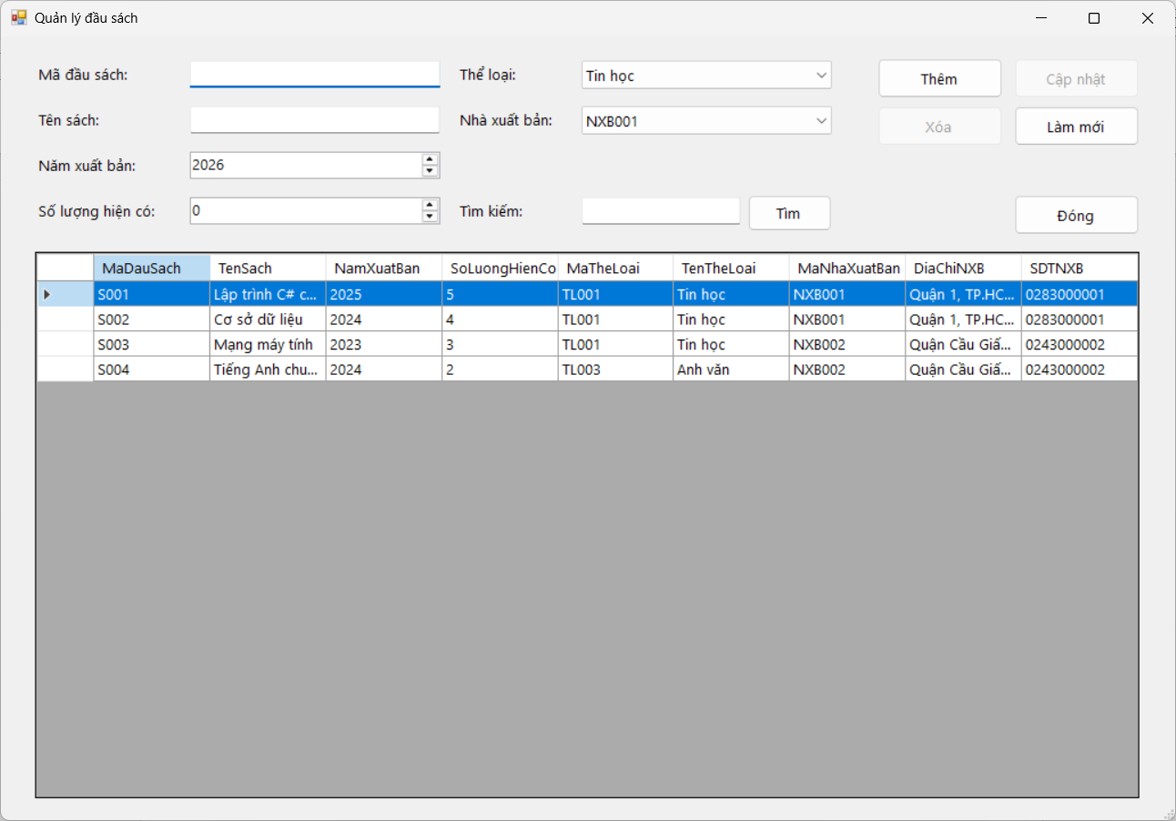
FrmSach.cs:
using System;
using System.Data;
using System.Windows.Forms;
using QuanLyThuVien.Services;
namespace QuanLyThuVien.Forms
{
public partial class FrmSach : Form
{
private readonly SachService service = new SachService();
private readonly DanhMucService danhMuc = new DanhMucService();
public FrmSach() { InitializeComponent(); }
private void FrmSach_Load(object sender, EventArgs e)
{
cboTheLoai.DataSource = danhMuc.LayTheLoai(); cboTheLoai.DisplayMember = "TenTheLoai"; cboTheLoai.ValueMember =
"MaTheLoai";
cboNXB.DataSource = danhMuc.LayNhaXuatBan(); cboNXB.DisplayMember = "MaNhaXuatBan"; cboNXB.ValueMember =
"MaNhaXuatBan";
TaiDuLieu(); LamMoi();
}
private void TaiDuLieu()
{
dgvSach.DataSource = service.LayDanhSach(txtTim.Text.Trim());
dgvSach.AutoSizeColumnsMode = DataGridViewAutoSizeColumnsMode.Fill;
}
private DauSach LayDuLieuForm()
{
return new DauSach
{
MaDauSach = txtMa.Text.Trim(),
TenSach = txtTen.Text.Trim(),
NamXuatBan = (int)numNam.Value,
SoLuongHienCo = (int)numSoLuong.Value,
MaTheLoai = cboTheLoai.SelectedValue == null ? "" : cboTheLoai.SelectedValue.ToString(),
MaNhaXuatBan = cboNXB.SelectedValue == null ? "" : cboNXB.SelectedValue.ToString()
};
}
private void HienKetQua(KetQuaXuLy kq)
{
MessageBox.Show(kq.ThongBao, kq.ThanhCong ? "Thông báo" : "Lỗi",
MessageBoxButtons.OK, kq.ThanhCong ? MessageBoxIcon.Information : MessageBoxIcon.Warning);
if (kq.ThanhCong) { TaiDuLieu(); LamMoi(); }
}
private void btnThem_Click(object sender, EventArgs e) { HienKetQua(service.Luu(LayDuLieuForm(), false)); }
private void btnCapNhat_Click(object sender, EventArgs e) { HienKetQua(service.Luu(LayDuLieuForm(), true)); }
private void btnXoa_Click(object sender, EventArgs e)
{
if (string.IsNullOrWhiteSpace(txtMa.Text)) return;
if (MessageBox.Show("Xóa đầu sách đang chọn?", "Xác nhận", MessageBoxButtons.YesNo, MessageBoxIcon.Question) ==
DialogResult.Yes)
HienKetQua(service.Xoa(txtMa.Text.Trim()));
}
private void btnLamMoi_Click(object sender, EventArgs e) { LamMoi(); }
private void btnTim_Click(object sender, EventArgs e) { TaiDuLieu(); }
private void btnDong_Click(object sender, EventArgs e) { Close(); }
private void LamMoi()
{
txtMa.Clear(); txtTen.Clear(); numNam.Value = DateTime.Today.Year; numSoLuong.Value = 0;
txtMa.ReadOnly = false; txtMa.Focus(); btnThem.Enabled = true; btnCapNhat.Enabled = false; btnXoa.Enabled = false;
}
private void dgvSach_SelectionChanged(object sender, EventArgs e)
{
if (dgvSach.CurrentRow == null || dgvSach.CurrentRow.DataBoundItem == null) return;
DataRowView r = dgvSach.CurrentRow.DataBoundItem as DataRowView; if (r == null) return;
txtMa.Text = Convert.ToString(r["MaDauSach"]); txtTen.Text = Convert.ToString(r["TenSach"]);
numNam.Value = Convert.ToDecimal(r["NamXuatBan"]); numSoLuong.Value = Convert.ToDecimal(r["SoLuongHienCo"]);
cboTheLoai.SelectedValue = Convert.ToString(r["MaTheLoai"]); cboNXB.SelectedValue = Convert.ToString(r["MaNhaXuatBan"]);
txtMa.ReadOnly = true; btnThem.Enabled = false; btnCapNhat.Enabled = true; btnXoa.Enabled = true;
}
}
}
Độc giả và thẻ thư viện
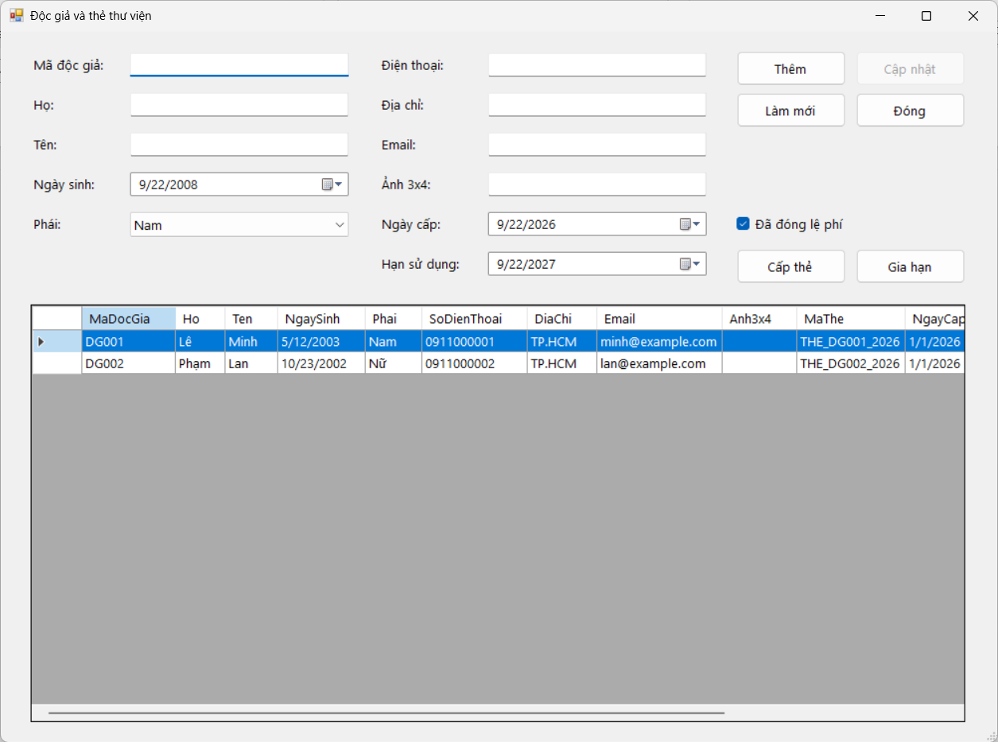
FrmDocGia.cs:
using System;
using System.Data;
using System.Windows.Forms;
using QuanLyThuVien.Services;
namespace QuanLyThuVien.Forms
{
public partial class FrmDocGia : Form
{
private readonly DocGiaService service = new DocGiaService();
public FrmDocGia() { InitializeComponent(); }
private void FrmDocGia_Load(object sender, EventArgs e)
{
cboPhai.Items.AddRange(new object[] { "Nam", "Nữ", "Khác" });
if (cboPhai.Items.Count > 0) cboPhai.SelectedIndex = 0;
dtNgayCap.Value = DateTime.Today; dtHan.Value = DateTime.Today.AddYears(1);
TaiDuLieu(); LamMoi();
}
private void TaiDuLieu()
{
dgvDocGia.DataSource = service.LayDanhSach();
dgvDocGia.AutoSizeColumnsMode = DataGridViewAutoSizeColumnsMode.DisplayedCells;
}
private DocGia LayForm()
{
return new DocGia
{
MaDocGia = txtMa.Text.Trim(),
Ho = txtHo.Text.Trim(),
Ten = txtTen.Text.Trim(),
NgaySinh = dtNgaySinh.Value.Date,
Phai = Convert.ToString(cboPhai.SelectedItem),
SoDienThoai = txtSDT.Text.Trim(),
DiaChi = txtDiaChi.Text.Trim(),
Email = txtEmail.Text.Trim(),
Anh3x4 = txtAnh.Text.Trim()
};
}
private void ShowResult(KetQuaXuLy kq)
{
MessageBox.Show(kq.ThongBao, kq.ThanhCong ? "Thông báo" : "Lỗi",
MessageBoxButtons.OK, kq.ThanhCong ? MessageBoxIcon.Information : MessageBoxIcon.Warning);
if (kq.ThanhCong) { TaiDuLieu(); LamMoi(); }
}
private void btnThem_Click(object sender, EventArgs e) { ShowResult(service.Luu(LayForm(), false)); }
private void btnCapNhat_Click(object sender, EventArgs e) { ShowResult(service.Luu(LayForm(), true)); }
private void btnCapThe_Click(object sender, EventArgs e)
{
if (string.IsNullOrWhiteSpace(txtMa.Text)) { MessageBox.Show("Vui lòng chọn độc giả."); return; }
ShowResult(service.CapThe(txtMa.Text.Trim(), dtNgayCap.Value, dtHan.Value, chkLePhi.Checked));
}
private void btnGiaHan_Click(object sender, EventArgs e)
{
if (string.IsNullOrWhiteSpace(txtMa.Text)) { MessageBox.Show("Vui lòng chọn độc giả."); return; }
ShowResult(service.GiaHanThe(txtMa.Text.Trim(), dtHan.Value, chkLePhi.Checked));
}
private void btnLamMoi_Click(object sender, EventArgs e) { LamMoi(); }
private void btnDong_Click(object sender, EventArgs e) { Close(); }
private void LamMoi()
{
txtMa.Clear(); txtHo.Clear(); txtTen.Clear(); txtSDT.Clear(); txtDiaChi.Clear(); txtEmail.Clear(); txtAnh.Clear();
dtNgaySinh.Value = DateTime.Today.AddYears(-18); dtNgayCap.Value = DateTime.Today; dtHan.Value =
DateTime.Today.AddYears(1); chkLePhi.Checked = true;
txtMa.ReadOnly = false; btnThem.Enabled = true; btnCapNhat.Enabled = false; txtMa.Focus();
}
private void dgvDocGia_SelectionChanged(object sender, EventArgs e)
{
if (dgvDocGia.CurrentRow == null || dgvDocGia.CurrentRow.DataBoundItem == null) return;
DataRowView r = dgvDocGia.CurrentRow.DataBoundItem as DataRowView; if (r == null) return;
txtMa.Text = Convert.ToString(r["MaDocGia"]); txtHo.Text = Convert.ToString(r["Ho"]); txtTen.Text = Convert.ToString(r["Ten"]);
if (r["NgaySinh"] != DBNull.Value) dtNgaySinh.Value = Convert.ToDateTime(r["NgaySinh"]);
cboPhai.SelectedItem = Convert.ToString(r["Phai"]); txtSDT.Text = Convert.ToString(r["SoDienThoai"]); txtDiaChi.Text =
Convert.ToString(r["DiaChi"]);
txtEmail.Text = Convert.ToString(r["Email"]); txtAnh.Text = Convert.ToString(r["Anh3x4"]);
if (r["NgayCap"] != DBNull.Value) dtNgayCap.Value = Convert.ToDateTime(r["NgayCap"]);
if (r["HanSuDung"] != DBNull.Value) dtHan.Value = Convert.ToDateTime(r["HanSuDung"]);
chkLePhi.Checked = r["DaDongLePhi"] != DBNull.Value && Convert.ToBoolean(r["DaDongLePhi"]);
txtMa.ReadOnly = true; btnThem.Enabled = false; btnCapNhat.Enabled = true;
}
}
}
Mượn - Trả sách
Mượn sách
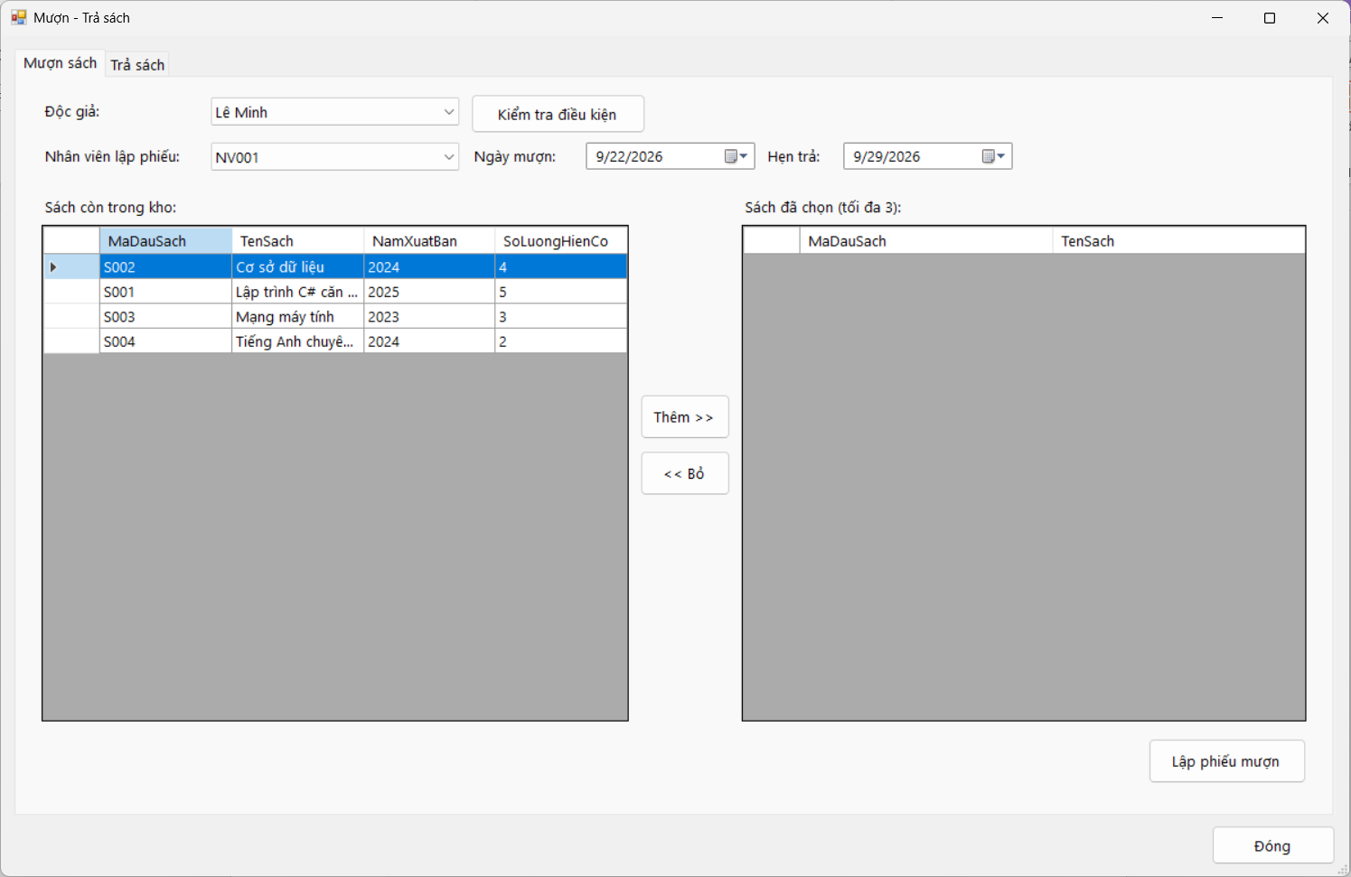

Trả sách
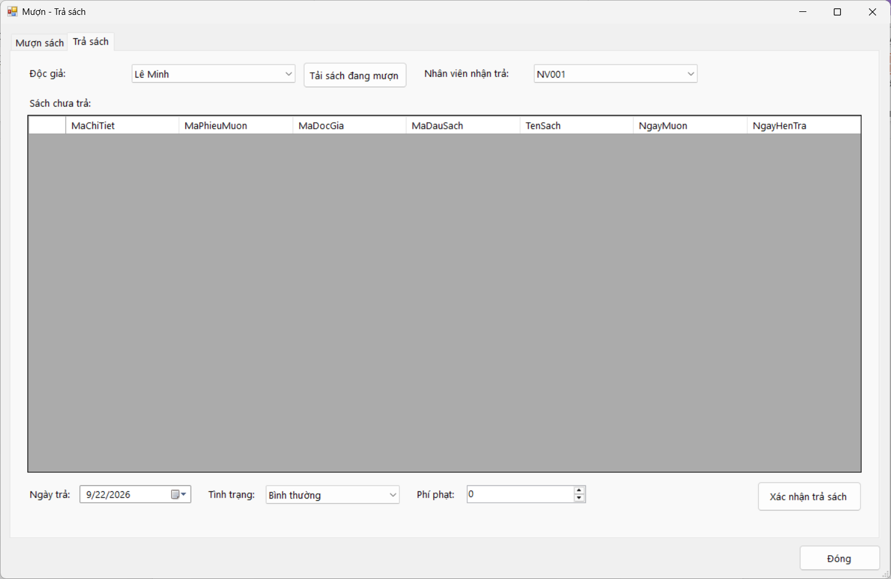
FrmMuonTra.cs:
using System;
using System.Collections.Generic;
using System.Data;
using System.Windows.Forms;
using QuanLyThuVien.Services;
namespace QuanLyThuVien.Forms
{
public partial class FrmMuonTra : Form
{
private readonly MuonTraService service = new MuonTraService();
private readonly SachService sachService = new SachService();
private readonly DocGiaService docGiaService = new DocGiaService();
private readonly DanhMucService danhMuc = new DanhMucService();
private DataTable selectedBooks;
public FrmMuonTra() { InitializeComponent(); }
private void FrmMuonTra_Load(object sender, EventArgs e)
{
DataTable readers = docGiaService.LayComboDocGia();
cboDocGia.DataSource = readers.Copy(); cboDocGia.DisplayMember = "HoTen"; cboDocGia.ValueMember = "MaDocGia";
cboDocGiaTra.DataSource = readers.Copy(); cboDocGiaTra.DisplayMember = "HoTen"; cboDocGiaTra.ValueMember =
"MaDocGia";
DataTable staff = danhMuc.LayNhanVien();
cboNhanVienMuon.DataSource = staff.Copy(); cboNhanVienMuon.DisplayMember = "MaNhanVien";
cboNhanVienMuon.ValueMember = "MaNhanVien";
cboNhanVienTra.DataSource = staff.Copy(); cboNhanVienTra.DisplayMember = "MaNhanVien"; cboNhanVienTra.ValueMember =
"MaNhanVien";
cboTinhTrang.Items.AddRange(new object[] { "Bình thường", "Rách/Hư hỏng", "Mất" }); cboTinhTrang.SelectedIndex = 0;
dtNgayMuon.Value = DateTime.Today; dtHenTra.Value = DateTime.Today.AddDays(7); dtNgayTra.Value = DateTime.Today;
TaoBangChon(); TaiSachCon(); TaiSachDangMuon();
}
private void TaoBangChon()
{
selectedBooks = new DataTable(); selectedBooks.Columns.Add("MaDauSach", typeof(string));
selectedBooks.Columns.Add("TenSach", typeof(string));
dgvSachChon.DataSource = selectedBooks; dgvSachChon.AutoSizeColumnsMode = DataGridViewAutoSizeColumnsMode.Fill;
}
private string MaDocGiaMuon { get { return cboDocGia.SelectedValue == null ? "" : cboDocGia.SelectedValue.ToString(); } }
private string MaDocGiaTra { get { return cboDocGiaTra.SelectedValue == null ? "" : cboDocGiaTra.SelectedValue.ToString(); } }
private string MaNhanVienMuon
{
get
{
return cboNhanVienMuon.SelectedValue == null ? "" :
cboNhanVienMuon.SelectedValue.ToString();
}
}
private string MaNhanVienTra
{
get
{
return cboNhanVienTra.SelectedValue == null ? "" : cboNhanVienTra.SelectedValue.ToString();
}
}
private void TaiSachCon()
{
dgvSachCon.DataSource = sachService.LaySachConTrongKho(); dgvSachCon.AutoSizeColumnsMode =
DataGridViewAutoSizeColumnsMode.Fill;
}
private void btnKiemTra_Click(object sender, EventArgs e)
{
KetQuaXuLy kq = service.KiemTraDieuKienMuon(MaDocGiaMuon, Math.Max(1, selectedBooks.Rows.Count));
lblTrangThai.Text = kq.ThongBao; lblTrangThai.ForeColor = kq.ThanhCong ? System.Drawing.Color.DarkGreen :
System.Drawing.Color.DarkRed;
}
private void btnThemSach_Click(object sender, EventArgs e)
{
if (dgvSachCon.CurrentRow == null || dgvSachCon.CurrentRow.DataBoundItem == null) return;
if (selectedBooks.Rows.Count >= 3) { MessageBox.Show("Chỉ được chọn tối đa 3 đầu sách khác nhau."); return; }
DataRowView r = dgvSachCon.CurrentRow.DataBoundItem as DataRowView; if (r == null) return;
string ma = Convert.ToString(r["MaDauSach"]);
foreach (DataRow row in selectedBooks.Rows) if (string.Equals(Convert.ToString(row["MaDauSach"]), ma,
StringComparison.OrdinalIgnoreCase)) { MessageBox.Show("Đầu sách này đã có trong danh sách mượn."); return; }
selectedBooks.Rows.Add(ma, Convert.ToString(r["TenSach"]));
}
private void btnBoSach_Click(object sender, EventArgs e)
{
if (dgvSachChon.CurrentRow != null && dgvSachChon.CurrentRow.DataBoundItem != null)
{
DataRowView r = dgvSachChon.CurrentRow.DataBoundItem as DataRowView; if (r != null) r.Row.Delete();
}
}
private void btnLapPhieu_Click(object sender, EventArgs e)
{
List<string> ds = new List<string>(); foreach (DataRow r in selectedBooks.Rows) if (r.RowState != DataRowState.Deleted)
ds.Add(Convert.ToString(r["MaDauSach"]));
KetQuaXuLy kq = service.LapPhieuMuon(MaDocGiaMuon, MaNhanVienMuon, ds, dtNgayMuon.Value, dtHenTra.Value);
MessageBox.Show(kq.ThongBao, kq.ThanhCong ? "Thông báo" : "Lỗi", MessageBoxButtons.OK, kq.ThanhCong ?
MessageBoxIcon.Information : MessageBoxIcon.Warning);
if (kq.ThanhCong) { selectedBooks.Rows.Clear(); TaiSachCon(); TaiSachDangMuon(); lblTrangThai.Text = ""; }
}
private void TaiSachDangMuon()
{
if (string.IsNullOrWhiteSpace(MaDocGiaTra)) return;
dgvDangMuon.DataSource = service.LaySachDangMuon(MaDocGiaTra); dgvDangMuon.AutoSizeColumnsMode =
DataGridViewAutoSizeColumnsMode.Fill;
}
private void btnTaiSachMuon_Click(object sender, EventArgs e) { TaiSachDangMuon(); }
private void cboDocGiaTra_SelectedIndexChanged(object sender, EventArgs e) { TaiSachDangMuon(); }
private void btnTraSach_Click(object sender, EventArgs e)
{
if (dgvDangMuon.CurrentRow == null || dgvDangMuon.CurrentRow.DataBoundItem == null)
{
MessageBox.Show("Vui lòng chọn sách cần trả."); return; }
DataRowView r = dgvDangMuon.CurrentRow.DataBoundItem as DataRowView; if (r == null) return;
string maCT = Convert.ToString(r["MaChiTiet"]);
KetQuaXuLy kq = service.TraSach(maCT, MaNhanVienTra, dtNgayTra.Value, Convert.ToString(cboTinhTrang.SelectedItem),
numPhiPhat.Value);
MessageBox.Show(kq.ThongBao, kq.ThanhCong ? "Thông báo" : "Lỗi", MessageBoxButtons.OK, kq.ThanhCong ?
MessageBoxIcon.Information : MessageBoxIcon.Warning);
if (kq.ThanhCong) { TaiSachDangMuon(); TaiSachCon(); numPhiPhat.Value = 0; cboTinhTrang.SelectedIndex = 0; }
}
private void btnDong_Click(object sender, EventArgs e) { Close(); }
}
}
Thống kê
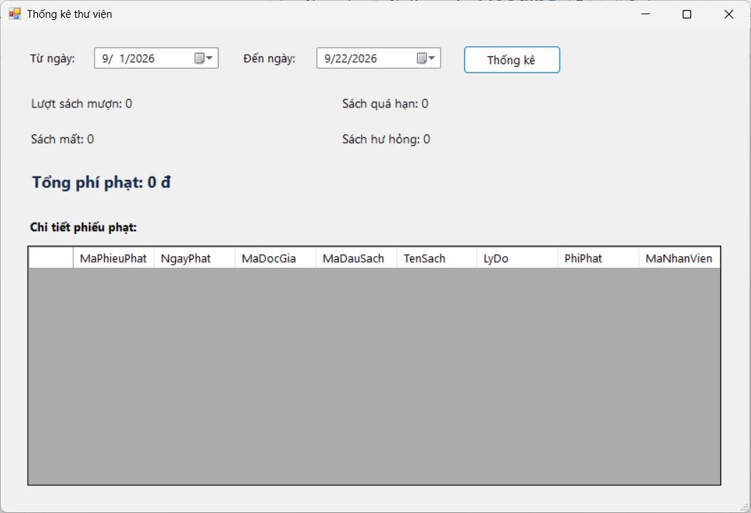
FrmThongKe.cs:
using System;
using System.Windows.Forms;
using QuanLyThuVien.Services;
namespace QuanLyThuVien.Forms
{
public partial class FrmThongKe : Form
{
private readonly ThongKeService service = new ThongKeService();
public FrmThongKe() { InitializeComponent(); }
private void FrmThongKe_Load(object sender, EventArgs e)
{
dtTu.Value = new DateTime(DateTime.Today.Year, DateTime.Today.Month, 1);
dtDen.Value = DateTime.Today;
TaiDuLieu();
}
private void TaiDuLieu()
{
ThongKeTongHop t = service.LayTongHop(dtTu.Value, dtDen.Value);
lblMuon.Text = "Lượt sách mượn: " + t.LuotSachMuon;
lblQuaHan.Text = "Sách quá hạn: " + t.SachQuaHan;
lblMat.Text = "Sách mất: " + t.SachMat;
lblHuHong.Text = "Sách hư hỏng: " + t.SachHuHong;
lblPhiPhat.Text = "Tổng phí phạt: " + t.TongPhiPhat.ToString("N0") + " đ";
dgvPhat.DataSource = service.LayChiTietPhat(dtTu.Value, dtDen.Value);
dgvPhat.AutoSizeColumnsMode = DataGridViewAutoSizeColumnsMode.Fill;
}
private void btnThongKe_Click(object sender, EventArgs e) { TaiDuLieu(); }
private void btnDong_Click(object sender, EventArgs e) { Close(); }
}
}

