### Assignment 1.5: Managing Sales Team for Highland Coffee in Odoo 18

#### Objective:

To understand and practice managing a sales team in Odoo 18, focusing on creating and organizing a sales structure for Highland Coffee. This includes setting up sales teams, assigning members, and tracking sales activities.

#### Scenario:

Highland Coffee is expanding its sales operations in Vietnam and needs to organize its sales team efficiently. Your task is to set up and manage the sales teams in Odoo 18.

#### Additional Questions:

1. How can setting sales targets in Odoo 17 help in managing team performance?
2. What are the benefits of using the "Leads" and "Opportunities" features for a sales team?

**Ref:**  
[Cách sử dụng phần mềm bán hàng (erpviet.vn)](https://erpviet.vn/ung-dung-quan-ly-ban-hang/)

##### 1. **Access the Sales Module:**

* Log in to Odoo 18.
* Navigate to the "Sales" module from the dashboard.

##### 2. **Create Sales Teams:**

* Create the following sales teams:
  1. **Ho Chi Minh Sales Team**
  2. **Hanoi Sales Team**

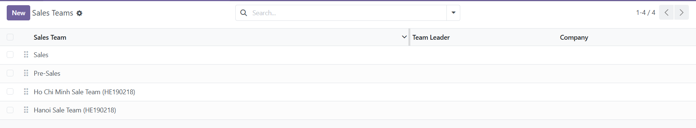

##### 3. **Add Team Members:**

##### Go to: **Sales > Configuration > Sales Teams > [Team Name] > Members**

##### **Ho Chi Minh Sales Team:**

##### Nguyen Van A – Sales Manager – nguyenvana@highlandcoffee.vn

##### Tran Thi B – Sales Representative – [tranthib@highlandcoffee.vn](mailto:tranthib@highlandcoffee.vn)

* 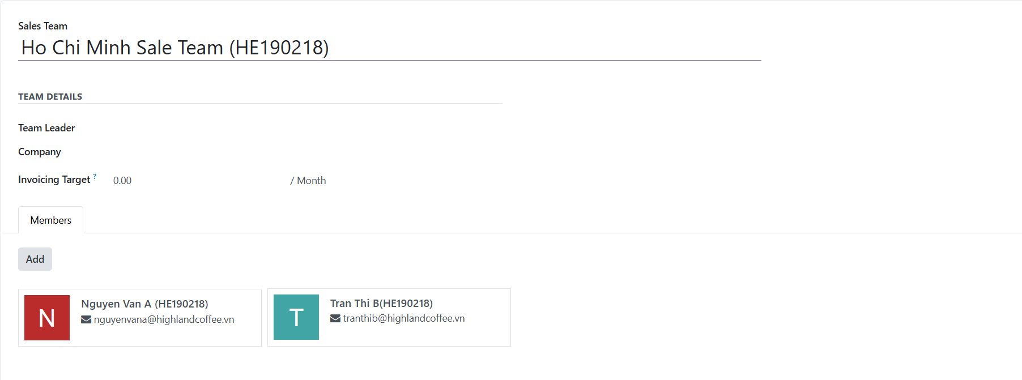

##### **Hanoi Sales Team:**

##### Pham Minh C – Sales Manager – phamminhc@highlandcoffee.vn

##### Le Thi D – Sales Representative – lethid@highlandcoffee.vn

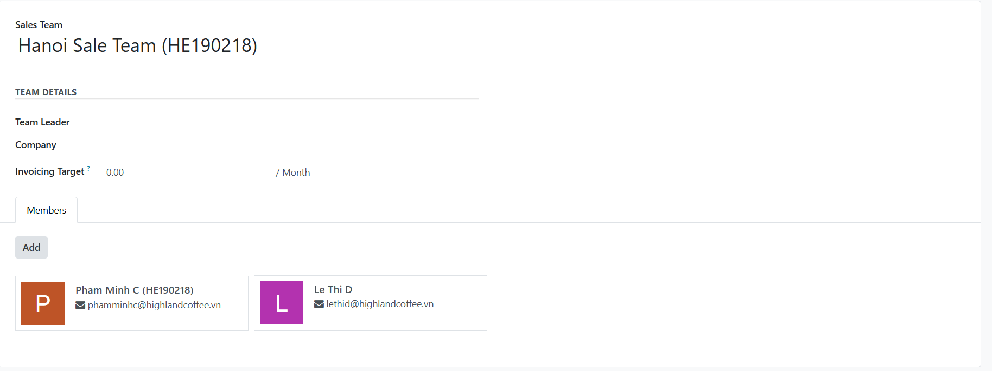

##### *Create user accounts in Settings if not already available.*

##### 4. **Set Sales Targets:**

##### Set monthly sales targets for each team:

##### **Ho Chi Minh Sales Team:** VND 500,000,000

* 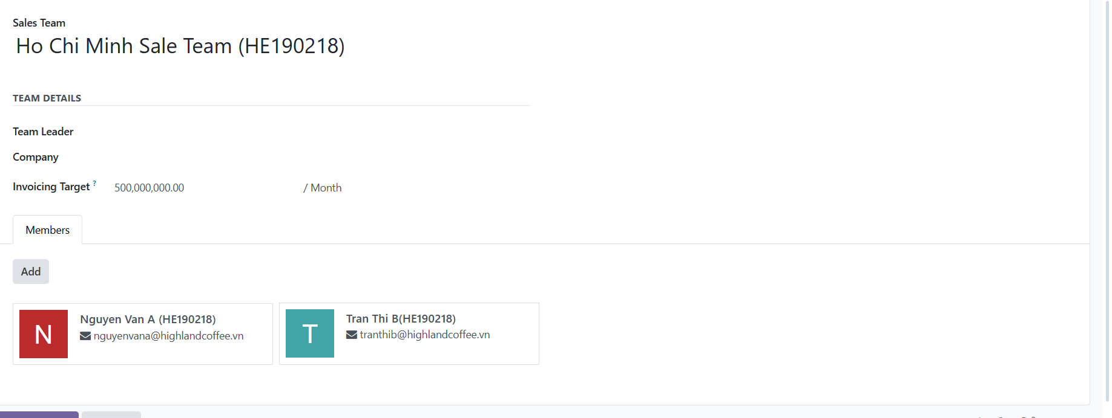

##### **Hanoi Sales Team:** VND 400,000,000

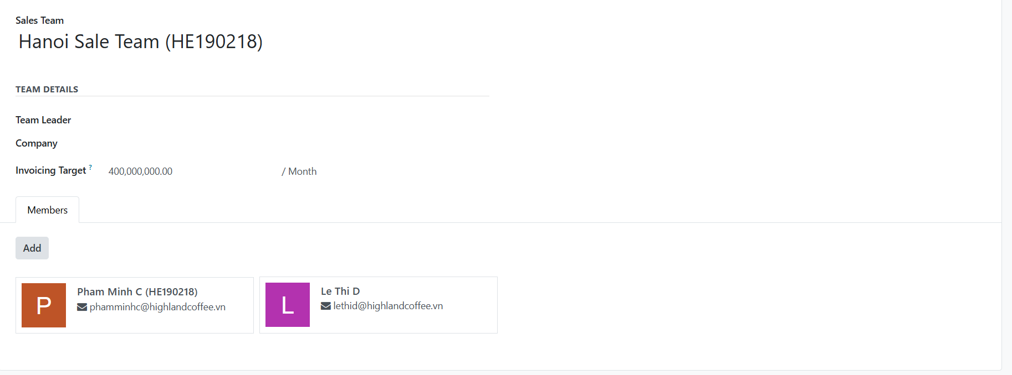

##### Navigate each sales team’s settings to input these targets.

##### 5. **Configure Team Communication:**

##### Enable:

##### Email aliases

##### Lead assignment alerts

##### Opportunity stage changes

##### This ensures internal communication and follow-ups are smooth.

##### 6. **Assign Leads to Teams:**

* Create the following leads and assign them to the respective teams:
  1. **Lead 1:** "New Corporate Client - Saigon Corp"
     + Assigned to: Ho Chi Minh Sales Team
     + Expected Revenue: VND 100,000,000
  2. **Lead 2:** "Potential Customer - Nguyen Trading"
     + Assigned to: Hanoi Sales Team
     + Expected Revenue: VND 50,000,000
* Fill in the lead details including expected revenue and source.

##### 7. **Track Sales Activities:**

* Schedule the following activities for each lead:
  + **Lead 1:**
    - Activity: "Call for Initial Discussion"
    - Deadline: In 2 days
    - Assigned to: Nguyen Van A

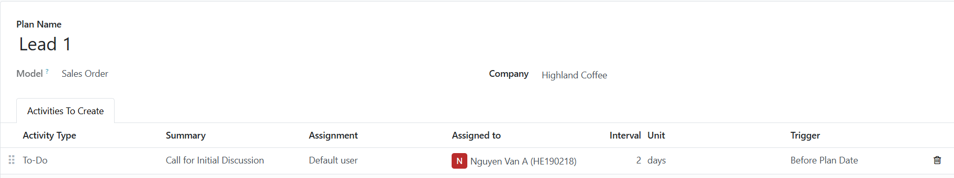

* + **Lead 2:**
    - Activity: "Send Quotation"
    - Deadline: In 3 days
    - Assigned to: Pham Minh C

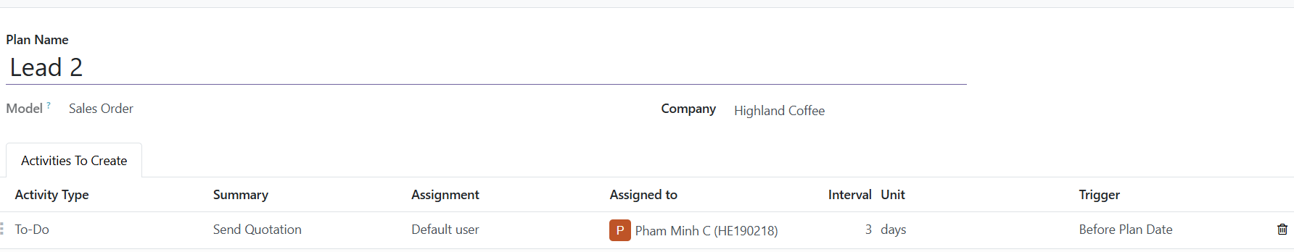

* Record these activities in the system and assign them to the appropriate team members.

##### 8. **Monitor Team Performance:**

* View the sales dashboard to monitor each team's performance.
* Take a screenshot of the dashboard showing the teams and their targets.
* 