**Odoo 18 CRM Assignment for Highland Coffee Chain**

**Objective:**

This assignment aims to help students practice managing the CRM module in Odoo 18 by simulating customer relationship management for the Highland Coffee chain.

**Scenario:**

You have been appointed as the CRM Manager for Highland Coffee, a growing chain of coffee shops in Vietnam. Your responsibilities include tracking customer leads, managing opportunities, and improving the overall sales process. Your task is to set up and manage the CRM system to ensure smooth operations.

**Deliverables:**

* **Pipeline Setup:** Screenshot of the customized pipeline stages.
* **Lead Management:** Screenshot of each step and Screenshot of CSV file of the leads.
* **Opportunity Tracking:** Screenshot of a report showing the movement of an opportunity through the pipeline.
* **CRM Analysis:** Screenshot of Pipeline performance report filtered by sales teams.

**Evaluation Criteria:**

* Correct setup of the CRM module and pipeline stages.
* Accurate data input for leads and opportunities.
* Proper usage of activities and stage movements.
* Quality of reports generated from the CRM system.
* Student ID, Student information inputted suitable in the function

This assignment should help students understand the CRM workflows in Odoo 17 Community Edition and practice managing a real-world scenario for Highland Coffee.

**Assignment Steps:**

**Step 1: Set Up the CRM Module**

1. **Activate the CRM Module:**
   * Log in to your Odoo 17 Community Edition instance.
   * Navigate to **Apps**.
   * Search for **CRM** and install the **CRM** module.

**Step 2: Create a Sales Pipeline for Highland Coffee**

1. **Go to CRM Module:**
   * After installation, click on the **CRM** module from the dashboard.
2. **Customize Pipeline Stages:**
   * Go to **Configuration > Pipeline Stages**.
   * Add the following stages for Highland Coffee’s sales process:
     + **New Lead**
     + **Qualified**
     + **Meeting Scheduled**
     + **Proposal Sent**
     + **Negotiation**
     + **Won**
     + **Lost**

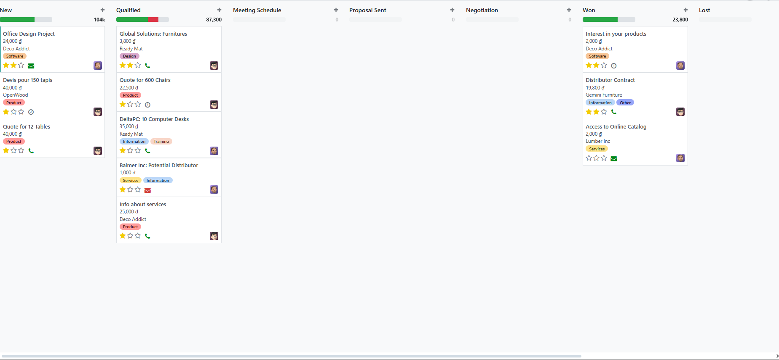

1. **Set Color Codes for Stages:**
   * Assign color codes to each stage for easy identification.
2. **Create Sales Teams:**
   * Navigate to **CRM > Configuration > Sales Teams**.
   * Create three sales teams representing different regions where Highland Coffee operates:
     + **North Region Sales Team**
     + **Central Region Sales Team**
     + **South Region Sales Team**



**Step 3: Generate Leads for Highland Coffee**

1. **Manually Create Leads:**
   * Go to **CRM > Sales > Leads**.
   * Click on **Create** and input lead details.
     + **Lead Name**: "Coffee Shop Inquiry – District 1"
     + **Customer**: Create a new customer **Nguyen Van A** with contact details.
     + **Priority**: Set as **Medium <two star>**.
     + **Sales Team**: Assign to **South Region Sales Team**.
     + **Contact Information**: Add phone number and email address.
2. **Import Leads from an Excel File:**
   * Click on the **Import** button in the Leads menu .
   * Use a CSV file with the following fields:
     + Lead Name
     + Sales Team
     + Contact Name
     + Email
     + Phone
     + Priority

*(Note: download the CSV file then upload.)*

**Step 4: Convert Leads into Opportunities**

1. **Convert Lead:**
   * Open the lead created earlier, "Coffee Shop Inquiry – District 1."
   * Click on the **Convert to Opportunity** button.
   * Assign it to a sales team member and mark the expected revenue as **$10,000**.
   * Set the expected closing date for the opportunity.

**Step 5: Schedule Activities for Leads**

1. **Schedule a Call:**
   * Open an opportunity in your pipeline.
   * Click on **Schedule Activity**.
   * Select **Call**, set the date and time, and assign it to yourself or a team member.
   * Write notes about the call (e.g., follow-up for a proposal).
2. **Schedule a Meeting:**
   * After the call, schedule a face-to-face meeting with the lead to present a proposal.
   * Record the meeting details in the CRM.

**Step 6: Track Opportunity Progress**

1. **Move Opportunities Through Stages:**
   * Move the opportunity through different stages of the pipeline as activities are completed.
   * For example, after sending the proposal, move it to the **Proposal Sent** stage.
2. **Log Communication:**
   * Record all interactions with the customer using the **Log Note** or **Log Call** options.
3. **Mark Opportunity as Won/Lost:**
   * Once the deal is closed, either move the opportunity to the **Won** stage or, if unsuccessful, mark it as **Lost** with the reason.

**Step 7: Analyze CRM Data**

1. **View Pipeline Reports:**
   * Go to **CRM > Reporting > Pipeline**.
   * Filter the pipeline data by sales team, opportunity stage, or expected closing date.
2. **Generate Custom Reports:**
   * Create a report that shows the performance of each sales team (North, Central, South) based on opportunities won and lost.

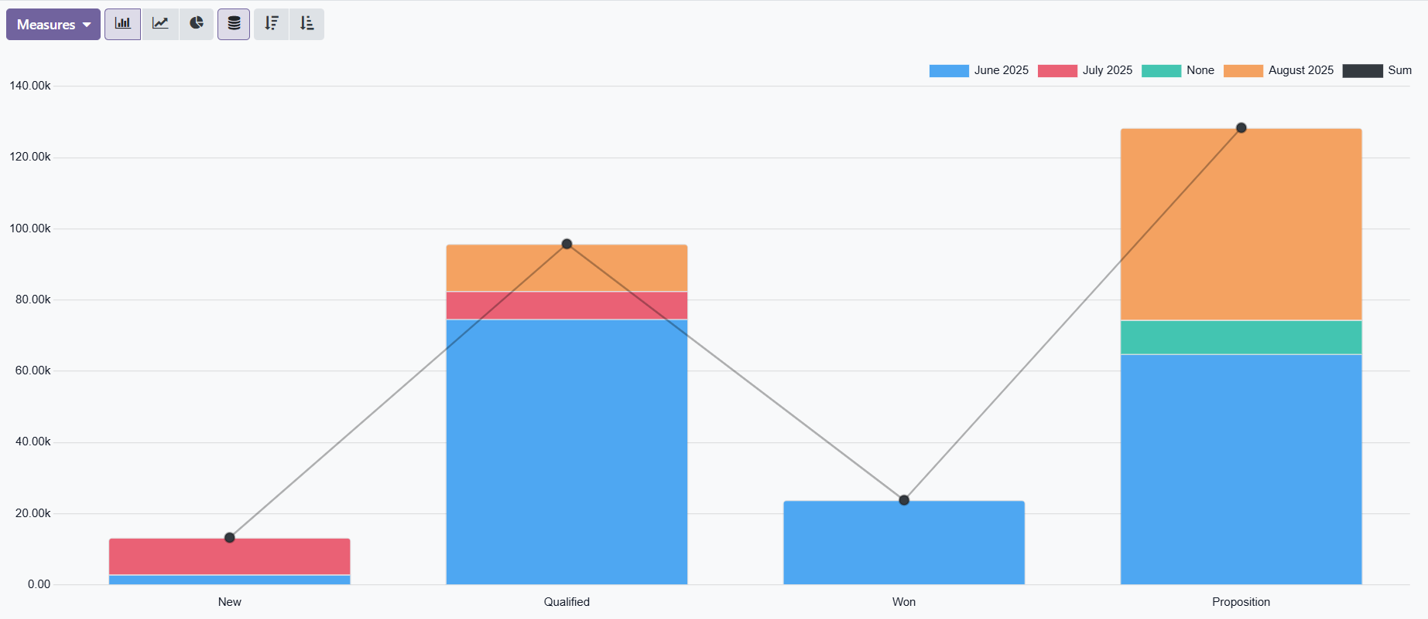

**Step 8: Export CRM Data**

1. **Export Opportunity Data:**
   * Go to **CRM > Sales > My Activities**.
   * Select multiple opportunities and click on the **Export** button.
   * Choose fields such as **Opportunity Name**, **Sales Team**, **Stage**, **Expected Revenue**, and **Expected Closing Date**.
   * Export the data as a CSV file for external analysis.