Exercise4:
- Code:
import React, { useReducer, useState } from "react";
import { Button, Form, Container, Row, Col, ListGroup, InputGroup } from "react-bootstrap";

const initialState = {
items: [],
filter: '',
sort: 'name',
editingId: null,
editingValue: '',
};

function reducer(state, action) {
switch (action.type) {
case 'ADD_ITEM':
if (!action.payload.trim()) return state;
return {
...state,
items: [
...state.items,
{
id: Date.now(),
name: action.payload,
created: Date.now(),
},
],
};
case 'REMOVE_ITEM':
return {
...state,
items: state.items.filter((item) => item.id !== action.payload),
};
case 'START_EDIT':
return {
...state,
editingId: action.payload.id,
editingValue: action.payload.name,
};
case 'CANCEL_EDIT':
return {
...state,
editingId: null,
editingValue: '',
};
case 'SAVE_EDIT':
return {
...state,
items: state.items.map((item) =>
item.id === state.editingId ? { ...item, name: state.editingValue } : item
),
editingId: null,
editingValue: '',
};
case 'SET_EDITING_VALUE':
return {
...state,
editingValue: action.payload,
};
case 'SET_FILTER':
return {
...state,
filter: action.payload,
};
case 'SET_SORT':
return {
...state,
sort: action.payload,
};
default:
return state;
}
}

function sortItems(items, sort) {
if (sort === 'name') {
return [...items].sort((a, b) => a.name.localeCompare(b.name));
} else if (sort === 'created') {
return [...items].sort((a, b) => a.created - b.created);
}
return items;
}

const Items = () => {
const [state, dispatch] = useReducer(reducer, initialState);
const [input, setInput] = useState('');

const handleAdd = (e) => {
e.preventDefault();
dispatch({ type: 'ADD_ITEM', payload: input });
setInput('');
};

const filteredItems = sortItems(
state.items.filter((item) =>
item.name.toLowerCase().includes(state.filter.toLowerCase())
),
state.sort
);

return (
<Container className="mt-4">
<Row>
<Col md={8} className="offset-md-2">
<Form onSubmit={handleAdd}>
<Form.Group controlId="formItem">
<Form.Label>Enter Item:</Form.Label>
<InputGroup className="mb-3">
<Form.Control
type="text"
value={input}
onChange={(e) => setInput(e.target.value)}
placeholder="Enter item name"
/>
<Button variant="primary" type="submit">
Add Item
</Button>
</InputGroup>
</Form.Group>
</Form>

<InputGroup className="mb-3">
<Form.Control
placeholder="Search items"
value={state.filter}
onChange={e => dispatch({ type: 'SET_FILTER', payload: e.target.value })}
/>
<Form.Select
value={state.sort}
onChange={e => dispatch({ type: 'SET_SORT', payload: e.target.value })}
style={{ maxWidth: 200 }}
>
<option value="name">Sort by Name</option>
<option value="created">Sort by Created Time</option>
</Form.Select>
</InputGroup>

<h5 className="mb-3">Item List:</h5>
<ListGroup>
{filteredItems.length === 0 && (
<ListGroup.Item className="text-center text-muted">No items found.</ListGroup.Item>
)}
{filteredItems.map((item) => (
<ListGroup.Item key={item.id} className="d-flex align-items-center justify-content-between">
{state.editingId === item.id ? (
<>
<Form.Control
style={{ maxWidth: 250, marginRight: 8 }}
value={state.editingValue}
onChange={e => dispatch({ type: 'SET_EDITING_VALUE', payload: e.target.value })}
size="sm"
/>
<div>
<Button
variant="success"
size="sm"
className="me-2"
onClick={() => dispatch({ type: 'SAVE_EDIT' })}
>
Save
</Button>
<Button
variant="secondary"
size="sm"
onClick={() => dispatch({ type: 'CANCEL_EDIT' })}
>
Cancel
</Button>
</div>
</>
) : (
<>
<span>{item.name}</span>
<div>
<Button
variant="warning"
size="sm"
className="me-2"
onClick={() => dispatch({ type: 'START_EDIT', payload: item })}
>
Edit
</Button>
<Button
variant="danger"
size="sm"
onClick={() => dispatch({ type: 'REMOVE_ITEM', payload: item.id })}
>
Remove
</Button>
</div>
</>
)}
</ListGroup.Item>
))}
</ListGroup>
</Col>
</Row>
</Container>
);
};

export default Items;
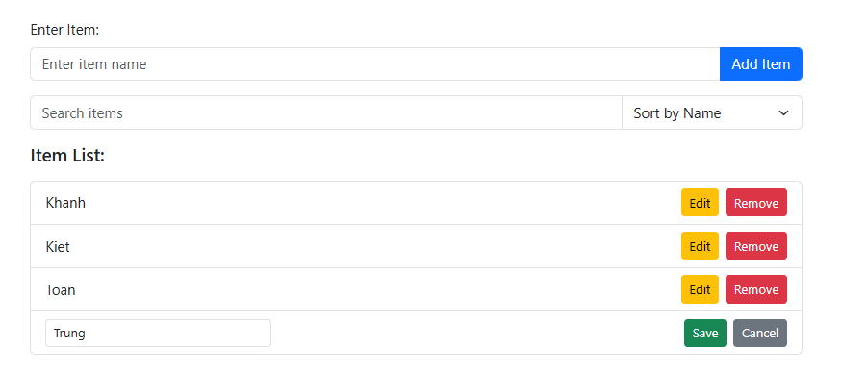
- Result:

Exercise5:
- Code:
import React, { useReducer } from "react";
import { Button, Container, Card } from "react-bootstrap";

const initialState = {
questions: [
{
id: 1,
question: "What is the capital of Australia?",
options: ["Sydney", "Canberra", "Melbourne", "Perth"],
answer: "Canberra",
},
{
id: 2,
question: "Which planet is known as the Red Planet?",
options: ["Venus", "Mars", "Jupiter", "Saturn"],
answer: "Mars",
},
{
id: 3,
question: "What is the largest ocean on Earth?",
options: [
"Atlantic Ocean",
"Indian Ocean",
"Pacific Ocean",
"Arctic Ocean",
],
answer: "Pacific Ocean",
},
],
currentQuestion: 0,
selectedOption: "",
score: 0,
showScore: false,
};

function quizReducer(state, action) {
switch (action.type) {
case "SELECT_OPTION":
return { ...state, selectedOption: action.payload };

case "NEXT_QUESTION":
const isCorrect =
state.selectedOption === state.questions[state.currentQuestion].answer;
return {
...state,
score: isCorrect ? state.score + 1 : state.score,
currentQuestion: state.currentQuestion + 1,
selectedOption: "",
showScore: state.currentQuestion + 1 === state.questions.length, // Hiển thị điểm khi hết câu hỏi
};

case "RESTART_QUIZ":
return {
...initialState, // Reset về trạng thái ban đầu
};

default:
return state;
}
}

function QuestionBank() {
const [state, dispatch] = useReducer(quizReducer, initialState);
const { questions, currentQuestion, selectedOption, score, showScore } = state;

const handleOptionSelect = (option) => {
dispatch({ type: "SELECT_OPTION", payload: option });
};

const handleNextQuestion = () => {
dispatch({ type: "NEXT_QUESTION" });
};

const handleRestartQuiz = () => {
dispatch({ type: "RESTART_QUIZ" });
};

return (
<Container className="mt-4">
<Card className="p-4">
{showScore ? (
<div className="text-center">
<h2>
Your Score: {score} / {questions.length}
</h2>
<Button variant="primary" onClick={handleRestartQuiz}>
Restart Quiz
</Button>
</div>
) : (
<div>
<h4>
Question {questions[currentQuestion].id}:<br />
{questions[currentQuestion].question}
</h4>
<div className="mt-3">
{questions[currentQuestion].options.map((option, index) => (
<Button
key={index}
variant={
selectedOption === option ? "success" : "outline-secondary"
}
className="m-2"
onClick={() => handleOptionSelect(option)}
>
{option}
</Button>
))}
</div>

<Button
variant="primary"
className="mt-3"
disabled={!selectedOption}
onClick={handleNextQuestion}
>
{currentQuestion === questions.length - 1
? "Finish Quiz"
: "Next Question"}
</Button>
</div>
)}
</Card>
</Container>
);
}

export default QuestionBank;
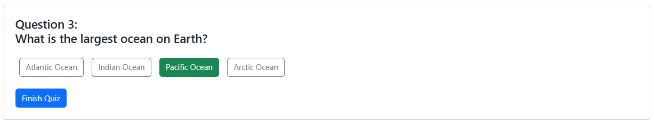
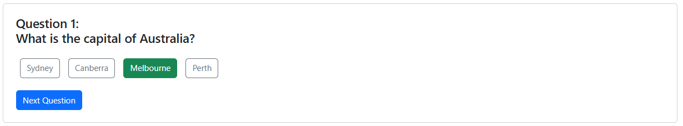
- Result:
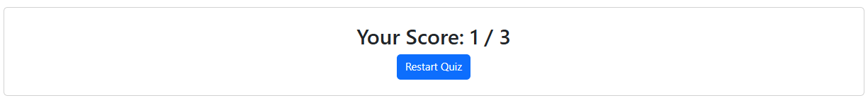
Exercise6:
- Code:
import React, { useReducer, useEffect, useRef } from "react";
import { Button, Container, Card, ProgressBar } from "react-bootstrap";
import { FaCheckCircle, FaTimesCircle } from "react-icons/fa";

const initialState = {
questions: [
{
id: 1,
question: "What is the capital of Australia?",
options: ["Sydney", "Canberra", "Melbourne", "Perth"],
answer: "Canberra",
},
{
id: 2,
question: "Which planet is known as the Red Planet?",
options: ["Venus", "Mars", "Jupiter", "Saturn"],
answer: "Mars",
},
{
id: 3,
question: "What is the largest ocean on Earth?",
options: [
"Atlantic Ocean",
"Indian Ocean",
"Pacific Ocean",
"Arctic Ocean",
],
answer: "Pacific Ocean",
},
],
currentQuestion: 0,
selectedOption: "",
score: 0,
showScore: false,
feedback: null, // {correct: true/false, message: string}
timer: 10,
highScore: 0,
};

function quizReducer(state, action) {
switch (action.type) {
case "SELECT_OPTION": {
const isCorrect = action.payload === state.questions[state.currentQuestion].answer;
return {
...state,
selectedOption: action.payload,
feedback: isCorrect
? { correct: true, message: "Correct! 🎉" }
: { correct: false, message: `Incorrect! The correct answer is ${state.questions[state.currentQuestion].answer}` },
};
}
case "NEXT_QUESTION": {
const isCorrect = state.selectedOption === state.questions[state.currentQuestion].answer;
const newScore = isCorrect ? state.score + 1 : state.score;
const isLast = state.currentQuestion + 1 === state.questions.length;
// Update high score if needed
let newHighScore = state.highScore;
if (isLast && newScore > state.highScore) {
newHighScore = newScore;
localStorage.setItem('quiz_high_score', newHighScore);
}
return {
...state,
score: newScore,
currentQuestion: state.currentQuestion + 1,
selectedOption: "",
feedback: null,
timer: 10,
showScore: isLast,
highScore: newHighScore,
};
}
case "RESTART_QUIZ": {
return {
...initialState,
highScore: state.highScore,
};
}
case "TICK": {
if (state.timer > 0) {
return { ...state, timer: state.timer - 1 };
} else {
// Nếu hết giờ mà chưa chọn đáp án, tự động chuyển câu và feedback sai
const isLast = state.currentQuestion + 1 === state.questions.length;
let newHighScore = state.highScore;
if (isLast && state.score > state.highScore) {
newHighScore = state.score;
localStorage.setItem('quiz_high_score', newHighScore);
}
return {
...state,
currentQuestion: state.currentQuestion + 1,
selectedOption: "",
feedback: null,
timer: 10,
showScore: isLast,
highScore: newHighScore,
};
}
}
case "LOAD_HIGHSCORE": {
return {
...state,
highScore: action.payload,
};
}
default:
return state;
}
}

function QuestionBank() {
const [state, dispatch] = useReducer(quizReducer, initialState);
const { questions, currentQuestion, selectedOption, score, showScore, feedback, timer, highScore } = state;
const timerRef = useRef();

// Load high score from localStorage on mount
useEffect(() => {
const hs = parseInt(localStorage.getItem('quiz_high_score'), 10) || 0;
dispatch({ type: 'LOAD_HIGHSCORE', payload: hs });
// eslint-disable-next-line
}, []);

// Timer effect
useEffect(() => {
if (showScore) return;
if (selectedOption) return; // Dừng timer khi đã chọn đáp án
timerRef.current = setInterval(() => {
dispatch({ type: 'TICK' });
}, 1000);
return () => clearInterval(timerRef.current);
}, [showScore, currentQuestion, selectedOption]);

// Khi chọn đáp án, dừng timer
useEffect(() => {
if (selectedOption) clearInterval(timerRef.current);
}, [selectedOption]);

const handleOptionSelect = (option) => {
if (!selectedOption) {
dispatch({ type: "SELECT_OPTION", payload: option });
}
};

const handleNextQuestion = () => {
dispatch({ type: "NEXT_QUESTION" });
};

const handleRestartQuiz = () => {
dispatch({ type: "RESTART_QUIZ" });
};

// Tiến trình
const progress = `${Math.min(currentQuestion + 1, questions.length)}/${questions.length}`;
const percent = ((currentQuestion) / questions.length) * 100;

return (
<Container className="mt-4">
<Card className="p-4">
<div className="d-flex justify-content-between align-items-center mb-2">
<div>Progress: <b>{progress}</b></div>
<div>
High Score: <b>{highScore}</b>
</div>
</div>
<ProgressBar now={percent} style={{ height: 8, marginBottom: 20 }} />
{showScore ? (
<div className="text-center">
<h2>
Your Score: {score} / {questions.length}
</h2>
<div className="mb-2">High Score: <b>{highScore}</b></div>
<Button variant="primary" onClick={handleRestartQuiz}>
Restart Quiz
</Button>
</div>
) : (
<div>
<div className="d-flex justify-content-between align-items-center">
<h4>
Question {questions[currentQuestion].id}:<br />
{questions[currentQuestion].question}
</h4>
<div style={{ fontWeight: 'bold', fontSize: 18 }}>
Time: <span style={{ color: timer < 5 ? 'red' : 'black' }}>{timer}s</span>
</div>
</div>
<div className="mt-3">
{questions[currentQuestion].options.map((option, index) => (
<Button
key={index}
variant={
selectedOption === option
? (option === questions[currentQuestion].answer ? "success" : "danger")
: "outline-secondary"
}
className="m-2"
onClick={() => handleOptionSelect(option)}
disabled={!!selectedOption}
>
{option}
</Button>
))}
</div>
{feedback && (
<div className="mt-3" style={{ fontSize: 18, fontWeight: 500 }}>
{feedback.correct ? (
<span className="text-success"><FaCheckCircle /> {feedback.message}</span>
) : (
<span className="text-danger"><FaTimesCircle /> {feedback.message}</span>
)}
</div>
)}
<Button
variant="primary"
className="mt-3"
disabled={!selectedOption}
onClick={handleNextQuestion}
>
{currentQuestion === questions.length - 1
? "Finish Quiz"
: "Next Question"}
</Button>
</div>
)}
</Card>
</Container>
);
}

export default QuestionBank;
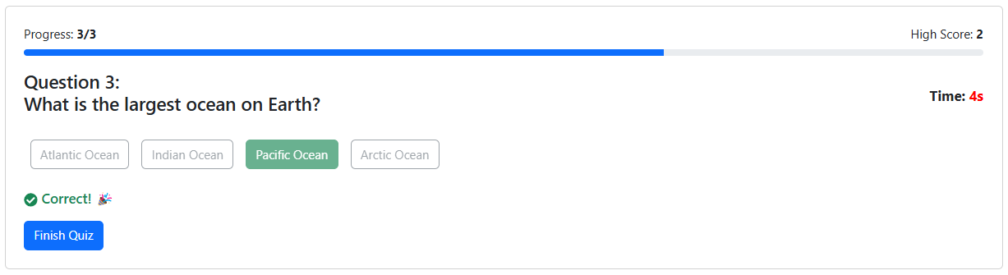
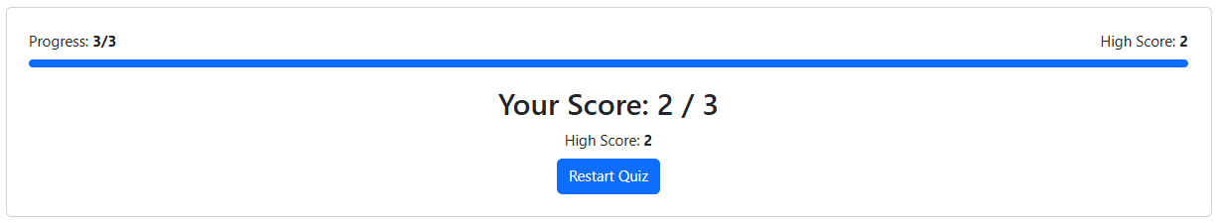
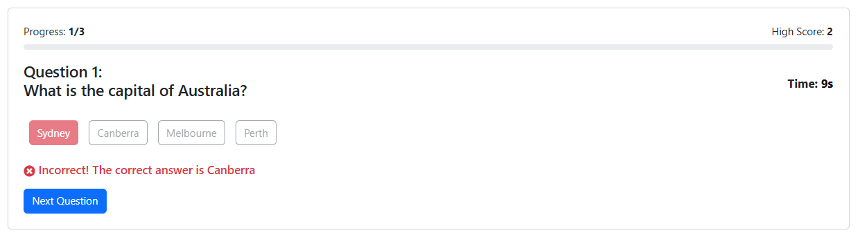
- Result:

