Code:
1. Question.jsx
import React from "react";

function Question({ question, onAnswer }) {
return (
<div style={{ marginBottom: "2rem" }}>
<h2>{question.question}</h2>
<ul style={{ listStyle: "none", padding: 0 }}>
{question.options.map((option) => (
<li key={option} style={{ margin: "0.5rem 0" }}>
<button onClick={() => onAnswer(option)} style={{ width: "500px", padding: "0.5rem", fontSize: "1rem" }}>
{option}
</button>
</li>
))}
</ul>
</div>
);
}

export default Question;
2. Result.jsx
import React from "react";

function Result({ score, total, onReplay }) {
return (
<div style={{ textAlign: "center", marginTop: "2rem" }}>
<h2>Quiz Ended</h2>
<p style={{ fontSize: "1.5rem" }}>Your Score: {score} / {total}</p>
<button onClick={onReplay} style={{ padding: "0.75rem 1.5rem", fontSize: "1rem", marginTop: "1rem" }}>Replay</button>
</div>
);
}

export default Result;
3. QuizApp.jsx
import React, { Component } from "react";
import Question from "./Question";
import Result from "./Result";

class QuizApp extends Component {
constructor(props) {
super(props);
this.state = {
questions: [
{
id: 1,
question: "Question 1: What is the capital of France?",
options: ["Paris", "London", "Berlin", "Madrid"],
answer: "Paris",
},
{
id: 2,
question: "Question 2: What is the largest planet in our solar system?",
options: ["Jupiter", "Saturn", "Mars", "Earth"],
answer: "Jupiter",
},
],
currentQuestion: 0,
score: 0,
quizEnd: false,
};
}

handleAnswer = (selectedOption) => {
const { questions, currentQuestion, score } = this.state;
const isCorrect = selectedOption === questions[currentQuestion].answer;
this.setState({
score: isCorrect ? score + 1 : score,
currentQuestion: currentQuestion + 1,
quizEnd: currentQuestion + 1 === questions.length,
});
};

handleReplay = () => {
this.setState({
currentQuestion: 0,
score: 0,
quizEnd: false,
});
};

render() {
const { questions, currentQuestion, score, quizEnd } = this.state;
return (
<div>
{!quizEnd ? (
<Question
question={questions[currentQuestion]}
onAnswer={this.handleAnswer}
/>
) : (
<Result
score={score}
total={questions.length}
onReplay={this.handleReplay}
/>
)}
</div>
);
}
}

export default QuizApp;
Result:
1. Question_1
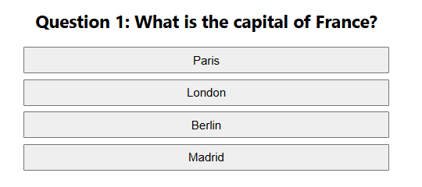
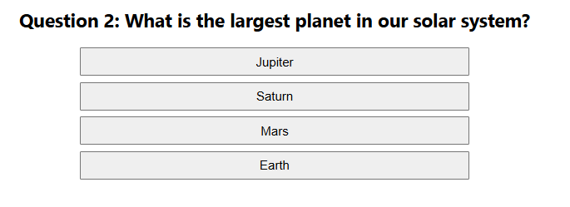

2. Question_2

3. Result
