1. AddQuestionForm
Code:
import React, { useState } from 'react';
import { Form, Button, Card } from 'react-bootstrap';

function AddQuestionForm({ onAddQuestion }) {
const [question, setQuestion] = useState('');
const [answers, setAnswers] = useState(['', '', '']);
const [correctAnswer, setCorrectAnswer] = useState('');

const handleAnswerChange = (idx, value) => {
const updated = [...answers];
updated[idx] = value;
setAnswers(updated);
};

const handleSubmit = (e) => {
e.preventDefault();
if (
question &&
answers.every((a) => a) &&
answers.includes(correctAnswer)
) {
onAddQuestion({ question, answers, correctAnswer });
setQuestion('');
setAnswers(['', '', '']);
setCorrectAnswer('');
}
};

return (
<Card className="mb-4">
<Card.Body>
<Card.Title>Thêm câu hỏi mới</Card.Title>
<Form onSubmit={handleSubmit}>
<Form.Group className="mb-2">
<Form.Control
type="text"
placeholder="Câu hỏi"
value={question}
onChange={e => setQuestion(e.target.value)}
/>
</Form.Group>
{answers.map((ans, idx) => (
<Form.Group className="mb-2" key={idx}>
<Form.Control
type="text"
placeholder={`Đáp án ${idx + 1}`}
value={ans}
onChange={e => handleAnswerChange(idx, e.target.value)}
/>
</Form.Group>
))}
<Form.Group className="mb-2">
<Form.Control
type="text"
placeholder="Đáp án đúng (phải trùng 1 đáp án trên)"
value={correctAnswer}
onChange={e => setCorrectAnswer(e.target.value)}
/>
</Form.Group>
<Button variant="primary" type="submit">Thêm câu hỏi</Button>
</Form>
</Card.Body>
</Card>
);
}

export default AddQuestionForm;
Result:
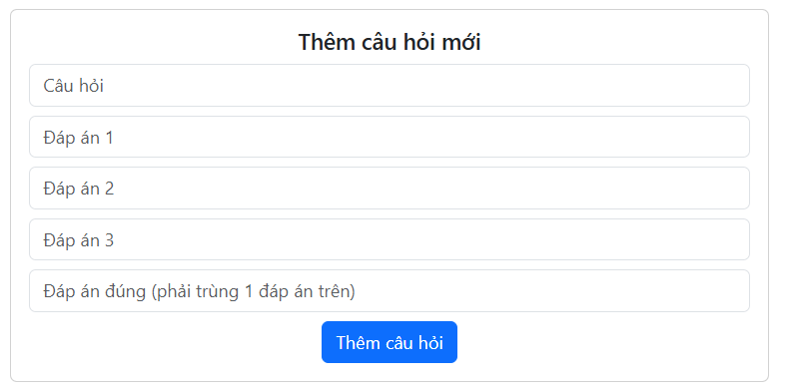
2. Quiz
a, Question.jsx
Code:
import React from 'react';
import { Card, ListGroup, Form } from 'react-bootstrap';

function Question({ qIdx, question, answers, selected, onSelect, nextButton }) {
return (
<Card style={{ marginTop: '50px', marginBottom: '10px'}}>
<Card.Body>
<Card.Title as="h2" style={{ color: 'red', textAlign: 'left', fontSize: 24 }}>
Question {qIdx + 1}
</Card.Title>
<div style={{ fontWeight: 'bold', marginBottom: 8, textAlign: 'left' }}>{question}</div>
<div style={{ padding: 16 }}>
<ListGroup>
{answers.map((ans, aIdx) => (
<ListGroup.Item
key={aIdx}
style={{
display: 'flex',
alignItems: 'center',
borderRadius: aIdx === 0
? '8px 8px 0 0'
: aIdx === answers.length - 1
? '0 0 8px 8px'
: '0',
border: '1px solid #dee2e6',
borderTop: aIdx === 0 ? '1px solid #dee2e6' : 'none',
padding: '10px 16px',
}}
>
<Form.Check
type="radio"
id={`q${qIdx}-ans${aIdx}`}
name={`question-${qIdx}`}
value={ans}
checked={selected === ans}
onChange={() => onSelect(ans)}
style={{
marginRight: 12,
accentColor: selected === ans ? '#1976d2' : undefined,
}}
/>
<span style={{ fontWeight: 500 }}>{ans}</span>
</ListGroup.Item>
))}
</ListGroup>
</div>
<div style={{ textAlign: 'left', marginTop: 5, marginLeft: 17 }}>
{nextButton}
</div>
</Card.Body>
</Card>
);
}

export default Question;
b, Quiz.jsx
Code:
import React, { useState } from 'react';
import { Container } from 'react-bootstrap';
import AddQuestionForm from './AddQuestionForm';
import Question from './Question';
import Score from './Score';
import { Button } from 'react-bootstrap';

export const quizData = [
{
question: 'What is ReactJS?',
answers: [
'A JavaScript library for building user interfaces',
'A programming language',
'A database management system',
],
correctAnswer: 'A JavaScript library for building user interfaces',
},
{
question: 'What is JSX?',
answers: [
'A programming language',
'A file format',
'A syntax extension for JavaScript',
],
correctAnswer: 'A syntax extension for JavaScript',
},
];

function Quiz() {
const [questions, setQuestions] = useState(quizData);
const [current, setCurrent] = useState(0);
const [selectedAnswers, setSelectedAnswers] = useState({});
const [score, setScore] = useState(0);
const [completed, setCompleted] = useState(false);

const handleSelectAnswer = (answer) => {
setSelectedAnswers((prev) => ({ ...prev, [current]: answer }));
};

const handleNext = () => {
if (selectedAnswers[current] === questions[current].correctAnswer) {
setScore((prev) => prev + 1);
}
if (current < questions.length - 1) {
setCurrent(current + 1);
} else {
setCompleted(true);
}
};

const handleAddQuestion = (newQ) => {
setQuestions((prev) => [...prev, newQ]);
};

if (completed) {
return <Score score={score} total={questions.length} />;
}

return (
<Container style={{ maxWidth: 700, margin: '0 auto' }}>
<div style={{ marginBottom: 32 }}>
<Question
qIdx={current}
question={questions[current].question}
answers={questions[current].answers}
selected={selectedAnswers[current]}
onSelect={handleSelectAnswer}
nextButton={
<Button
onClick={handleNext}
disabled={selectedAnswers[current] == null}
variant="danger"
>
{current === questions.length - 1 ? 'Finish' : 'Next'}
</Button>
}
/>
</div>
<div>
<AddQuestionForm onAddQuestion={handleAddQuestion} />
</div>
</Container>
);
}

export default Quiz;
Result:
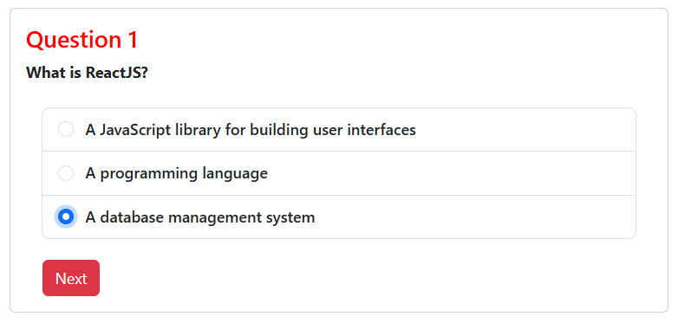
3. Score
Code:
import React from 'react';

function Score({ score, total }) {
return (
<div variant="success" style={{ maxWidth: 600, margin: '50px auto', textAlign: 'center' }}>
<h1 style={{ color: 'red' }}>Quiz Completed!</h1>
<h2>Your score: {score} / {total}</h2>
</div>
);
}

export default Score;
Result:
