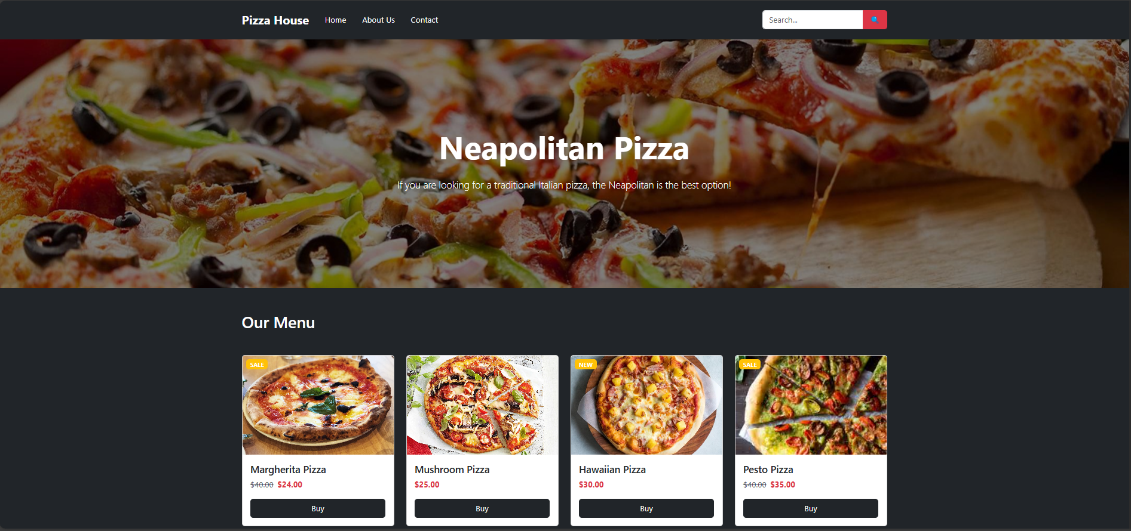

Code:
"use client"
import './App.css';

// Import images
import hawaiianPizza from "./assets/image/hawaiian_pizza.jpg"
import margheritaPizza from "./assets/image/margheri_pizza.jpg"
import mushroomPizza from "./assets/image/mushroom_pizza.jpg"
import pestoPizza from "./assets/image/pesto_pizza.jpg"
import heroImage from "./assets/image/background.jpg"

function App() {
return (
<div className="App">
{/* Header Section */}
<nav className="navbar navbar-expand-lg navbar-dark bg-dark py-3">
<div className="container">
<a className="navbar-brand fw-bold fs-4 text-white" href="#">
Pizza House
</a>

<button className="navbar-toggler" type="button" data-bs-toggle="collapse" data-bs-target="#navbarNav">
<span className="navbar-toggler-icon"></span>
</button>

<div className="collapse navbar-collapse" id="navbarNav">
<ul className="navbar-nav me-auto mb-2 mb-lg-0">
<li className="nav-item">
<a className="nav-link text-white mx-2" href="#">
Home
</a>
</li>
<li className="nav-item">
<a className="nav-link text-white mx-2" href="#">
About Us
</a>
</li>
<li className="nav-item">
<a className="nav-link text-white mx-2" href="#">
Contact
</a>
</li>
</ul>

<div className="d-flex">
<div className="input-group" style={{ width: "250px" }}>
<input type="text" className="form-control" placeholder="Search..." />
<button className="btn btn-danger" type="button">
🔍
</button>
</div>
</div>
</div>
</div>
</nav>

{/* Hero Section */}
<div className="hero-section" style={{ backgroundImage: `url(${heroImage})` }}>
<div className="container">
<div className="row justify-content-center text-center">
<div className="col-lg-8">
<h1 className="display-3 fw-bold text-white mb-4">Neapolitan Pizza</h1>
<p className="lead text-white">
If you are looking for a traditional Italian pizza, the Neapolitan is the best option!
</p>
</div>
</div>
</div>
</div>

{/* Menu Section */}
<div className="menu-section bg-dark py-5">
<div className="container">
<h2 className="text-white mb-5">Our Menu</h2>
<div className="row">

{/* Margherita Pizza */}
<div className="col-lg-3 col-md-6 mb-4">
<div className="card h-100">
<div className="position-relative">
<img
src={margheritaPizza || "/placeholder.svg"}
alt="Margherita Pizza"
className="card-img-top"
style={{ height: "200px", objectFit: "cover" }}
/>
<span className="badge bg-warning position-absolute top-0 start-0 m-2">SALE</span>
</div>
<div className="card-body d-flex flex-column">
<h5 className="card-title">Margherita Pizza</h5>
<div className="mb-3">
<span className="text-muted text-decoration-line-through me-2">$40.00</span>
<span className="fw-bold text-danger">$24.00</span>
</div>
<button className="btn btn-dark mt-auto">Buy</button>
</div>
</div>
</div>

{/* Mushroom Pizza */}
<div className="col-lg-3 col-md-6 mb-4">
<div className="card h-100">
<div className="position-relative">
<img
src={mushroomPizza || "/placeholder.svg"}
alt="Mushroom Pizza"
className="card-img-top"
style={{ height: "200px", objectFit: "cover" }}
/>
</div>
<div className="card-body d-flex flex-column">
<h5 className="card-title">Mushroom Pizza</h5>
<div className="mb-3">
<span className="fw-bold text-danger">$25.00</span>
</div>
<button className="btn btn-dark mt-auto">Buy</button>
</div>
</div>
</div>

{/* Hawaiian Pizza */}
<div className="col-lg-3 col-md-6 mb-4">
<div className="card h-100">
<div className="position-relative">
<img
src={hawaiianPizza || "/placeholder.svg"}
alt="Hawaiian Pizza"
className="card-img-top"
style={{ height: "200px", objectFit: "cover" }}
/>
<span className="badge bg-warning position-absolute top-0 start-0 m-2">NEW</span>
</div>
<div className="card-body d-flex flex-column">
<h5 className="card-title">Hawaiian Pizza</h5>
<div className="mb-3">
<span className="fw-bold text-danger">$30.00</span>
</div>
<button className="btn btn-dark mt-auto">Buy</button>
</div>
</div>
</div>

{/* Pesto Pizza */}
<div className="col-lg-3 col-md-6 mb-4">
<div className="card h-100">
<div className="position-relative">
<img
src={pestoPizza || "/placeholder.svg"}
alt="Pesto Pizza"
className="card-img-top"
style={{ height: "200px", objectFit: "cover" }}
/>
<span className="badge bg-warning position-absolute top-0 start-0 m-2">SALE</span>
</div>
<div className="card-body d-flex flex-column">
<h5 className="card-title">Pesto Pizza</h5>
<div className="mb-3">
<span className="text-muted text-decoration-line-through me-2">$40.00</span>
<span className="fw-bold text-danger">$35.00</span>
</div>
<button className="btn btn-dark mt-auto">Buy</button>
</div>
</div>
</div>

</div>
</div>
</div>

{/* Booking Section */}
<div className="booking-section bg-dark py-5">
<div className="container">
<h2 className="text-white text-center mb-5">Book Your Table</h2>
<div className="row justify-content-center">
<div className="col-lg-8">
<form>
<div className="row mb-3">
<div className="col-md-4">
<input type="text" className="form-control" placeholder="Your Name *" />
</div>
<div className="col-md-4">
<input type="email" className="form-control" placeholder="Your Email *" />
</div>
<div className="col-md-4">
<select className="form-select">
<option>Select a Service</option>
<option>Dine In</option>
<option>Takeaway</option>
<option>Delivery</option>
</select>
</div>
</div>

<div className="row mb-3">
<div className="col">
<textarea className="form-control" rows="5" placeholder="Please write your comment"></textarea>
</div>
</div>

<div className="row">
<div className="col">
<button
type="submit"
className="btn fw-bold px-4"
style={{
backgroundColor: "#ffc107",
borderColor: "#ffc107",
color: "#000",
}}
>
Send Message
</button>
</div>
</div>
</form>
</div>
</div>
</div>
</div>
</div>
)
}

export default App

