Navigation
Code:
- Src/components/Navigation.jsx
import React from 'react';
import { Navbar, Nav, Container } from 'react-bootstrap';
import { NavLink } from 'react-router-dom';

function Navigation() {
return (
<Navbar bg="dark" variant="dark" expand="lg">
<Container>
<Navbar.Brand as={NavLink} to="/">Home</Navbar.Brand>
<Navbar.Toggle aria-controls="basic-navbar-nav" />
<Navbar.Collapse id="basic-navbar-nav">
<Nav className="me-auto">
<Nav.Link as={NavLink} to="/products-list">Product List</Nav.Link>
</Nav>
</Navbar.Collapse>
</Container>
</Navbar>
);
}

export default Navigation;

Result:

Home
Code:
- Src/components/Home.jsx
import React, { useEffect, useState } from 'react';
import axios from 'axios';
import { Container, Row, Col, Card, Button, Spinner, Alert } from 'react-bootstrap';
import { useNavigate } from 'react-router-dom';

function Home() {
const [products, setProducts] = useState([]);
const [error, setError] = useState('');
const [loading, setLoading] = useState(true);
const navigate = useNavigate();

const handleViewDetail = (id) => {
navigate(`/product-detail/${id}`);
};

useEffect(() => {
axios.get('http://localhost:3000/products')
.then((res) => {
setProducts(res.data || []);
setLoading(false);
})
.catch(() => {
setError('Failed to fetch products.');
setLoading(false);
});
}, []);

if (loading) {
return (
<Container className="d-flex justify-content-center align-items-center" style={{ minHeight: '60vh' }}>
<Spinner animation="border" variant="light" />
</Container>
);
}

if (error) {
return (
<Container className="d-flex justify-content-center align-items-center" style={{ minHeight: '60vh' }}>
<Alert variant="danger">{error}</Alert>
</Container>
);
}

if (!products.length) {
return (
<div style={{ background: '#23272f', minHeight: '100vh', width: '100vw', display: 'flex', flexDirection: 'column', justifyContent: 'center', alignItems: 'center' }}>
<h2 style={{ color: '#fff', fontSize: 48, fontWeight: 700, marginBottom: 16, fontFamily: 'Segoe UI, Arial, sans-serif' }}>Product List</h2>
<div style={{ color: '#fff', fontSize: 32, fontFamily: 'Segoe UI, Arial, sans-serif' }}>No products found.</div>
</div>
);
}

return (
<div style={{ background: '#000', minHeight: '100vh', padding: '0', margin: 0 }}>
<Container style={{ paddingTop: 40, paddingBottom: 40 }}>
<h2 style={{ color: '#fff', textAlign: 'center', marginBottom: 32 }}>Product List</h2>
<Row>
{products.map((product) => (
<Col key={product.id} xs={12} sm={6} md={4} lg={3} className="mb-4 d-flex align-items-stretch">
<Card style={{ width: '100%', background: '#fff', borderRadius: 12, boxShadow: '0 2px 12px #0001', display: 'flex', flexDirection: 'column', height: '100%' }}>
<Card.Img variant="top" src={product.image} alt={product.name} style={{ height: 300, objectFit: 'cover', borderTopLeftRadius: 12, borderTopRightRadius: 12, background: '#fff' }} />
<Card.Body className="d-flex flex-column text-center">
<Card.Title style={{ color: '#d7263d', fontSize: 17 }}>{product.name}</Card.Title>
<Card.Text style={{ color: '#444', fontSize: 14, minHeight: 60 }}>{product.description}</Card.Text>
<div style={{ marginTop: 'auto' }}>
<div>
<span style={{ textDecoration: 'line-through', color: '#888', fontSize: 15 }}>{product.price} đ</span>
</div>
<div>
<span style={{ color: '#d7263d', fontWeight: 'bold', fontSize: 20 }}>{product.currentPrice} đ</span>
</div>
</div>
<div className="d-flex justify-content-center mt-3">
<Button variant="danger" size="sm" style={{ fontSize: 12, width: '100px', padding: '4px 16px' }} onClick={() => handleViewDetail(product.id)}>View Details</Button>
</div>
</Card.Body>
</Card>
</Col>
))}
</Row>
</Container>
</div>
);
}

export default Home;

Result:
- if there is data

- if there is no data
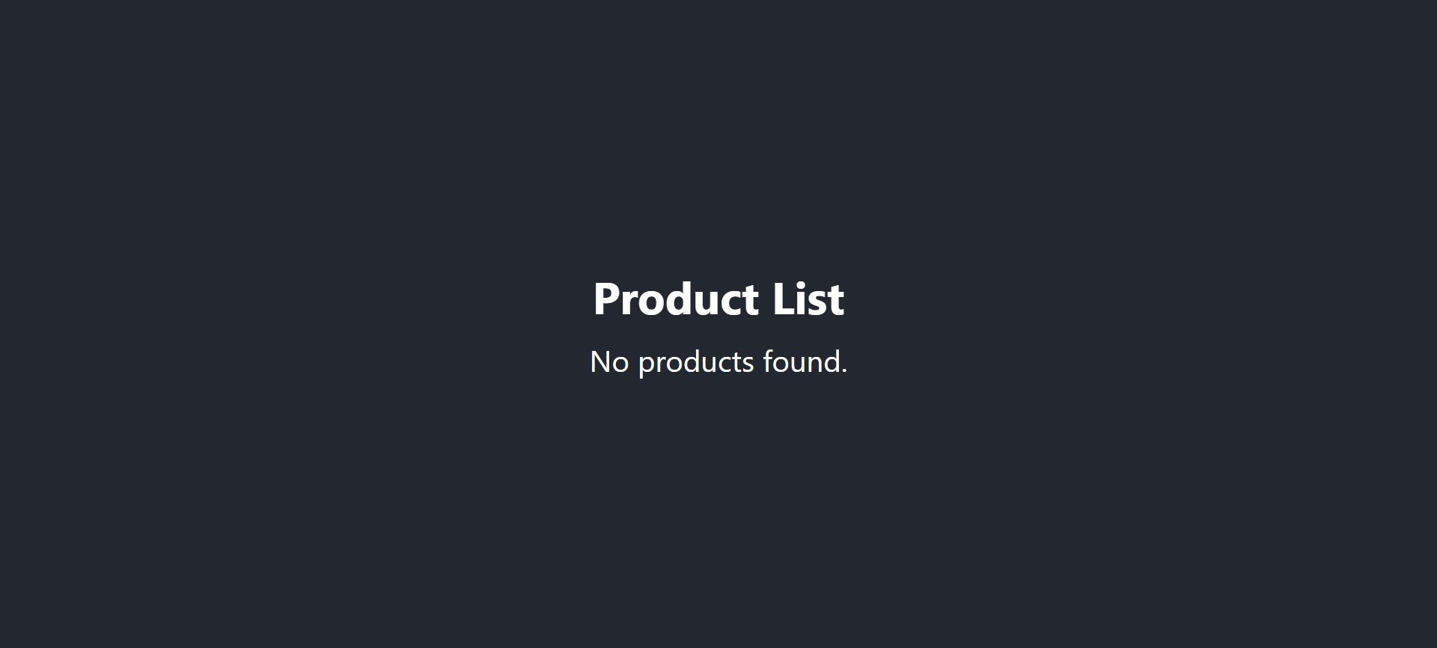

Product List
Code:
- Src/components/ProductList.jsx
import React, { useEffect, useState } from 'react';
import axios from 'axios';
import { Container, Row, Col, Button, Spinner, Alert, Form, Table } from 'react-bootstrap';
import { useNavigate } from 'react-router-dom';

function ProductList() {
const [products, setProducts] = useState([]);
const [error, setError] = useState('');
const [loading, setLoading] = useState(true);
const defaultImage = 'https://upload.wikimedia.org/wikipedia/commons/thumb/3/3f/Placeholder_view_vector.svg/330px-Placeholder_view_vector.svg.png';
const [form, setForm] = useState({ name: '', description: '', price: '', currentPrice: '', image: defaultImage });
const navigate = useNavigate();

// Load product list from API
useEffect(() => {
axios.get('http://localhost:3000/products')
.then((res) => {
setProducts(res.data);
setLoading(false);
})
.catch(() => {
setError('Failed to fetch products.');
setLoading(false);
});
}, []);

const handleInputChange = (e) => {
setForm({ ...form, [e.target.name]: e.target.value });
};

const handleAddProduct = async (e) => {
e.preventDefault();
const { name, description, price, currentPrice } = form;
if (!name || !description || !price || !currentPrice) return;

try {
const productData = {
...form,
image: form.image || defaultImage
};
const res = await axios.post('http://localhost:3000/products', productData);
setProducts([...products, res.data]);
setForm({ name: '', description: '', price: '', currentPrice: '', image: defaultImage });
} catch (err) {
setError('Failed to add product.');
}
};

const handleDelete = async (id) => {
try {
await axios.delete(`http://localhost:3000/products/${id}`);
setProducts(products.filter(p => p.id !== id));
} catch (err) {
setError('Failed to delete product.');
}
};

const handleEdit = (id) => {
navigate(`/edit-product/${id}`);
};

if (loading) {
return (
<Container className="d-flex justify-content-center align-items-center" style={{ minHeight: '60vh' }}>
<Spinner animation="border" variant="light" />
</Container>
);
}

if (error) {
return (
<Container className="d-flex justify-content-center align-items-center" style={{ minHeight: '60vh' }}>
<Alert variant="danger">{error}</Alert>
</Container>
);
}

return (
<div style={{ background: '#23272f', minHeight: '100vh', padding: 0, margin: 0 }}>
<Container style={{ paddingTop: 20, paddingBottom: 40 }}>
<Row className="justify-content-center">
<Col xs={12} md={10} lg={10} xl={10}>
<h2 style={{ color: '#fff', textAlign: 'center', marginBottom: 16, fontWeight: 700 }}>Add Product</h2>
<Form onSubmit={handleAddProduct} className="mb-4">
<Form.Group as={Row} className="mb-3" controlId="formName">
<Form.Label column md={2} style={{ color: '#fff', fontWeight: 500, fontSize: 18, textAlign: 'left', display: 'flex', alignItems: 'center', justifyContent: 'center', paddingRight: 0 }}>Name:</Form.Label>
<Col md={10}>
<Form.Control name="name" value={form.name} onChange={handleInputChange} autoComplete="off" style={{ textAlign: 'left' }} />
</Col>
</Form.Group>
<Form.Group as={Row} className="mb-3" controlId="formDescription">
<Form.Label column md={2} style={{ color: '#fff', fontWeight: 500, fontSize: 18, textAlign: 'left', display: 'flex', alignItems: 'center', justifyContent: 'center', paddingRight: 0 }}>Description:</Form.Label>
<Col md={10}>
<Form.Control name="description" value={form.description} onChange={handleInputChange} autoComplete="off" style={{ textAlign: 'left' }} />
</Col>
</Form.Group>
<Form.Group as={Row} className="mb-3" controlId="formPrice">
<Form.Label column md={2} style={{ color: '#fff', fontWeight: 500, fontSize: 18, textAlign: 'left', display: 'flex', alignItems: 'center', justifyContent: 'center', paddingRight: 0 }}>Price:</Form.Label>
<Col md={10}>
<Form.Control name="price" value={form.price} onChange={handleInputChange} autoComplete="off" style={{ textAlign: 'left' }} />
</Col>
</Form.Group>
<Form.Group as={Row} className="mb-3" controlId="formCurrentPrice">
<Form.Label column md={2} style={{ color: '#fff', fontWeight: 500, fontSize: 18, textAlign: 'left', display: 'flex', alignItems: 'center', justifyContent: 'center', paddingRight: 0 }}>Current Price:</Form.Label>
<Col md={10}>
<Form.Control name="currentPrice" value={form.currentPrice} onChange={handleInputChange} autoComplete="off" style={{ textAlign: 'left' }} />
</Col>
</Form.Group>
<div className="mt-3" style={{ textAlign: 'center' }}>
<Button type="submit" variant="primary">Add Product</Button>
</div>
</Form>
<h2 style={{ color: '#fff', textAlign: 'center', marginBottom: 16, fontWeight: 700 }}>Product List</h2>
<div style={{ background: '#fff', borderRadius: 8, overflow: 'auto' }}>
<Table striped bordered hover responsive style={{ marginBottom: 0 }}>
<thead>
<tr style={{ textAlign: 'left', verticalAlign: 'middle' }}>
<th style={{ textAlign: 'left', width: 40 }}>#</th>
<th style={{ textAlign: 'left', minWidth: 180 }}>Name</th>
<th style={{ textAlign: 'left' }}>Description</th>
<th style={{ textAlign: 'left', minWidth: 140 }}>Price</th>
<th style={{ textAlign: 'left', minWidth: 150 }}>Current Price</th>
<th style={{ textAlign: 'center', width: 90 }}>Action</th>
</tr>
</thead>
<tbody>
{products.length === 0 ? (
<tr>
<td colSpan="6" style={{ textAlign: 'center', fontWeight: 500, fontSize: 20 }}>No products found.</td>
</tr>
) : (
products.map((product, idx) => (
<tr key={product.id} style={{ verticalAlign: 'middle' }}>
<td style={{ textAlign: 'left' }}>{idx + 1}</td>
<td style={{ textAlign: 'left' }}>{product.name}</td>
<td style={{ textAlign: 'left' }}>{product.description}</td>
<td style={{ textDecoration: 'line-through', color: '#888', textAlign: 'left' }}>{product.price} đ</td>
<td style={{ color: '#d7263d', fontWeight: 'bold', textAlign: 'left' }}>{product.currentPrice} đ</td>
<td style={{ textAlign: 'center' }}>
<Button variant="danger" size="sm" onClick={() => handleDelete(product.id)}>Delete</Button>
<Button className="mt-2" variant="danger" size="sm" onClick={() => handleEdit(product.id)}>Edit</Button>
</td>
</tr>
))
)}
</tbody>
</Table>
</div>
</Col>
</Row>
</Container>
</div>
);
}

export default ProductList;

Result:
- Add Product
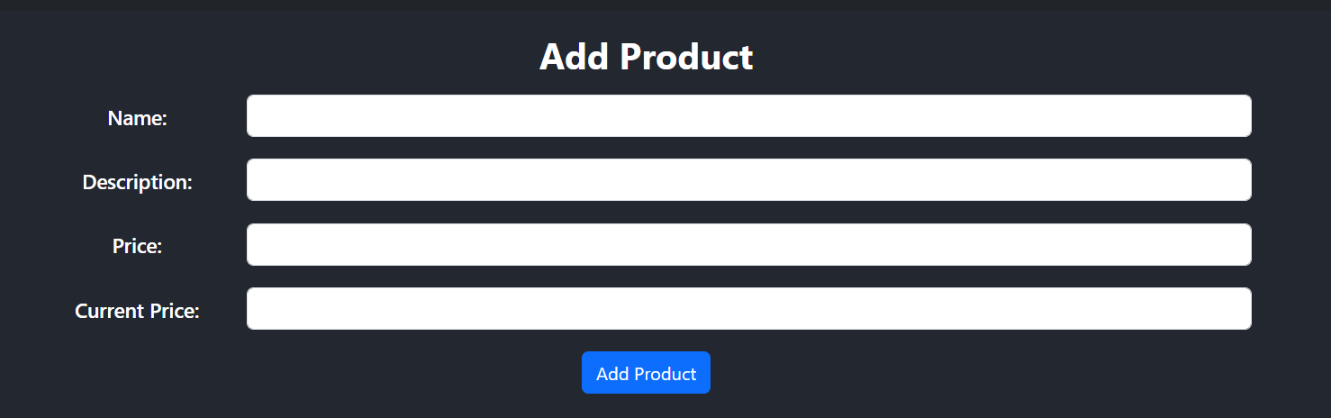
- Product List
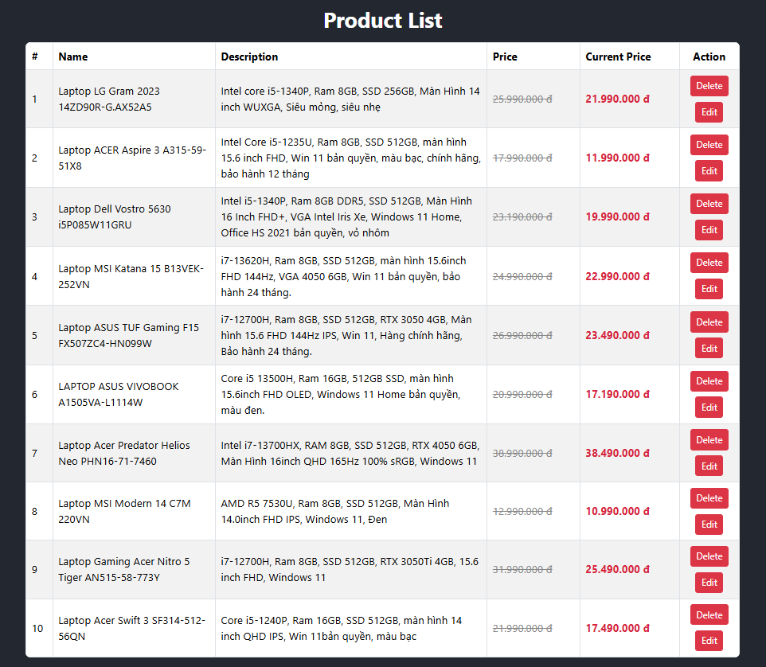

Product Detail
Code:
- Src/components/ProductDetail.jsx
import React, { useEffect, useState } from 'react';
import { useParams, useNavigate } from 'react-router-dom';
import { Container, Button, Alert, Card } from 'react-bootstrap';

function ProductDetail() {
const { id } = useParams();
const navigate = useNavigate();
const [product, setProduct] = useState(null);
const [error, setError] = useState('');

useEffect(() => {
fetch(`http://localhost:3000/products/${id}`)
.then(res => {
if (!res.ok) throw new Error('Product not found');
return res.json();
})
.then(data => setProduct(data))
.catch(() => setError('Product not found'));
}, [id]);

if (error) {
return (
<Container className="d-flex justify-content-center align-items-center" style={{ minHeight: '60vh' }}>
<Alert variant="danger">{error}</Alert>
</Container>
);
}

if (!product) {
return (
<Container className="d-flex justify-content-center align-items-center" style={{ minHeight: '60vh' }}>
<div className="spinner-border text-light" role="status">
<span className="visually-hidden">Loading...</span>
</div>
</Container>
);
}

// Chuyển đổi và tính toán
const price = parseFloat(product.price) || 0;
const currentPrice = parseFloat(product.currentPrice) || 0;
const discountPercentage = price > 0 ? Math.round(((price - currentPrice) / price) * 100) : 0;

return (
<div className="bg-dark text-white d-flex justify-content-center align-items-center" style={{ minHeight: '100vh' }}>
<Card className="text-center p-4 bg-dark border-0" style={{ maxWidth: '600px' }}>
<h2 className="mb-4">{product.name}</h2>

<div className="mb-4">
<Card.Img
variant="top"
src={product.image || 'https://via.placeholder.com/500x300?text=No+Image'}
alt={product.name}
className="img-fluid mx-auto"
style={{ maxHeight: '250px', objectFit: 'contain', backgroundColor: '#fff', padding: '10px', borderRadius: '8px' }}
/>
</div>

<div className="mb-3 text-white">
<p>{product.description || 'No description available.'}</p>
<p><strong>Price:</strong> {product.price} đ</p>
<p><strong>Current Price:</strong> {product.currentPrice} đ</p>
<p><strong>Discount:</strong> {discountPercentage} %</p>
</div>

<div className="d-flex justify-content-center gap-3 mt-3">
<Button variant="primary" onClick={() => navigate('/')}>Back Home</Button>
<Button variant="danger" onClick={() => navigate(`/edit-product/${product.id}`)}>Edit</Button>
</div>
</Card>
</div>
);
}

export default ProductDetail;

Result:

Edit Product
Code:
- Src/components/EditProduct.jsx
import React, { useEffect, useState } from 'react';
import { useParams, useNavigate } from 'react-router-dom';
import axios from 'axios';
import { Container, Row, Col, Button, Spinner, Alert, Form } from 'react-bootstrap';

function EditProduct() {
const { id } = useParams();
const navigate = useNavigate();
const [form, setForm] = useState({ name: '', description: '', price: '', currentPrice: '', image: '' });
const [loading, setLoading] = useState(true);
const [error, setError] = useState('');
const [success, setSuccess] = useState(false);

useEffect(() => {
// Lấy 1 sản phẩm cụ thể theo id từ json-server
axios.get(`http://localhost:3000/products/${id}`)
.then((res) => {
const found = res.data;
setForm({
name: found.name,
description: found.description,
price: found.price,
currentPrice: found.currentPrice,
image: found.image
});
setLoading(false);
})
.catch(() => {
setError('Failed to fetch product.');
setLoading(false);
});
}, [id]);

const handleInputChange = (e) => {
setForm({ ...form, [e.target.name]: e.target.value });
};

const handleSubmit = (e) => {
e.preventDefault();

// Tạo bản sao của form để gửi đi, đảm bảo có đầy đủ dữ liệu
const formData = {
...form,
// Giữ nguyên ảnh cũ nếu không có ảnh mới được chọn
image: form.image || (form.image === undefined ? '' : form.image)
};

axios.put(`http://localhost:3000/products/${id}`, formData)
.then(() => {
setSuccess(true);
setTimeout(() => {
navigate('/products-list');
}, 1000);
})
.catch(() => {
setError('Failed to update product.');
});
};

if (loading) {
return (
<Container className="d-flex justify-content-center align-items-center" style={{ minHeight: '60vh' }}>
<Spinner animation="border" variant="light" />
</Container>
);
}

if (error) {
return (
<Container className="d-flex justify-content-center align-items-center" style={{ minHeight: '60vh' }}>
<Alert variant="danger">{error}</Alert>
</Container>
);
}

return (
<div style={{ background: '#23272f', minHeight: '100vh', padding: 0, margin: 0 }}>
<Container style={{ paddingTop: 30, paddingBottom: 40 }}>
<h2 style={{ color: '#fff', textAlign: 'center', marginBottom: 24, fontWeight: 700 }}>Edit Product</h2>
<Form onSubmit={handleSubmit}>
<Form.Group as={Row} className="mb-3" controlId="formName">
<Form.Label column md={2} style={labelStyle}>Name:</Form.Label>
<Col md={10}>
<Form.Control name="name" value={form.name} onChange={handleInputChange} autoComplete="off" />
</Col>
</Form.Group>
<Form.Group as={Row} className="mb-3" controlId="formDescription">
<Form.Label column md={2} style={labelStyle}>Description:</Form.Label>
<Col md={10}>
<Form.Control as="textarea" rows={2} name="description" value={form.description} onChange={handleInputChange} autoComplete="off" />
</Col>
</Form.Group>
<Form.Group as={Row} className="mb-3" controlId="formPrice">
<Form.Label column md={2} style={labelStyle}>Price:</Form.Label>
<Col md={10}>
<Form.Control name="price" value={form.price} onChange={handleInputChange} autoComplete="off" />
</Col>
</Form.Group>
<Form.Group as={Row} className="mb-3" controlId="formCurrentPrice">
<Form.Label column md={2} style={labelStyle}>Current Price:</Form.Label>
<Col md={10}>
<Form.Control name="currentPrice" value={form.currentPrice} onChange={handleInputChange} autoComplete="off" />
</Col>
</Form.Group>
<div className="mt-3 text-center">
<Button variant="primary" className="me-2" onClick={() => navigate('/')}>Back Home</Button>
<Button type="submit" variant="danger">Save Product</Button>
</div>
{success && <Alert variant="success" className="mt-3">Product updated successfully!</Alert>}
</Form>
</Container>
</div>
);
}

const labelStyle = {
color: '#fff',
fontWeight: 500,
fontSize: 18,
textAlign: 'center',
display: 'flex',
alignItems: 'center',
justifyContent: 'center',
padding: 0
};

export default EditProduct;

Result:
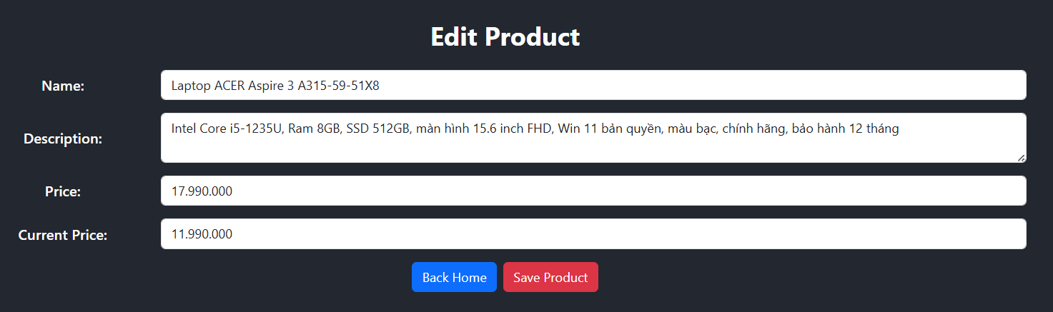

App.js
Code:
- Src/App.js
import React from 'react';
import { BrowserRouter as Router, Routes, Route } from 'react-router-dom';
import Navigation from './components/Navigation';
import Home from './components/Home';
import ProductList from './components/ProductList';
import ProductDetail from './components/ProductDetail';
import EditProduct from './components/EditProduct';

function App() {
return (
<Router>
<Navigation />
<Routes>
<Route path="/" element={<Home />} />
<Route path="/products-list" element={<ProductList />} />
<Route path="/product-detail/:id" element={<ProductDetail />} />
<Route path="/edit-product/:id" element={<EditProduct />} />
</Routes>
</Router>
);
}

export default App;

