Navigation
Code:
- Src/components/Navigation.jsx

- import React from 'react';
- import { Link } from 'react-router-dom';
- import { Navbar, Nav, Container } from 'react-bootstrap';

- const Navigation = () => (
- <Navbar bg="light" variant="light" expand="lg">
- <Container>
- <Navbar.Brand as={Link} to="/">Home</Navbar.Brand>
- <Navbar.Toggle aria-controls="basic-navbar-nav" />
- <Navbar.Collapse id="basic-navbar-nav">
- <Nav className="me-auto">
- <Nav.Link as={Link} to="/about">About</Nav.Link>
- <Nav.Link as={Link} to="/news">News</Nav.Link>
- <Nav.Link as={Link} to="/quizzes">Quiz</Nav.Link>
- <Nav.Link as={Link} to="/contact">Contact</Nav.Link>
- </Nav>
- </Navbar.Collapse>
- </Container>
- </Navbar>
- );

- export default Navigation;

Result:

QuizPage
Code:
- Src/components/QuizPage.jsx
- import React from 'react';
- import { useDispatch, useSelector } from 'react-redux';
- import { selectAnswer, next, prev, first, last, submit } from '../redux/quizSlice';
- import { Container, Row, Col, Button } from 'react-bootstrap';

- const QuizPage = () => {
- const dispatch = useDispatch();
- const { currentIndex, questions } = useSelector(state => state.quiz);
- const current = questions[currentIndex];

- return (
- <Container fluid className="mt-4">
- <Row className="justify-content-center">
- <Col xs={12}>
- <div style={{ background: '#222', color: '#fff', padding: '40px 0', marginBottom: 32 }}>
- <h1 className="text-center" style={{ fontWeight: 600, fontSize: '2.5rem' }}>JavaScript Quiz</h1>
- </div>
- </Col>
- <Col md={10} lg={8}>
- <div className="mb-4">
- <span style={{ fontWeight: 700, fontSize: '1.2rem' }}>Q.{currentIndex + 1} Inside which HTML element do we put the JavaScript?</span>
- </div>
- <Row className="mb-4" xs={1} md={2}>
- {current.options.map((opt, idx) => (
- <Col key={idx} className="mb-3">
- <Button
- variant={current.selected === opt ? 'primary' : 'outline-primary'}
- className="w-100 text-start py-3"
- style={{ backgroundColor: '#e7f1ff', color: '#222', border: current.selected === opt ? '2px solid #0d6efd' : 'none' }}
- onClick={() => dispatch(selectAnswer({ index: currentIndex, answer: opt }))}
- >
- <span style={{ marginRight: 8 }}>
- <input type="radio" checked={current.selected === opt} readOnly style={{ marginRight: 8 }} />
- </span>
- {opt.replace(/<|>/g, match => match === '<' ? '&lt;' : '&gt;')}
- </Button>
- </Col>
- ))}
- </Row>
- <hr />
- <div className="d-flex justify-content-center mb-4 gap-2">
- <Button variant="primary" onClick={() => dispatch(first())}>First</Button>
- <Button variant="primary" onClick={() => dispatch(prev())}>Prev</Button>
- <Button variant="primary" onClick={() => dispatch(next())}>Next</Button>
- <Button variant="primary" onClick={() => dispatch(last())}>Last</Button>
- </div>
- <div className="d-flex justify-content-start gap-2">
- <Button variant="info" onClick={() => window.location.href='/quizzes'}>Quiz</Button>
- <Button variant="info" onClick={() => window.location.href='/quiz/review'}>Quiz Review</Button>
- <Button variant="info" onClick={() => dispatch(submit())}>Submit</Button>
- </div>
- </Col>
- </Row>
- </Container>
- );
- };

- export default QuizPage;

Result:
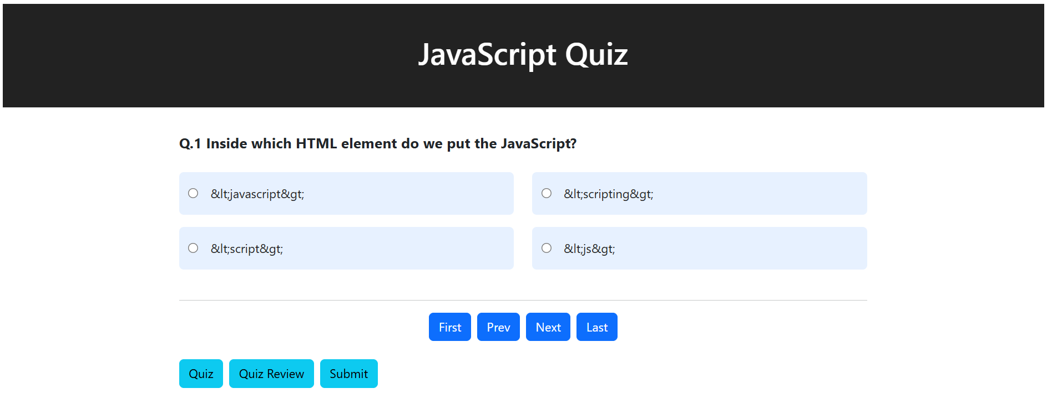
QuizReview
Code:
- Src/components/QuizReview.jsx

- import React from 'react';
- import { useSelector } from 'react-redux';
- import { Container, Row, Col } from 'react-bootstrap';

- const ReviewPage = () => {
- const { questions } = useSelector(state => state.quiz);

- return (
- <Container fluid className="mt-4">
- <Row className="justify-content-center">
- <Col xs={12}>
- <div style={{ background: '#222', color: '#fff', padding: '40px 0', marginBottom: 32 }}>
- <h1 className="text-center" style={{ fontWeight: 600, fontSize: '2.5rem' }}>Quiz Review</h1>
- </div>
- </Col>
- <Col md={10} lg={8}>
- {questions.map((q, idx) => {
- const isCorrect = q.selected === q.correct;
- return (
- <div
- key={q.id}
- style={{
- background: isCorrect ? '#d6f5df' : '#f8d7da',
- borderRadius: 10,
- marginBottom: 20,
- padding: 20,
- border: 'none',
- boxShadow: '0 2px 8px rgba(0,0,0,0.04)'
- }}
- >
- <div style={{ fontWeight: 700, color: isCorrect ? '#155724' : '#842029', fontSize: '1.1rem', marginBottom: 8 }}>
- Q{idx + 1}. {q.question}
- </div>
- <div style={{ marginBottom: 12 }}>
- {q.options.map((opt, i) => {
- const isSelected = q.selected === opt;
- const isAnswer = q.correct === opt;
- return (
- <div key={i} style={{ display: 'flex', alignItems: 'center', marginBottom: 4 }}>
- <input
- type="radio"
- checked={isSelected}
- readOnly
- style={{
- marginRight: 8,
- accentColor: isSelected ? (isAnswer ? '#198754' : '#dc3545') : (isAnswer ? '#198754' : '#adb5bd')
- }}
- />
- <span style={{
- fontWeight: isAnswer ? 700 : 400,
- color: isAnswer ? '#155724' : (isSelected ? (isCorrect ? '#155724' : '#842029') : '#222'),
- opacity: isAnswer || isSelected ? 1 : 0.6,
- textDecoration: !isAnswer && !isSelected ? 'line-through' : 'none'
- }}>
- {opt}
- </span>
- </div>
- );
- })}
- </div>
- <div style={{ background: '#e9ecef', borderRadius: 5, padding: 8, fontWeight: 500, color: '#222', marginTop: 8 }}>
- Right answer is: <span style={{ fontWeight: 700 }}>{q.correct}</span>
- </div>
- </div>
- );
- })}
- </Col>
- </Row>
- </Container>
- );
- };

- export default ReviewPage;

Result:
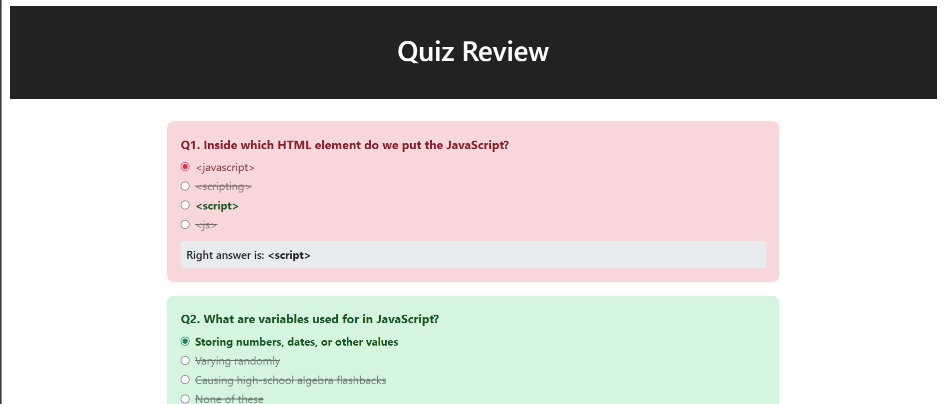

quizSlice
Code:
- Src/redux/quizSlice.jsx
- import { createSlice } from '@reduxjs/toolkit';

- const initialState = {
- currentIndex: 0,
- showResult: false,
- questions: [
- {
- id: 1,
- question: 'Inside which HTML element do we put the JavaScript?',
- options: ['<javascript>', '<scripting>', '<script>', '<js>'],
- correct: '<script>',
- selected: null
- },
- {
- id: 2,
- question: 'What are variables used for in JavaScript?',
- options: [
- 'Storing numbers, dates, or other values',
- 'Varying randomly',
- 'Causing high-school algebra flashbacks',
- 'None of these'
- ],
- correct: 'Storing numbers, dates, or other values',
- selected: null
- }
- // có thể thêm nhiều câu hơn ở đây
- ]
- };

- const quizSlice = createSlice({
- name: 'quiz',
- initialState,
- reducers: {
- selectAnswer: (state, action) => {
- const { index, answer } = action.payload;
- state.questions[index].selected = answer;
- },
- next: (state) => {
- if (state.currentIndex < state.questions.length - 1) state.currentIndex += 1;
- },
- prev: (state) => {
- if (state.currentIndex > 0) state.currentIndex -= 1;
- },
- first: (state) => {
- state.currentIndex = 0;
- },
- last: (state) => {
- state.currentIndex = state.questions.length - 1;
- },
- submit: (state) => {
- state.showResult = true;
- }
- }
- });

- export const { selectAnswer, next, prev, first, last, submit } = quizSlice.actions;
- export default quizSlice.reducer;

Code:
- Src/redux/store.jsx
- // src/redux/store.js
- import { configureStore } from '@reduxjs/toolkit';
- import quizReducer from './quizSlice';

- const store = configureStore({
- reducer: {
- quiz: quizReducer,
- },
- });

- export default store;

App.js
Code:
- Src/App.jsx
- import React from 'react';
- import { BrowserRouter as Router, Routes, Route } from 'react-router-dom';

- import QuizPage from './components/QuizPage';
- import ReviewPage from './components/ReviewPage';
- import Navigation from './components/Navigation';
- import './App.css';

- const About = () => <div className="container mt-4"><h2>About</h2><p>This is the About page.</p></div>;
- const News = () => <div className="container mt-4"><h2>News</h2><p>This is the News page.</p></div>;
- const Contact = () => <div className="container mt-4"><h2>Contact</h2><p>This is the Contact page.</p></div>;

- function App() {
- return (
- <Router>
- <div>
- <Navigation />
- <Routes>
- <Route path="/" element={<QuizPage />} />
- <Route path="/about" element={<About />} />
- <Route path="/news" element={<News />} />
- <Route path="/contact" element={<Contact />} />
- <Route path="/quizzes" element={<QuizPage />} />
- <Route path="/quiz/review" element={<ReviewPage />} />
- </Routes>
- </div>
- </Router>
- );
- }

- export default App;

Index.js
Code:
- Src/index.jsx

- import React from 'react';
- import ReactDOM from 'react-dom/client';
- import App from './App';
- import { Provider } from 'react-redux';
- import store from './redux/store';
- import './index.css';
- import 'bootstrap/dist/css/bootstrap.min.css';

- const root = ReactDOM.createRoot(document.getElementById('root'));
- root.render(
- <Provider store={store}>
- <App />
- </Provider>
- );

