Navigation
Code:
- Src/components/Navigation.jsx
- import React from 'react';
- import { Link } from 'react-router-dom';
- import { Navbar, Nav, Container } from 'react-bootstrap';

- const Navigation = () => {
- return (
- <Navbar bg="dark" variant="dark" expand="lg">
- <Container>
- <Navbar.Brand as={Link} to="/">CartApp</Navbar.Brand>
- <Nav className="me-auto">
- <Nav.Link as={Link} to="/">Products</Nav.Link>
- <Nav.Link as={Link} to="/add">Add Product</Nav.Link>
- <Nav.Link as={Link} to="/cart">Cart</Nav.Link>
- </Nav>
- </Container>
- </Navbar>
- );
- };

- export default Navigation;

Result:
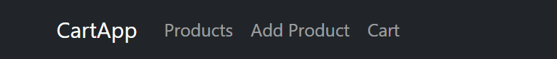

Add Product
Code:
- Src/components/ProductForm.jsx
- import React, { useState } from 'react';
- import { useDispatch } from 'react-redux';
- import { addProduct } from '../redux/Actions';
- import { useNavigate } from 'react-router-dom';
- import { Form, Button } from 'react-bootstrap';

- const ProductForm = () => {
- const [form, setForm] = useState({
- id: '',
- name: '',
- price: '',
- description: '',
- catalogs: '',
- });

- const dispatch = useDispatch();
- const navigate = useNavigate();

- const handleChange = (e) => {
- setForm({...form, [e.target.name]: e.target.value });
- };

- const handleSubmit = (e) => {
- e.preventDefault();
- const newProduct = {
- ...form,
- price: parseFloat(form.price),
- catalogs: form.catalogs.split(',').map(c => c.trim()),
- };
- dispatch(addProduct(newProduct));
- navigate('/');
- };

- return (
- <>
- <h3>Add New Product</h3>
- <Form onSubmit={handleSubmit}>
- <Form.Group className="mb-2">
- <Form.Label>ID</Form.Label>
- <Form.Control name="id" value={form.id} onChange={handleChange} required />
- </Form.Group>

- <Form.Group className="mb-2">
- <Form.Label>Name</Form.Label>
- <Form.Control name="name" value={form.name} onChange={handleChange} required />
- </Form.Group>

- <Form.Group className="mb-2">
- <Form.Label>Price</Form.Label>
- <Form.Control name="price" value={form.price} onChange={handleChange} type="number" step="0.01" required />
- </Form.Group>

- <Form.Group className="mb-2">
- <Form.Label>Description</Form.Label>
- <Form.Control name="description" value={form.description} onChange={handleChange} />
- </Form.Group>

- <Form.Group className="mb-2">
- <Form.Label>Catalogs (comma-separated)</Form.Label>
- <Form.Control name="catalogs" value={form.catalogs} onChange={handleChange} />
- </Form.Group>

- <Button type="submit" variant="primary">Add Product</Button>
- </Form>
- </>
- );
- };

- export default ProductForm;

Result:
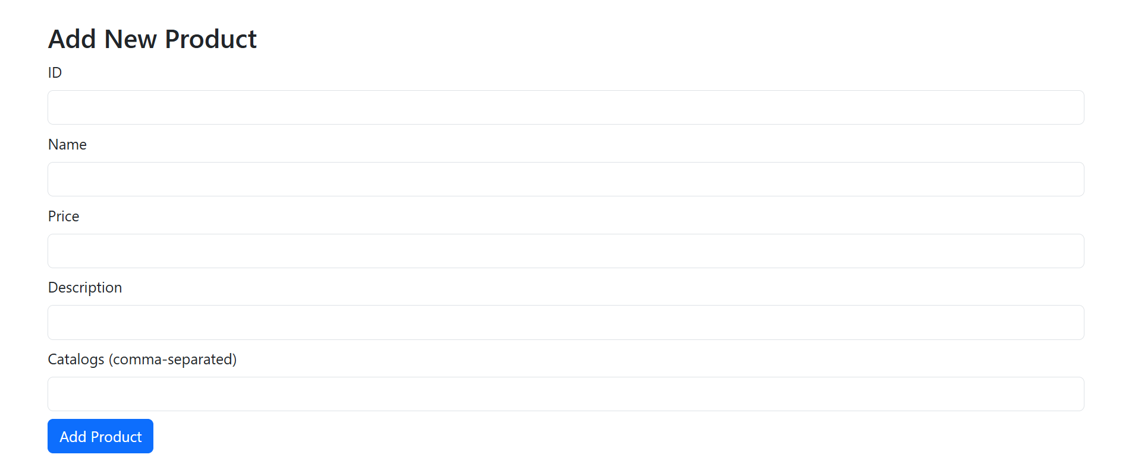
Cart
Code:
- Src/components/Cart.jsx
- import React from 'react';
- import { useSelector } from 'react-redux';
- import { Table } from 'react-bootstrap';

- const Cart = () => {
- const cartItems = useSelector(state => state.cart);

- const total = cartItems.reduce((sum, item) => sum + item.price, 0);

- return (
- <>
- <h3>Your Cart</h3>
- <Table striped bordered hover>
- <thead>
- <tr>
- <th>#</th>
- <th>Name</th>
- <th>Price</th>
- <th>Catalogs</th>
- </tr>
- </thead>
- <tbody>
- {cartItems.map((p, idx) => (
- <tr key={idx}>
- <td>{idx + 1}</td>
- <td>{p.name}</td>
- <td>${p.price.toFixed(2)}</td>
- <td>{p.catalogs.join(', ')}</td>
- </tr>
- ))}
- </tbody>
- </Table>
- <h5>Total: ${total.toFixed(2)}</h5>
- </>
- );
- };

- export default Cart;

Result:
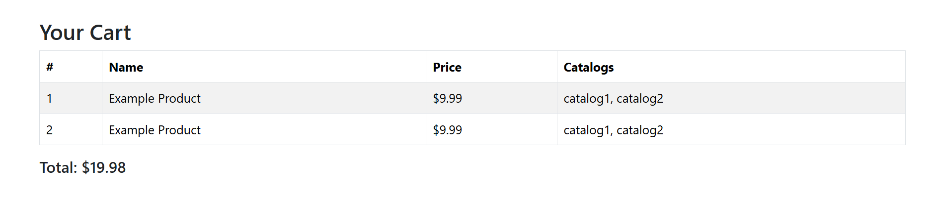

Products
Code:
- Src/components/ProductList.jsx
- import React, { useEffect } from 'react';
- import { useDispatch, useSelector } from 'react-redux';
- import { loadProducts, addToCart } from '../redux/Actions';
- import { Card, Button, Row, Col } from 'react-bootstrap';

- const ProductList = () => {
- const dispatch = useDispatch();
- const products = useSelector(state => state.products);

- useEffect(() => {
- if (products.length === 0) {
- dispatch(loadProducts());
- }
- }, [dispatch, products.length]);

- return (
- <Row>
- {products.map(product => (
- <Col md={4} key={product.id}>
- <Card className="mb-3">
- <Card.Body>
- <Card.Title>{product.name}</Card.Title>
- <Card.Text>{product.description}</Card.Text>
- <Card.Text>Price: ${product.price}</Card.Text>
- <Card.Text>
- Catalogs: {product.catalogs.join(', ')}
- </Card.Text>
- <Button onClick={() => {
- dispatch(addToCart(product));
- alert(`Add ${product.name} to cart success!`);
- }}>
- Add to Cart
- </Button>
- </Card.Body>
- </Card>
- </Col>
- ))}
- </Row>
- );
- };

- export default ProductList;

Result:
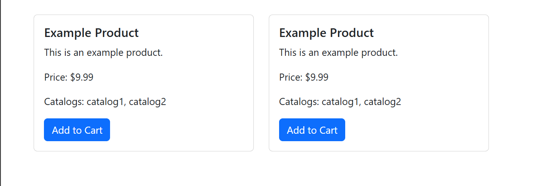

**Redux**:
Code:
- Src/redux/Actions.jsx
- // Action types
- export const ADD_PRODUCT = 'ADD_PRODUCT';
- export const ADD_TO_CART = 'ADD_TO_CART';
- export const LOAD_PRODUCTS = 'LOAD_PRODUCTS';

- // Async Action (Thunk)
- export const loadProducts = () => {
- return (dispatch) => {
- // simulate API
- setTimeout(() => {
- const products = [
- {
- id: '123456',
- name: 'Example Product',
- price: 9.99,
- description: 'This is an example product.',
- catalogs: ['catalog1', 'catalog2'],
- },
- ];
- products.forEach(product => {
- dispatch({ type: ADD_PRODUCT, payload: product });
- });
- }, 500);
- };
- };

- export const addProduct = (product) => ({
- type: ADD_PRODUCT,
- payload: product,
- });

- export const addToCart = (product) => ({
- type: ADD_TO_CART,
- payload: product,
- });

- Src/redux/Reducers.jsx
- import { ADD_PRODUCT, ADD_TO_CART } from './Actions';

- const initialProductState = [];

- export const productReducer = (state = initialProductState, action) => {
- switch (action.type) {
- case ADD_PRODUCT:
- return [...state, action.payload];
- default:
- return state;
- }
- };

- const initialCartState = [];

- export const cartReducer = (state = initialCartState, action) => {
- switch (action.type) {
- case ADD_TO_CART:
- return [...state, action.payload];
- default:
- return state;
- }
- };

- Src/redux/Store.jsx
- import { createStore, applyMiddleware, combineReducers } from 'redux';
- import { thunk } from 'redux-thunk';

- import { productReducer, cartReducer } from './Reducers';

- const rootReducer = combineReducers({
- products: productReducer,
- cart: cartReducer,
- });

- const Store = createStore(rootReducer, applyMiddleware(thunk));

- export default Store;

App.js
Code:
- Src/App.jsx
- import React from 'react';
- import { BrowserRouter as Router, Routes, Route } from 'react-router-dom';
- import { Container } from 'react-bootstrap';

- import ProductForm from './components/ProductForm';
- import Cart from './components/Cart';
- import ProductList from './components/ProductList';
- import Navigation from './components/Navigation';

- const App = () => (
- <Router>
- <Navigation />
- <Container className="mt-4">
- <Routes>
- <Route path="/" element={<ProductList />} />
- <Route path="/add" element={<ProductForm />} />
- <Route path="/cart" element={<Cart />} />
- </Routes>
- </Container>
- </Router>
- );

- export default App;

Index.js
Code:
- Src/App.jsx
- import React from 'react';
- import ReactDOM from 'react-dom/client';
- import App from './App';
- import { Provider } from 'react-redux';
- import store from './redux/Store';
- import 'bootstrap/dist/css/bootstrap.min.css';

- const root = ReactDOM.createRoot(document.getElementById('root'));

- root.render(
- <React.StrictMode>
- <Provider store={store}>
- <App />
- </Provider>
- </React.StrictMode>
- );

Navigation
Code:
- Src/components/Navigation.jsx
Result:

Navigation
Code:
- Src/components/Navigation.jsx
Result:

Navigation
Code:
- Src/components/Navigation.jsx
Result:

