**Họ tên: Vũ Bảo Lâm**

**Mã sinh viên: 211241205**

**Lớp: N03 – IT1**

**Lab 5**

1. Lab 5.1

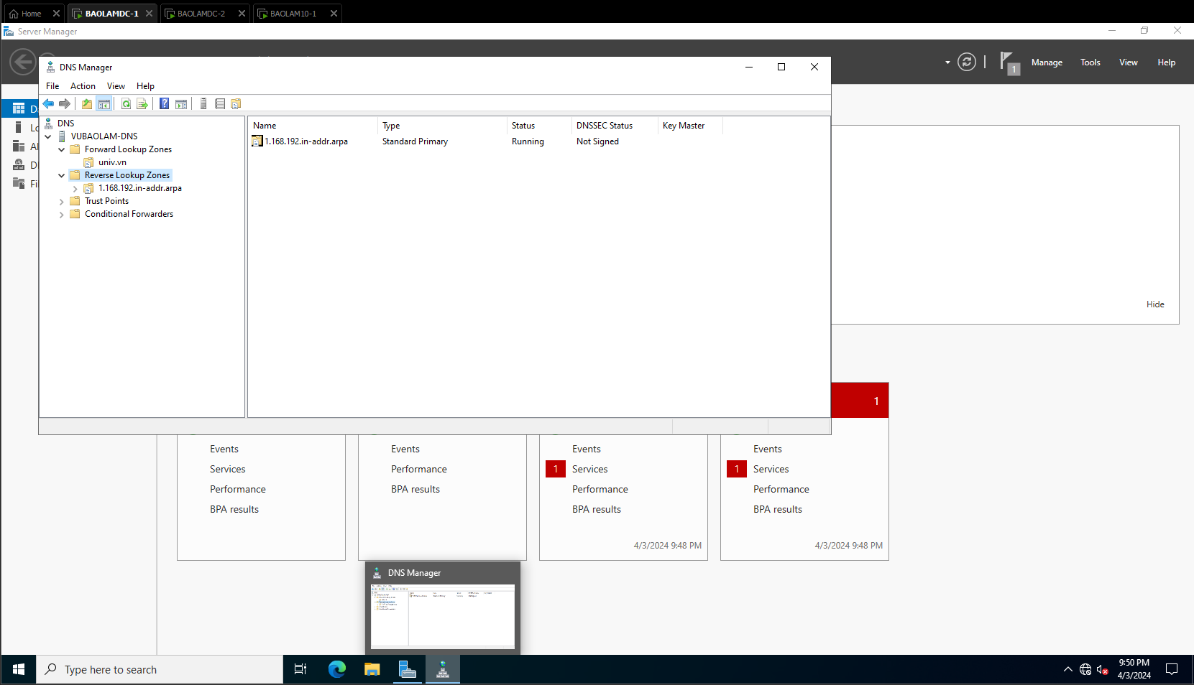

Bước 2: Kiểm tra trên máy Win 10-1

Bước 3: Cấu hình Backup DNS trên máy DNS-2

1. Lab 5.2

Cấu hình DHCP

Cấu hình DNS

Univ.vn

Student.vn

Hanoi.com

Bước 2: Cấu hình dịch vụ web

Kiểm tra:

1. Lab 5.3

Bước 1

Bước 2: Cấu hình mail

Bước 3: Cấu hình trên máy DNS

