# 40个超赞的国外经典的HTML5实例教程

想索取更多相关资料请加qq：649085085或登录<http://www.bj-accp.com>

PS;本文档由北大青鸟广安门收集自互联网，仅作分享之用。

在这个教程列表上我们为您收集了最具有代表性的各类型HTML5免费教程，它们会帮助你更好的利用html5来优化完善你的web项目，而且让人惊喜的是HTML5的一些热门特性都在这些案例里面体现出来了，相信这些前沿的交互细节会为你的项目锦上添花!教程都很详细，您可以按着它们的详细指南一步步制作，来挑选你的法宝吧。

　　Making a Beautiful HTML5 Portfolio

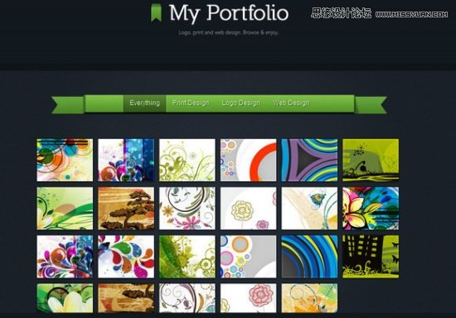

　　Create offline Web applications on mobile devices with HTML5

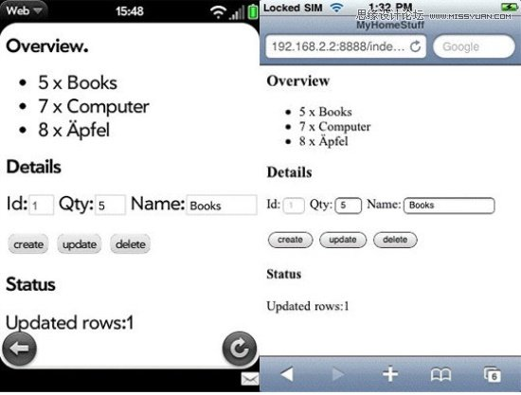

　　Growing Thumbnails Portfolio

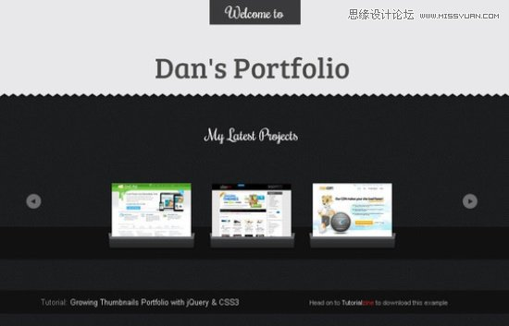

　　HTML5 Unleashed: Tips, Tricks and Techniques



　　Create a Stylish Contact Form with HTML5 & [CSS](http://webdesign.chinaitlab.com/List_1367.html)3

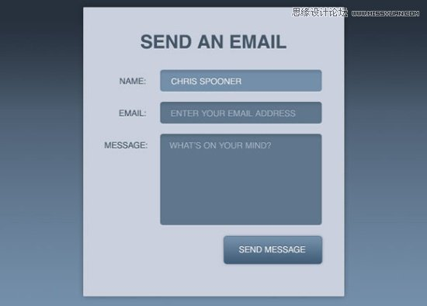

　　Create Vector Masks using the HTML5 Canvas



　　HTML5 File Uploads with jQuery

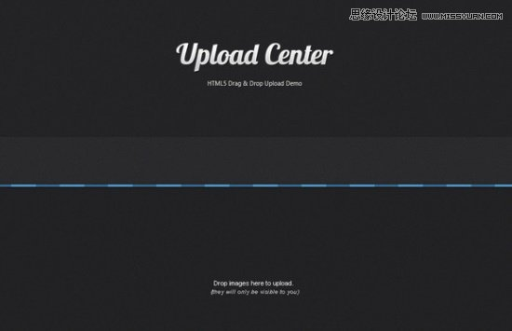

　　Create a Grid Based Web Design in HTML5 & [CSS](http://webdesign.chinaitlab.com/List_1367.html)3

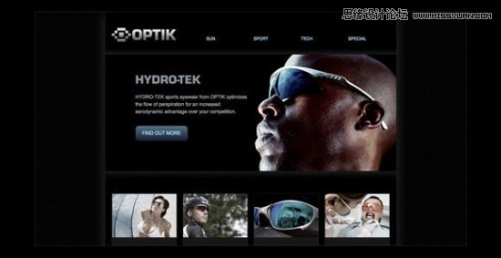

　　Designing a Blog with HTML5

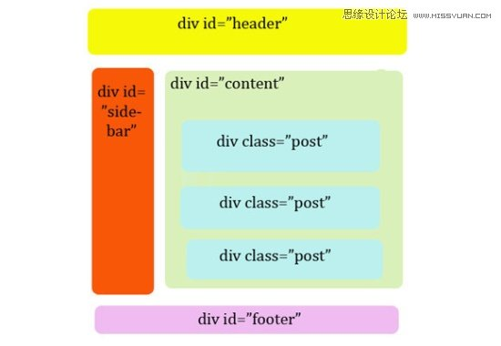

　　How to Build Cross-Browser HTML5 Forms

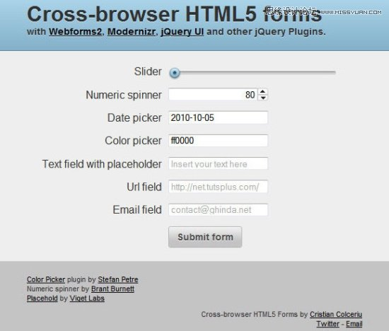

　　Implementing HTML5 Drag and Drop

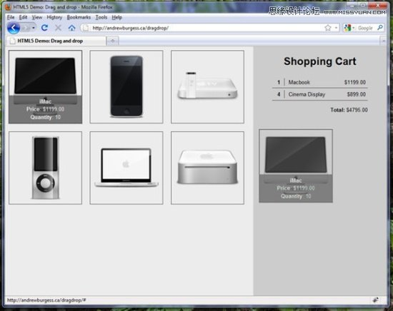

　　Coding a [CSS](http://webdesign.chinaitlab.com/List_1367.html)3 & HTML5 One-Page Website Template

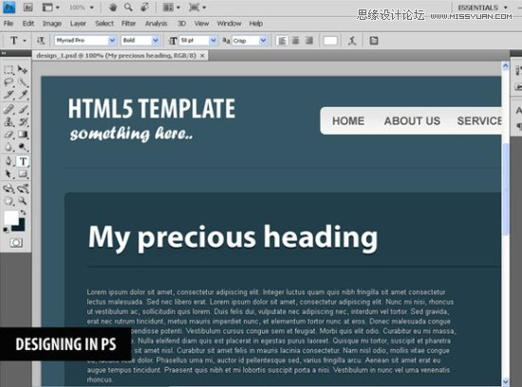

　　HTML5 and CSS3 Without Guilt

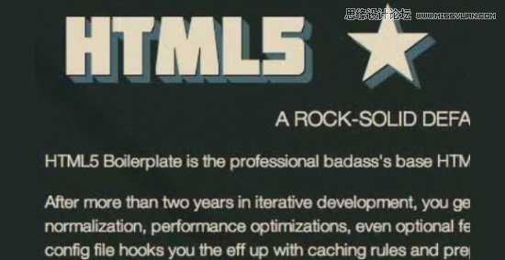

　　How to Make an HTML5 iPhone App

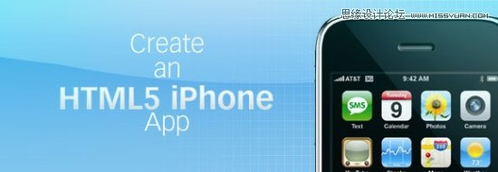

　　Design & Code a Cool iPhone App Website in HTML5

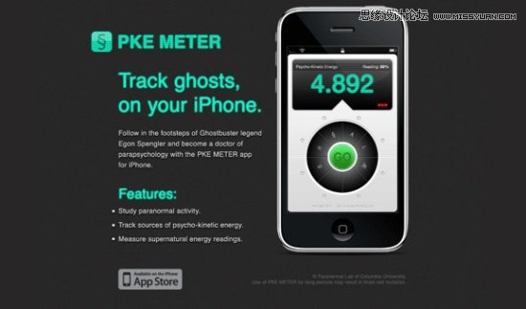

　　Have a Field Day with HTML5 Forms

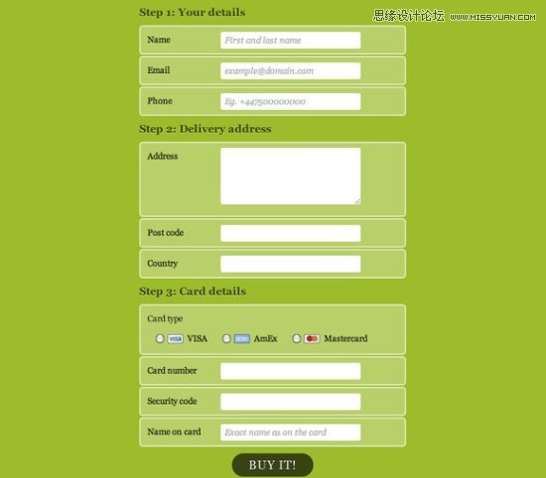

　　HTML 5 and CSS 3: The Techniques You’ll Soon Be Using

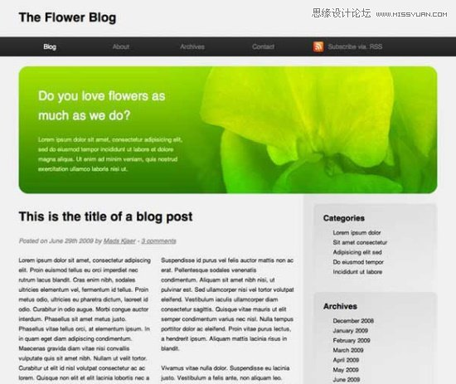

　　HTML5 Canvas Element Guide



　　Bouncing a Ball Around with HTML5 and [Java](http://java.chinaitlab.com/)Script

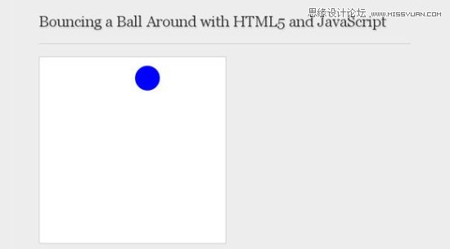

　　Blowing up HTML5 video and mapping it into 3D space

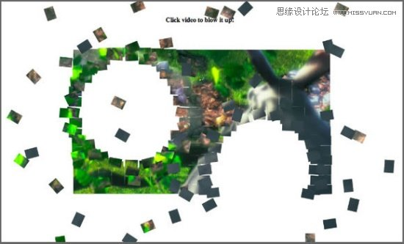

　　Code a Backwards Compatible, One Page Portfolio with HTML5 and CSS3



　　Code a Vibrant Professional Web Design with HTML5/CSS3

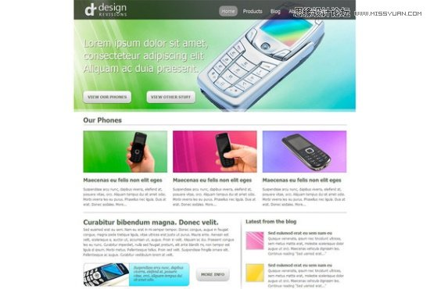

　　Simple Website Layout Tutorial Using HTML 5 and CSS 3

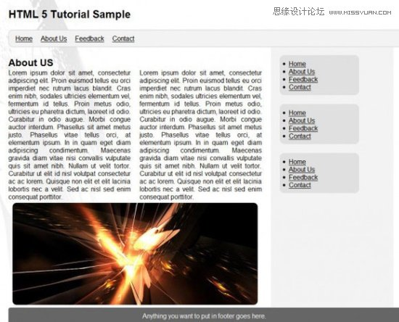

　　How to Draw with HTML 5 Canvas



　　The video element

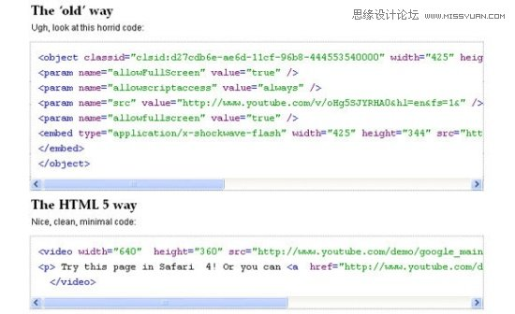

　　Building a live news blogging system in php

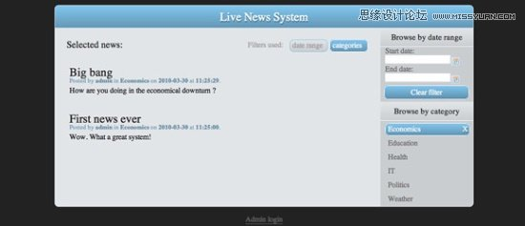

　　Combining Modern CSS3 and HTML5 Techniques

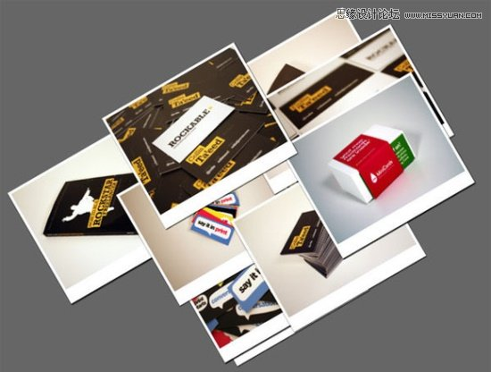

　　webOS HTML5 Database Storage Tutorial

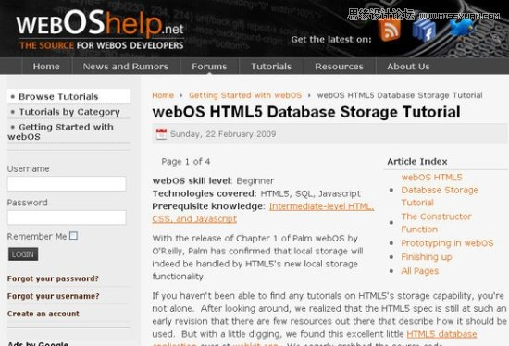

　　The Official Guide to HTML5 Boilerplate

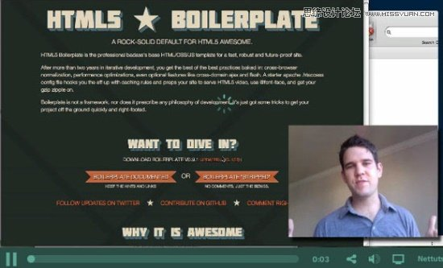

　　How To Create a Cute Popup Bar With HTML5, CSS3 and jQuery

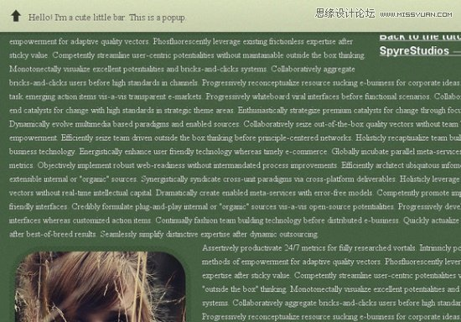

　　An HTML5 Slideshow with Canvas & jQuery

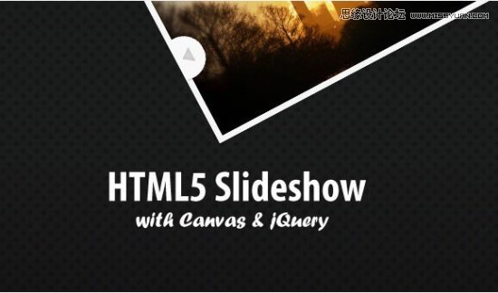

　　Designing Search Boxes with HTML5 and CSS3

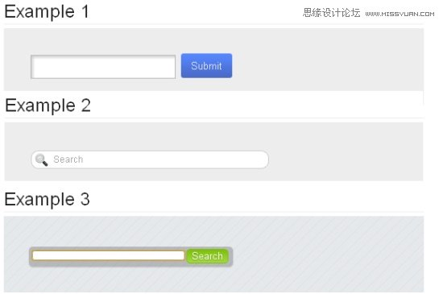

　　Rethinking Forms in HTML5

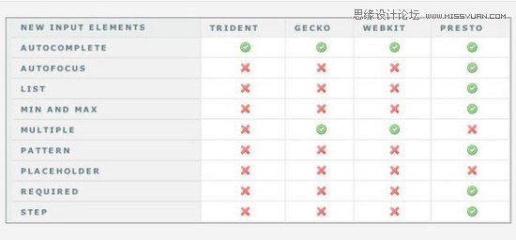

　　HTML 5 Tutorial for Web Developers: The Video Element

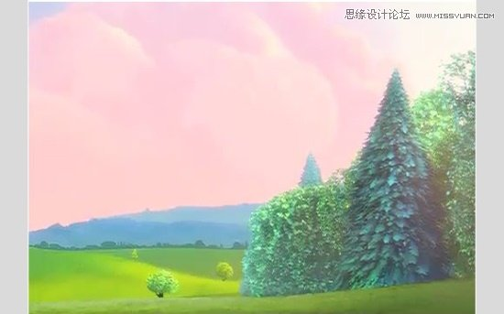

　　HTML5 Apps: Positioning with Geolocation

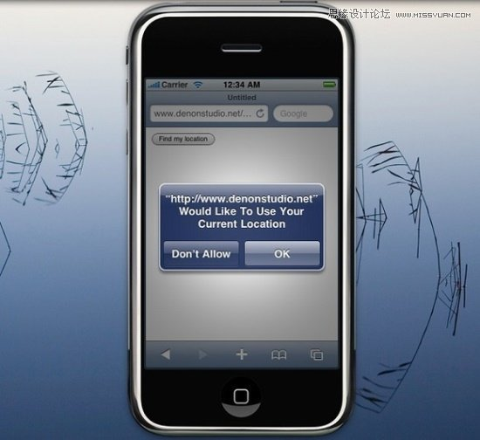

　　How to Make All Browsers Render HTML5 Correctly — Even IE6!

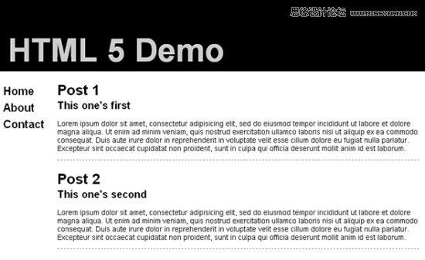

　　Coding Up a Web Design Concept into HTML & CSS

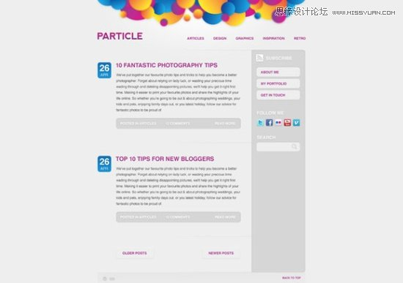

　　HTML5 Visual Cheat Sheet

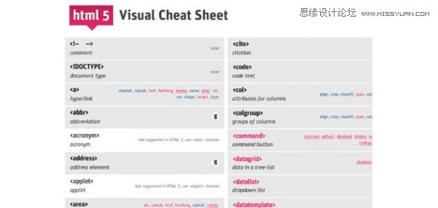

　　HTML5 Canvas Experiment

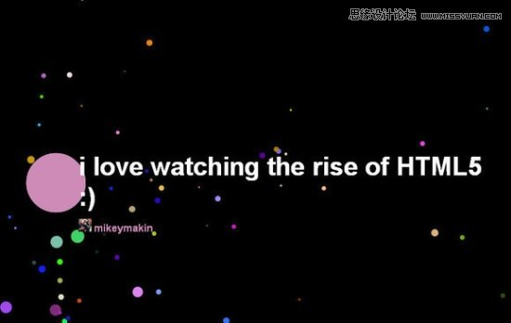

　　How to Create a Drop-down Nav Menu

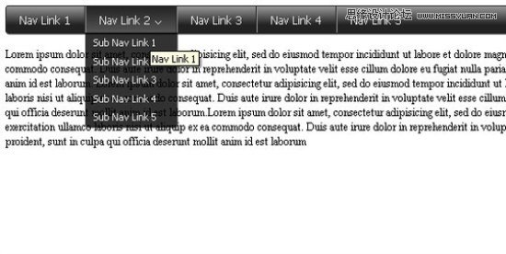

想索取更多相关资料请加qq：649085085或登录<http://www.bj-accp.com>

PS;本文档由北大青鸟广安门收集自互联网，仅作分享之用。