**Eproject**

**E-Project for <** Semester 2**>**

---

**<PROJECT NAME>**

---

|  |  |
| --- | --- |
| **Authors** | **Aptech – C2310L - Group : 4** |
| 1. < BAO TRAN GIA> - < Student1545951 > [(Leader)]  2. < BAO LE GIA> - < Student1291693 >  3. < THIEN NGUYEN THANH > - < Student1545352 >  4. < HUNG NGUYEN XUAN MINH > -< Student1527956 > |
| **Centre Name** | Aprotrain Aptech |
| **Date** | <day month, year> |
| Course | ACCP |
| Curriculum Code | OV-7091-ADSE |
| **Semester** | Semester 2 |
| **Instructor** | NGUYEN TRUONG KHAC NGOC |

**Ho Chi Minh City, DD/MM/YYY**



**TABLE OF CONTENTS**

Clearly organized list of document sections and subsections

**I. Introduce eProject – Project name:**...................................................................... 3 1. Problem definition of project .................................................................................. 3 2. List of Inputs to the Website ................................................................................... 3 3. List of Outputs Expected from the Website ............................................................ 3 4. Overview of Processes Involved in the Website ..................................................... 3 5. Hardware and Software Required for Implementing the Project............................ 4 6. Flow chart................................................................................................................ 4 7. Table assigning tasks to members (Leader) ............................................................ 5

**II. Instruction to run the project**................................................................................ 6 1. Import database and tables into SQL Server............................................................ 6 2. Import Project into Visual Studio ............................................................... 7 3. Run Web Application (Web Admin): ............................................................... 9

*a. Login ................................................................................................................ 9 b. Manage Information of Claims/ Orders/ Customers ..................................... 10* 4. Run Web Application (Web User): ........................................................................ 14 *a. Home Page .................................................................................................... 15 b. Login.............................................................................................................. 17 c. Forgot Password ........................................................................................... 18 d. Register.......................................................................................................... 19 e. Profile/Personal Order/ Change Password/ Logout..................................... 19 f. Insurance Plan Page ..................................................................................... 21 g. About Us Page............................................................................................... 29 h. Contact Us Page............................................................................................ 30* 5. Database ............................................................................................................... 29 *a. ER Diagram................................................................................................... 29 b. Detail of Tables............................................................................................. 30* 6. Contributions........................................................................................................ 32



 **INTRODUCE EPROJECT – PROJECT NAME**

**1. Problem definition of project:** (Introduce project)

**2. List of Inputs to the Website:**

✓ Admin: (example below)

• Login.

• Create/Read/Update/Delete(CRUD) Account/Orders of User.

• Manage contents of About Us, Contact Us, Claims.

✓ User: (example below)

• Register/Login/Change Password.

• Buy

• Pay

**3. List of Outputs Expected from the Website**

✓ Admin:

✓ User:

**4. Overview of Processes Involved in the Website** (example below) • Manage Accounts and Orders of Users.

• Manage contents of About Us, Contact Us, Requests/Claims.

• Register, Login/Change Password.

• Users paid money.





**5. Hardware and Software Required for Implementing the Project** ✓ Hardware: (example below)

• 64 Megabytes of RAM or better.

• Dot Net Framework.

✓ Software:

• Visual Studio 2019.

• Microsoft SQL Server Management Studio 18.

**6. Flow chart of User**

✓ Admin: (example below)

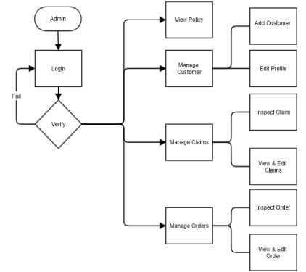

✓ User: (example below)

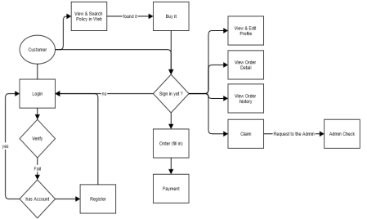**7. Table assigning tasks to members (for Leader)** (example below)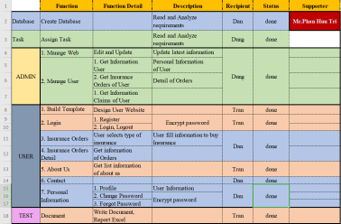

**INSTRUCTION TO RUN THE PROJECT**

**1. Import database and tables into SQL Server** (example below)

You open ProjectSem3_NGO.sql file that We sent with SQL Server. It looks like this:

Create a **new Database with the same name as the SQL file** I sent you: **OnlineInsuranceDB**



Then, **press Execute** 

to **Run**

This is **Run success**

**2. Import Project into Visual Studio** (example below)

You open OnlineInsurance_Server.sln folder then double click on

OnlineInsurance_Server.sln file. It will open Visual Studio along with

OnlineInsurance_Server.sln.

Open **Solution Explorer** → Right click on 

**Dependencies** → Choose **Manage NuGet**

**Packages**… → Choose **Browse**

→ install **Libraries** 

Then, double click on

**appsetting.json** → add



**ConnectionStrings** and please

**REPAIR:**

**Server:** Server name of SQL Server 

Management Studio in your computer.

**Database:** Name of sql file we send with SQL Server

Management Studio.

**user id:** must use ‘sa’.

**password:** your ‘sa’ password.

After that, add **Paypal **



Choose **Tools** in 

Visual’s menu

→ choose NuGet

Package Manager

→ choose Package

Manager Console

**Add this statement** with:

**Server:** Server name of SQL Server

Management Studio in your computer.

**Database:** Name of sql file we send with SQL Server

Management Studio.



**Database:** Name of sql file we send with SQL

Server Management Studio + Context:

**OnlineInsuranceDBContext**





**3. Run Web Application (Web Admin):** (example below)

a. Login

Login Admin Account



b. Manage Information of Claims/Customers/ Orders

Claim



Edit Claim

Customers



Edit Customers



Orders



Edit Orders



OrderDetail of Orders



Edit OrderDetail of Orders



Policies

After each Edit, click ‘Save Change’ to save your changes (admin)





**4. Run Web Application (Web User):** (example below)

a. Home Page:

First, our website has 3 default sections: header, body, footer. The header and footer are default sections.

Header includes: website logo, website name, phone number, website menu and social links.

Body includes: greeting, website images



Introduction about the website



Introduce about services that the website provides



Our target



Footer includes:



b. Login

Look at the menu and click on ‘Login’ in website menu, fill your right email and password then click Login button, you can sign in your account.

If you forgot your password, click ‘I forgot my password’ to recover your password.

If you don't have any account before, click ‘Register a new membership’ to register a new account.

If you want to back to the Home page, click ‘Back to Home’.

If you forgot your password, click ‘I forgot my password’.



c. Forgot Password

Fill your right mail and click Request new password button to confirm. Then, change a new password

d. Register

Look at the menu and click on ‘Register’ in website menu, fill your right information, then click Register button, you can register a new account.

If you want to go back to the Home page, click ‘Back to Home’.





e. Personal Information/Change Password/ Personal Order

When you login success, Welcome button on the menu will appear, click there will be a page containing personal information, change password and log out your account from the site.

User can see their information here: Profile.



My Order: it show your orders information when you bought insurance. Change Password

Logout: when you want to leave your account





f. Insurance Plan Page

Introduce benefits of our insurance, show four type of insurance and their detail. Click ‘See Details’ to see detailed information about insurance and buy it if you want. Details of each insurance includes Detail, Provision, Price, Use Time.





Detail



Provision





Price



Use Time

Click ‘Buy Now’ to buy insurance. Fill your right information, [**note**: Type Payment includes 2 type: Pay off and Installment, please careful], then click ‘Buy Now’in the end of the form

This is Pay Off



This is Installment



Click on ‘PayPal’ to pay







After user pay by PayPal, click on **My Order** like this:



Detail Order of My Order:

This is Pay Off





This is Installment: User paid: 4$ in first month (total: 5 months),

**Now User want to Pay Off**

****After click ‘Buy Now’, this is the Detail of Installment





Users can choose to Pay Off for an Installment Order



Claim Insurance: User can send request to Website Manager (Admin)



g. About Us Page



h. Contact Us Page



**5. Database**

**a. ER Diagram**



**b. Detail of Tables**









**CONTRIBUTIONS**

|  |  |  |
| --- | --- | --- |
| **No.** | **Team Member Name** | **Contributions** |
| **1** | **[Member Name 1]** | - User interface (UI/UX) design and user experience. |
|  | - Coding for the user  management module. |  |
|  | - Participation in testing and bug fixing. |  |
| **2** | **[Member Name 2]** | - Development of search and data sorting features. |
|  | - Building API for  integration with external systems. |  |
|  | - Writing detailed  documentation for API and integration. |  |
| **3** | **[Member Name 3]** | - Database construction and data schema design. |
|  | - Coding for the post  management module. |  |
|  | - Contribution to the  automated testing process. |  |

**Tips for Writing Documentation:**

**Use Clear Language:**

Write in a clear and concise manner.

Avoid jargon that might not be familiar to your target audience.

**Include Visuals:**

Use diagrams, charts, and screenshots to illustrate concepts.

Visuals aid understanding and make the documentation more engaging.

**Collaborate:**

If it's a team project, collaborate on documentation to ensure a comprehensive and well-rounded perspective.

**Follow a Style Guide:**

Adopt a consistent writing style and format throughout the documentation.

