Tấn Công

* **DLG:**

Paper: <https://arxiv.org/pdf/1906.08935>

Github: <https://github.com/mit-han-lab/dlg>

Code 1: <https://colab.research.google.com/drive/1DclXdceFcAbetwQ9bMF_L7przdw1ok-m#scrollTo=Tstw5CoD3lWo>

Code 2:

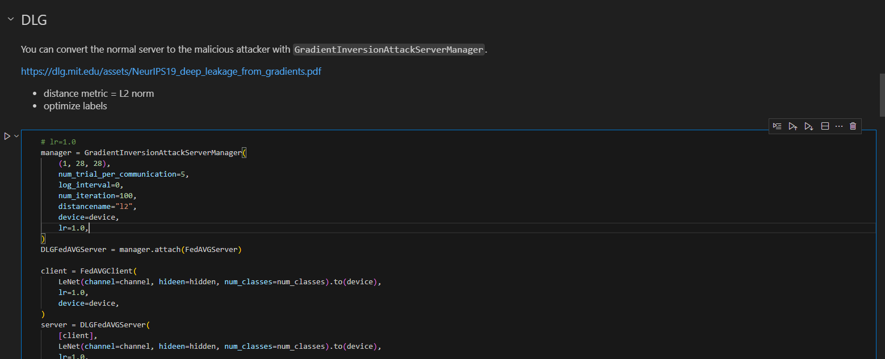  
…  
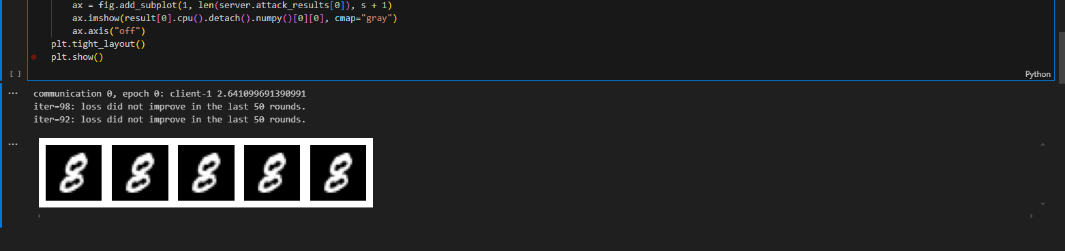

So sánh (by chat-gpt)

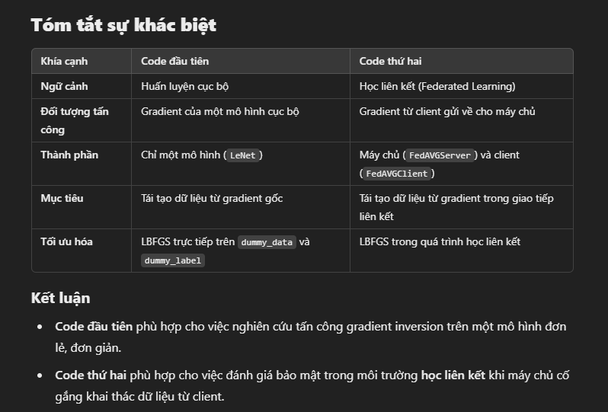

* **iDLG:**

Paper:

Github: