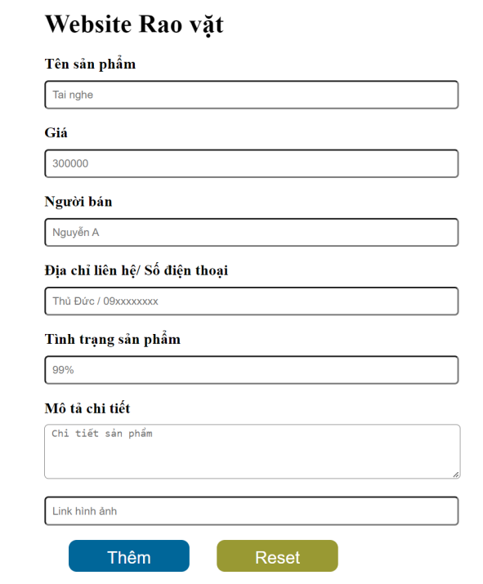
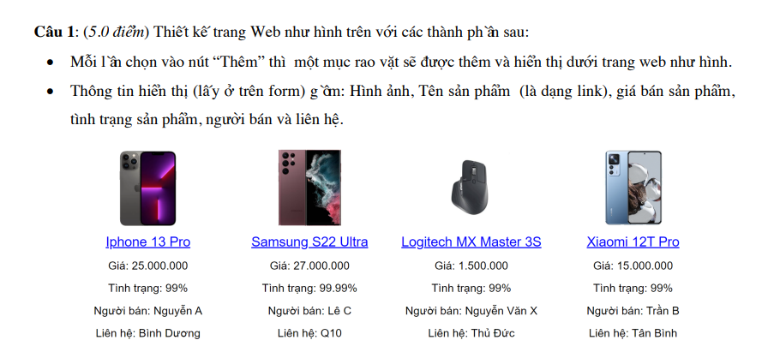
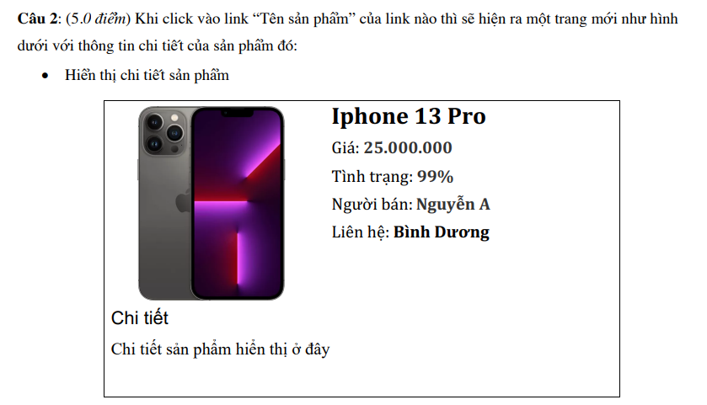
<!DOCTYPE html>
<html>
<head>
<meta charset="utf-8">
<title>De2GK</title>
<script src="https://code.jquery.com/jquery3.7.1.js">
</script>
<style>
html {
font-family: Arial, Helvetica, sans-serif;
display: flex;
justify-content: center;
align-items: center;
}

body {
display: flex;
flex-direction: column;

align-items: center;
}

#inputContainer {
width: 30%;
display: flex;
flex-direction: column;
}

#inputContainer label {
font-weight: bold;
}

#inputContainer input, textarea {
padding: 10px;
margin: 5px 0px 15px;

border: 2px solid rgb(136, 136, 136);
border-radius: 5px;

width: 100%;
}

#inputContainer textarea {
border-width: 1px;
padding-top: 7px;
}

/* --- Button ---*/

#buttonContainer {
justify-content: center;

display: flex;
width: 100%;

gap: 30px;
}

#buttonContainer input[type="button"] {
background-color: rgb(36, 36, 184);
color: aliceblue;
font-size: 15px;
border: 0px;
width: 25%;
}

#buttonContainer input[type="button"]:hover {
background-color: rgb(44, 44, 212);
}

#buttonContainer input[type="Reset"] {
background-color: rgb(117, 128, 26);
color: aliceblue;
font-size: 15px;
border: 0px;
width: 25%;
}

#buttonContainer input[type="Reset"]:hover {
background-color: rgb(139, 151, 32);;
}

/* --- contentContainer --- */
#contentContainer {
margin: 50px 0px;

width: 80%;
display: flex;
flex-wrap: wrap;

justify-content: center;

gap: 20px 50px;
}

.content {
display: flex;
flex-direction: column;
align-items: center;

padding: 10px 0px;
gap: 20px;

width: 250px;
height: 400px;
/* background-color: rgb(240, 240, 240); */

/* border: 1px solid rgb(129, 129, 129);
border-radius: 10px; */
}

.content-img {
height: 50%;
}

.content-img img {
height: 100%;
border-radius: 10px;
}

.content p {
margin: 0px;
}

.content a {
font-size: 20px;
}
</style>
</head>

<body>
<div id="inputContainer">
<form>
<h1>Website Rao vặt</h1>

<label for="name" > Tên sản phẩm </label>
<input type="text" id="name" placeholder="Tai nghe">

<label for="price"> Giá </label>
<input type="text" id="price" placeholder="30000">

<label for="seller"> Người bán </label>
<input type="text" id="seller" placeholder="Nguyễn A">

<label for="location">Địa chỉ liên hệ / Số điện thoại </label>
<input type="text" id="location" placeholder="Thủ Đức / 09xxxxxxxx">

<label for="status" id="aa">Tình trạng sản phẩm</label>
<input type="text" id="status" placeholder="99%">

<label for="detail"> Mô tả chi tiết </label>
<textarea name="textarea" id="detail" rows="5" placeholder="Chi tiết sản phẩm" > </textarea>

<input type="text" id="linkimg" placeholder="Link hình ảnh" >

<div id="buttonContainer">
<input type="button" id="insert" value="Thêm">

<input type="reset" id="reset" value="Reset">
</div>
</form>
</div>

<div id="contentContainer"> </div>
</body>

<!-- Thao tác button -->
<script>
const list = [];

// Button insert
$("#insert").click(function(){
const name = $("#name").val();
const price = $("#price").val();
const seller = $("#seller").val();
const location = $("#location").val();
const status = $("#status").val();
const detail = $("#detail").val();
const img = $("#linkimg").val();

const index = list.length;
list.push({
name: name,
img: img,
price: price,
status: status,
seller: seller,
location: location,
detail: detail
});

const con = $("<div class='content'> <div>");

con.append(`
<div class="content-img">
<img class="img" src="${img}" alt="">
</div>

<a onclick="press(${index})" href="#" >${name}</a>

<p class="content-text">
<span>Giá: </span>
<span class="price">${price}</span>
</p>

<p class="content-text">
<span>Tình trạng: </span>
<span class="status">${status}</span>
</p>

<p class="content-text">
<span>Người bán: </span>
<span class="seller">${seller}</span>
</p>

<p class="content-text">
<span>Liên hệ: </span>
<span class="location">${location}</span>
</p>
`);

$("#contentContainer").append(con);
});

// Button reset
$("#reset").click(function() {
$("#contentContainer").html("");
});
</script>

<!-- Thao tác a -->
<script>
function press(index) {
var myWindow = window.open("", "_blank");

const img = list[index].img;
const name = list[index].name;
const price = list[index].price;
const status = list[index].status;
const seller = list[index].seller;
const location = list[index].location;
const detail = list[index].detail;

const des = `
<div style="display: flex; ">
<img src="${img}"> </img>

<div style="display: flex; flex-direction: column; width: 400px">
<h1>${name}</h1>
<p>Giá: <b>${price}</b></p>
<p>Tình trạng: <b>${status}</b></p>
<p>Người bán: <b>${seller}</b></p>
<p>Liên hệ: <b>${location}</b></p>
</div>
</div>

<h1> Chi tiết </h1>
<p>${detail}</p>
`;
myWindow.document.write(des); // javascript
}
</script>
</html>

