***EVR Maternity-eBRS***

**Functional Requirements DEFINITION**

Version 1.0

Version Date: 02/10/2018

**VERSION HISTORY**

|  |  |  |  |  |  |
| --- | --- | --- | --- | --- | --- |
| **Version #** | **Developed**  **By** | **Development**  **Date** | **Reviewed**  **By** | **Approved**  **By** | **Date** |
| 1.0 | *Benjamin Ndovi*  *Jacob Mziya* | 02/10/2018 |  |  |  |
| 1.1 | *Benjamin Ndovi*  *Towera Moyo* | 20/01/2019 |  |  |  |
|  |  |  |  |  |  |

**1.1 Purpose of The Functional Requirements Definition** **4**

**2 Business Requirements Overview** **4**

2.1 Assumptions/Constraints 4

**3 Functional Requirements** **4**

3.1 Usability Requirements 5

3.1.1 Learnability 5

3.1.2 Performance 5

3.1.3 Productivity 5

3.1.4 Error Torrelance 5

3.2 Performance Requirements 6

3.3 Supportability Requirements 6

3.4 Security Requirements 6

3.5 Hardware Requirements 6

3.5.1 Input Components 6

3.5.2 Output Components 6

3.5.3 Central Processor 7

3.5.4 Connection Devices 7

3.6 Power Back up Components 7

3.7 Interface Requirements 7

3.8 User Stories 7

## 1.1 Purpose of The Functional Requirements Definition

The user requirements document describes and tracks the necessary information required to effectively define the business and functional requirements. Its intended user is the project manager, project team, sponsors, client/user and any stakeholders as defined by the project document whose input/approval into the requirements document is required during.

## 2 Business Requirements Overview

The overall objective of this user requirement is to develop a Maternity-eBRS system that will be used in the Maternity wing of the facilities in T/A Mtema which are Ngoni, Mbabzi, Ukwe and M’bang’ombe health centers. The Maternity-eBRS system will enhance the collection of maternity process data and reporting by utilizing the eBRS component to record the outcome of each birth in a facility.

This will enhance the efficiency of capturing maternity and birth information through the same system.

### 2.1 Assumptions/Constraints

* eBRS is deployed in the facilities
* Users are trained and using eBRS
* Power performance is consistent.
* Frequent maintenance and monitoring of workstations

## 3 Functional Requirements

The Maternity-eBRS will combine the Maternity and eBRS components of data capturing and reporting. The process will follow the Ministry of Health (MoH) maternity policies. The system will interface/sync with ANC data for continuity of care purpose. Patient interaction will start from the time the patient/pregnant woman arrives at the facility for delivery. Maternity is a process that starts at the end of ANC when the mother is ready for delivery. The first interaction starts when the mother reports to the facility. It involves admission for observation and recording of vital events into the partograph during labor up to the point of delivery. eBRS starts at the end of Maternity, thus post-maternity process. Refer to the diagram below:



### 3.1 Usability Requirements

#### 3.1.1 Learnability

System users, that are facility staff, will be trained on all levels of functionality so that they will be able to use the system effectively and efficiently without compromising the maternity guidelines. Therefore the system must be simple and easy for user training.

#### 3.1.2 Performance

This is the performance of a user to complete a task. 99.5% of users must be able to complete a task without supervision/assistance.

#### 3.1.3 Productivity

Users must be able to complete a task with minimal number of screens to go through. Users must be able to utilize barcode scanning to initialize a task.

#### 3.1.4 Error Torrelance

The system must allow a user to flow back or undo a task if they make a mistake.

### 3.2 Performance Requirements

* The system must be up and running at all times. The connection to the server must be stable and reliable. The servers will be placed at the facilities. This will enhance the connectivity of workstations to the server thereby avoiding downtimes.

### 3.3 Supportability Requirements

The system will adapt to the Baobab Health Trust maintenance policy

### 3.4 Security Requirements

Every user must have a unique username and password to be used to access the system. Only authenticated users will be allowed to use the system. The system will automatically logout a user if idle for a particular period.

The system will be customized and personalized according to the user requirements and needs.

### 3.5 Hardware Requirements

These are all the physical components that are used to operate maternity registration system. The physical components can be classified into these groups:

* Input components
* Output components
* Central processor
* Connection devices
* Power backup components

#### 3.5.1 Input Components

These are all devices that are used to enter data into Maternity patient registration system. Examples of such devices include:

* Scanner – This is used to enter data into maternity registration system such as patient identities and drugs during drug dispensation.
* Touchscreen – This is the primary device for entering data into the system. It is used to enter various patient details ranging from Patient registration to follow up visits.

#### 3.5.2 Output Components

These are all devices that are used to give feedback to the users of maternity registration system. Examples include:

* Label printers – These give hard-copy output such as bar-coded patient identities and patient visit summaries.
* Touchscreen Computers – These give feedback like reports.

#### 3.5.3 Central Processor

This is a device that stores, processes and gives feedback to the users on all the data that is entered. This device is called a server.

#### 3.5.4 Connection Devices

These consists of connection wires and a connection device called a switch that is used to connect the central processor and touchscreen workstations.

### 3.6 Power Back up Components

These are devices that are used to supply electricity to the system even when there is no electricity coming from ESCOM. The power back up devices consist of four car batteries and a battery charger. The whole system is designed in such a way that it runs from the car batteries even when ESCOM electricity is on. This means that when the ESCOM electricity goes off, the system continues running because the batteries supply power continuously.

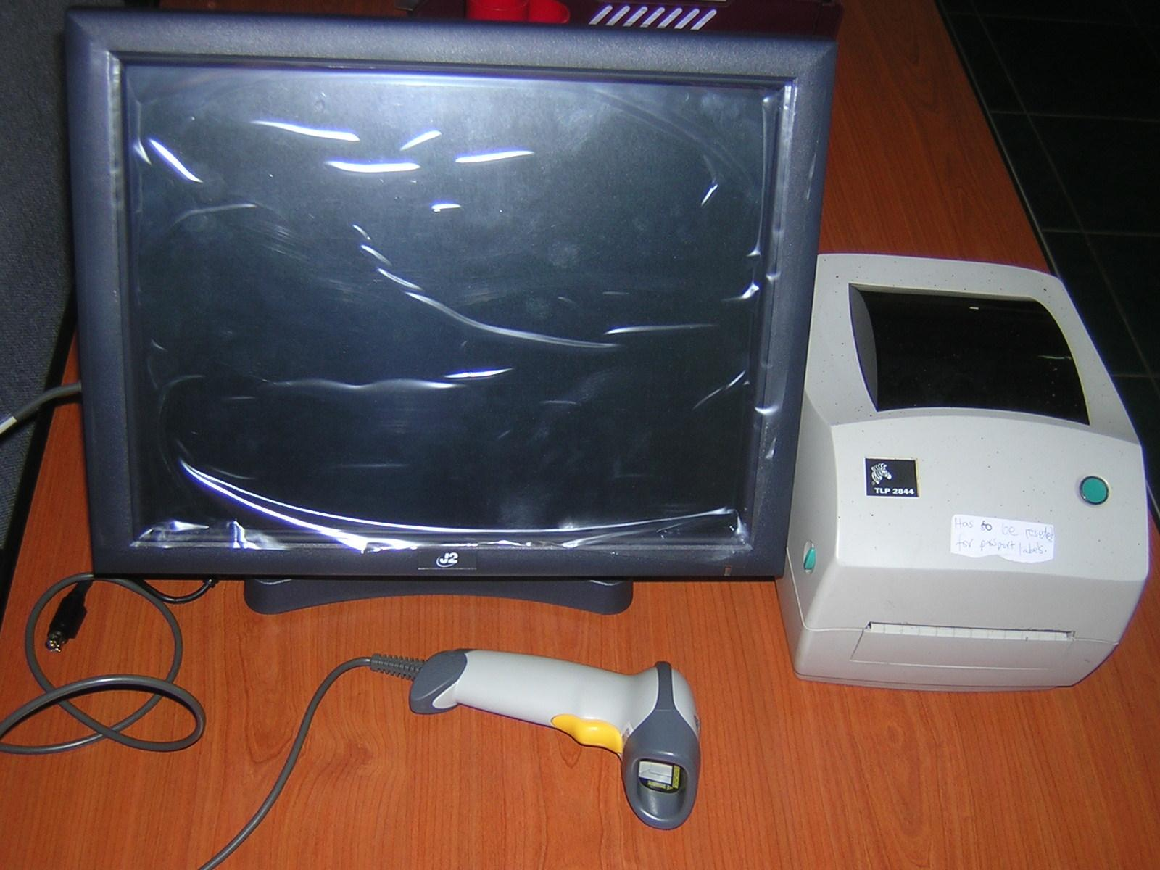

*A typical Maternity-eBRS workstation*

### 3.7 Interface Requirements

The Maternity-eBRS will adopt the eBRS interface layout. The workflow will be designed to accommodate the maternity component that comes as an initial stage of the workflow.

### 3.8 User Stories

|  |  |  |
| --- | --- | --- |
|  | **Goal/Desire** | **Benefit** |
| 1 | As a user I want to be able to have an interface that has a flow and should be limited to a number of screens and not multiple. | The interface should be straightforward. |
| 2 | As a user I want to be able to register a maternity patient on arrival for delivery/admission | This will assist to track and monitor the patient |
| 3 | As a user I want to be able to enter observations for a patient | This will enable management of the pregnancy and or delivery |
| 4 | As a user I want to be able to enter delivery outcomes and baby register birth information at delivery | This will enable registration of post-natal outcomes and birth registration for birth certificate production |
| 5 | As a user I want to be able to produce periodic reports such as monthly reports that I can print in an A4 page and submit to the DHO | This will enable submission of clinical reports to the DHO |
| 6 | As a user I want to be able to see number of deliveries for that particular day at a glance, for example after opening the system. | This will enable reporting |
| 7 | As a user I want to be able to verify the birth data before submitting to eBRS | This will enable filling the NR8 form and verifying data before submission |
| 8 | As a user i don’t want to enter the same information twice | This will prevent errors and save time. |
| 9 | As a user I want to be getting a count of number of births for that particular day | This will enable reporting |
| 10 | As a BHT user I want to monitor records entered periodically such as daily, weekly, monthly and view trends on the monitoring dashboard. |  |
| 11 | As a data manager, I want to be able to have a record created from Maternity to eBRS | That there may be consistency of data and no duplication of efforts |