

**MCHINJI NRB & DHO CONNECTIVITY DESIGN**

NRB office has an internet connection through Government Wide area Network(GWAN) whose upstream provider is SimbaNet, on the other hand Baobab Health Trust`s Internet Service Provider(ISP) uses SimbaNet as its upstream provider. There is an end to end connectivity between BHT Gateway Router at BHT HQ in Lilongwe and Mchinji NRB office. This has given as an opportunity to connect the sites in Mchinji using OpenVPN which implements secure Virtual private network between the two sites via the internet.

**Network Diagram**

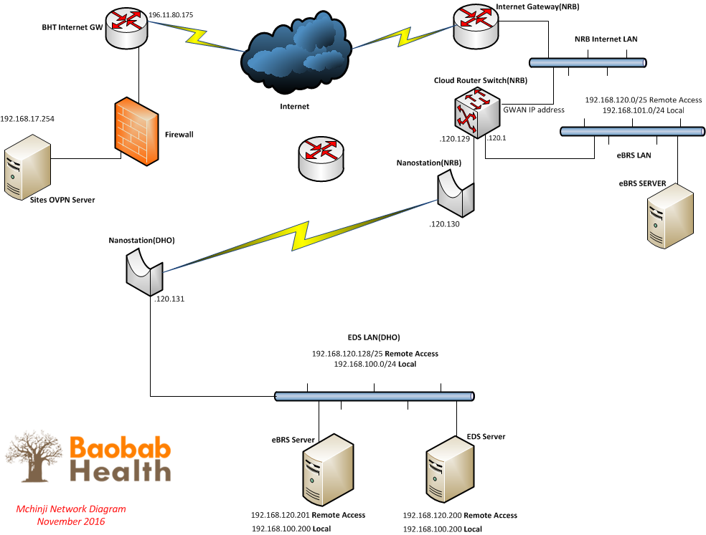

**Summary**

**Cloud Router Switch**

* Connects to the internet
* Establishes VPN Connection to the internet
* Segments the eBRS LAN, the Link to Mchinji District Hospital and the internet

**NanoStations**

* Links the NRB office and Mchinji District Hospital.
* The link is bridged from the interface on the cloud router switch at NRB office to the switch at the Hospital

**IP address scheme**

* The router will be dynamically assigned a static IP address “192.168.200.2” every time it establishes a VPN connection to BHT.
* The default IP address for the tunnel is 192.168.200.1, all routes to BHT should be pointed to this address
* Subnets 192.168.100.0/24 and 192.168.101.0/24 are BHT standard subnets for Local use only.
* NRB office has been assigned 192.168.101.0/24 and the District Hospital has been assigned 192.168.100.0/24
* For remote Access NRB office and the District Hospital have been assigned 192.168.120.0/24 subnet for use, this subnet has been broken into two /25 subnets.
* The subnet 192.168.120.0/25 has been assigned to NRB office eBRS network, 192.168.120.1 is the interface on the Cloud router switch, and 192.168.120.10 has been reserved for the eBRS server
* The Subnet 192.168.120.128/25 has been assigned to the District Hospital EDS network, 192.168.120.129 is assigned to the interface that connects to the nanostation on the cloud router switch at NRB and 192.168.100.200 & 201 are assigned to the EDS & eBRS server respectively.