

**OpenVPN Plugin client Setup**

This Howto will show you how to setup the openvpn client on Debian based linux distributions using the openvpn network manager plugin.

* Install OpenVPN network manager plugin on Debian based linux distributions

*apt-get install network-manager-openvpn-gnome*

* Open the plugin in network manager

Am using Linux mint 18.2 on my PC, my network manager is found on the start menu under Preferences/Network Connections. You should find out how to get the network manager on your linux distribution.

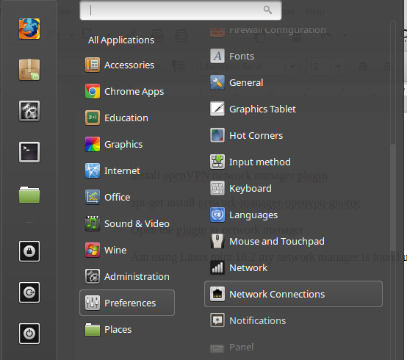

* Click add on the next window

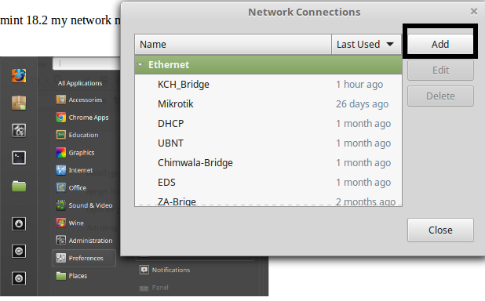

* Choose Openvpn on the “connection type” window

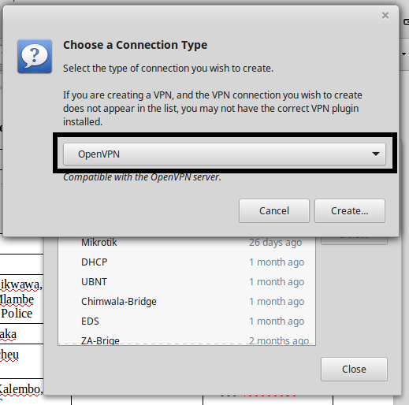

* On the VPN setup window under VPN enter the settings as indicated below

Connection: Any name

Gateway: 196.11.80.175

Authentication type : Certificates(TLS)

User Certicate: choose your name.crt file

CA Certificate: Choose the ca.crt file

private key: Choose your name.key file

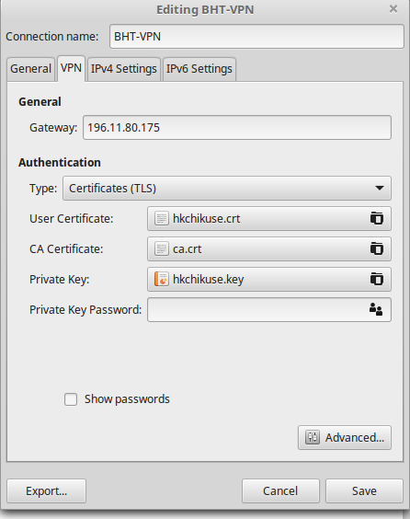

* Whilst on the VPN window Click on advanced and then tick on use LZO data compression and then click ok.

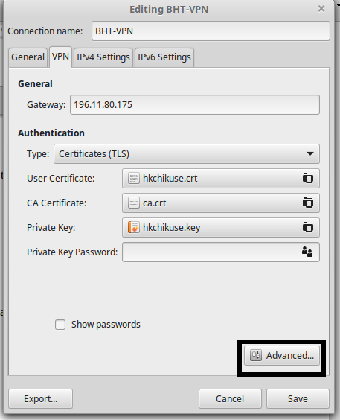

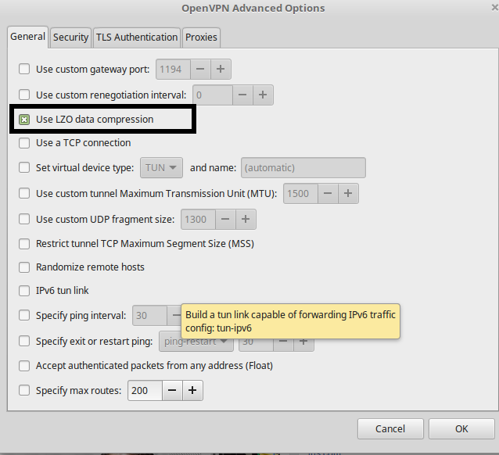

* Under IPV4 Settings click on routes then tick on “Use this connection only for resources on its network” then click ok

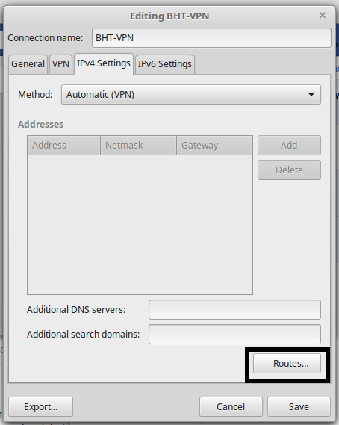

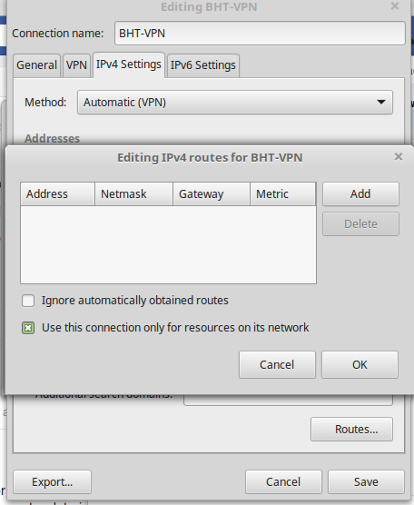

* Finally click Save on the main VPN window. you should be able to find the new connection on your network connections menu under vpn connections as seen in the below image.

