

**SOUTHERN REGION BACKBONE NETWORK DESIGN**

**Network Diagram**

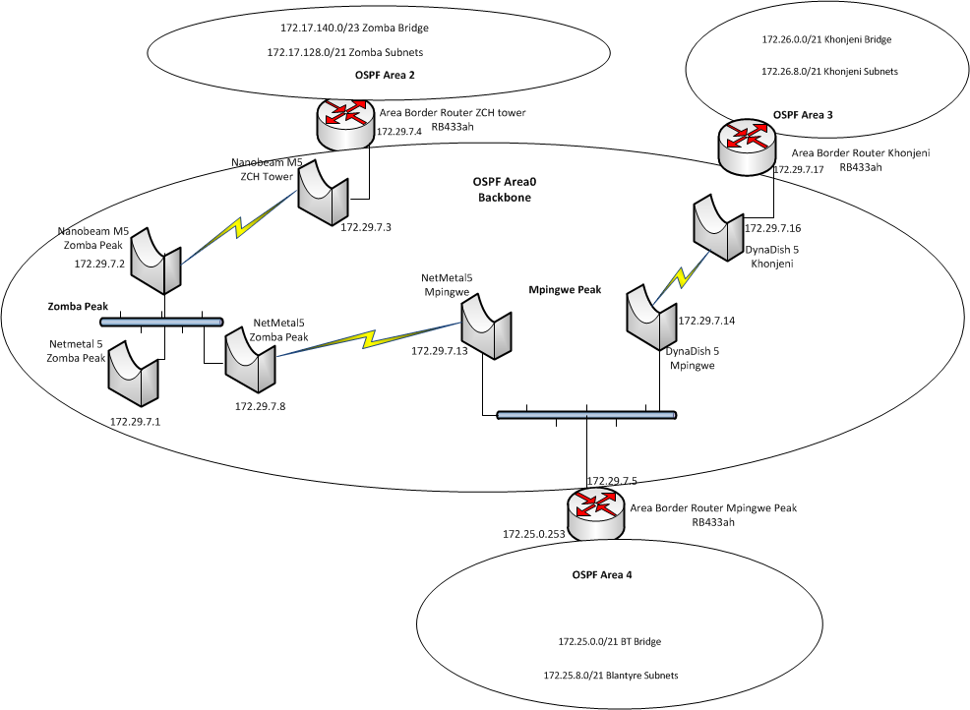

Summary

**Areas**

* An area is a logical collection of OSPF networks, routers, and links that have the same area identification. A router within an area must maintain a topological database for the area to which it belongs. The router does not have detailed information about network topology outside of its area, which thereby reduces the size of its database.
* Areas limit the scope of route information distribution. It is not possible to do route update filtering within an area. The link-state database (LSDB) of routers within the same area must be synchronized and be exactly the same; however, route summarization and filtering is possible between different areas. The main benefit of creating areas is a reduction in the number of routes to propagate - by the filtering and the summarization of routes.

**Area Border Routers**

* An area border router (ABR) is a kind of router that is located near the border between one or more Open Shortest Path First (OSPF) areas. It is used to establish a connection between backbone networks and the OSPF areas. It is a member of both the main backbone network and the specific areas to which it connects, so it stores and maintains separate routing information or routing tables regarding the backbone and the topologies of the area to which it is connected.
* The ABRs summarize the link-state records of each area and advertise destination address summaries to neighboring areas

**Backbone Area(Area 0)**

* An OSPF restriction requires all areas to be directly connected to the backbone area so that packets can be properly routed. All packets are routed first to the backbone area by default. Packets that are destined for an area other than the backbone area are then routed to the appropriate ABR and on to the remote host within the destination area.

**Hub wide Bridges**

* Interconnects sites connected to a single hub, the bridges reduce the number of subnets at a hub thereby reduce the size of the routing table within an area.

**Khonjeni Hub**

* Has 172.29.7.17 as the Area Border Router
* Everything that connects behind the ABR is in area 3
* Every site that is connected through khonjeni hub is in area 3 and must be bridged and be assigned ip addresses within the 172.26.0.0/21
* The Local area networks behind the routers e.g. the one sitting the EDS servers must be segmented from the khonjeni wide bridge and must be assigned addresses within 172.26.8.0/21 subnet
* The LAN subnets must be derived from the 172.26.8.0/21 root subnet and can be broken into subnets depending on the size of the LAN at the site, the smallest must be a /28.

**Mpingwe Hub**

* Has 172.29.7.5 as the Area Border Router
* Everything that connects behind the ABR is in area 4
* Every site that is connected through Mpingwe hub is in area 4 and must be bridged and be assigned ip addresses within the 172.25.0.0/21
* The Local area networks behind the routers e.g. the one sitting the EDS servers must be segmented from the BT wide bridge and must be assigned addresses within 172.25.8.0/21 subnet.
* The LAN subnets must be derived from the 172.25.8.0/21 root subnet and can be broken into subnets depending on the size of the LAN at the site, the smallest must be a /28.

**ZCH Hub**

* Has 172.29.7.4 as the Area Border Router
* Everything that connects behind the ABR is in area 2
* Every site that is connected through ZCH hub is in area 2 and must be bridged and be assigned ip addresses within the 172.17.140.0/23 subnet
* The Local area networks behind the routers e.g. the one sitting the EDS servers must be segmented from the Zomba wide bridge and must be assigned addresses within 172.17.128.0/21 subnet.
* The LAN subnets must be derived from the 172.17.128.0/21 root subnet and can be broken into subnets depending on the size of the LAN at the site, the smallest must be a /28.