How to Setup OpenVPN client on a Mikrotik Router

Make sure that you have correctly setup ip connectivity on your router and that you are able to access the internet and the BHT OVPN server

- Open your Mikrotik via winbox on the main menu click on interfaces

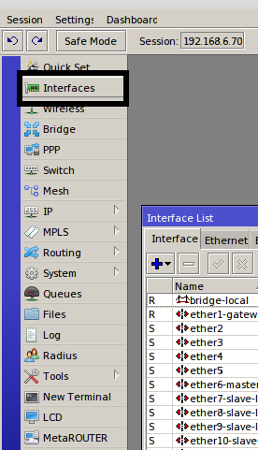

- Then on the Interface list click on the plus symbol
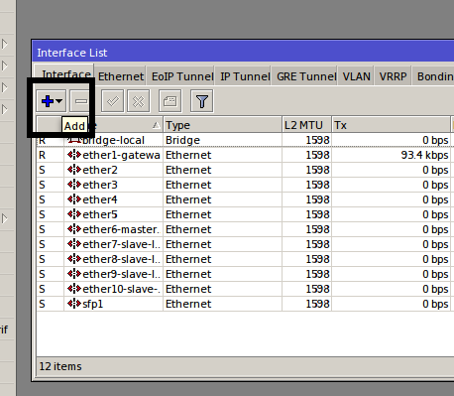

- Then Select OVPN client

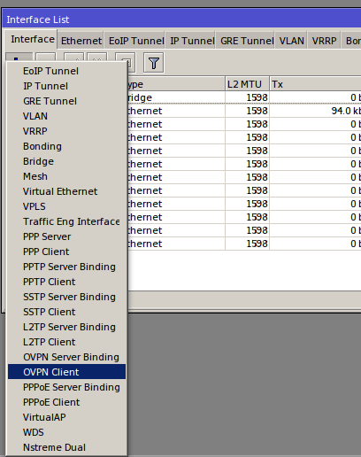

- Configure the parameters as shown in the below screenshot then click on apply
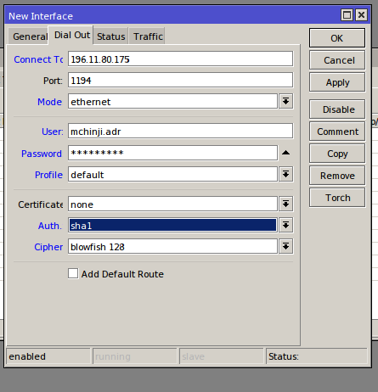

NOTE:
- 196.11.80.175 is the ip address of the BHT Internet GW router which then forwards tcp port 1194 to the OVPN server
- Punch in the username and password provided to you by the Engineering Department

Testing
- the router should receive a dynamic ip address on the ovpn interface which you have just created
to check go on the main menu then ip under ip click on addresses

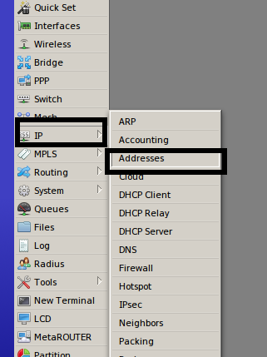

you should see an ip address on the ovpn client interface which you have just created with a D in front indicating that its a dynamically assigned ip address.

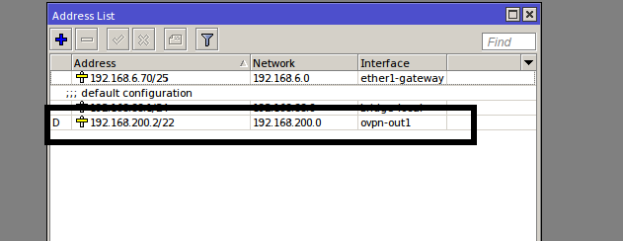

You should be able to ping default gw for the VPN which is 192.168.200.1
to ping in the mikrotik router go on the main menu and click on on tools under tools click on ping

