

Configuring the evrs mesh routers from standard config backup file
VERSION 0.0.1

Accessing the Router for the first time and copying the standard Configuration backup to it.

1.0 Open the router the routerboard using winbox, default ip address is 192.168.88.1
Configure ip address 192.168.100.1 for inter ether1

1.0.1 On the Main menu Click on IP then, Addresses.Click on the plus symbol under the address list
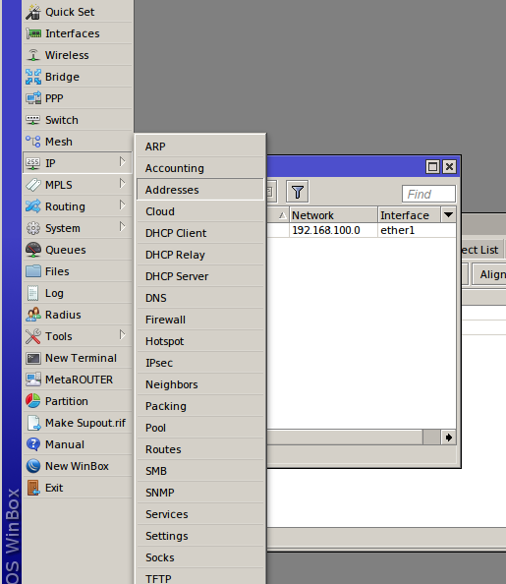

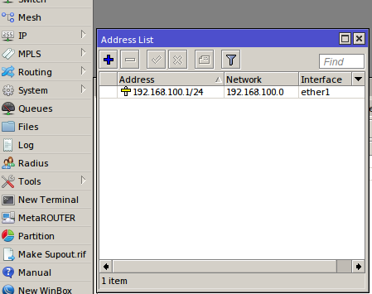

1.0.2 Open the Routers root folder by Clicking on Files On the Main menu

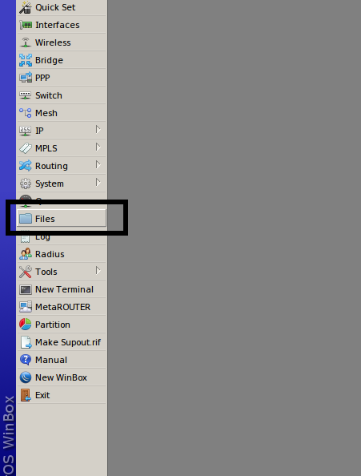

1.0.3 In your Documents Locate the standard Configuration backup file which will be shared then drag and drop it into router under the folder which you have opened.
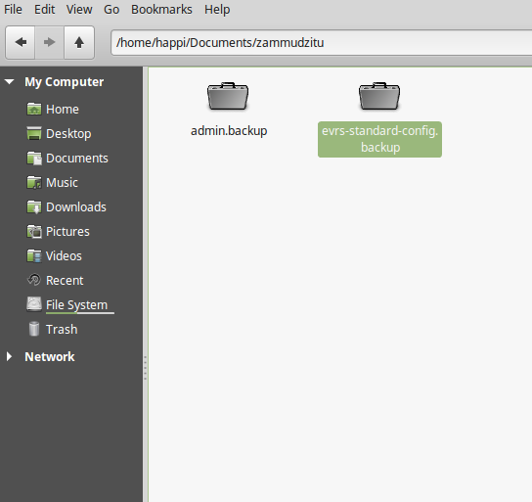

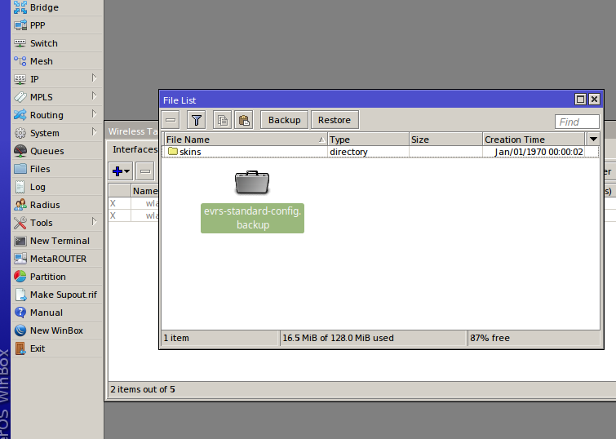

1.0.4 Click on the file which you have copied to the router in the files list, then click on restore. The password should be b@0b@bll.
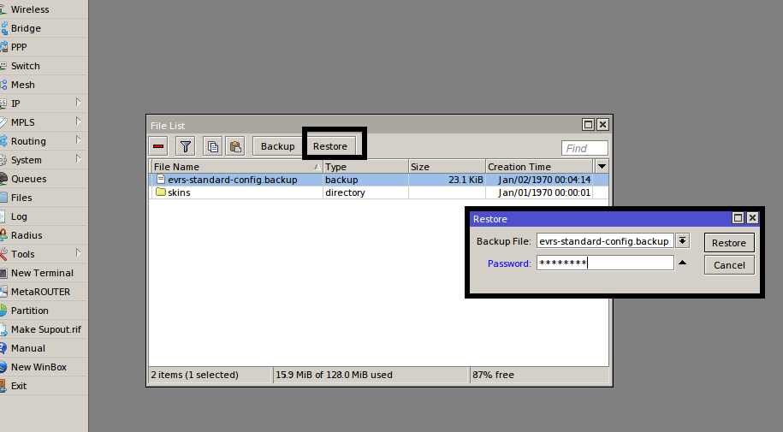
The router will prompt you to confirm the password, confirm the restore by pressing yes. After the Confirmation the router will reboot.

1.0.5 Once the router has rebooted connect to the router using Winbox on IP Address 192.168.100.1 Username admin Password b@0b@bll

Putting the Configuration into place.

1.0 Configuring the Wireless Interfaces

1.1 On the Main menu Click on interfaces
Enable the wlan3 and wlan4 one by one by the selecting the interface name and clicking on the enable symbol as shown in the picture below
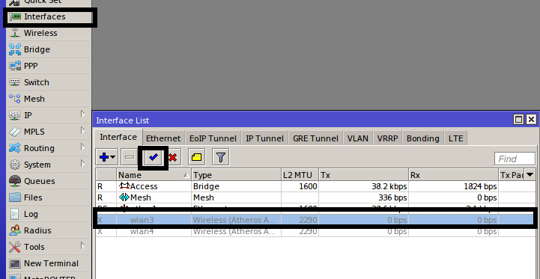

1.2 Identify the the 5Ghz interface. It should have the parameters like the one in the picture below

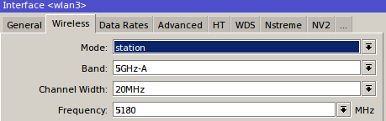

1.2.1 Change the following configuration on the interfaces

Interface name to “Main”under General as shown below
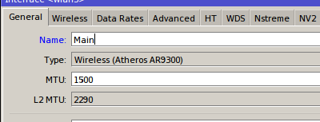

1.2.2 Under Wireless change
- Mode to “ap bridge”
- Band to “A/N”
- SSID to “evrs”.The SSID will be set according to the operational frequency selected.
- evr = 5180
- evr 2 = 5300
- evr 3 = 5200
- evr 4 = 5220

- Security profile to “mesh”
the wireless configuration should be as shown in the picture below

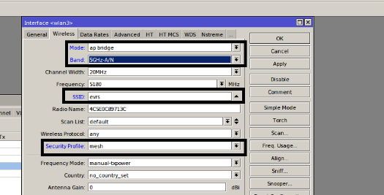

1.2.3 Under WDS change wds mode to “Dynamic mesh” and WDS Default Bridge to “Mesh”
then click on apply and ok
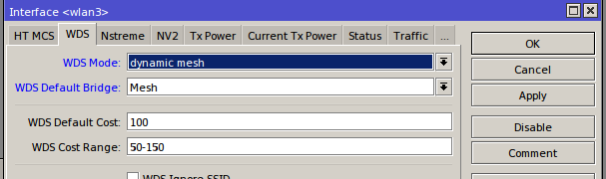

2.0 Still Under interfaces click on interfaces wlan4

2.0.1 Under General Rename the interface to “Zammudzi”
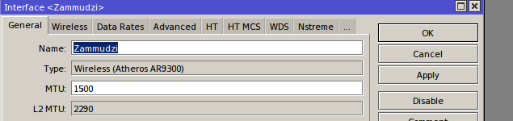
2.0.2 Under wireless Change the following parameters
- Mode to “ap bridge”
- Band to “2Ghz B/G/N”
- ssid to “ZaM`mudzi Mwathu”
- Security profile to “zammudzi”

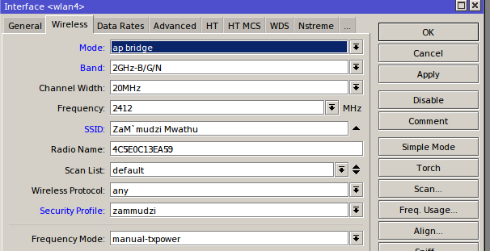

Click on apply and ok

3.0 Adding the 5Ghz interface to the Mesh
3.0.1 On the Main Menu click on Mesh then click on ports and then the plus symbol to add interfaces
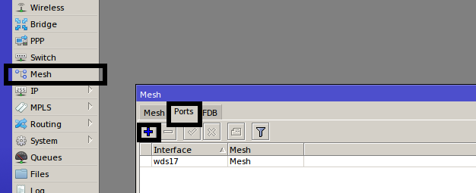

3.0.2 Select the 5Ghz interfaces which you renamed to “Main”
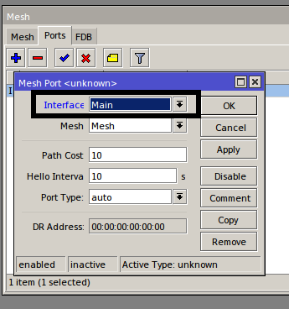

3.1.0 Adding the Wi-Fi Access interface to the Access Bridge to enable share the Ethernet interface ip address and DHCP

3.1.1 On the Main menu click on Bridge
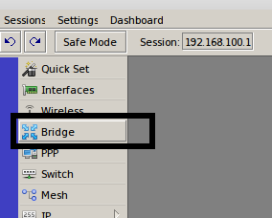

3.1.2 Click on ports and the then the plus symbol to add interfaces
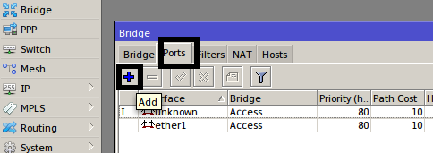

3.1.3 Select the 2.4Ghz interface which you renamed to “Zammudzi” then click apply and ok

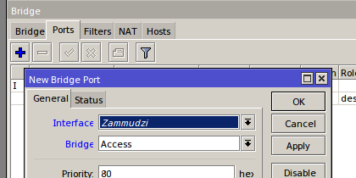

4.0 Add IP Address for the Mesh interface according to the village your configuring. Refer to the ip address list.

4.0.1 On the Main click on IP then Addresses
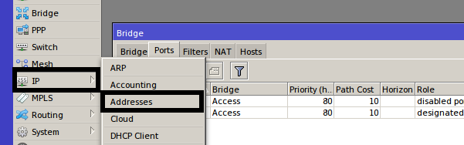

4.0.2 Change the ip address of the Mesh interface by double clicking on it when finished click on apply and ok
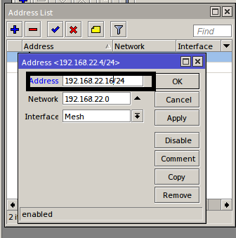

5.0 Change the Identity of the router to the name of the village you are configuring.

5.0.1 On the Main Menu click on System then identity
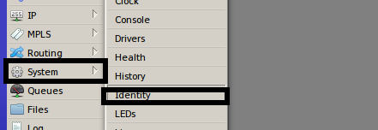

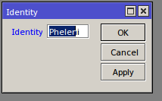
- Edit the name the click on apply and ok

Testing

- On Ethernet cable check if you are receiving an ip address
- Try to connect to the ZaM`mudzi Mwathu WIFI.
- Check if the router is meshing with its peers.The picture below shows that the router is connected with two mesh peers
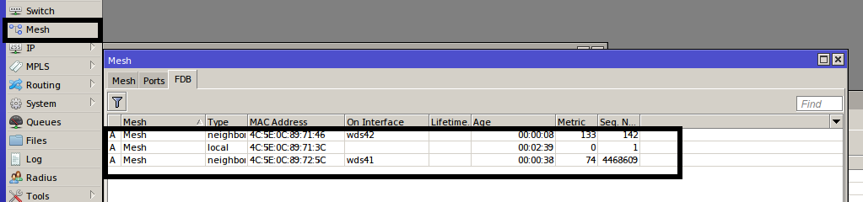
- Login into the router and ping the peers
- Ping the Mesh portal which Ngoni HC router 192.168.22.1

