***EVR PhASE 2***

**Functional Requirements DEFINITION**

Version 1.0

Version Date: 11/09/2017

**VERSION HISTORY**

|  |  |  |  |  |  |
| --- | --- | --- | --- | --- | --- |
| **Version #** | **Implemented**  **By** | **Revision**  **Date** | **Approved**  **By** | **Approval**  **Date** | **Reason** |
| 1.0 | *Khazgani Chirwa Nasasara* | 11/09/2017 |  |  | Initial Functional Requirements Definition draft |
| 1.1 | *Khazgani Chirwa Nasasara* | 4/12/2017 |  |  | Edited Functional Requirements Definition draft |
|  |  |  |  |  |  |

**TABLE OF CONTENTS**

**1 Introduction 4**

1.1 Purpose of The Functional Requirements Definition 4

**2 Business Requirements Overview 4**

2.1 Assumptions / Constraints 4

**3 Functional Requirements 4**

3.1 Usability Requirements 9

3.2 Performance Requirements 9

3.3 Supportability Requirements 9

3.4 Security Requirements 9

3.5 HARDWARE REQUIREMENTS 9

3.6 Interface Requirements 10

**4 Compliance Requirements 10**

4.1 Assumptions / Constraints 10

**Functional Requirements Definition Approval 11**

**Appendix A: References 12**

**Appendix B: Key Terms 13**

# Introduction

## Purpose of The Functional Requirements Definition

The Functional Requirements Definition documents tracks the necessary information required to effectively define business and functional requirements. The Functional Requirements Definition document is created during the Planning Phase of the project. Its intended audience is the project manager, project team, project sponsor, client/user, and any stakeholder whose input/approval into the requirements definitions process is needed.

# Business Requirements Overview

The overall objective of the EVR phase two is to develop and implement an integrated community health information system. The eBRS is currently being deployed in district and central hospitals with funding from CDC. In this proposal, we plan to refine and augment clinical modules for use at the rural health center level to generate birth report information to be automatically sent to NRB in a format consistent with eBRS. This gives us an opportunity to develop a scalable implementation model for the health center level with possibilities of leveraging demographic data already captured through existing Electronic Medical Record systems and Zam’Mudzi Mwathu application.

Taking a systems-thinking approach in the implementation of the solution, we aim to increase the value of the use of civil registration systems as secondary consumers of data derived from clinical information systems

## Assumptions / Constraints

* Patients would be registered and issued a National Patient ID from existing EMRs.
* There will be EMRs at the OPD, ANC and Maternity departments.
* The generic ANC application will be deployed.
* Touchscreen computer, label printer and scanner will be used as the workstation for the ANC, OPD and Maternity applications.
* The Immunization schedule will be accessed via a mobile device and will have some connection to the facilities. Printing will be done at the facility as well as in the field during out reach activities, therefore a small portable printer will be sourced for easy printing in the field.
* The Immunization register will have an offline mode for when the application is being used in the field.

# Functional Requirements

The associated user story describing these requirements are below.

***Antenatal***

* As a nurse from ANC I want to use the generic ANC application with addition of capturing father details soon after the mother is registered so that their record already exists when creating the birth report.
* As an ANC nurse registering a mother and father I want to capture first name, last name, gender, date of birth, home address and current address if a record does not already exist so that I can issue a National Patient ID.
* As an ANC nurse registering a mother and father I want to be able to search an existing patient ID barcode so that I can find a patient.

***Maternity***

* As a maternity nurse delivering a mother I want to capture birth weight, gestation weeks , date of birth, gender and mode of delivery so that I can use this information when generating the birth report.
* As a maternity nurse discharging a new baby, I want to be able to create a birth report from information already collected through other applications so that I do not spend a lot of time creating a record.
* As a maternity nurse discharging a new baby I want the mother demographics, father demographics, delivering details and baby address pre populated from details previously captured so that I can just enter baby name and preview information before saving the birth report.
* As a maternity nurse I want to have print out after the birth report has been created with baby name, birth date, address and mother demographics so that I can stick in the health passport as confirmation that birth has been reported.
* As a maternity nurse discharging a patient I want to generate a custom immunization schedule for the new-born child so that the parents are less likely to miss necessary immunizations, which could compromise baby's immune response.
* As a maternity nurse, I want to be able to generate maternity reports for reporting.

***Immunization***

* As an HSA providing immunization to children I want to be able to access the immunization schedule through a mobile device so that I can have access to the schedule during out outreach activities.
* As an HSA providing immunization to children I want to see name of baby, address, required immunization and schedule date so that I can provide relevant immunization.
* As an HSA providing immunization I want to just select immunizations provided on a visit for a particular child so that I can update the child record easily.

***Administration***

* As a maternity/ANC nurse I want to generate a report at the click of a button so that I do not spend a lot of time compiling a report manually.
* As a system administrator I want DDE to synchronize daily from 19:00hrs so that it does not disrupt the clinic operations but still update the master and backup data.

**Culture and Sequence Diagrams**

Figure 1 below depicts the holistic view of the implementation, the key information collected at each point and how that information flows. As described in the requirements overview the objective of EVR Phase two is to create a birth report from information collected in existing EMRs. The OPD and EVR collect demographic data which can be used in the ANC application when registering a new Mother and Father by scanning the existing barcode on registration. Table 1 depicts the sequence in the ANC.

Birth weight, date of delivery, gender, mode of delivery and gestation weeks will then be appended to this record at the Maternity after delivery. This information will be verified upon discharge, the baby name added and a birth report is created. Table 2 depicts sequence of birth report creation.

In addition to creation of the birth report, an immunization schedule will be created for HSAs to track immunizations for babies. This schedule will be pre-populated by the system and the HSA notified on the new birth. Table 3 below depicts the sequence of creation of the immunization schedule.

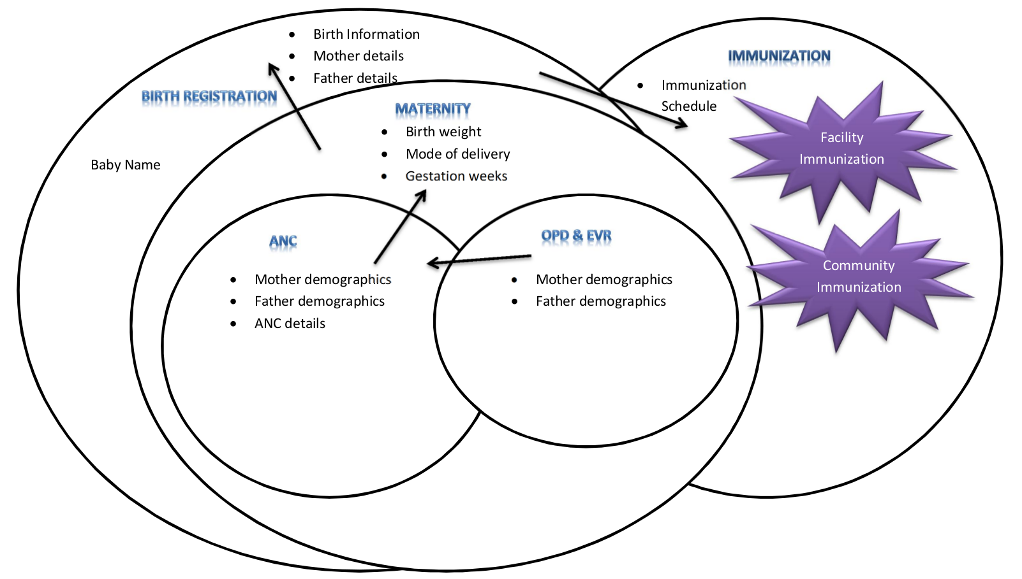

*Figure 1: Activities culture diagram*

|  |
| --- |
| **1 Title: Management of ANC mothers** |
| **Intent 1**: Register Mother and Father demographic data  **Intent 2**: Collect parent details for birth report  **Trigger:** Mother comes to clinic for first visit    Scan National Patient ID barcode / Register Mother and issue National Patient ID    Find out if Father is available    Scan National Patient ID barcode / Register Father and issue National Patient ID    Proceed with ANC services |

*Table 1: ANC sequence diagram*

|  |
| --- |
| **2 Title: Creation of Birth Report** |
| **Intent 1**: Create birth report  **Trigger:** Mother gives birth    Scan National Patient ID barcode / Register Mother and issue National Patient ID    Find out if Father information is available    Scan National Patient ID barcode / Register Father and issue National Patient ID    Enter name of the baby    Enter delivery details (baby weight, gestation weeks)    Show preview of birth report    Parents to confirm the reported details    Send Birth Report. |

*Table 2: Birth Report sequence diagram*

|  |
| --- |
| **3 Title: Creation of Immunization Register** |
| **Intent 1**: Create Immunization Register for HSAs  **Trigger:** New birth at the facility    Pre-populate immunization register    Calculate when each immunization is to be administered    Print out/display an immunization schedule    Notify HSA from that catchment area on new birth |

*Table 3: Immunization register sequence diagram*

## Usability Requirements

1. The system developed must have a couple of related questions on one page to minimize the number of clicks.
2. The system should be able to produce the standard MoH reports for ANC and Maternity. Refer to Appendix A
3. Create a dashboard that will be used to monitor system usage.
4. The immunization register should be able to work off-line when they are in the field.

## Performance Requirements

1. Synchronization of data on the DDE application should happen daily.
2. Birth report created at the facility should be pushed to the DC office.

## Supportability Requirements

1. Health workers providing ANC and immunization services will need to be trained on how to use the system
2. Support will be provided to the site everyday for a week after the system is in use and then routine visits will be done after that.
3. User manuals will be provided to the users after deployment is done.

## Security Requirements

1. The application should be able to auto-log out if it is idle for 30 minutes.
2. A governance document will be developed and signed by the custodians of the mobile devices to ensure they are secured and used for intended purpose.

## HARDWARE REQUIREMENTS

* For each site that this system will be deployed there will be need of a full workstation (touchscreen computer, printer and scanner) at all points where ANC services are provided to clients and a full workstation in the Maternity ward.
* Touchscreen mobile devices and portable printer will be used for the immunization register.
* There is need to provide charging facilities for the mobile devices and portable printers.

## Interface Requirements

* Touchscreen-based application will be used in all points in the ANC and Maternity. The interface for the system will be required to be appealing to the user with use of few and soft colors.
* A mobile-based application will be used for the immunization schedule

# Compliance Requirements

To deploy these systems in the health centers there is need to inform the Lilongwe District Hospital Office of the intent and scope of the project and the targeted facilities.

The ANC application will need to conform to the guidelines as required by the Department of Reproductive Health. Report that will be generated by the application will be according to the MoH standard reports.

## Assumptions / Constraints

* In the ANC application there will be some information collected ie Father details that are not in the ANC guidelines and may create more work for them to collect.
* This system will be used in the facilities serving TA Mtema. Our target group is people living in TA Mtema but they are not the only ones coming to these facilities, people from other TAs will be accessing services there and their information will be captured and added to the reports.

**Functional Requirements Definition Approval**

The undersigned acknowledge they have reviewed the Electronic Village Register **Functional Requirements Definition** and agree with the approach it presents. Any changes to this Requirements Definition will be coordinated with and approved by the undersigned or their designated representatives.

|  |  |  |  |
| --- | --- | --- | --- |
| Signature: |  | Date: |  |
| Print Name: |  |  |  |
| Title: |  |  |  |
| Role: | Donor Representative |  |  |

|  |  |  |  |
| --- | --- | --- | --- |
| Signature: |  | Date: |  |
| Print Name: |  |  |  |
| Title: |  |  |  |
| Role: | Technical Assistant |  |  |

|  |  |  |  |
| --- | --- | --- | --- |
| Signature: |  | Date: |  |
| Print Name: |  |  |  |
| Title: |  |  |  |
| Role: | Baobab Representative |  |  |

**Appendix A: References**

The following table summarizes the documents referenced in this document.

|  |  |  |
| --- | --- | --- |
| **Document Name and Version** | **Description** | **Location** |
| ANC Report – Version 4Do | Standard MoH ANC report | Attached |
| Maternity Report – Version 3 | Standard MoH Maternity report | Attached |
| NR8 Form | Standard facility birth report form | Attached |

**Appendix B: Key Terms**

The following table provides definitions for terms relevant to this document.

|  |  |
| --- | --- |
| **Term** | **Definition** |
| ANC | Antenatal Clinic |
| MoH | Ministry of Health |
| HSA | Health Surveillance Assistant |