UML Diagrams for Online Banking System

Class Diagram

Use Case Diagram

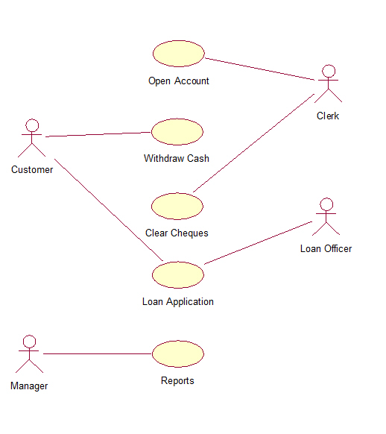

Sequence Diagram

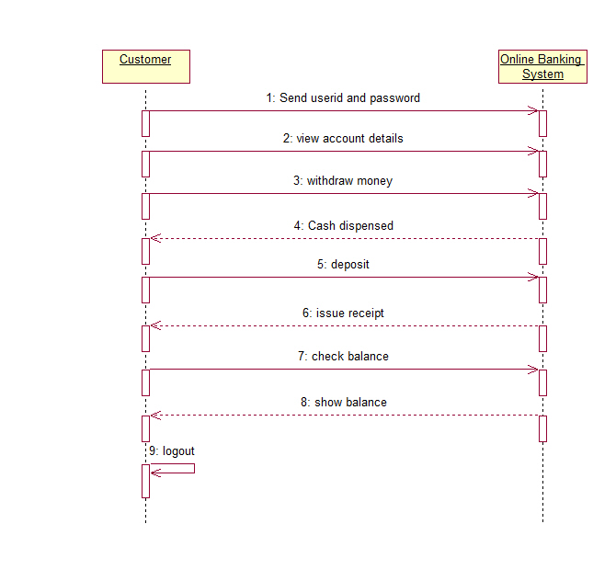

Collaboration Diagram

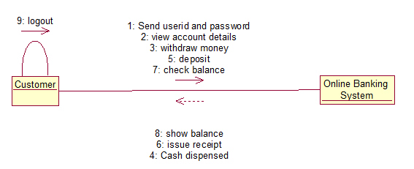

Statechart Diagram

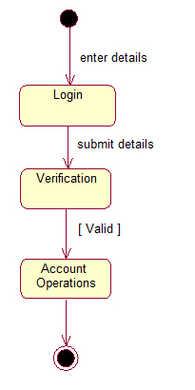

Activity Diagram

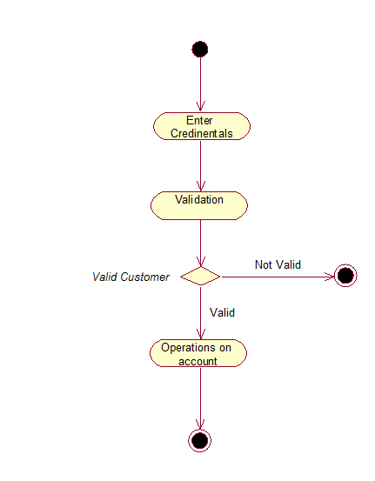

Component Diagram

