Appendix
A.1 Recent catastrophic failures of large offshore wind turbine blades
Fig. A1 summarizes typical structural failure cases of rotor blades in the offshore wind farms all over the world. The blade failure rates are high for current multi-megawatt class wind turbines.
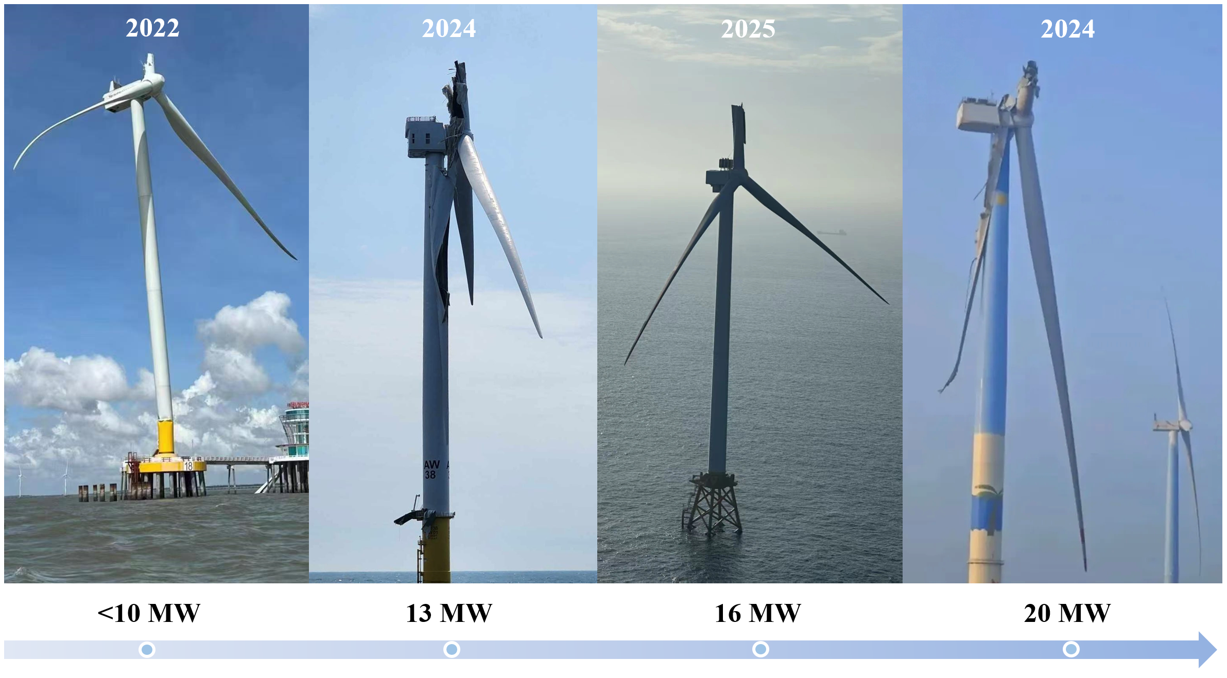
Fig. A1. Frequent early-stage catastrophic failures of rotor blades in recent years, accompanied by​ the upscaling of offshore wind turbines to 20-megawatt (MW) class.
A.2 Comparison of the external nodal force distribution
Table A1 and Figs. A2-A4 present the characteristics of the external nodal force distribution based on two load reconstruction methods.
Table A1 Nodal force comparison between Method Q_{ZB} = 0 (spanwise force neglected) and Method Q_{ZB} ≠ 0 (spanwise force considered)
Nodal force | Method | Maximum (N) | Minimum (N) | Range (N) | Mean (N)
f_{XB} | Q_{ZB} = 0 | 493.291 | −521.333 | 1014.624 | 6.047
 | Q_{ZB} ≠ 0 | 540.629 | −568.253 | 1108.882 | 6.392
f_{YB} | Q_{ZB} = 0 | 55.805 | −42.831 | 98.636 | −0.476
 | Q_{ZB} ≠ 0 | 239.350 | −249.291 | 488.641 | −0.550
f_{ZB} | Q_{ZB} = 0 | 0 | 0 | 0 | 0
 | Q_{ZB} ≠ 0 | 12.516 | −3.334 | 15.850 | 6.603
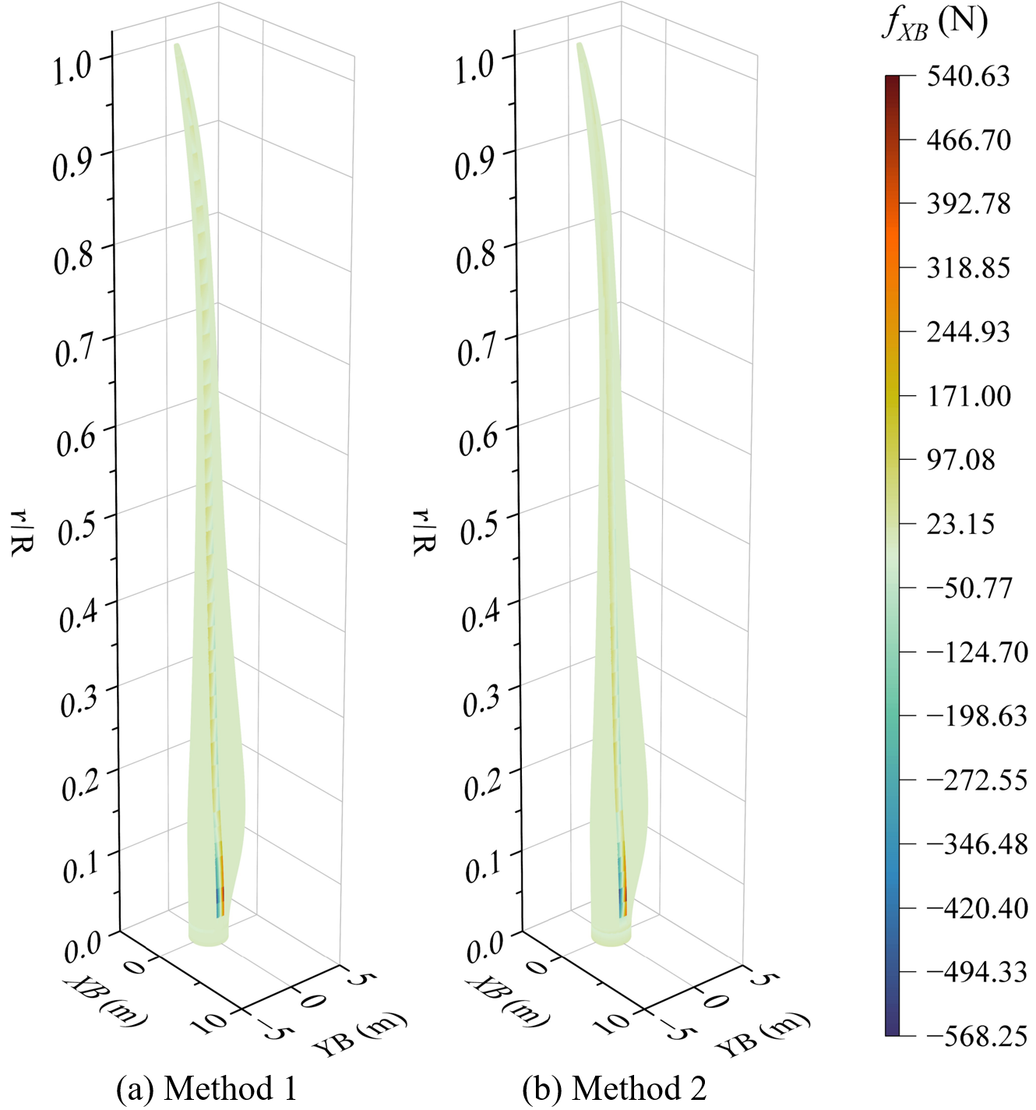
Fig. A2. Contour plots of the flapwise nodal force f_{XB} calculated via two load reconstruction methods: with the spanwise force neglected (Q_{ZB} = 0) and considered (Q_{ZB} ≠ 0).
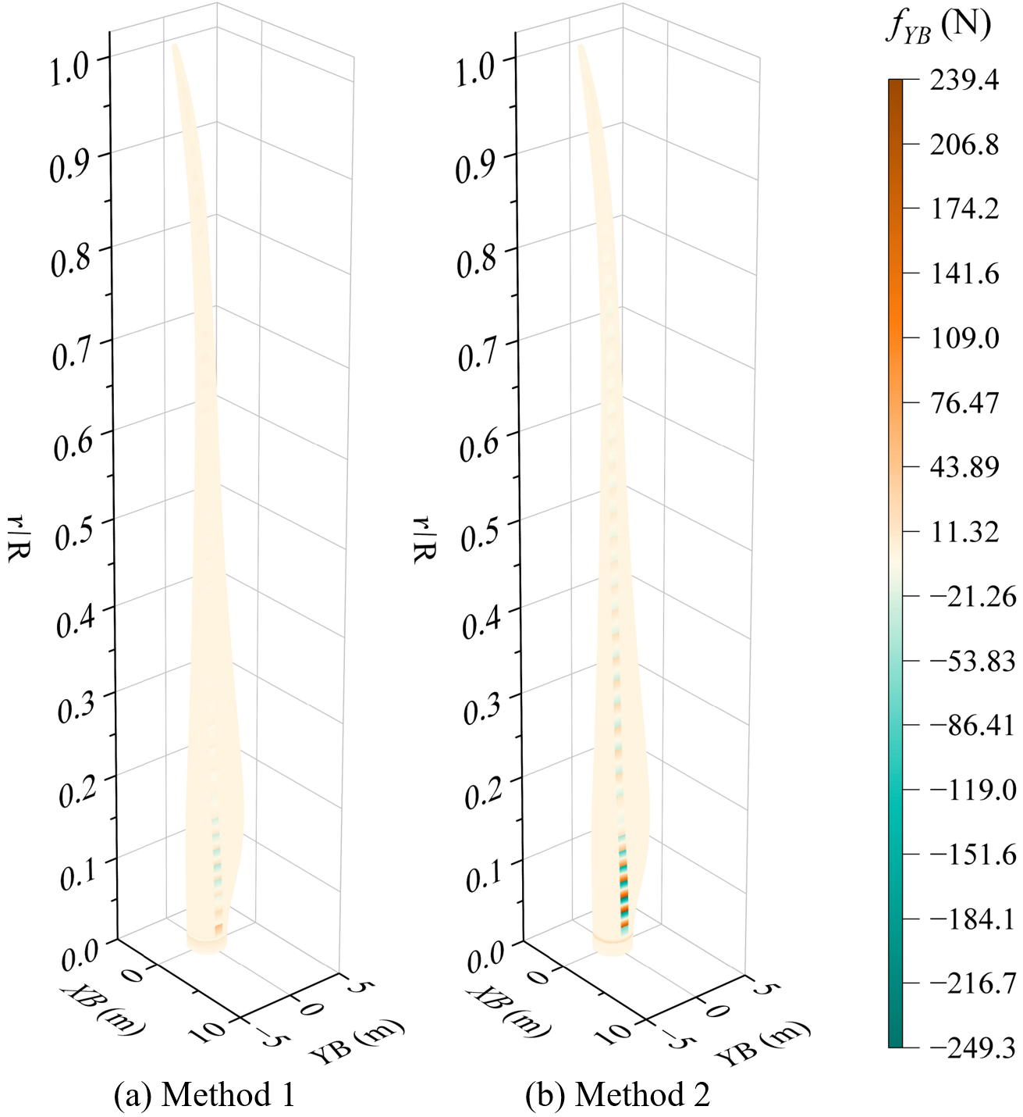
Fig. A3. Contour plots of the lead-lag nodal force f_{YB} calculated via two load reconstruction methods: with the spanwise force neglected (Q_{ZB} = 0) and considered (Q_{ZB} ≠ 0).
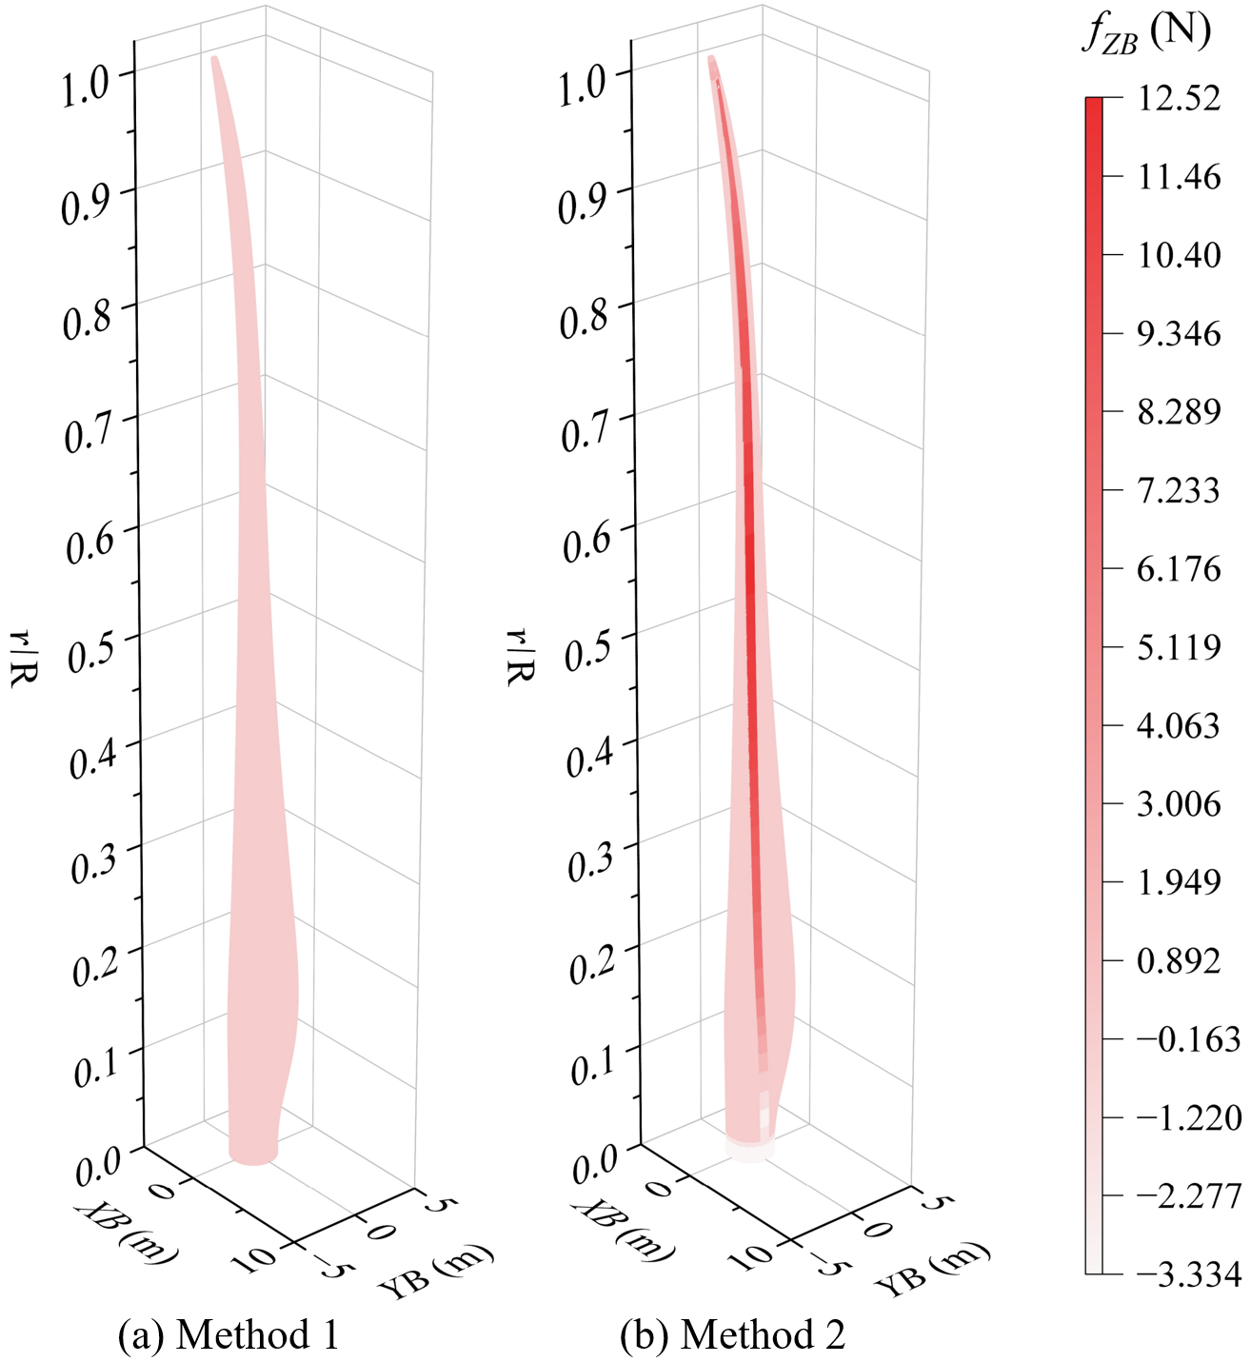
Fig. A4. Contour plots of the spanwise nodal force f_{ZB} calculated via two load reconstruction methods: with the spanwise force neglected (Q_{ZB} = 0) and considered (Q_{ZB} ≠ 0).

