**8x: 0.01**

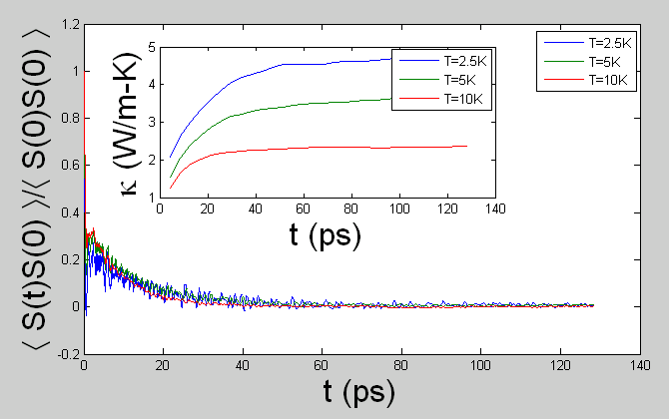

**0.05**

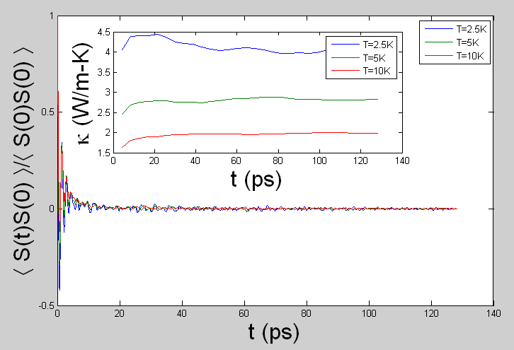

**0.1**

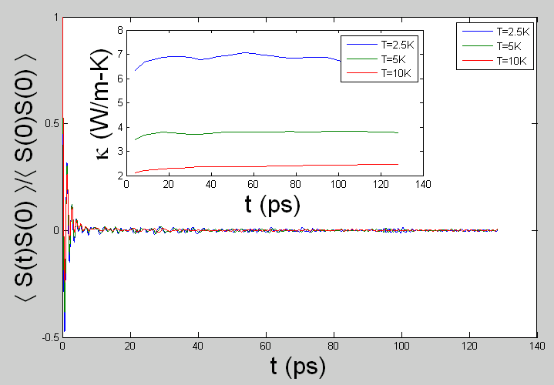

**0.5**

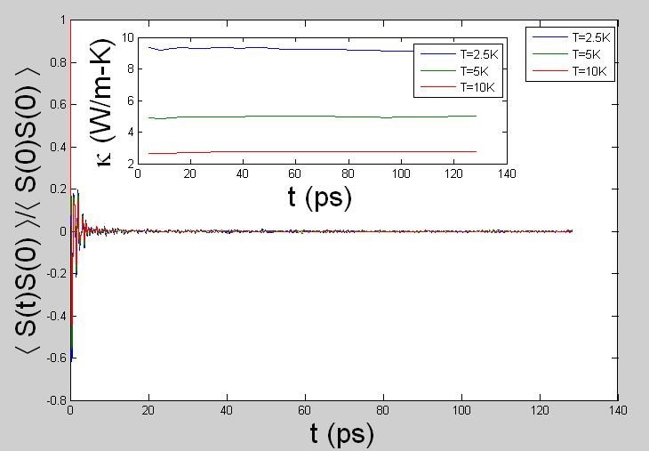

**4x**

**1.5(1-x)0.5x**

**8x**

**1.0(1-x)3.0x**