**Design of low-cost control for greenhouse environment**

Nguyen Ngoc Bao - Nguyen Sieu High School, Ha Noi - Viet Nam

E-mail: **nnbao04@gmail.com**

Phone: **0986915640**

Bui Trong Bao Khanh - Nguyen Sieu High School, Ha Noi - Viet Nam

E-mail: **btbaokhanh@gmail.com**

Phone: **0967548724**

Supervisor: Dr. Le Quang Thao – VNU, University of Science, Ha Noi - Viet Nam

E-mail: [thaolq@hus.edu.vn](mailto:thaolq@hus.edu.vn)

Phone: +84.983.712.941

**Abstract**

*Agricultural development in the greenhouse model, bring technology into production has always been one of Vietnam's top objectives, especially in the period of industrial revolution 4.0. It not only contributes to improving crop productivity but also controls plant growth, reducing the dependence of product quality on natural environmental factors****such as global warming, acid rain, etc.***

*The paper presents the design of a monitoring system for environmental parameters and controls it in a way that is conductive to the development of greenhouse plants. Environmental parameters such as temperature, humidity, soil moisture, and light are collected by wireless sensor network and stored on the Web server in real time. When parameters exceed the threshold, the system will control the actuators to optimize the treatment of crops in the greenhouse. The results can bring financial saving on agriculture in the greenhouse, solving the problem of food security remains a global change, especially in low-income countries*

*Keywords:****greenhouse, monitoring, WSN, sensor, parameters***

1. **Introduction**

***1.1. Overview of the Project***

**Global warming and greenhouse effects are the main factors and threats to the growth of wildlife plants and animals. Global warming is the long-term rise to the average temperature of the Earth’s atmosphere. This is associated with the aspect of greenhouse effects. Greenhouse effect is a process when radiation from the Sun warms the planet’s atmosphere to a temperature that is higher than expected. Plants in Vietnam have suffered a great loss because of those factors. Large amount of plants on Earth decreases in quality and therefore, plant’s growth needs a new technique to have a better life.**

***Greenhouse technology*** is the technique of providing favorable environment condition to the plants. It is rather used to protect the plants from the adverse climatic conditions such as:

* Wind, **depends on how strong the wind is, can help the plant growing sturdier or damage it**
* Temperature **can trigger the plants’ growth, as well as seed germination**
* Precipitation **causes** **a great impact on the plants’ growth. For example, too much or too little water will lead to the total damage of the plants.**
* Excessive radiation **exposure can ultimately destroy the plant**
* Insects and diseases

It is also of vital importance to create an ideal micro climate around the plants. This is possible by erecting a greenhouse, where the environmental conditions are so modified that one can grow any plant in any place at any time by providing suitable environmental conditions with minimum labor.

Greenhouses are framed or inflated structures covered with transparent or translucent material large enough to grow crops under partial or fully controlled environmental conditions to get optimum growth and productivity.

**When the parameters such as light intensity, temperature, humidity, etc has measured and the results exceed the threshold value, the center will activate controlling module. This can help to decrease to temperature in greenhouse, close and open curtain and turn on light, display for users to know the current status inside greenhouse, etc.**

***1.2. Advantages and disadvantages of the greenhouse:***

**Greenhouse is used to monitor some environmental factors that affect the plants or crops such as temperature, soil moisture, humidity, light intensity and CO2 concentration. Others are operated to overcome adverse shortage like growing season. Besides, the farmers won’t have to plough, instead they will manage the greenhouse by a remote control. The harvesting time can be shortened too.**

**However, greenhouses are one of the main reasons for global warming. It causes the heat to be trapped inside, which lead to the greenhouse effect. Furthermore, the cost of building and maintaining the greenhouse is too high so farmers in low-income or developing countries cannot afford it. Another reason is that greenhouse is artificial so there will be a lack of natural process. One of them is pollination, a process in which plants fertilized themselves or got help from things like wind, insects and human to produce seeds.**

***1.3. Embedded system:***

**Embedded system is a controller program that can be controlled by a real-time monitoring system. A program is embedded into a larger mechanical component. Embedded system has a stable working conditions and it is automatically controlled.**In our project, we designed and developed the low-cost control for greenhouse environment, which can monitor and control temperature, humidity, soil moisture and light density…. Data is used to drive precision farming and the results can be dramatic. These tools not only help boost productivity but can also extend to help reduce food loss and waste elsewhere in the food supply network.

1. **Materials and Methods**

***2.1. System block diagram:***

***Figure 1. Diagram of the main block system***

**System’s main board is the microcontroller Atmaga32, this board is the brain of the system. Sensors measure the environmental factors value in digital or analog and the results is transported back to the Atmega32. Power supply is required for the main board to function. From the main board, logic algorithm is compared to the best working value – threshold value. Results are given out in 3 parts: display in LCD module, output functions such as lights and fans, in addition to that, livestream are also added for users’ satisfaction.**

***2.2. Sensor node Information***

***2.2.1. Temperature and Humidity sensor – DHT11***

The***DHT11*** is a basic, ultra low-cost digital temperature and humidity sensor. It uses a capacitive humidity sensor and a thermistor to measure the surrounding air and spits out a digital signal on the data pin (no analog input pins needed). It's simple to use but requires careful timing to grab data. The only real downside of this sensor is you can only get new data from it once every 2 seconds, so when using our library, sensor readings can be up to 2 seconds old [16].

***Overview of DHT11:***

* **Range: 0-50℃ in temperature, 20-90% in humidity**
* **Temperature accuracy: ±2℃**
* **4 pins to connect**
* **Resolution: 8 bits**
* **Supply voltage: 3-5.5 V DC**

**With DHT11, some factors that can affect the measuring results are temperature, connection error, light effects, high or low supply voltage.**

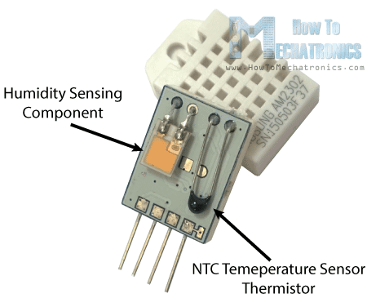

*Figure 2. Diagram of DHT11 sensor*

For measuring humidity, they use the humidity sensing component which has two electrodes with moisture holding substrate between them. So as the humidity changes, the conductivity of the substrate changes or the resistance between these electrodes' changes. This change in resistance is measured and processed by the IC which makes it ready to be read by a microcontroller.

On the other hand, for measuring temperature these sensors use NTC temperature sensor or a thermistor. A thermistor is a variable resistor that changes its resistance with change of the temperature. These sensors are made by sintering of semi conductive materials such as ceramics or polymers in order to provide larger changes in the resistance with just small changes in temperature. The term “NTC” means “Negative Temperature Coefficient”, which means that the resistance decreases with increase of the temperature [17].

***2.2.2. Low-cost Light sensor – CdS***

A ***Light Dependent Resistor (LDR)*** is also called a photoresistor or a cadmium sulfide (CdS) cell. It is also called a photoconductor. It is basically a photocell that works on the principle of photoconductivity. The passive component is basically a resistor whose resistance value decreases when the intensity of light decreases. This optoelectronic device is mostly used in light varying sensor circuit, and light and dark activated switching circuits. Some of its applications include camera light meters, street lights, clock radios, light beam alarms, reflective smoke alarms, and outdoor clocks

***Overview of the Low-cost Light sensor:***

* **Cell resistance: 400-600 LUX**
* **Temperature best working condition: 25℃**
* **Dark resistance at 0 LUX: 10MΩ**

**With this low-cost light sensor, factors that can affect the working results is light intensity, pins connection, etc.**

The basic structure of an LDR is shown below:

[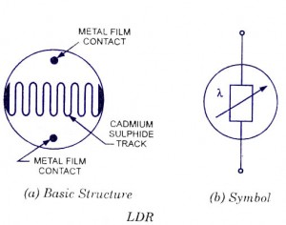](http://www.circuitstoday.com/wp-content/uploads/2009/08/ldr-light-dependent-resistor.jpg)

*Figure 3. LDR sensor* 

The snake like track shown below is the Cadmium Sulfide (CdS) film which also passes through the sides. On the top and bottom are metal films which are connected to the terminal leads. It is designed in such a way as to provide maximum possible contact area with the two metal films. The structure is housed in a clear plastic or resin case, to provide free access to external light. As explained above, the main component for the construction of LDR is cadmium sulfide (CdS), which is used as the photoconductor and contains no or very few electrons when not illuminated. In the absence of light, it is designed to have a high resistance in the range of megaohms. As soon as light falls on the sensor, the electrons are liberated, and the conductivity of the material increases. When the light intensity exceeds a certain frequency, the photons absorbed by the semiconductor give band electrons the energy required to jump into the conduction band. This causes the free electrons or holes to conduct electricity and thus dropping the resistance dramatically.

***2.2.3. Low-cost Soil Moisture sensor – Dielectric***

The ***Dielectric*** is used to measure the volumetric water content of soil. The sensor uses capacitance to measure dielectric permittivity of the surrounding medium. In soil, dielectric permittivity is a function of the water content. The sensor creates a voltage proportional to the dielectric permittivity, and therefore the water content of the soil. The sensor averages the water content over the entire length of the sensor. There is a 2 cm zone of influence with respect to the flat surface of the sensor, but it has little or no sensitivity at the extreme edges. The figure above shows the electromagnetic field lines along a cross-section of the sensor, illustrating the 2 cm zone of influence.

***Overview of the Low-cost Soil Moisture sensor - Dielectric***

* **Supply voltage: 5V**
* **Digital value is indicated by out a pin**
* **4 pins: out, VCC, GND, DO, AO**
* **Depth of detection: 37mm**

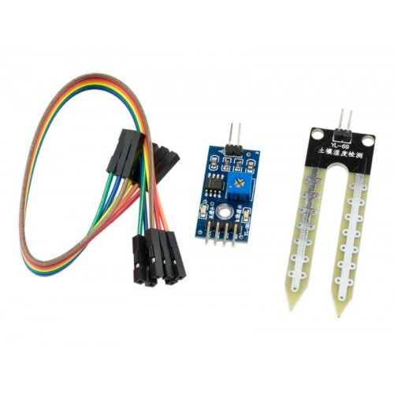

***Figure 4. Soil moisture sensor***

1. **Results and Discussion**

**3.1. Moisture calculation**

**Moisture is the value of water or other liquids diffused in a certain amount of air, or a surfaced of an object. Moisture is measured in percentage (%).**

**Moisture percentage is measured and evaluated by the equation:**

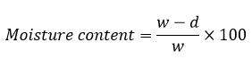

**Whereas w: wet weight**

**d: weight after drying**

**3.2. Temperature calculation**

**Temperature is the average kinetic energy of particles colliding to the wall of a container or a system. Temperature is measured if Celsius (C) or Kelvin (K).**

**Temperature is measured by this formula:**

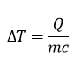

**Whereas ΔT: change in temperature**

**Q: amount of heat absorbed or released**

**m: mass of the body**

**c: specific heat of the body**

**3.3. Light intensity calculation**

**Light intensity is the strength or amount of light produced by a specific light source. It is the measure of wavelength weighted power and the unit for light intensity is percentage (%).**

**Light intensity is measured by:**

Artboard 1.png

**3.4. Soil moisture sensor calculation**

**Soil moisture is different to the moisture in the air. This is the calculation of the moisture in the soil to find out if a plant needs more water or less water.**

1. **Conclusion**

The CGE system was successfully designed and fabricated.

The system was able to detect any variability of environmental factors that can affect the growth of plants such as temperature, light intensity, CO2 concentration and soil moisture in real time.

The system is also very cheap

In the future, we will carry out the outdoor testing

1. **References**

[1].https://en.wikipedia.org/wiki/Greenhouse

[2].<https://getrevising.co.uk/grids/advantages-and-disadvantages-of-greenhouses-2>

[3].https://www.1001artificialplants.com/2018/10/17/8-advantages-and-disadvantages-of-greenhouse-technology/

[4].https://www.mouser.com/ds/2/758/DHT11-Technical-Data-Sheet-Translated-Version-1143054.pdf

[5].file:///C:/Users/MyPC/Downloads/sunrom-443700.pdf

[6]. <https://web.extension.illinois.edu/hkmw/downloads/55040.pdf>

[7] https://formulas.tutorvista.com/physics/temperature-formula.html