**How to use MesoCalc?  
A tutorial with exercises extracted from cuneiform texts**

Christine PROUST (CNRS, SPHERE, Université Paris-Diderot)   
and   
Baptiste MÉLÈS (CNRS, Archives Henri Poincaré, Université de Lorraine)

The current version of MesoCalc and this tutorial (May 2017) will be updated soon with new features, notably iterative addition of measures and reciprocal of non-regular numbers

**Table of Content**

1- General principles 2

1.1. Numbers 2

1.2. Operations 4

2- Operations on SPVN 6

2.1. Multiplication 6

2.2. Reciprocal 7

2.3. Division by a regular number 8

2.4. Division by a non-regular number 9

2.5. Exponential operations 9

2.6. Addition and subtraction 10

3- Operations on measurement values 11

3.1. Addition 11

3.2. Subtraction 11

3.3. Surface 12

3.4. Volume 13

3.5. Possible adaptations 14

3.6. Impossible adaptations 16

4- Bibliography 16

# General principles

MesoCalc is a **Mesopotamian calculator**. It computes in **sexagesimal place-value notation**, operates on **measures**, and converts **dates**.

|  |  |
| --- | --- |
| [MesoCalc](http://baptiste.meles.free.fr/site/mesocalc.html) automates the basic operations that were performed routinely in mathematical and economic activities in Mesopotamia. The numerical and metrological systems adopted in MesoCalc reflect the standard of Old Babylonian scribal schools (see ‘[Numbers and Metrology](http://cdli.ox.ac.uk/wiki/doku.php?id=numbers_metrology)’ in cdli:wiki). Most of the operations attested in other documentations (for example, third or first millennium texts) can be performed with MesoCalc, with some adaptations (see §3.5). However, calculations with special metrologies are not possible right now. New features of MesoCalc will be developed for these special metrologies (see §3.6). MesoCalc is also able to convert Neo-Babylonian dates into modern date.  MesoCalc attempts to adhere as far as possible to the ancient notions of numbers, quantities and operations as explained in 1.1 and 1.2.  MesoCalc has been written in a programming language (called JavaScript) which, concretely, allows any user to download the program as a single file and to execute it, be it online or offline, in his or her web browser. Moreover, MesoCalc is a free software, published under the GNU General Public License (version 3 or any later version). Every user is allowed to copy it, modify it and redistribute his or her own modifications, provided that his or her version be published under the same license. | C:\Users\Christine\Desktop\menu.png  <http://baptiste.meles.free.fr/site/mesocalc.html> |

## 1.1. Numbers

Two kinds of numbers are used in cuneiform texts, as well as in MesoCalc: positional and non-positional numbers.

### Sexagesimal Place Value Notation

Sexagesimal Place Value Notation (SPVN) is attested mainly in mathematical texts. As indicated by its name, this notation is sexagesimal (base sixty) and positional (the value of a sign derives from its place in the number).

This notation uses 59 digits. In cuneiform, the digits are noted with vertical wedges (), the value of which is 1, and winkelhaken (), the value of which is 10, repeated as many times as necessary. The digits are transcribed in modern language (and in MesoCalc) as 1, 2, … 59. Example,   is transcribed 49.

According to the place value principle, each sign represents sixty times the same sign occupying the previous place (at the right hand). For example, in(1.21), the left hand wedge represents sixty times the right hand wedge.

Moreover, the place of the unit in the number is not indicated in cuneiform writing. For example, the number represented by one wedge ( ) corresponds at the same time to 1, and 60, and 1/60, and any power of 60; the number  corresponds at the same time to 3, and 3×60, and 3/60, and 3 multiplied by any power of 60; the number(1.21) corresponds at the same time to 60+21, and (60+21)×60, and (60+21)/60, and (60+21) multiplied by any power of 60, and so on. In modern language, we say that the notation is floating.

From a mathematical point of view, the floating notation has a great advantage for performing multiplication and reciprocals, because all of the calculations are reduced to operations on integers (see §2.1 – 2.5).

### Modes 60F and 60A

As did ancient scribes, MesoCalc works in floating sexagesimal place value notation for multiplications and reciprocals. The floating mode (60F) is the default setting. In this mode, the product of 3 by 20 is 1.

However, the user may prefer to work in absolute sexagesimal place value notation, where the place of the unit is at the final place (at the right). For that, MesoCalc uses ‘0’ in final places if necessary, even if this notation never appears in Old Babylonian sources. The absolute mode (60A) is an option of the “computing system”. In this mode, the product of 3 by 20 is 1.0 (See more explanations and examples in the introduction of MesoCalc).

### Non positional numbers

Non positional numbers are used in cuneiform texts for expressing quantities, that is, for counting discrete items (sheeps, men, years …) or measurement units.

The main non positional system is the so-called “system S” (S meaning “sexagesimal”). The diagram below illustrates the differences between the system S (first row), and the SPVN (last row). Note that both have a sexagesimal structure.

|  |  |  |  |  |  |  |  |  |  |  |
| --- | --- | --- | --- | --- | --- | --- | --- | --- | --- | --- |
| **System S** |  |  |  |  |  |  |  |  |  |  |
|  | ×10 ← |  | ×6 ← |  | ×10 ← | cuneiform version of DIC | ×6 ← | cuneiform version of U | ×10 ← | cuneiform version of DIC |
| šar’u  36 000 |  | šar2 3 600 |  | geš’u 600 |  | geš2 60 |  | u 10 |  | diš 1 |
|  |  |  |  |  |  |  |  |  |  |  |
| **SPVN** |  |  |  |  |  |  |  |  |  |  |
| cuneiform version of U | ×10 ← | cuneiform version of DIC | ×6 ← | cuneiform version of U | ×10 ← | cuneiform version of DIC | ×6 ← | cuneiform version of U | ×10 ← | cuneiform version of DIC |

For example, the numbers of years in the [Sumerian King List](http://cdli.ox.ac.uk/wiki/doku.php?id=king-lists_genealogies) are noted in System S. In the table below are represented the cuneiform signs used for the first five reigns in the Old Babylonian prism [Ashm 1923-444](http://cdli.ucla.edu/%20P384786) face 1, lines 1-17. The corresponding numbers are provided in the last column in modern notation, but make apparent the arithmetical structure of the cuneiform notation.

|  |  |  |  |
| --- | --- | --- | --- |
|  | Cuneiform signs | Transliteration | Number of years |
| Line 4  (reign 1) |  | 8(šar2) | 8×3600 |
| Line 5  (reign 2) |  | 1(šar'u) | 36000 |
| Line 7  (reigns 1 + 2) |  | 1(šar'u) 8(šar2) | 36000+8×3600 |
| Line 12  (reign 3) |  | 1(šar'u) 2(šar2) | 36000+2×3600 |
| Line 14  (reign 4) |  | 8(šar2) | 8×3600 |
| Line 15  (reign 5) |  | 1(šar'u) | 36000 |
| Line 17  (reigns 3+4+5) |  | 3(šar'u) | 3×36000 |

Note that it is used here the CDLI conventions for transliteration of numbers: 3(diš) means three times the sign DIŠ (), 3(šar2) means three times the sign ŠAR2 (), and so on.

For more information on the numerical systems used in the Old Babylonian period, see [Numbers & Metrology in the 2nd millennium](http://cdli.ox.ac.uk/wiki/doku.php?id=numbers_metrology_2nd_millennium).

## 1.2. Operations

Different operations are performed with different kinds of numbers. If we strictly respect the elementary teaching in Old Babylonian scribal schools, the operations work as follows (for details on the *modus operandi* with MesoCalc, see §2).

**A multiplication** acts on two numbers in SPVN. However, the modern user may wish to multiply more than two numbers. MesoCalc offers the possibility to iterate the operations: an extra window is opened for that (see yellow box below).

Example: 44.26.40 × 9 = 6.40 (more in §2.1)

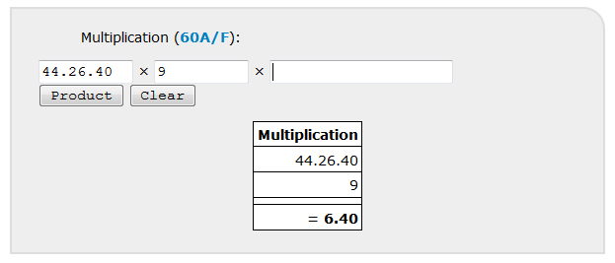

Computing **reciprocals** is possible only with regular numbers. A regular number in a given base is a number which admits a reciprocal with a finite number of digits in this base. For example, in base 60, the numbers 2, 3, 4, 5, 6 are regular, but 7 is not regular; the regular numbers in base 60 admit only 2, 3 and 5 as prime factors.

Example: the reciprocal of 44.26.40 is 1.21 (more in §2.2)

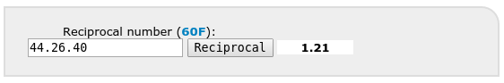

**Dividing** by a number is multiplying by the reciprocal of this number (which implies that only divisions by regular numbers provide exact result).

Example: 9 ÷ 44.26.40 = 9 × 1.21 = 12.9 (more in §2.3)

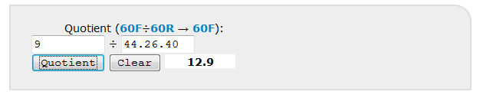

Addition and subtraction act mainly on quantities (see §3.1- 3.2).

However, mathematical and economic practices are more flexible than what was taught in scribal schools. In mathematical problems, addition or subtraction of SPVN often occurs (see §2.6). Merchants may use non regular rates and, in this case, they may have to divide by non regular numbers (see 2.4). Moreover, even if, in ancient practices, multiplications act only on SPVN, the pressed modern reader might wish multiply two lengths in order to obtain directly an area (see 3.4). MesoCalc permits these operations.

# 2- Operations on SPVN

## 2.1. Multiplication

For multiplying 20 by 9, go to “Multiplication”, enter 20, then 9, and click on “product” (or enter with your keyboard). The result is 3.

See example in [Ist Ni 03373](%3c%20http:/www.cdli.ucla.edu/P368742)

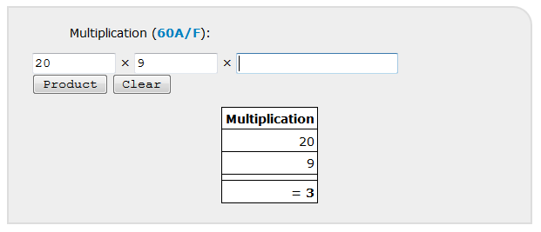

For multiplying 30.5 by 22.30, go to “Multiplication”, enter 30.5, then 22.30, and click on “product”. The result is 11.16.52.30.

See example in [UM 29-16-504 + UM 29-16-661](http://www.cdli.ucla.edu/P256992) (note an error in the last digit of the product)

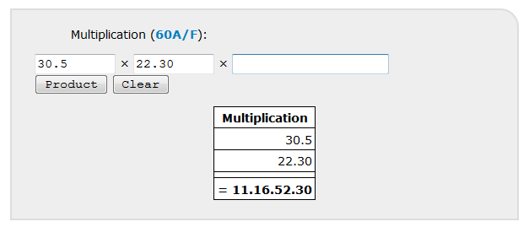

|  |  |
| --- | --- |
| For generating the multiplication table by 15, go to “multiplication table”, enter 15, and click on “table”.  See example in [HS 214a](http://www.cdli.ucla.edu/P254581) | C:\Users\Christine\Desktop\table15.png |

## 2.2. Reciprocal

For calculating the reciprocal of 4.26.40, go to “reciprocal number”, enter 4.26.40, click on “ireciprocal” (or enter with your keyboard). The result is 13.30.

See example in [Ist Ni 10241](http://www.cdli.ucla.edu/P368962)

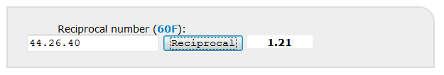

For generating the standard table of reciprocal, click on “reciprocal table”.

|  |  |
| --- | --- |
| For generating a table of reciprocal of regular numbers between *a* and *b* up to *n* digits, enter *a* (in SPVN), then *b* (in SPVN), then *n* (window ‘up to’) and click on “Table of regular and reciprocal numbers”. For example, if you wish the table of reciprocals of the 3-digits regular numbers beginning with 2 and their reciprocals, enter: from 2 to 3 up to 3 sexagesimal digits.  Seleucid tablet [AO 6456](http://www.cdli.ucla.edu/P254386) gives (almost all) regular numbers up to 8-digits beginning with 2 and their reciprocals. The complete table is obtained by entering ‘from 2 to 3 up to 8 sexagesimal digits’ | C:\Users\Christine\Desktop\2to3.png |

## 2.3. Division by a regular number

For dividing 2.13.20 by 3.20

1. Calculate the reciprocal of 3.20. The result is 18.
2. Multiply 2.13.20 by 18. The result is 40.

Shortcut: go to “quotient”.

See example in [VAT 6505](http://www.cdli.ucla.edu/P254921) #7 and [CBS 1215](http://www.cdli.ucla.edu/P254479) #7

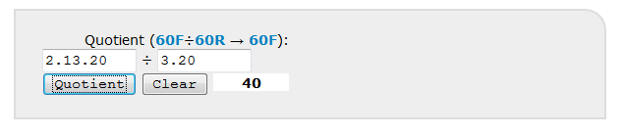

## 2.4. Division by a non-regular number

How divide 57.16 by 35.20? There is a problem because the number 35.20 is not regular (if you enter 35.20 in the field “Regular number?” MesoCalc returns you “no”). Thus, it is necessary to search an approximation of the reciprocal of 35.20. For that, several methods are possible.

The first (and not the best) is to approximate the non-regular divisor by a regular divisor. For that, go to ‘Arithmetical properties’, ‘Regular approximation’, enter 35.20 up to 4 sexagesimal digits. MesoCalc returns the following output:

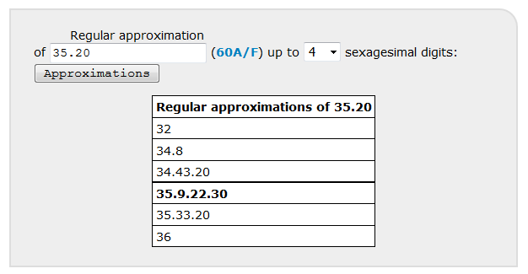

The 4-digits regular number the closest to 35.20 is 35.9.22.30. The quotient 57.16 ÷ 35.9.22.30 provides an approximation of the quotient 57.16 ÷ 35.20:

57.16 ÷ 35.9.22.30 = 57.16 × 1.42.24 = 1.37.44.6.24

(Note that, in order to control the error, it should be necessary to frame the exact value by two approximate values, thus, to divide as well 57.16 by 35.33.20; the exact quotient should appear to be between 1.36.30 and 1.37.50).

Another method of approximation is to proceed by dichotomy. This is a better method (it converges much faster), which was probably used by ancient scribes.

See example in [Ist L 3381](http://www.cdli.ucla.edu/P132620). In this administrative text, the approximation found by the scribe is 1.37, which corresponds to the capacity 1 ½ *sila* 7 *gin* noted on the tablet, that is, a quite good approximation of the exact value.

## 2.5. Exponential operations

For calculating the square of 1.25.34.8, go to “square” in “exponential operations”, enter 1.25.34.8, click on “square” (or enter with your keyboard). The result is 2.2.2.2.5.5.4.

See example in Ist Si 428 < <http://www.cdli.ucla.edu/xxxx> > (not yet on cdli)

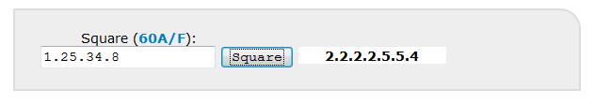

For calculating the square root of 2.2.2.2.5.5.4, go to “square root” in “exponential operations”, enter 2.2.2.2.5.5.4, click on “square root” (or enter with your keyboard). The result is 1.25.34.8.

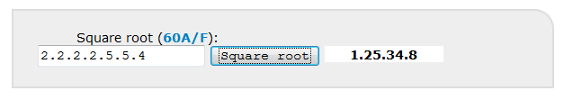

In the same way, you find that the square of 30 is 15, and the square root of 15 is 30. For understanding this latter unexpected result, keep in mind that MesoCalc works in floating notation. In absolute notation, the results would be different:

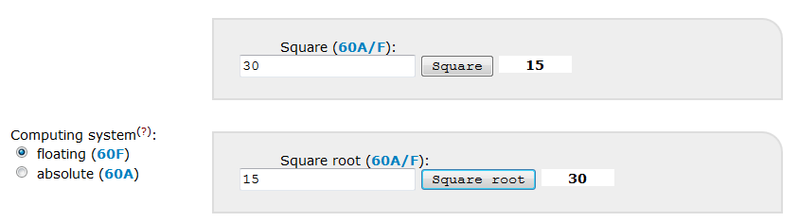

Choose the mode “absolute notation (60A)”. In “60A”, the square of 30 is given as 15.0 by MesoCalc. The square root of 15 is given as “Undefined”, and the square root of 15.0 is given as 30.

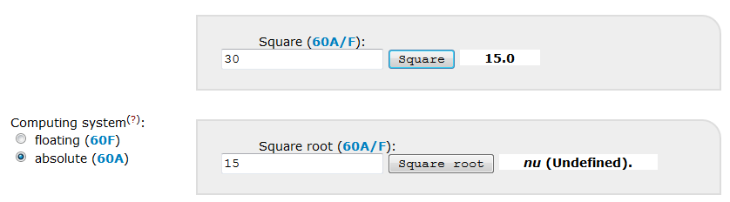

## 2.6. Addition and subtraction

Additions and subtractions on SPVN are not frequent, but occur in some mathematical texts, mainly in the procedures used for solving quadratic problems. Performing additions and subtraction with MesoCalc may imply the use of “0” in order to place correctly the digits of the numbers to be added the ones in relation to the others.

See example in [BM 13901](http://www.cdli.ucla.edu/P254406). In this text, obv., col. i, line 7, the number 15 must be added to the number 14.30. The context of the problem indicates that the digits of these numbers must be placed as follows:

15

14 30

In MesoCalc, go to “addition”, enter 15 and 14.30.0, the result is 14.30.15.

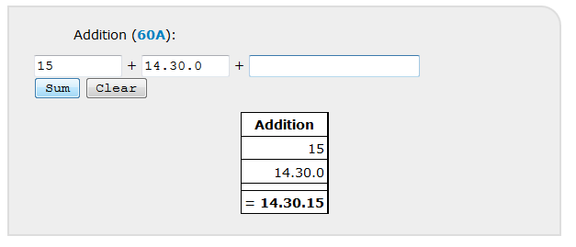

# 3- Operations on measurement values

MesoCalc provides the results using fractions as in ancient texts, but does not accept fractions as inputs. This feature will be implemented soon! For the moment, the fractions of units must be converted into integer numbers of lower units. Numbers can be entered in sexagesimal or decimal system. MesoCalc provides also an approximation of the results in modern metric system.

## 3.1. Addition

Additions are omnipresent in administrative and economic texts. Sometimes, in some large account tablets, dozens or even hundreds of entries are to be added (see for example [MAH 19472](http://www.cdli.ucla.edu/P113474) or [BM 19027](http://www.cdli.ucla.edu/P108470)). For checking the totals and sub-totals in such large accounts, the additions must be iterated many times. This feature will be offered by MesoCalc soon!

## 3.2. Subtraction

Subtractions appear mostly in balanced accounts.

For example, in [YBC 16487](http://www.cdli.ucla.edu/P112497), a silver account from Umma dated from the Ur III period, the total of the receipts is a weight of 1 1/2 *mana* 6 1/3 *gin* 27 še of silver (obverse, line 1), and the total of the expenditures is a weight of 2/3 *mana* 8 5/6 *gin* 10 *še* of silver (reverse, line 1'). According to the text, the deficit is 2/3 *mana 7* 1/2 *gin* 17 *še* (reverse, line 3'). To check this, go to “subtract weights”, enter the integer numbers of *mana*, *gin* and *še*, either in sexagesimal or decimal notation (both options are illustrated below), and click on “=”.

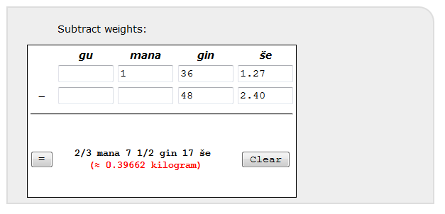

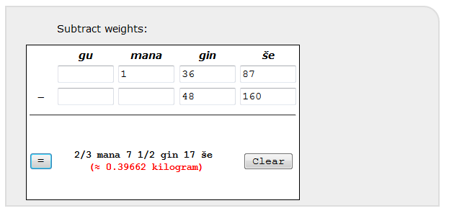

MesoCalc provides the result 2/3 *mana* 7 1/2 *gin* 17 *še*, which is indeed the deficit given by the text.

## 3.3. Surface

According to school texts, the areas were calculated through the intermediate of SPVN.

For example, in [UM 29-15-192](http://www.cdli.ucla.edu/P254900), it is asked to seek the area of a square the side of which is 2 *šu-si*. The length 2 *šu-si* corresponds to the number 20 (in SPVN) according to [metrological table for lengths](http://cdli.ucla.edu/pubs/cdlj/2009/cdlj2009_001.html). The calculation on SPVN appears explicitly in a corner of the tablet: 20 is multiplied by 20, which gives 6.40. This result can be checked as follows:

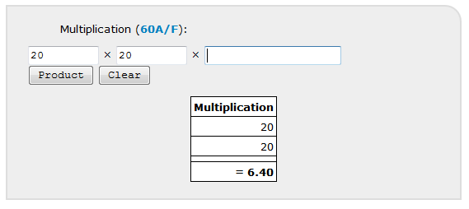

The number 6.40 corresponds to the area 1/3 *še* according to metrological tables (see [metrological table of surfaces](http://cdli.ucla.edu/pubs/cdlj/2009/cdlj2009_001.html), §9.3 completed with §9.2 for small units), with a mental control of the order of magnitude.

However, the pressed modern reader might wish to get directly an area by multiplying two length measures. MesoCalc offers this option as follows.

If you want to calculate directly the area of [UM 29-15-192](http://www.cdli.ucla.edu/P254900) quoted above (the area of a square the side of which is 2 *šu-si*), go to “Multiply lengths to get a surface”, enter “2” in the first row, column *šu-si*, and in the second row, column *šu-si*. Click on “=”. You get 1/3 *še*.

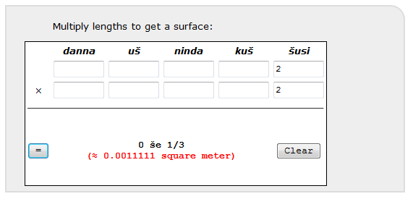

## 3.4. Volume

The volumes were calculated in the same manner as the areas through the intermediate of SPVN. However, the pressed modern reader can get directly a volume by entering the three dimensions.

For example, [YBC 1821](http://www.cdli.ucla.edu/P143411) is an Ur III text which lists the dimensions of portions of canals, and the corresponding volumes. In obverse, column i, lines 1-2, the dimensions of the portion of canal are 1 *ninda* length, 2 *ninda* width, and 4 *kuš* depth, and the corresponding volume is 8 *sar.* It is easy to check this result mentally, but MesoCalc can be used as well. Go to “Multiply lengths to get a volume”, enter the three dimensions. You get 8 *sar.*

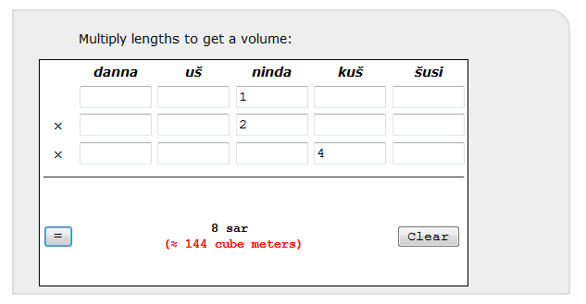

In reverse, column ii, lines 4-5, the dimensions of the portion of canal are 3 ½ *ninda* length, 1 ½ *ninda* width, and 7 *kuš* depth, and, according to the CDLI transliteration, the volume is 37 2/3 *sar* 5 *gin.* In order to check this latter result, go to “Multiply lengths to get a volume”, enter the three dimensions 3 ½ *ninda* (or 3 *ninda* 6 *kuš*), 1 ½ *ninda* (or 1 *ninda* 6 *kuš*), and 7 *kuš*. The calculated volume is 36 2/3 *sar* 5 *gin* (discrepancy 1 sar with the transliteration)*.*

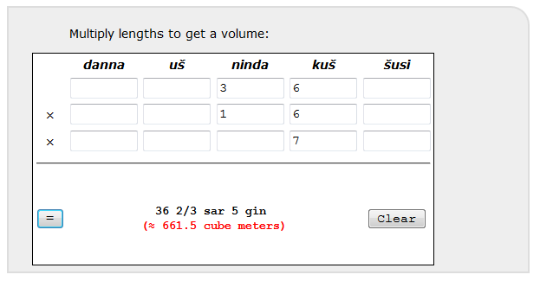

## 3.5. Possible adaptations

Most of the metrologies adopted in various documentations dated from the third millennium differ from the OB standard metrology that MesoCalc is based on. However, these differences do not affect the basic structure, and MesoCalc can be used with minor adaptations.

### Surfaces in ED III tables from Fara

The tablet [VAT 12593](http://www.cdli.ucla.edu/sP010678) contains a table of surfaces, where the measures of the sides of squares are listed, and the corresponding areas are provided. The measures of the sides are expressed as numbers of *ninda* (ninda-DU in the text), these numbers themselves expressed in system S. In MesoCalc, you can use the unit *uš* instead of sixties of *ninda* because 1 *uš* = 60 *ninda.*

For higher numbers (more than 3600 *ninda*), if any, you can use MesoCalc by entering the numbers of *ninda* in absolute sexagesimal place value notation. Note that such a use of SPVN is an aberration from a historical point of view because SPVN was never used for expressing quantities; this is just a hocus-pocus allowing the adaptation of MesoCalc to borderline situations.

For example, the second row of the table in [VAT 12593](http://www.cdli.ucla.edu/sP010678) gives the side of a square as 9×60 *ninda*, and the corresponding surface as 2 *šar* 4 *bur’u* 2 *bur gan*. To check this result, go to “Multiply lengths to get a surface”, enter “9” in the first and the second row, columns “*uš*”, click on “=”. You get 2 *šar* 4 *bur'u* 2 *bur gan*.

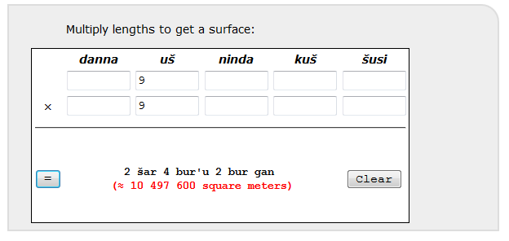

Other similar example is found in [MS 3047](http://www.cdli.ucla.edu/%20P252059), where the fifth row gives the dimensions of a rectangle as 50 *ninda* and 50×60 *ninda*, and the corresponding 1 *šar* 2 *bur’u* 3 *bur* 1 *eše*. You get this result with MesoCalc as follows:

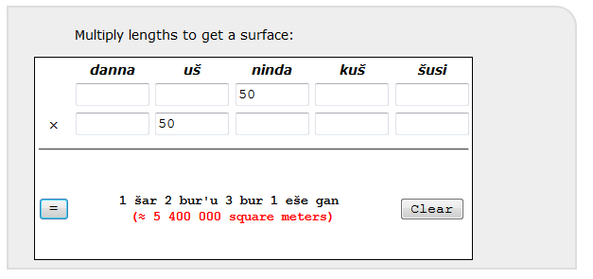

### Surfaces in ED III field texts from Lagaš

The tablet [DP 607](http://www.cdli.ucla.edu/%20P221257) uses the length unit “gi”, the value of which is ½ ninda. Thus, in order to use MesoCalc, you have to convert *gi* into *ninda*: the numbers of *gi* must be divided by two to get the numbers of *ninda*. For example, the third field listed on the tablet gives the field as 60+40 *ninda*  4 *gi* (transliteration 1(ĝeš2) 4(u) 4(diš) gi) and the width as 10 *ninda* 5 *gi* (transliteration 1(u) 5(diš) gi). The area is given as 2 *eše* ½ ¼ *gan* (that is, 2 *eše* 75 *sar*).

Adaptation of the length: 60+40 *ninda*  4 *gi* = 60+42 *ninda* = 1 *uš* 42 *ninda*

Adaptation of the width: 10 *ninda* 5 *gi* = 12 1/2 *ninda* = 12 *ninda* 6 *kuš*

You get the correct result with MesoCalc as follows:

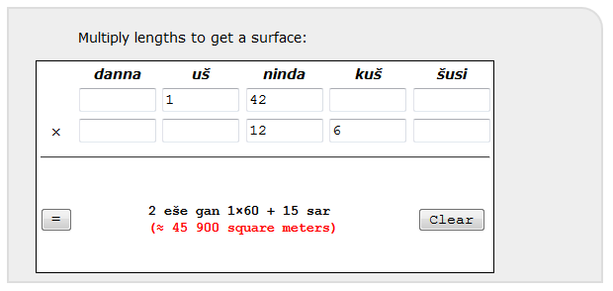

## 3.6. Impossible adaptations

Such adaptations are not possible when the structure of the metrological systems differ from the Old Babylonian standard.

Examples:

* Systems of capacity with, for example, 1 *gur* = 120 *sila* (3rd and 2nd millennium Mari), or 1 *gur* = 240 *sila* (most of the cities in early 3rd millenium), or 1 *gur* = 180 *sila* (1st millenium).
* System of length with 1 *kuš* = 24 *šu-si* (Late Babylonian period)

# 4- Bibliography

The following publications may help the reader to go further on sexagesimal place-value notation and metrology. Most of the examples quoted in §3 can be found in the two forthcoming volumes edited by Chemla et al. See also cdli:wiki pages on ‘[Numbers and Metrology](http://cdli.ox.ac.uk/wiki/doku.php?id=numbers_metrology)’.

Chambon, Gregory. 2011. *Normes et pratiques: l'homme, la mesure et l'ecriture en Mésopotamie. I. Les mesures de capacite et de poids en Syrie ancienne, d'Ebla à Emar*, vol. 21.

Chemla, Karine, Agathe Keller, and Christine Proust. forthcoming. "Cultures of computation and quantification in the ancient world." Springer.

Chemla, Karine and Cécile Michel. forthcoming. "Mathematics and administration in the ancient world." Springer.

Englund, Robert K. 2001. "Grain accounting practices in archaic Mesopotamia." Pp. 1-35 in *Changing Views on Ancient Near Eastern Mathematics* vol. 19, *Berliner Beiträge zum Vorderen Orient*, edited by J. Høyrup and P. Damerow. Berlin.

Friberg, Jöran. 1992. "Numbers and Counting in the Ancient Near East." Pp. 1139-1146 in *The Anchor Bible Dictionary IV*, edited by D. N. Freedman. New York.

Høyrup, Jens. 1982. "Investigation of an early Sumerian Division Problem c. 2500 B. C." *Historia Mathematica* 9:19-36.

Høyrup, Jens. 1993. ""Remarkable Numbers" in Old Babylonian Mathematical Texts: A note on the psychology of numbers." *Journal of Near Eastern Studies* 52:281-286.

Høyrup, Jens. 1993. "On subtractive operations, subtractive numbers." *Zeitschcrift für Assyriologie und Vorderasiatische Archäologie* 83:42-60.

Høyrup, Jens. 2002. "A note on Old Babylonian computational techniques." *Historia Mathematica* 29:193-198.

Neugebauer, Otto. 1932-3. "Zur transcription mathematischer und astronomischer Keilschrifttexte." *Archiv fur Orientforschung* 8:221-223.

Proust, Christine. 2009. "Numerical and metrological graphemes: from cuneiform to transliteration." *Cuneiform Digital Library Journal* 2009:1.

Proust, Christine. 2013. "Du calcul flottant en Mésopotamie." *La Gazette des Mathématiciens* 138:23-48. < <http://www.cdli.ucla.edu/pubs/cdlj/2009/cdlj2009_001.html>>. English translation here: <https://cnrs.academia.edu/ChristineProust>.

Thureau-Dangin, François. 1921. "Numération et métrologie sumériennes." *Revue d'Assyriologie* 18:123-142.

Thureau-Dangin, François. 1928. "L'origine du système sexagésimal." *Revue d'Assyriologie* 25:115-121.

Thureau-Dangin, François. 1930. "Nombres concrets et nombres abstraits dans la numération babylonienne." *Revue d'Assyriologie* 27:116-119.

Tinney, Steve and Eleanor Robson. "Mathematical Notations." <http://oracc.museum.upenn.edu/doc/help/editinginatf/maths/index.html>