CSCI-466

CMP

Dominion Game

[www.(nameofwebsite).com](http://www.(nameofwebsite).com)

09-13-2017

Mathew Griffin

Carlos Perez

Brent Parker

# Contributions:

### Mathew Griffin:

To be determined.

### Carlos Perez:

To be determined.

### Brent Parker:

Completed the cover page, Problem Statement, and Glossary of Terms sections.

# Problem Statement

The goal of this project is to create a video game version of the card game, Dominion. This game will run in a web browser so that users can simply go to a website and start playing. The initial version doesn’t need to have all the features that the physical card game offers, but more features can be added to future versions, and expansion packs. In future implementations of the game, we’d like to see multiplayer capabilities, a scoreboard that can be seen by all players, the ability for players to play against the computer, and a log to keep track of players actions. We’d also like to offer expansion packs for the players so that they can add additional cards to the game.

A game of Dominion includes 10 kingdom cards that are chosen at random from a deck of 17 different kingdom cards. 10 copies of the 10 chosen kingdom cards are added to the supply which will be shared by all players. The initial version of this project will offer 11 of the 17 kingdom cards so that players will still get variability in their games. In addition to those cards, three types of treasure cards and four types of victory point cards will also be added to the supply.

Players will each get their own draw deck, hand of cards, area for their played cards, and discard pile. They will start with 7 copper cards, and 3 estates cards. Treasure cards, can be played to purchase things. Each type of treasure card has a unique buying power, or buy points. The types of treasure cards are: Copper, Silver, and Gold, they are part of the supply. Copper is free to buy. Silver costs 3 buy points to buy and increases buy points by 2 when played. Gold costs 6 buy points to buy and increases buy points by 3 when played.

At the beginning of the game and at the end of the player’s turn, five cards are moved from the draw deck to the player’s hand. If a player attempts to draw a card when no cards remain in the draw deck, then all the cards from the discard pile are moved to the draw deck and shuffled to randomize the order.

The player’s hand contains the cards drawn from the draw deck. A player may choose to play any of the treasure or action cards by clicking on the card image. Action cards may only be played if the player has actions points available. If a card can be legally played, it is moved from the player’s hand to the played card area and the game is modified as described on the text of the card. Treasure cards do not require actions and always increase the amount of buy points available to the player.

When a player no longer can, or wishes to play more action cards, they may choose to add cards from the supply to their deck. To buy a card, a player needs at least one buy action, their buy points need to be at least as great as the cost, and the quantity of the card in the supply must be greater than zero. If the player can buy a card they may click on the supply pile and move one copy to their discard pile. When a player can, or no longer wishes to buy cards, they end their turn. All cards in the played cards area, or remaining in the player’s hand are moved to the player’s discard pile. The player draws five new cards and the next turn begins.

The game ends either when the last province is purchased or when any three other supply piles are empty. When the game ends, the total value of victory points in each player’s deck should be calculated. The player with the highest number of victory points total wins the game, if it’s a tie, the player who went first will lose.

In future iterations of the game there should be a scoreboard that players can view on the games website. This way players can keep track of their improvements, and compare their best scores with others. This could be done by ranking the average points per turn that a player earns. The scoreboard should have the player’s name, the score, and the ten kingdom cards used. The score data should be stored for permanence.

Some type of multiplayer capabilities should be added in the future as well. Multiplayer capabilities would significantly increase the scope of the project. The ideal way would be a networked system with all players at different computers. Another option is the “hot seat” method where players take turns sharing one computer. The main difficulty with the second method is that certain cards require decision making on another player’s turn. This could make the game so cumbersome in some situations as to be basically unplayable.

Hopefully A.I will be in the first release of this game. Since network multiplayer won’t be in the first release, and it would be the only other way to give users a smooth experience, it makes sense to at least have the option to play against the computer.

A Gamelog could be added to the game eventually. This is necessary for multiplayer, but may be helpful for single player as well. In a multiplayer game, it is important to be able to see what cards were purchased, played, or discarded on other players’ turns. A solitaire player may wish to examine past games to improve their future play. If players have access to a gamelog, it’s possible for them to critically examine games that they finished a long time ago. However, the potential audience for that is very limited and the gamelog should be added after multiplayer capabilities are implemented.

Adding additional cards in later updates would extend the lifetime of the game. So far 268 unique Kingdom Cards have been officially released through the base game and the expansions. An additional 33 are being released in October 2017 bringing the total up to 301. That means that there are more than 400 quadrillion unique combinations of 10 cards. In October, that number will rise to more than a quintillion. Each new card adds more variety than the last, making this an ideal target for future expansions.

This game should be released when the minimum requirements for an enjoyable experience have been met. Once the game is released and players are offering their feedback about the game, less important features can be added, and some features and game fixes that players request can also be added.

# Glossary of Terms

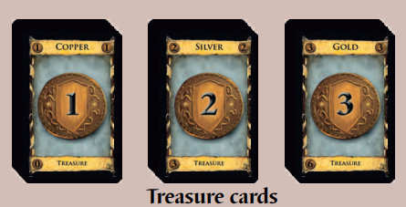

**Treasure cards** consist of copper, silver, and gold cards. These cards are placed in the supply after each player takes 7 copper cards.These cards generate coins.

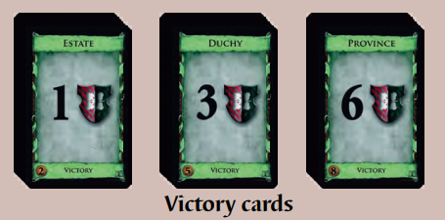

**Victory cards** Estate, Duchy, and Province cards are the basic victory cards, and are available in every game. If 3-4 people are playing, 12 (or 8 if 2 people are playing) each of Estate, Duchy, and Province cards are placed face-up in the supply after each player takes 3 estate cards.

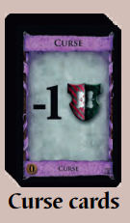

**Curse cards** are mostly used with specific action cards like Witch cards. 10 curse cards go in the supply for a 2 player game, 20 cards go in the supply for 3 players, and 30 cards go in the supply for 4 players. These have a negative victory point value.

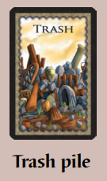

The **trash pile card** is a place where players put cards that were trashed in the game.

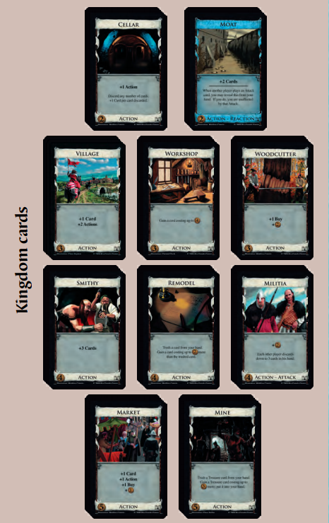

Most Kingdom cards are **action cards** which have effects like generating coins, when a player is in their action phase.

10 **Kingdom cards** are selected by the players at the beginning of the game. 10 of each of the selected cards are placed face-up in piles on the table.

**Action phase** is when the player can play an action card for every action they have, then follow the card’s instructions.

**Buy phase** is when players can play any of their treasure cards that they want to, which will generate coins.

**Clean-up phase** is when players collect their hand and their cards and place them into their discard pile.

**Actions** refers to the number of action cards a player can play. Players start with 1 action, but sometimes cards can grant extras.

**Buys:** Players can increase their buys when they play treasure cards. Buys allow the player to purchase cards from their supply.

**Coins** are the main currency in dominion. Each card has a certain cost in coins. Playing treasure cards and some action cards will produce coins.

**Cost** is the amount of coins that must be paid to buy a card.

**Deck:** A set of cards. This can be a draw pile, discard pile, cards in hand, or a combination of those three

**Discard:** To move a card into the discard pile. This is done during a clean-up phase, or when another card has an effect that requires a card to be discarded.

**Discard Pile:** The pile that discarded cards should be placed in.

**Draw:** This is when a player takes a card from their deck and puts it in their hand.

**Hand:** A player’s hand consists of the cards they can play.

**Play Area:** The table, or other surface where the entire game takes place. This is where all the decks and piles reside, and where the players gather around.

**Supply** refers to all the cards that players can buy in the game.

**Supply Pile** is the deck of cards that players can buy from.

**Value:** This refers to the amount of coins that must be used to buy the card.

# References

Vaccarino, D. X. (n.d.). *Dominion Game Rules.* Rio Grande Games.

Wikipedia. (n.d.). *Wikipedia*. Retrieved from Dominion (card game): https://en.wikipedia.org/wiki/Dominion_(card_game)