CSCI-466

CMP

Dominion Game

September 20, 2017

Mathew Griffin

Carlos Perez

Brent Parker

# Contributions:

### Mathew Griffin:

System Requirements and Assisted with Glossary

Stakeholders, Actors & Goals, Casual Use Cases, Traceability Matrix, Use Case Diagram

### Carlos Perez:

Project Management, assign tasks, table of content.

User Interface Specifications, Preliminary design, User effort estimation.

### Brent Parker:

cover page, Problem Statement, and Glossary of Terms sections.

Sequence Diagram, added terms to glossary.

Contents

Contributions: 2

Mathew Griffin: 2

Carlos Perez: 2

Brent Parker: 2

Contents 3

Problem Statement 4

Glossary of Terms 7

System Requirements 10

Stakeholders 13

Actors and Goals 13

Casual Use Cases 14

Use Case Diagram 15

Sequence Diagram 16

Traceability Matrix 17

Preliminary Design 18

User Effort Estimation 19

Project Management 20

References 23

# Problem Statement

The goal of this project is to create a video game version of the card game, Dominion. This game will run in a web browser so that users can simply go to a website and start playing. The initial version doesn’t need to have all the features that the physical card game offers, but more features can be added to future versions, and expansion packs. In future implementations of the game, we’d like to see multiplayer capabilities, a scoreboard that can be seen by all players, the ability for players to play against the computer, and a log to keep track of players actions. We’d also like to offer expansion packs for the players so that they can add additional cards to the game.

A game of Dominion includes 10 kingdom cards that are chosen at random from a deck of 17 different kingdom cards. 10 copies of the 10 chosen kingdom cards are added to the supply which will be shared by all players. The initial version of this project will offer 11 of the 17 kingdom cards so that players will still get variability in their games. In addition to those cards, three types of treasure cards and four types of victory point cards will also be added to the supply.

Players will each get their own draw deck, hand of cards, area for their played cards, and discard pile. They will start with 7 copper cards, and 3 estates cards. Treasure cards, can be played to purchase things. Each type of treasure card has a unique buying power, or buy points. The types of treasure cards are: Copper, Silver, and Gold, they are part of the supply. Copper is free to buy. Silver costs 3 buy points to buy and increases buy points by 2 when played. Gold costs 6 buy points to buy and increases buy points by 3 when played.

At the beginning of the game and at the end of the player’s turn, five cards are moved from the draw deck to the player’s hand. If a player attempts to draw a card when no cards remain in the draw deck, then all the cards from the discard pile are moved to the draw deck and shuffled to randomize the order.

The player’s hand contains the cards drawn from the draw deck. A player may choose to play any of the treasure or action cards by clicking on the card image. Action cards may only be played if the player has actions points available. If a card can be legally played, it is moved from the player’s hand to the played card area and the game is modified as described on the text of the card. Treasure cards do not require actions and always increase the amount of buy points available to the player.

When a player no longer can, or wishes to play more action cards, they may choose to add cards from the supply to their deck. To buy a card, a player needs at least one buy action, their buy points need to be at least as great as the cost, and the quantity of the card in the supply must be greater than zero. If the player can buy a card they may click on the supply pile and move one copy to their discard pile. When a player can, or no longer wishes to buy cards, they end their turn. All cards in the played cards area, or remaining in the player’s hand are moved to the player’s discard pile. The player draws five new cards and the next turn begins.

The game ends either when the last province is purchased or when any three other supply piles are empty. When the game ends, the total value of victory points in each player’s deck should be calculated. The player with the highest number of victory points total wins the game, if it’s a tie, the player who went first will lose.

In future iterations of the game there should be a scoreboard that players can view on the games website. This way players can keep track of their improvements, and compare their best scores with others. This could be done by ranking the average points per turn that a player earns. The scoreboard should have the player’s name, the score, and the ten kingdom cards used. The score data should be stored for permanence.

Some type of multiplayer capabilities should be added in the future as well. Multiplayer capabilities would significantly increase the scope of the project. The ideal way would be a networked system with all players at different computers. Another option is the “hot seat” method where players take turns sharing one computer. The main difficulty with the second method is that certain cards require decision making on another player’s turn. This could make the game so cumbersome in some situations as to be basically unplayable.

Hopefully A.I will be in the first release of this game. Since network multiplayer won’t be in the first release, and it would be the only other way to give users a smooth experience, it makes sense to at least have the option to play against the computer.

A Gamelog could be added to the game eventually. This is necessary for multiplayer, but may be helpful for single player as well. In a multiplayer game, it is important to be able to see what cards were purchased, played, or discarded on other players’ turns. A solitaire player may wish to examine past games to improve their future play. If players have access to a gamelog, it’s possible for them to critically examine games that they finished a long time ago. However, the potential audience for that is very limited and the gamelog should be added after multiplayer capabilities are implemented.

Adding additional cards in later updates would extend the lifetime of the game. So far 268 unique Kingdom Cards have been officially released through the base game and the expansions. An additional 33 are being released in October 2017 bringing the total up to 301. That means that there are more than 400 quadrillion unique combinations of 10 cards. In October, that number will rise to more than a quintillion. Each new card adds more variety than the last, making this an ideal target for future expansions.

This game should be released when the minimum requirements for an enjoyable experience have been met. Once the game is released and players are offering their feedback about the game, less important features can be added, and some features and game fixes that players request can also be added.

# Glossary of Terms

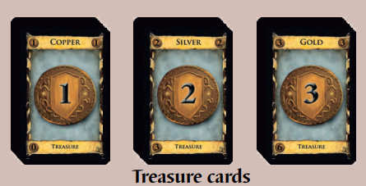

**Treasure cards** consist of copper, silver, and gold cards. These cards are placed in the supply after each player takes 7 copper cards.These cards generate coins.

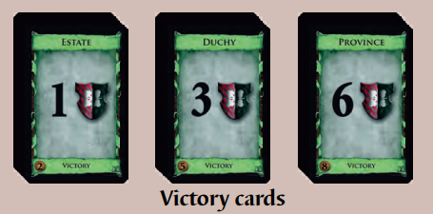

**Victory cards** Estate, Duchy, and Province cards are the basic victory cards, and are available in every game. If 3-4 people are playing, 12 (or 8 if 2 people are playing) each of Estate, Duchy, and Province cards are placed face-up in the supply after each player takes 3 estate cards.

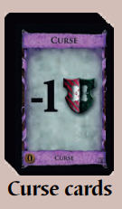

**Curse cards** are mostly used with specific action cards like Witch cards. 10 curse cards go in the supply for a 2 player game, 20 cards go in the supply for 3 players, and 30 cards go in the supply for 4 players. These have a negative victory point value.

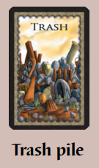

The **trash pile card** is a place where players put cards that were trashed in the game.

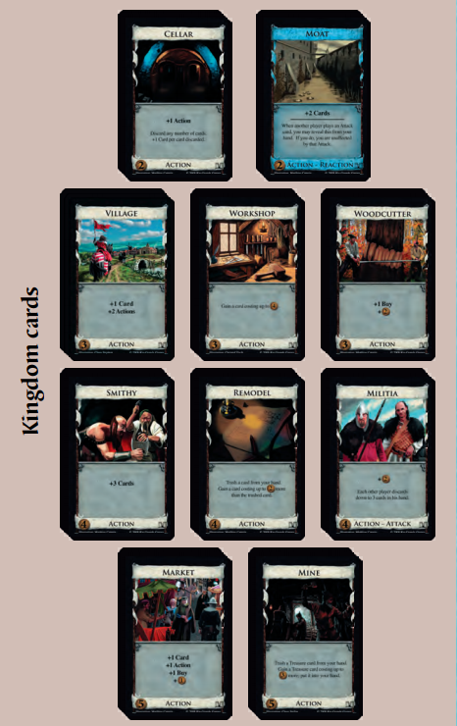

10 **Kingdom cards** are selected by the players at the beginning of the game. 10 of each of the selected cards are placed face-up in piles on the table.

Most Kingdom cards are **action cards** which have effects like generating coins, when a player is in their action phase.

**Action phase** is when the player can play an action card for every action they have, then follow the card’s instructions.

**Buy phase** is when players can play any of their treasure cards that they want to, which will generate coins.

**Clean-up phase** is when players collect their hand and their cards and place them into their discard pile.

**Actions** refers to the number of action cards a player can play. Players start with 1 action, but sometimes cards can grant extras.

**Buys:** Players can increase their buys when they play treasure cards. Buys allow the player to purchase cards from their supply.

**Coins** are the main currency in dominion. Each card has a certain cost in coins. Playing treasure cards and some action cards will produce coins.

**Cost** is the amount of coins that must be paid to buy a card.

**Deck:** A set of cards. This can be a draw pile, discard pile, cards in hand, or a combination of those three

**Discard:** To move a card into the discard pile. This is done during a clean-up phase, or when another card has an effect that requires a card to be discarded.

**Discard Pile:** The pile that discarded cards should be placed in.

**Draw:** This is when a player takes a card from their deck and puts it in their hand.

**Hand:** A player’s hand consists of the cards they can play.

**Play Area:** The table, or other surface where the entire game takes place. This is where all the decks and piles reside, and where the players gather around.

**Supply** refers to all the cards that players can buy in the game.

**Supply Pile** is the deck of cards that players can buy from.

**Value:** This refers to the amount of coins that must be used to buy the card.

**Play Game:** A button that when pressed, will start an instance of the game, or resume one that’s currently in progress.

**Play Card:** When a player plays a card, they gain whatever actions or money the card is worth, and place the card in the trash pile.

**Buy Card:** When a player buys a card, they use the amount of coins that the card is worth, and add the card to either their hand, or their discard pile.

**End Turn:** Players push this button when they don’t have any moves left. This initiates the next players turn.

# System Requirements

**Functional Requirements**

| Identifier | Priority | Requirement |
| --- | --- | --- |
| Req1 | 10 | The system shall initialize the board by selecting 10 random Kingdom cards, creating the supply with those cards, giving each player a shuffled starting deck and drawing five cards when a new game begins. |
| Req2 | 10 | The system shall move the top card from the deck to a player’s hand whenever a draw is required and the deck is not empty. |
| Req2.1 | 10 | The system shall move the contents of the discard pile to the deck and randomize the card order when a draw is required and the deck is empty. The system shall then draw a card. |
| Req3 | 10 | The system shall increase the number of coins available to a player by the value of the treasure card whenever a treasure card is played. |
| Req4 | 10 | The system shall buy a card when a supply pile is clicked on by the player provided that player has at least one buy and at least as many coins as the cost of the card. |
| Req4.1 | 10 | The system shall decrement the number of buys available when a card is bought. |
| Req4.2 | 10 | The system shall decrease the coins available to the player by the cost of the bought card when a card is bought. |
| Req4.3 | 10 | The system shall move one card from the appropriate supply pile to the purchasing player’s discard pile when a card is bought or gained |
| Req4.4 | 10 | The system shall check to see if the supply pile is empty when a card is bought or gained. If it is, the system will check to see if the game has ended. |
| Req4.5 | 10 | The system shall set available actions to zero when a card is legally bought. |
| Req5 | 10 | The system shall move all played cards and all cards remaining in the player’s hand to the discard pile followed by drawing five new cards when a player indicates that their turn has ended. |
| Req6 | 9 | The system shall end the game when there are three empty supply piles or when the Province supply pile empties. |
| Req 6.1 | 9 | The system shall calculate each player’s score by adding the value of the victory cards when the game has ended |
| Req 6.2 | 9 | The system shall display an end game screen with the calculated scores of all players when the game ends. |
| Req7 | 8 | The system should perform the text on an action card whenever an action card is played. For example, if a *Smithy* card is played, the player will draw 3 cards. |
| Req8 | 5 | The system should allow a player to view a high score board sorted by the most efficient games played. |
| Req9 | 4 | The system should give a player starting a new game the option of playing against a very simple AI opponent. |
| Req10 | 2 | The system should allow two to four players to play over a network. |
| Req11 | 2 | The system should record all changes to the game state and allow players to export it after the game is finished. |

**Nonfunctional Requirements**

|  |  |  |
| --- | --- | --- |
| Identifier | Priority | Requirement |
| Req12 | 7 | The system should allow players to play a card from their hand, buy a card, or end their turn with a single click |
| Req13 | 7 | The system should take no more than ten seconds to initialize a new game |
| Req14 | 7 | The system should take no more than three seconds to complete an action card |
| Req15 | 7 | The system should take no more than five seconds to show the victory screen when the game has ended. |

**On-Screen Appearance Requirements**

|  |  |  |
| --- | --- | --- |
| Identifier | Priority | Requirement |
| Req16 | 10 | The system shall display all cards in their appropriate locations (the supply piles, the deck, the player’s hand, the cards that have been played, and the discard pile) |
| Req17 | 9 | The system shall display the current player’s stats (actions, buys, buy points) |
| Req18 | 8 | The system shall display the quantity of cards in the supply piles and the draw deck |

Below is a the layout for a potential UI:

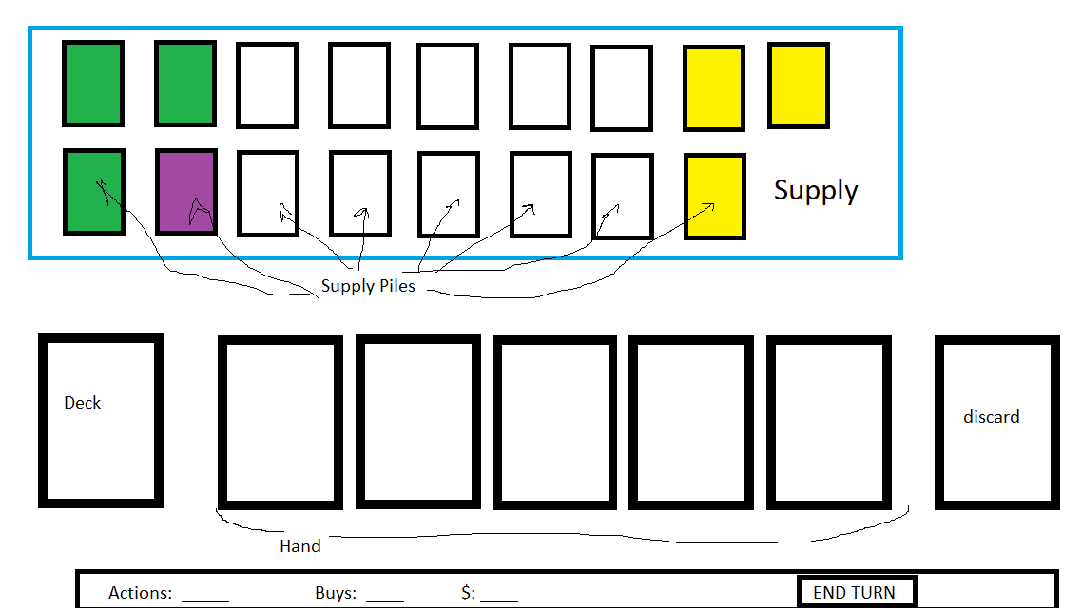

# Stakeholders

We have identified four major stakeholders:

S1: The customer/end user -- In this case, the customer and end user can be considered the same group. They are people who pay for and use this software.

S2: The design team -- These are the people in charge of making the necessary decisions to make this project a reality.

S3: Video game publisher – A publisher gets the completed game to the customers. It can either be an external publishing company or the design team could self-publish. Using an existing IP may limit the publishing options.

S4: Board game publisher – Dominion is an existing IP and the rights to digitally publish would have to be obtained from the publisher of the cardboard version. The publisher has been identified as Rio Grande Games.

# Actors and Goals

This project has four actors:

A1: The Player – This is any person who uses our software to play a game of Dominion.

A2: Opponents – This actor only occurs in multiplayer vs human games. Opponents are special cases of the Player actor used when more than one player is affected by a given interaction. The initiating actor is considered the Player and Player actors are considered opponents. There may be multiple Opponents in a game, but they should be uniquely identified.

A3: High Score Board – This will be an external file or database that records the best games played.

A4: Game Log File – The system can record all the changes to a gamestate and a player may choose to export it to an external file.

# Casual Use Cases

The summary use cases are as follows:

**UC-1: Play Game** – Allows the Player to play a game of Dominion.

Extension Point: Play Card – The player may play a card from their hand.

Extension Point: Buy Card – Allows the player to get new cards.

Inclusion Point: End Turn – Play passes to the next player.

Extension Point: Change Opponent – The Player may change the game type between solitaire, vs humans, and vs AI.

Derived from Reqs 1-7

**UC-2: Play Card** – Allows the player to play a card from their hand. The play must be legal and each card will give unique instructions that the system will follow.

(optional sub use case, «extend» UC-1: Play Game).

Derived from Reqs 3, 7

**UC-3: Buy Card** – Allows the Player to buy a card from a supply pile and add it to their discard.

(optional sub use case, «extend» UC-1: Play Game).

Derived from Req 4

**UC-4: End Turn** – A Player must indicate each time that their turn ends. The system will automatically finish any tasks required by the rules before the turn ends, and play will pass to the next player to begin their turn. In a solitaire game the player simply begins their next turn.

(mandatory sub use case, «include» from UC-1: Play Game).

Derived from Reqs 2, 5

**UC-5: Select Opponent –** Allows the Player to change from the default selection of a solitaire game to a multiplayer game against either human or AI opponents and back again. This use case requires a significant amount of resources and expertise that the development team does not currently have. Further research in this area is likely to add several currently unknown subcases, but given the low priority and limited time this use case is a placeholder until that research is completed.

(optional sub use case, «extend» UC-1: Play Game).

Derived from Reqs 9, 10

**UC-6: View High Scores** – Allows the player to see a list of the best games played. While there are many possible ways to define best, points/turns seems to be a reasonable metric of efficiency. The high score list may also include other information the player’s name, the date, and the Kingdom Cards used.

Derived from Req 8

**UC-7: Export Game Log** – As the game is being played, the system should keep track of changes to the game state. When the game ends, the player may optionally export it to a file. Depending on the details of multiplayer implementation, the game log might be used by a player to see what happened on an opponent’s turn.

Derived from Req 11

# Use Case Diagram

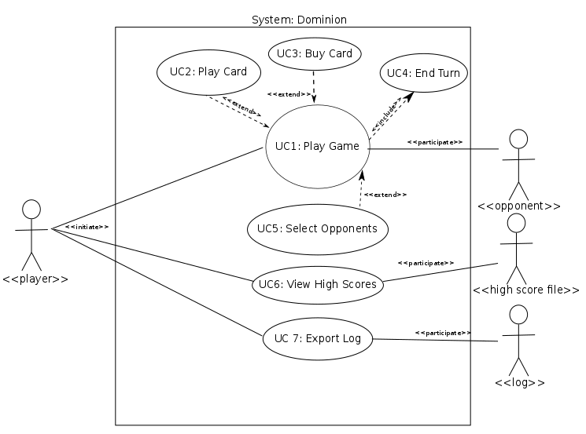

# Sequence Diagram

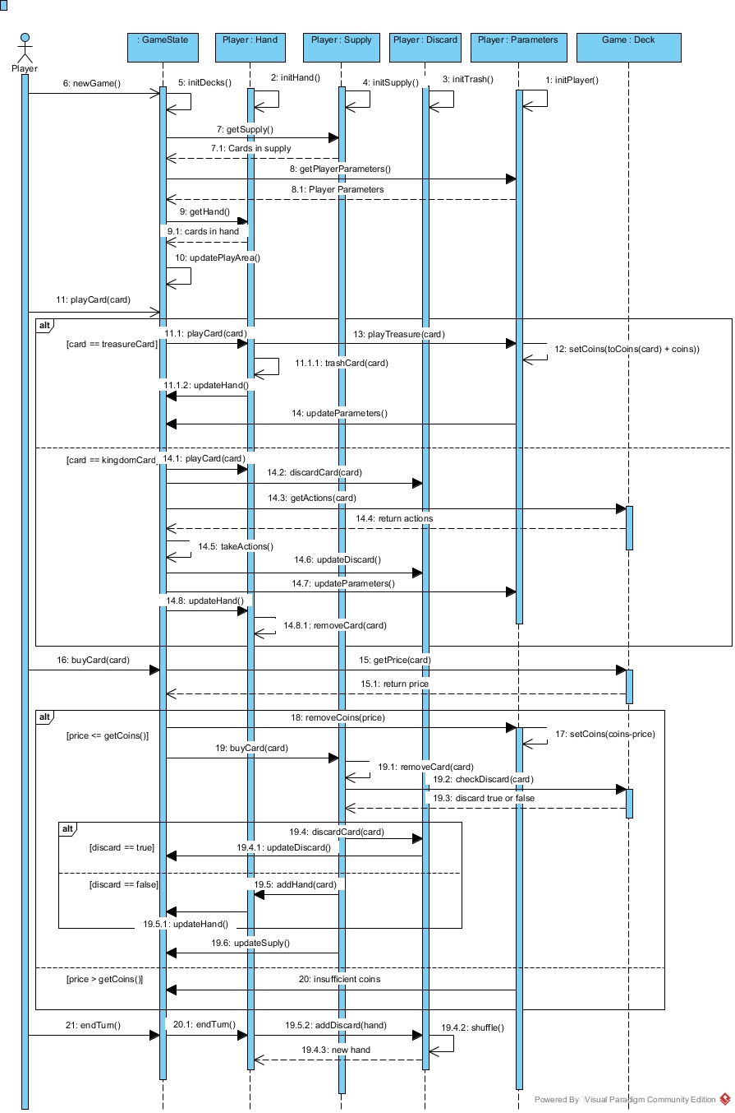

# Traceability Matrix



Above is the traceability matrix for this project. The play game use case is by far the highest priority. The next three highest are play card, buy card, and end turn. These are al included in or extend the play game use case. Play game and its subcases are where the bulk of our effort will be directed early in the project.

# Preliminary Design

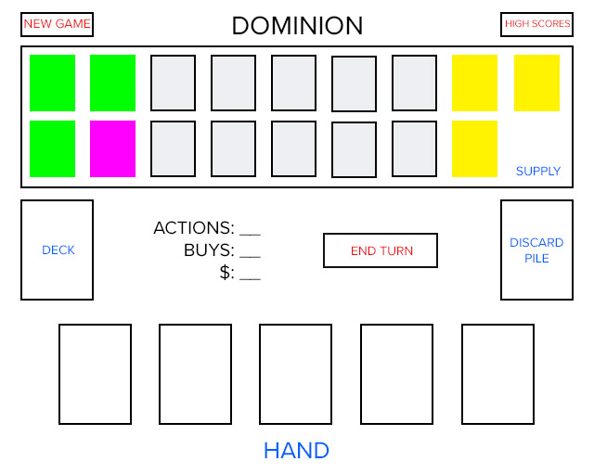

The game will start with the high score screen and the button to toggle New Game in the top corner. When the button is pressed the cards will show like the above mockup. The user will be able to click on any card in his hand to use the action. The deck is only for display and holding the cards, it will not display an active, same as the discard pile. Ending turn button will end the current turn. Actions, buys and $ have no button action, but will update dynamically. All the cards in the supply can be clicked on to buy with actions and/or buys.

If the “New Game” button is pressed anytime during a game, a warning sign will show if you would like to reset the game and start from zero.

High score button will activate the high score chart.

# User Effort Estimation

**NEW GAME**

1. Click “New game”
2. Game starts

**MOVE CARD TO DITCH PILE**

1. Click “card” to move.
2. Click on “ditch pile”.

**USE ACTION/BUYS**

1. If user has actions/buys, he can click on a card or buy a card.
2. Click on the card he wants to use, and move it to his hand.
3. Discarding the other card.

**END TURN**

1. Once all moves are done.
2. Click “End Turn”,
3. Next turn will be shown now.

**SEE HIGH SCORES**

1. Click “High Scores” button in the top right corner.
2. Click “X” (close button) once the user is done.

# 

# Project Management

| Week | Tasks |
| --- | --- |
| 9/11 – 9/17 | * Carlos: Design basic board the board, and place where elements will be placed. Design in CSS Kingdom cards and place in board. * Matthew: Design in CSS Treasure and Curse cards. Prepare all strings different cards will need. * Brent: Design in CSS Victory and Trash pile cards. For victory cards, generate the strings we will need * Goal for the week is to start to have our assets ready for functionality, and communicate with the team |
| 9/18 – 9/24 | * Finish task from last week and share with the team and get feedback from everyone. * Carlos: Functionality to start board’s deck with 10 Kingdom cards and give the user 5 random cards from the deck. * Matthew: Treasure cards functionality. Assign the value of the cards, and basic functionality that will decrease the buy actions if clicked on a card. * Brent: Give the player their 7 copper cards and 3 estates cards (actions don’t need to work perfect at this point, just make sure he gets the cards when he starts the same). * Goal for the week is to start with basic functionality that will be the framework of the game, and start shaping gameplay. |
| 9/25 – 10/1 | * Carlos: Action cards, once a player click on an action card. Perfect the action (coins, moves, whatever the card value/action says) * Matthew: Give a player a card after using his coins from the coin system. * Brent: Trash pile functionality. Move cards from the trash to the top supply, only if supply is empty. * Goal for the week is to get the card functionality in check, and perform quick moves with the cards. |
| 10/2 – 10/8 | * Carlos: When no more moves are available, and player wishes to move all cards to pile, also move 5 cards from supply into the deck * Matthew: Buy cards from the supply into a player’s deck functionality and move card from supply to deck * Brent: End game logic, if there are no more cards to grab, or any 3 supply piles are empty, end the game and give final score/coins left. * This week’s goal: Wrap up functionality as far as gameplay. |
| 10/9 – 10/15 | Make up week. If we are behind, or we need time catch up. Also test our code, and fix bugs from the functionality that should be complete. |
| 10/16 – 10/22 | * Carlos: Calculate final store, when a game ends. * Matthew: Treasure cards functionality. Assign the value of the cards, and basic functionality that will decrease the buy actions if clicked on a card. * Brent: Give the player their 7 copper cards and 3 estates cards (actions don’t need to work perfect at this point, just make sure he gets the cards when he starts the same). * Goal for the week is to start with basic functionality that will be the framework of the game, and start shaping gameplay. |
| 10/23 – 10/29 | Prepare demo for next week. Use this time to fix final bugs, and present also prepare the report for the demo. Iron our bugs and prepare to turn in final demo one next week. Depending on the stage of the game, different people can pick up different bugs and functionality that needs to be done. |
| 10/30 – 11/5 | DEMO 1 DUE 11/6  Make sure game is in good standing to turn in. |
| 11/6 – 11/12 | * Carlos: High score functionality, add up the score of the player and store. * Matthew: Rules of the game, add a tutorial to let the user know how to play the game. * Brent: Hint system. Give player tooltips for help, and add (?) icons for players to seek help if needed. * Work on UI, make the experience easier, and show the player how to work. |
| 11/13 – 11/19 | * Carlos: Work on animations, make the game more presentable. * Matthew: Iron out cards, graphics and work on CSS to make the game easier on the eyes. * Brent: CSS fixes, bugs, and make sure the game works on different browsers (chrome,ie,firefox). |
| 11/20 – 11/26 | SHORT WEEK – HAPPY THANKSGIVING  Easy week, fix bugs that we find and work on smaller items as we feel, but mostly taking it easy for this week. |
| 11/27 – 12/3 | * Carlos: Fixes, bugs and documentation for next week. * Matthew: Documentation, reporting and final stages of the game. * Brent: Testing the game, provide feedback to others and work on a final bug list we can all work on during the week. |
| 12/4 – 12/10 | DEMO 2 DUE 12/11 – FINAL VERSION  Go over the list of final bugs and fixes that Brent worked on last week. |
| 12/11 | Turn in final Project |

# References

Vaccarino, D. X. (n.d.). *Dominion Game Rules.* Rio Grande Games.

Wikipedia. (n.d.). *Wikipedia*. Retrieved from Dominion (card game): https://en.wikipedia.org/wiki/Dominion_(card_gam