Brandon Pennington
GEOG 498G

Semester Project Final Report – DC Crime Analysis
INTRODUCTION:
Crime is a subject consistently on the minds of many urban city dwellers nationwide, but a question that has always proved quite interesting to me is how authorities hope to stay ahead of the bad guys and what might be contributing to trends in the spatial patterns of crime, which is what leads me to the topic of my research this semester. The study area for my research was Washington DC; chosen because it is local, I happen to currently live in the suburbs, and have plans to move to the opposite side of the city in the next year or so, so the topic is quite relevant to important decisions I will be making in the future. Washington DC is also a sizeable destination for college students working internships in government, policy, and national defense. Combine that with the massive amount of tourism that the District of Columbia sees on a routine basis, and that could result in some interesting crime statistics.
The main research question of this project is whether there is a significant correlation between given points of interest and to what degree that correlation extends. ATM locations, density of bus stops, density of liquor license establishments, and relative reported populations were the variables I chose to test how crime is distributed across the District. I determined that the spatial unit used in the research would be census tracts. This research attempts to answer whether there is a sizeable correlation crime and the various points of interest, and how negative or positive (if any) that correlation is. With the data available to me, I set out to answer this question as well as possible utilizing population and location data for the previously mentioned points of interest throughout the District of Columbia.
LITERATURE REVIEW:
In attempting to answer the question of which factors influence crime, starting with considering public transportation in DC seemed like a good natural starting point. According to a study conducted by the Wallstreet Journal, just under 38% of households in the District do not own a car (Madigan, 2012). This coupled with another recent report by Greater Greater Washington and based on census data found that 88% of new DC households end up being car-free households (Chung, 2014). This leads to the logical assumption that, when prioritizing factors of importance to explain crime rates in the DC metropolitan area, the sheer volume of public transportation usage should be considered.
There has been a plethora of research conducted on the topic. Many reports suggest that a significant proportion of crimes committed may have been done so as crimes of opportunity. Ronald Clarke summarizes the definition of crime of opportunity as having three major components: nodes - places of interest people travel to/where crimes are committed, paths – the area between the nodes, and edges – boundaries from which outside influencers may influence the commitment of crimes (Clarke, 2012). After defining what a crime of opportunity is, it is easy to see how areas of higher transit could appeal to a would-be criminal. According to the DC Metro Transit Police five-year crime report, the number of crimes committed on buses and at or near bus stops at least doubles the numbers of those committed on metro trains and facilities (WMATA, 2020).
Bars and establishments known for selling alcohol are also known to be a center of crime activity. The prevalence of bars has been tied to an increase in physical assaults in the areas immediately surrounding said establishments (Scott, Dedel, 2006). Alcohol intoxication has been known to lead to a reduction of inhibitions and an increase in erratic behavior, so including liquor license holding establishments seemed to be another logical addition to my model that I was able to procure significant data for.
DATA – PROCESSING & SELECTION:
The entirety of the data used in the analysis for this project was derived from opendata.dc.gov. I wanted to ensure that the data was from a reputable, state sponsored source that was freely available in the interest of transparency and reproducibility. Due to the scope of the analysis – how long it would take to gather, clean, and process the data, as well as conduct the analysis and interpret the results, I limited my overall analysis to two years: 2017-2018. However, upon running the models and tests for both years I saw that the results did not seem quite different enough to justify automating the process to do a batch analysis of several other years. I underestimated the generally accepted observation among data scientists that data cleaning is commonly 70-80% of the work involved with dealing with these types of data-driven questions (Lohr, 2014).
As for the data gathering portion of the pre analysis workload, data collected for analysis includes population data for the census tracts of DC, point data for locations of various types of reported crime, liquor license holding establishments, ATMs, and bus stops. Originally, the public transportation aspect of the analysis was meant to be done via utilizing metro train stop locations, but problems arose in attempting to get meaningful correlation results from such sparse points proved to be too difficult to work with.
The spatial unit for the analysis was the census tract. Population was used as a factor as well but normalized by calculating the crimes to population ratio to avoid the crime results from mirroring the population statistics. Normalizing the number of crimes for population and ensuring proper counts of the various points of interest were crucial in preprocessing. To get those counts, I had to conduct spatial joins to get the resulting point-in-polygon counts required to perform any of the exploratory spatial data analysis. This is in line with the “tidy data” approach to data science. Tidy data simply refers to the concept that data should be manipulated in a way that results in it following some sort of standard of mapping the lines up with the individual observations that are being studied (Wickam, 2014).
METHODS AND ANALYSIS:
The methods of analysis chosen to include in this crime analysis include choropleth map plotting, ordinary least squares (OLS) regression, Local Moran’s I, Geographically Weighted Regression, and Multiscale Geographically Weighted Regression. My level of experience with each of these various geospatial methods and models varied, but in the end I was successful in gaining what I believe to be meaningful insight and perspective from their results.
I began my exploratory spatial data analysis by creating some initial choropleth maps to see if I could visually pick up on any patterns that I would like to delve deeper into testing. In comparing the populations of census tracts to the amounts of crimes per census tract, there did seem to be slightly higher values around some of the inner-city portions of the metro line, but once I plotted the bus stop total by census tract, I felt as though more of a pattern could be explained by going down that route, although the plot of liquor license establishments and ATMs showed somewhat similar values by comparison.
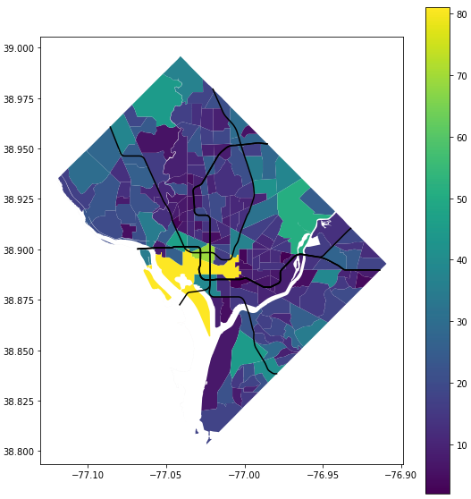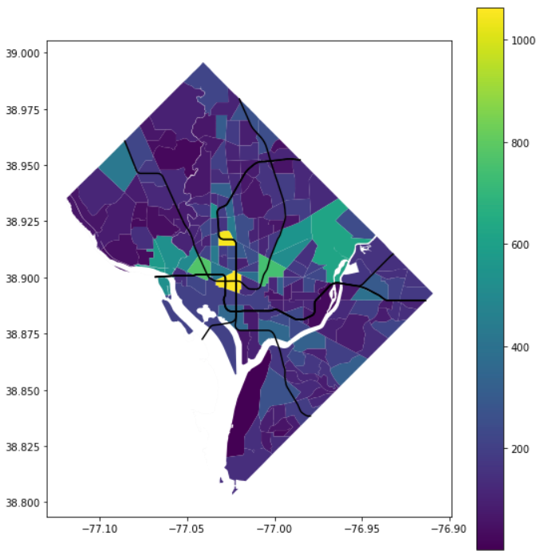
Fig. 1: Census tract bus stop totals (left), census tract crime instances (right)
The next step of my analysis was to perform Local Indicators of Spatial Autocorrelation (LISA), which was the calculation of Local Moran’s I. The LISA calculations done in my analysis were performed on polygon data (the census tracts), so a spatial weights matrix had to be created first. Spatial weights are a foundation of analysis of spatial dependence on any level and provides the “skeleton” of the data structure in regard to what elements are physical neighbors. My spatial weights are based on Queen contiguity, which means that two units are considered neighbors if they share any portion of a border at all, instead of specifying a distance threshold between neighbors or other various methods (Anselin, Rey, 2014).
My initial hypothesis on where the hot and cold spots would be regarding crime were confirmed by the plot of the Local Moran’s I autocorrelation. Hotspots were concentrated in and around the National Mall, to include tracts leading up to the White House, with cold spots being relegated mostly to the suburban outskirts of the District. My hypothesis is supported by research that suggests crime and tourism have a high correlation to each other (Mawby, 2017). Amongst the National Mall hotspots were a few spatial outliers as well.
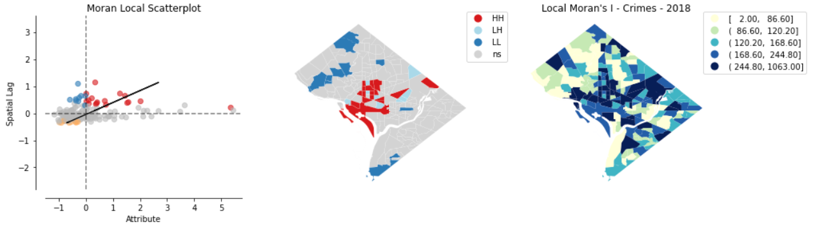
Fig. 2: Hot & cold spots of 2018 crime derived from Moran’s Local I calculation
The next step in my analysis was to develop and run an Ordinary Least Squares (OLS) regression model. OLS regression models are used to infer whether an attribute or group of various attributes is relevant to a target variable. My target variable in this model is total crimes which I’m attempting to explain in terms of population per crime committed and the total number of liquor establishments, ATMs, and bus stops in each census tract, respectively. The R-squared value is the proportion of the variance in the dependent variable that is explainable by the independent variable(s). An R-squared value of 0.644 denotes that there is a moderate positive correlation between the dependent and independent variables. The R-squared and adjusted R-squared values are quite close, so that is reason to suspect that the model has not been subject to overfitting and that the variables selected are all relevant to some degree. According to the individual variable t tests performed along with the OLS regression, the quantity of ATMs in each census tract is the least relevant to the number of total number crimes committed in said census tract in 2018.
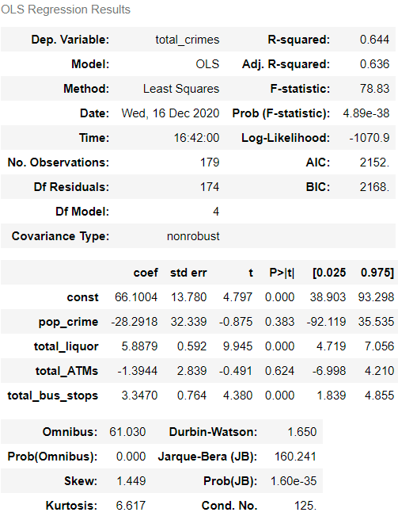
Fig 3: OLS Regression test results for POI effect on crime in 2018
The final portion of my analysis for consideration was conducted using Geographically Weighted Regression (GWR) and Multiscale Geographically Weighted Regression (MGWR). GWR is a geospatial statistical technique that recognizes and aids in filling in the gaps left by other spatial models that are limited when they cannot account for effects varying over space. MGWR takes things a step further by providing the capability of multiscale analysis while providing the insights on heterogeneity and scale that GWR provides (Oshan, 2019). This gives us insight as to how the differences of a dependent variable (in this case crime in DC in the year 2018) is distributed across a study area, which can possibly give insight as to how a process is clustering over a given study area. MGWR also benefits from being able to specify a different bandwidth for each covariate in a given model (Oshan, 2017).
The process included first getting the X, Y coordinates of the centroids of each census tract so that the distances between census tracts can be calculated in a standardized way. Then, the spatial bandwidths are calculated, and the model is fit. Both GWR and MGWR are implemented similarly. The intercepts are then extracted to be plotted on a map, and the t-values must be filtered to drop insignificant values (Oshan, 2019). These values are then set to 0, and the maps reflect this with the spatial unit appearing in grey. The heterogeneity of the dataset values varied, with higher t values for the intercept case and crime in the northeastern parts of the district, higher t values in the southwestern parts of the district for liquor establishments, and comparatively lower t values in the southwestern parts of the district regarding the density of bus stop locations.
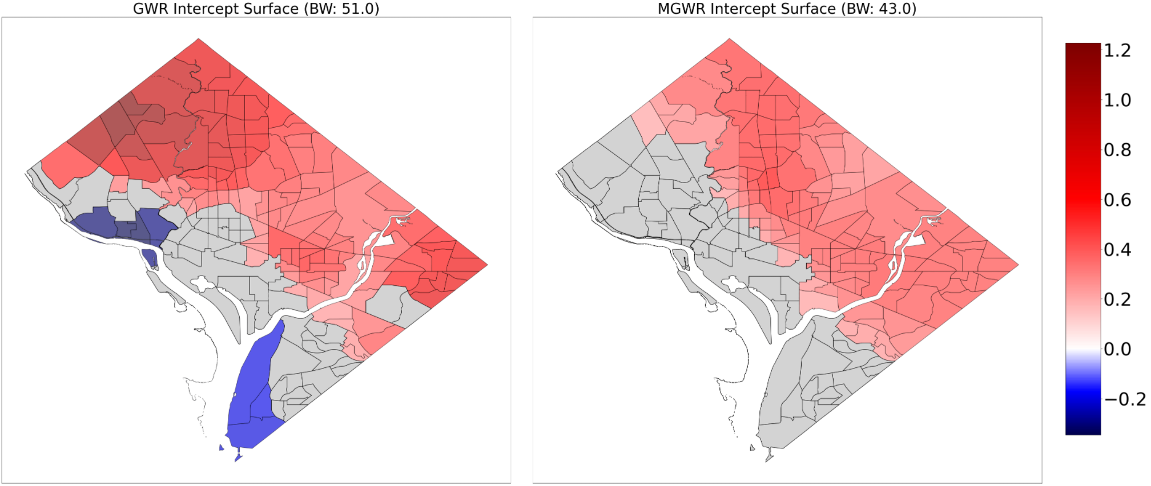
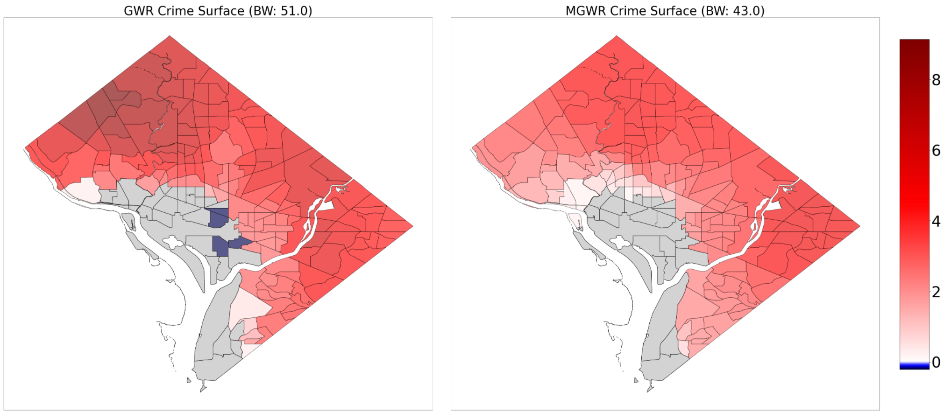
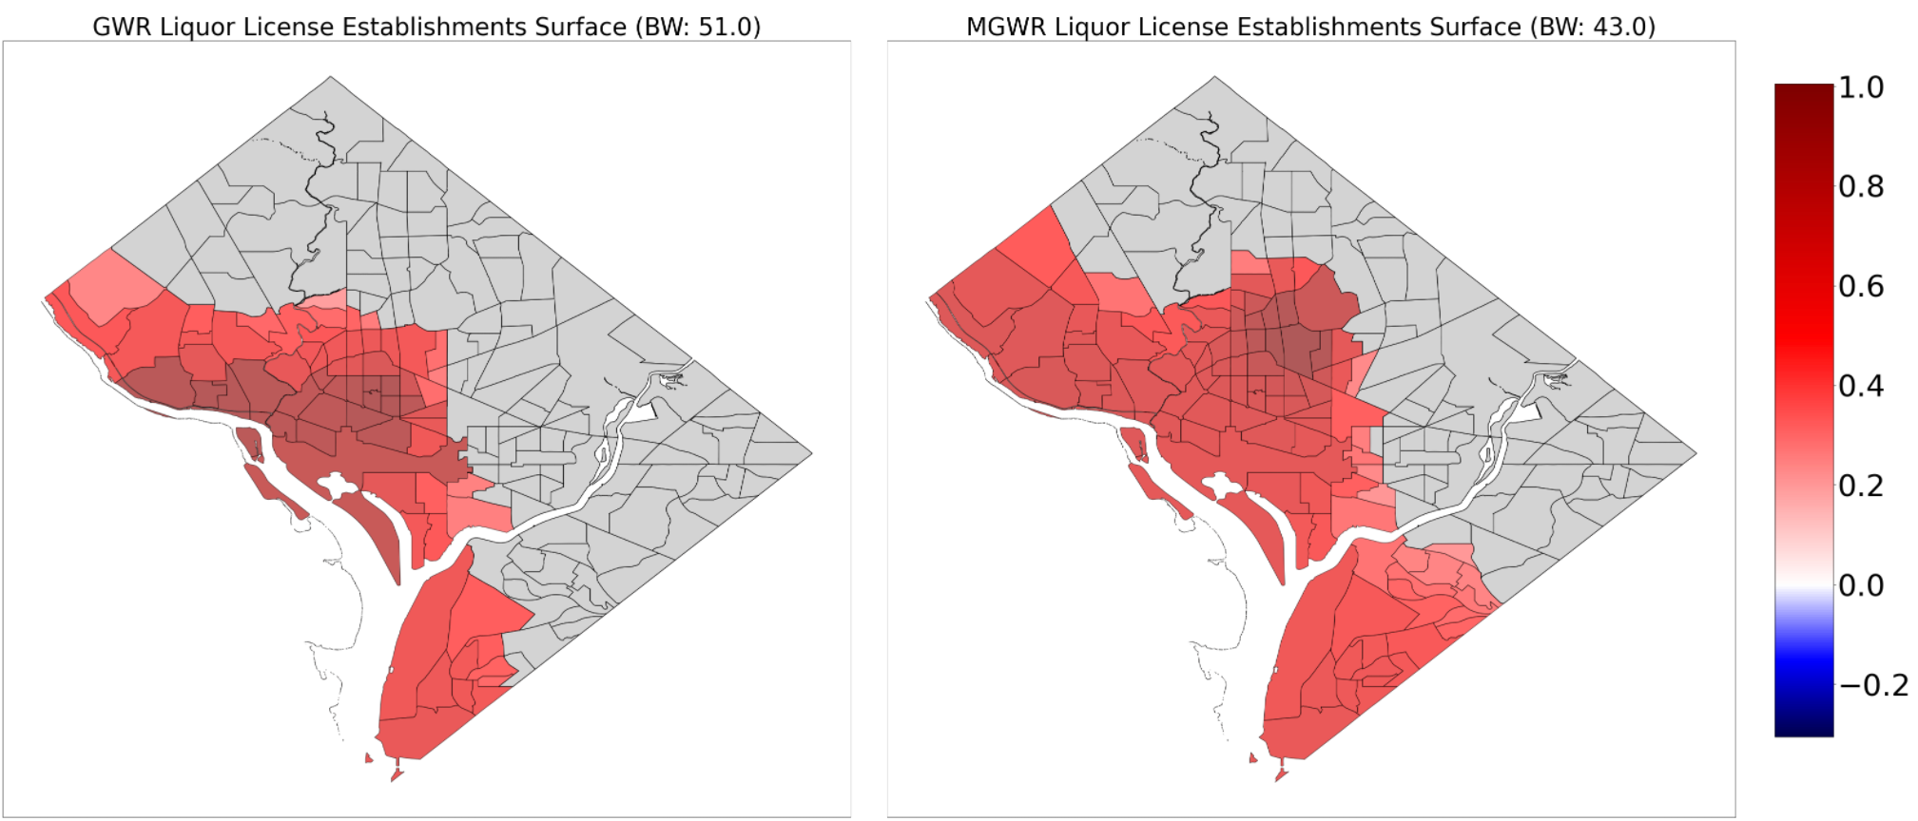
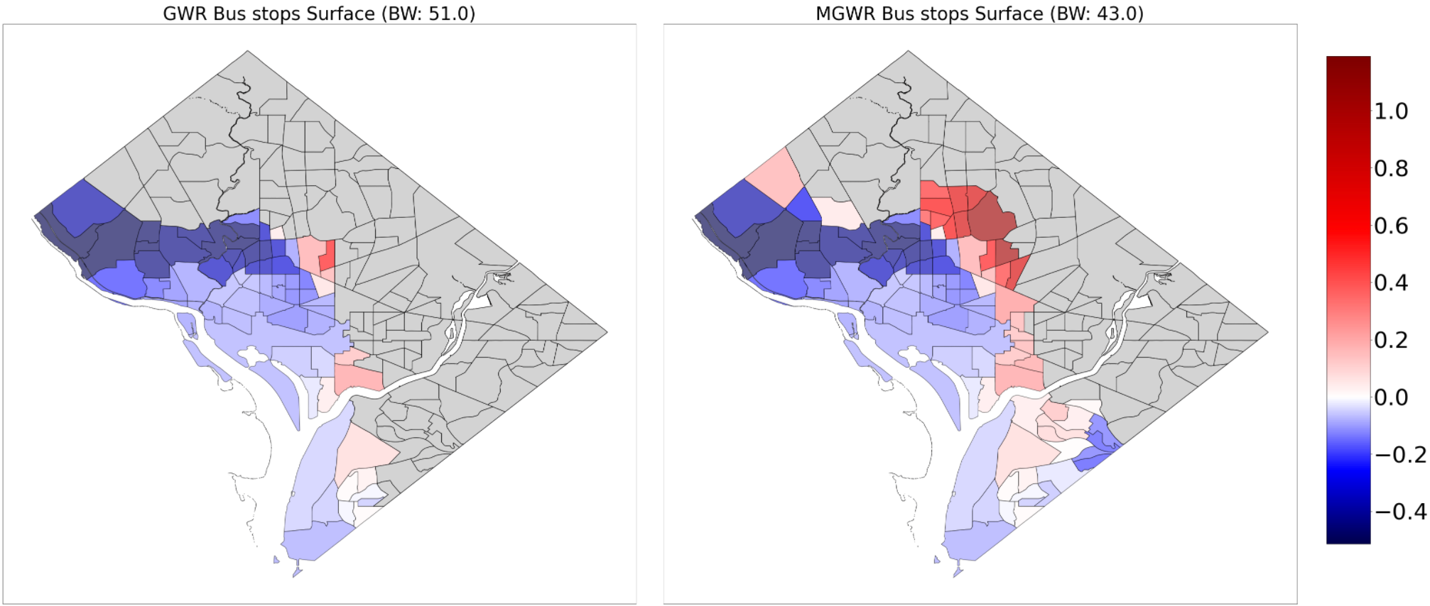
Fig 4: Surface comparison results between GWR & MGWR analysis
DISCUSSION AND CONCLUSION:
After running these three tests, I can conclude that to a varying degree, all the points of interest tested-- liquor license establishments, ATMs, and metro bus stops were all relevant to the question of how crime happens in DC and how it is dispersed over the district. The regression test explained that a higher presence liquor license holding establishments and bus stops had a greater impact on crime in each census tract than simply how populated it was or how many ATMs were in the area. The Local Moran’s I test helped pinpoint crime hot spots throughout the district, as well as verify my initial assumptions that higher crime rates would likely fall in and around the various tourist destinations downtown. The introduction of GWR/MGWR tests of scale and heterogeneity were an interesting and totally new concept to me,
Although I believe I got some good quality results from my analysis for this project, there are some notable limitations to my process. It would have been nice to be able to resolve my inability to somehow include metro train station stops in my figures for transportation. I was able to get around it with objectively a more impactful point of interest to study, but I feel like metro stations could have had significant affect on my research question as well. Another spatial variable that would have been nice to be able to include came to me when researching relative numbers of crimes near transportation hubs. Parking lots and parking garages actually rank much higher for crime prevalence than I could have imagined, and with a bit of data cleaning, a dataset on opendata.dc.gov. Another topic that must be addressed lies in the scope of my GWR/MGWR analysis. This type of analysis is best done on larger datasets, and my choice of using census tracts as my spatial unit resulted in 179 observations, when it would have been best to be able to find a dataset at least twice as large to run that kind of analysis on. Expanding the study area to the greater DMV area would likely be more sufficient of a scope to run these tests most effectively.
FUTURE ENDEAVORS:
Future work to expand the usefulness of this research would be the capability of being able to report on individual crimes, especially with considerations to the division of violent and nonviolent offenses. The FBI is in the process of transitioning to a standardized system of reporting that may very well address this concern in the form of NIBRS – the National Incident Based Reporting System (FBI, 2018). The FBI is operating in conjunction with the Bureau of Justice Statistics on the National Crime Statistics Exchange to bring this concept to reality. According to the FBI website, this system should be done with its transition period from its previous system of reporting and moving into its operational phase in January 2021.

WORKS CITED:
Madigan, Kathleen. “Vital Signs: More Households Don't Own a Car.” The Wall Street Journal, Dow Jones & Company, 21 Jan. 2014, blogs.wsj.com/economics/2014/01/21/vital-signs-more-households-dont-own-a-car/.
Chung, Payton. “88% Of New DC Households Are Car-Free.” Greater Greater Washington, 12 Sept. 2014, ggwash.org/view/35905/88-of-new-dc-households-are-car-free.
Clarke, Ronald. “Opportunity Makes the Thief. Really? And so What?” Crime Science, BioMed Central, 1 Jan. 2012, crimesciencejournal.biomedcentral.com/articles/10.1186/2193-7680-1-3.
“5-Year Crime Statistics: WMATA.” Washington Metropolitan Area Transit Authority, DC Metro Police, Accessed 12 Dec. 2020, www.wmata.com/about/transit-police/crime-stats.cfm.
Scott, Michael, and Kelly Dedel. “Assaults in and Around Bars 2nd Ed. | ASU Center for Problem-Oriented Policing.” ASU - Center for Problem-Oriented Policing, Arizone State University, 2006, popcenter.asu.edu/content/assaults-and-around-bars-2nd-ed.
Wickham, H. (2014). Tidy Data. Journal of Statistical Software, 59(10), 1 - 23. doi:http://dx.doi.org/10.18637/jss.v059.i10
Lohr, Steve. “For Big-Data Scientists, 'Janitor Work' Is Key Hurdle to Insights.” The New York Times, The New York Times, 18 Aug. 2014, www.nytimes.com/2014/08/18/technology/for-big-data-scientists-hurdle-to-insights-is-janitor-work.html?_r=0.
Mawby, R.. (2017). Crime and tourism: What the available statistics do or do not tell us. International Journal of Tourism Policy. 7. 81. 10.1504/IJTP.2017.085292.
Oshan, Taylor, et al. MGWR: A Python Implementation of Multiscale Geographically Weighted Regression for Investigating Process Spatial Heterogeneity and Scale. International Journal of Geo-Information, 8 June 2019, www.mdpi.com/2220-9964/8/6/269/pdf.
Oshan, Taylor, et al. Inference in Multiscale Geographically Weighted Regression. Geographical Analysis, 2019, github.com/TaylorOshan/MnM4SDS_Fall2020/blob/master/readings/Yu_et_al-2019-Geographical_Analysis%20(1).pdf.

Oshan, Taylor, et al. Single and Multiscale Models of Process Spatial Heterogeneity. Geographical Analysis, 2017, https://github.com/TaylorOshan/MnM4SDS_Fall2020/blob/master/readings/Wolf_et_al-2017-Geographical_Analysis.pdf.
“National Incident-Based Reporting System (NIBRS).” Criminal Justice Information Services (CJIS), Federal Bureau of Investigation, 10 Sept. 2018, www.fbi.gov/services/cjis/ucr/nibrs.

