**064 — FORMANT**

other Formant modules, the resonant filter module requires no calibration or adjustment procedure. The operation of the circuit can be checked by feeding in a white noise input from the noise module. Varying the three filter par­ameters should produce clearly audible changes in the resulting sound. It will also be apparent that rapid variation of the Q- and fo controls produces effects similar to phasing, thus the filter mod­ule can be used to provide manual phasing.

The scale on each of the fo poten­tiometers on the front panel is calibrated with five nominal frequencies. The three middle settings in particular should be viewed as rough guidelines, since the resistance curve of logarithmic poten­tiometers can exhibit fairly wide toler­ances.

The filter module should be placed between the COM-module and the power amp. However, if one wishes to use the headphone output on the COM­module, the resonant filter module can be connected directly before the latter. **Appendix**

With the component values given in the circuit diagram, the centre frequency of the filters can be varied between roughly 50 and 2300 Hz. To calculate the cor­rect values for higher frequencies than this, the procedure is as follows:

Firstly, the desired maximum frequency of fo can be used to calculate the value of C2 = C3 = C4=C5=C6=C7=C from the following equation:

16

C —

fo max

where C is in nanofarads and fo in kHz. Secondly the value of resistor R (see figure 2) can be determined on the basis of the desired minimum centre fre­quency fo min:

16

R — C • fo min

where C is in nanofarads, R is in kS2, and fo in kHz

The value of Ro = R11 = R14 = R26 = R29 = R41 = R44 can be calculated from:

10

Ro —

R — 2

where R and Ro are in k2. These equations can be used to check the values of figure **4.**

**chapter 9**

**ADSR**

**The ADSR (Attack-Decay-Sustain­Release) shaper is used to control the VCF and VCA modules and thereby determine the dynamic harmonic structure and dynamic amplitude characteristic of the VCO signals.**

It is often not realised, even by mu­sicians, how much the character of an instrument is determined **by the** dy­namic amplitude and harmonic behaviour, rather than **by the steady-**state harmonic content **of the instru­ment.** If the attack **and decay periods** of a note are **artificially modified, then** the whole **character of the sound is** altered. An **interesting and amusing** experiment **is to record the sounds of** several **musical instruments, but to** remove **the attack and decay periods by** bringing **up the recording level after the** note starts **and fading it down before** the note **ends. Then ask some musical** friends to **identify the instruments.** They will no **doubt be amazed how** characterless **the sound of an instrument** becomes when robbed of **its particular** amplitude envelope.

On the other hand, **starting with a single** basic waveform such as the triangle **out­put** of the Formant VCO, **a whole range of** instrument sounds can be produced simply by varying the amplitude envel­ope, ranging from 'soft' sounds such as flute and some organ voices, to 'hard', percussive sounds such as piano and xylophone.

Envelope control of the harmonic content using the VCF allows even greater variation in the character of the sound.

**Types of envelope curves**

The envelope shaper of the synthesiser must be able to simulate the envelope contour of conventional musical instru­ments when the synthesiser is used in an imitative capacity, and also to produce envelopes that are purely synthetic in character (i.e. not found in sounds produced by normal acoustic methods). Fortunately, there are relatively few types of envelope contour that are musically important, and these are all fairly easy to generate electronically.

**1. Attadc/decay contour**

The simplest type of envelope curve is that consisting only of attack and decay periods. The envelope contour rises to a peak *when* the note is played, and begins to decay immediately the peak is

**passed (see figure 1). By varying the attack and decay times a wide variety** of sounds can **be produced.**

For example, if a rapid **attack and slow decay is applied to the VCA control, then a percussive sound like a piano results. Applied to the VCF in the low-pass mode, the same envelope contour can produce very bright, metallic sounds, depending on the input wave­form.**

**If the attack period is made long and the decay period short, then applying this to the VCA will produce com­pletely synthetic 'fantasy' sounds** simi­lar **to those obtained by playing a recording backwards. Applying this type of envelope contour to the VCF can produce sounds similar to those of a brass instrument played staccato.**

**However, the main use of this type of envelope curve is for the production of percussive sounds such as xylophone, marimba, glockenspiel, bells and gongs, cymbals, and struck or plucked strings such as guitar, banjo, harp, other string instruments played pizzicato, harpsi­chord, and of course, piano.**

**2. Attack-sustain-release contour**

**The attack/decay characteristic pre­viously described is typical of instru­ments where the sound is initiated by a short pulse of energy (e.g. by striking or plucking a string), after which the sound dies away** since there **is no further excitation to sustain it. The envelope contour shown in figure 2 is typical of instruments in which a note is sounded and sustained, such as a pipe organ, woodwind instruments, and bowed string instruments. In a pipe organ the note builds up fairly rapidly after a key is depressed as standing wave modes are established in the pipe, and the note is sustained by virtue of the fact that air is continuously blown into the pipe. When the supply of air stops on releasing the key the note terminates more or less rapidly.**

**The same basic contour applies to woodwind instruments and to string instruments played with a bow, since the note is here again sustained by blowing or bowing. However, with such instruments much greater expression can be obtained by modulation of the**

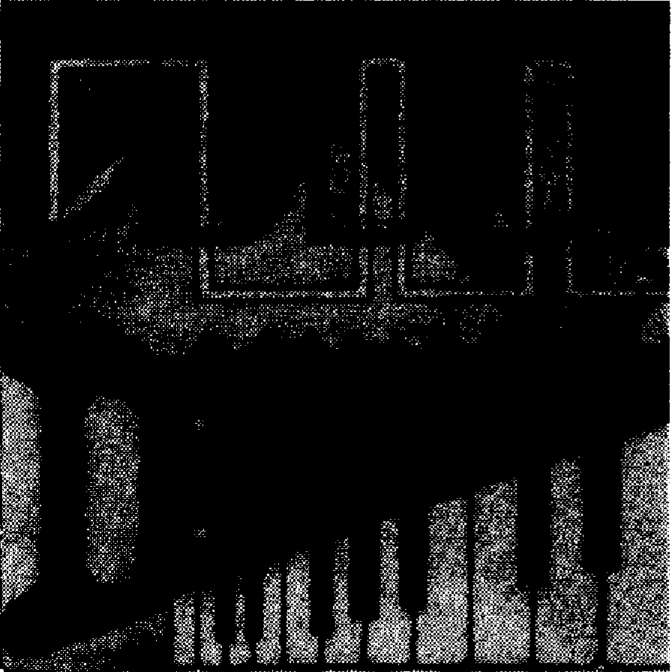

**FORMANT — 065**

**steady-state level, since this is deter­mined by the player, and not by a mechanical blower as is the case with a pipe organ.**

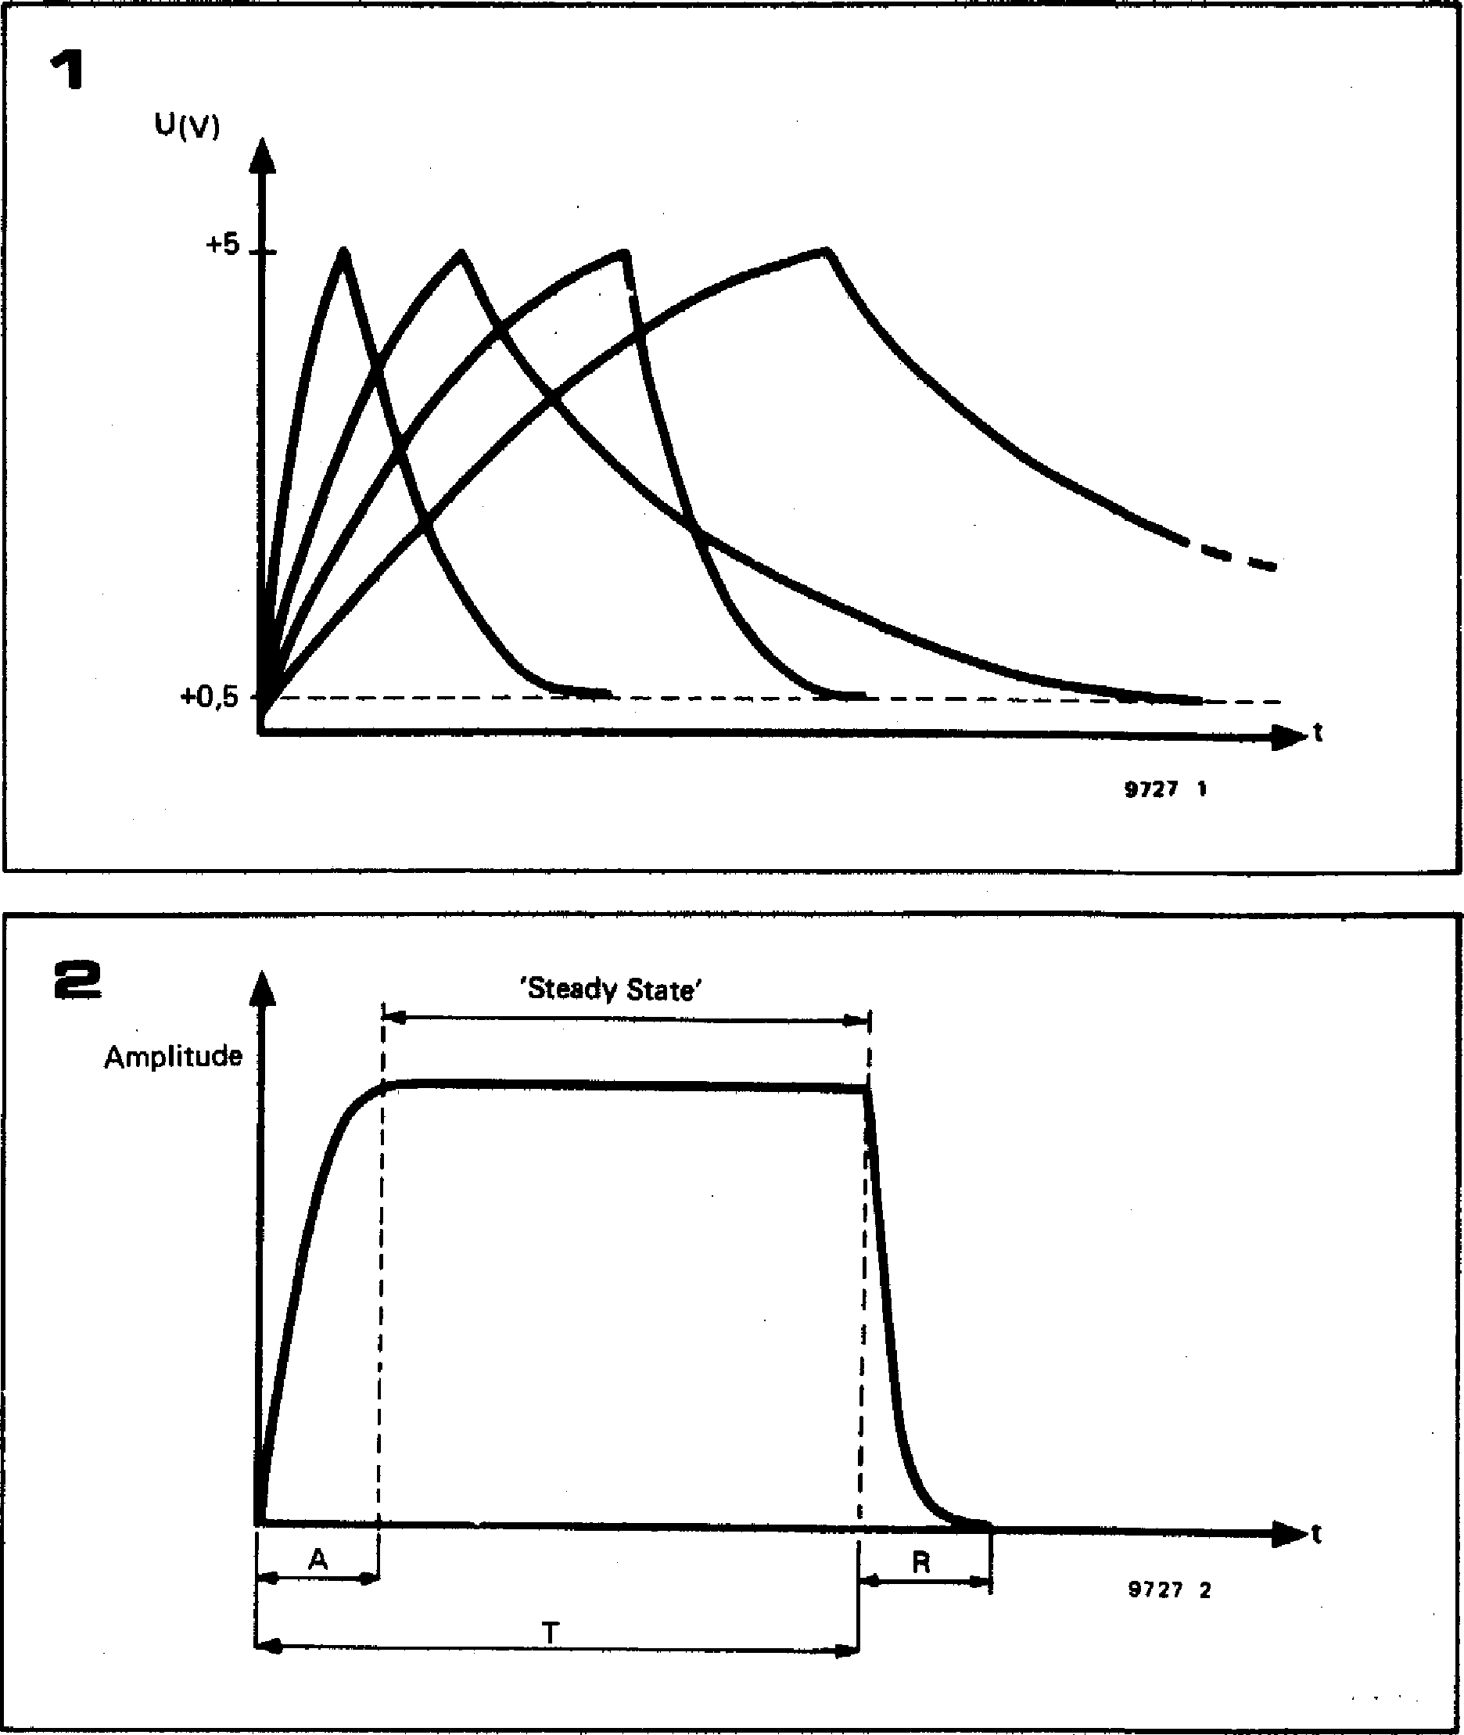

u(V)

**+5**

**+0,5**

**9727 1**

**1**

**2**

**•**

**Amplitude**

**'Steady State'**

**I**t

**9727 2**

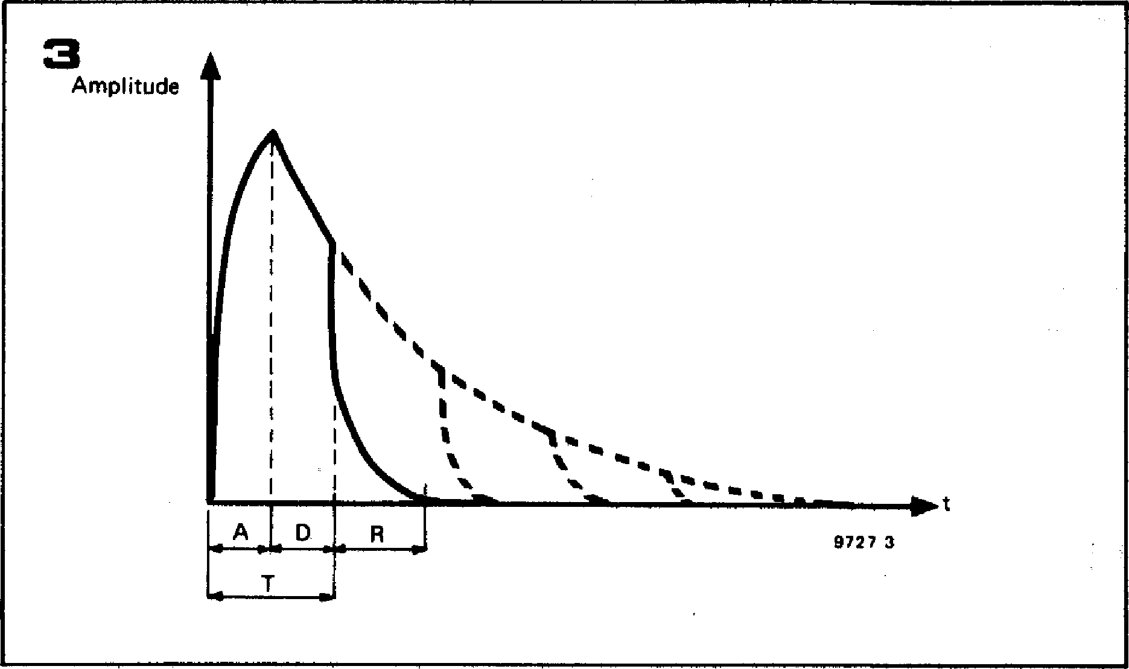

**With a synthesiser, a degree of ex­pression can be obtained by modulating the VCA using the low-frequency oscillators or noise source.**

**3. Attack-decay-release contour**

**A variation on the attack-decay contour
  
is shown in figure 3. Here the slow**

**Figure 1. The attack-decay envelope contour is the simplest contour found in music.**

**Figure 2. The attack-sustain-release contour is used to simulate instruments where the note can be sustained at a constant level, such as organ, woodwind, and bowed string instru­ments.**

**Figure 3. Instruments such as the piano can be simulated using the attack-decay-release contour. As long as the key remains de­pressed the decay path is followed, but once the key is released the note is ended more abruptly, following the release contour.**

**decay is allowed to continue for only a certain time, and the note is then terminated by a more rapid release. The most common example of this type of contour is provided by our old friend, the piano. When a note is sounded and the key remains depressed, then the damper is held off the string and the note decays over a period of a few seconds. If, however, the key is released after playing a note, the felt damper contacts the string and the note termin­ates after about 500 ms.**

**4. Attack-decay-sustain-release contour**

**Most of the examples given so far relate to envelope control of the VCA, since the amplitude contour of a sound is somewhat easier to visualise than its dynamic tone colour behaviour. How­ever, the most complex envelope contour, shown in figure 4, is a good illustration of envelope control of the VCF.**

**Many brass instruments, such as the trumpet, are characterised by a rapid build-up of harmonics during the attack period of the note, which gives the instrument a very strident sound. Once the note is established, however, the harmonics die away somewhat, and the tone is much more mellow during the steady state period. Finally, during the release period at the end of the note, the note dies away fairly rapidly.**

**This type of characteristic can be obtained by using the VCF in the low-pass mode and controlling it with an envelope contour similar to that shown in figure 4. As the control voltage rises during the attack period, so the turn­over frequency of the VCF increases, passing more harmonics. During the decay period the VCF turnover fre­quency falls until the steady-state value is reached, and finally, during the release period the VCF turnover fre­quency drops very rapidly.**

**Envelope shaper requirements**

**It is apparent from figure 5 that the envelope contours shown in figures I to 3 are merely special cases of the more general attack-decay-sustain-release con­tour illustrated in figure 4. Any of the four contours can be generated by an envelope shaper having the following four functions:**

* **variable attack time (A)**
* **variable decay time (D)**
* **variable sustain level (S)**
* **variable release time (R)**

**These four parameters can be preset manually using the ADSR controls of the envelope shaper. The envelope shaper is controlled by the gate pulse output of the keyboard. When a key is depressed the gate output goes high and this initiates the attack-decay sequence. The output of the envelope shaper then remains at the sustain level until the key is released, when the release period begins.**

**066 — FORMANT**

**Block diagram**

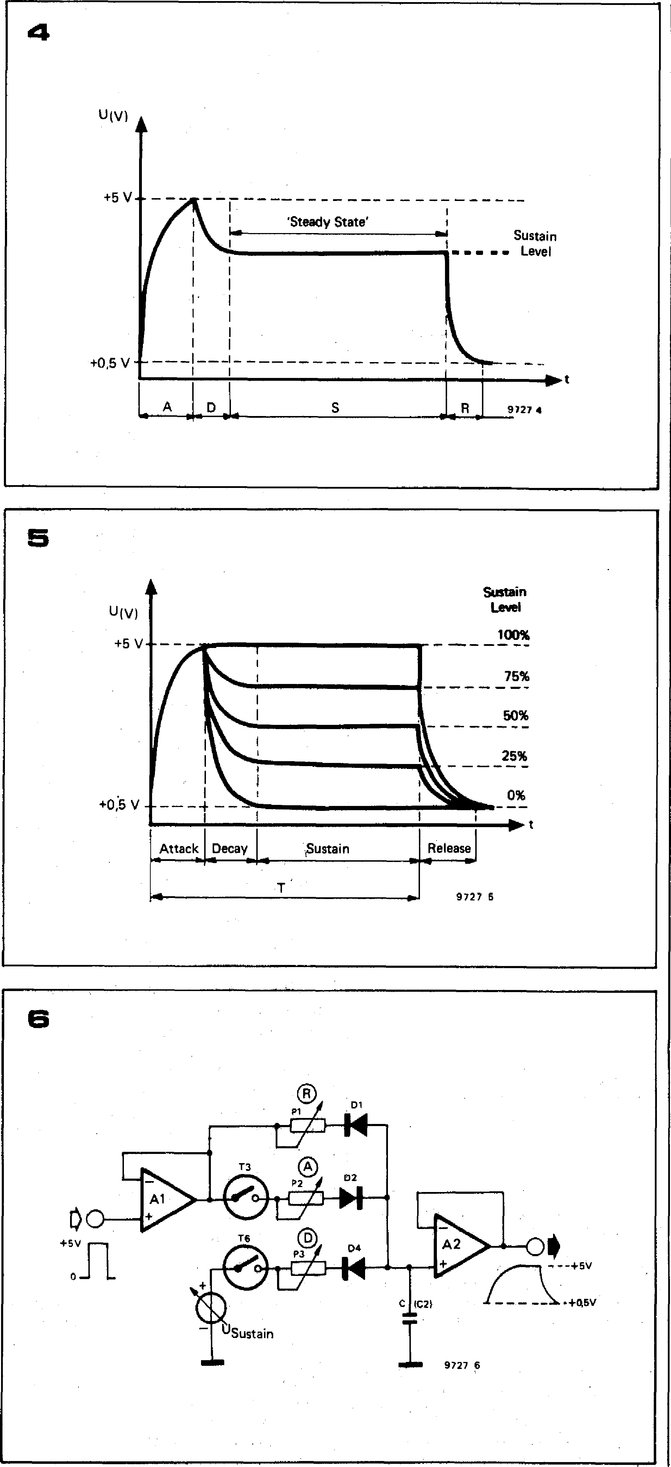

**+5 V**

**'Steady State'**

**sr Sustain**

**sw Level**

**6.•**

**+0,5 V —**

—I —

►t

**4**

**9727 1**

**The required exponential attack, decay and release characteristics are easily obtained by charging and discharging a capacitor through resistors, and the sustain level by clamping the capacitor voltage to a preset D.C. level during the sustain period. The basic principle of the envelope shaper is illustrated in figure 6. The gate pulse is fed to a volt­age follower Al , and when the gate pulse is high C charges exponentially through P2 and D2 (and T3).**

**At the end of the Attack period, `switch' T3 is opened and T6 is closed. Capacitor C now discharges through D4 and P3 (Decay), until the Sustain level is reached. This level is maintained until the gate pulse finishes, either when the key is released or when a preset time has elapsed.**

**When the gate pulse finishes, the output of Al goes to zero volts, and C dis­charges through DI and P1 (Release). The capacitor cannot discharge fully,**

|  |
| --- |
| **ADSR adjustment ranges:**  **Attack period (Al 10 ms...20s**  **Decay period (D) 10ms...20s**  **Sustain level IS ) 0.5 V . .. 5V**  **Release period (R) 10ms...20s** |

**since DI ceases to conduct once the voltage on C has fallen to about 0.5 V, but this is not important as it merely constitutes a D.C. offset which can be compensated for. The attack, decay and release times may be adjusted by means of P2, P3 and Pl.**

**Complete circuit**

**The complete circuit, which is shown in figure 7, is, of course, more complicated. The envelope shaper has two modes of operation, ADSR and AD, which are selected by means of Si,With S 1 in position 'b' (ADSR) the circuit operates as follows:**

**When a key is depressed the gate pulse output goes to +5 V. ICI has a gain slightly greater than unity, so about +6 V appears at its output.**

**The leading edge of the gate pulse also
  
triggers moaostable TI /T2, which pro-**

**FORMANT — 067**

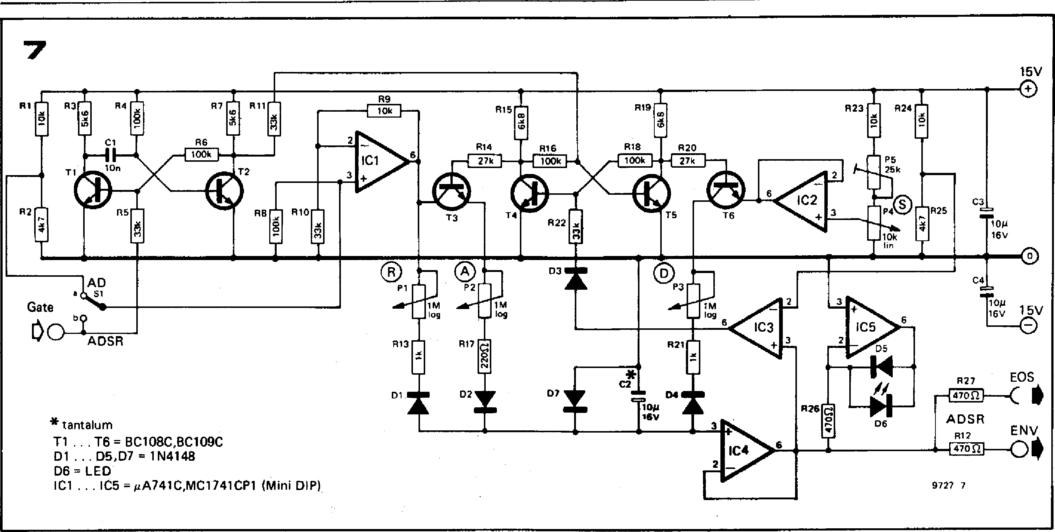

**15V**

Gate

**Lir1/4** b

**0 ADSR**

* tantalum

**Ti T6 = 8C108C,BC109C**

**D1 D5,D7 = 1N4148**

**D6 = LED**

**IC1 ...105 = #A741C,MC1741CP1** (Mini DIP)

9727 7

**7**

**duces a short pulse to set flip-flop T4/ 15 (T5 turned on and T4 turned off). The collector voltage of T4 thus rises, turning on T3 and allowing C2 to charge from the output of IC I through T3, P2, R17 and D2. This is the attack period.**

**The voltage on C2 is fed to voltage-follower buffer IC4, which is connected to the outputs EOS and ENV and also to the non-inverting input of IC3. This IC functions as a comparator, with its inverting input held at about 4.7 V by R24 and R25. When the voltage on C2, and hence at the output of IC4, exceeds this value, the output of IC3 swings positive, resetting flip-flop T4/T5, turning off T3 and terminating the attack period. T6 is turned on, initiating the decay period when C2 discharges through D4, R21, P3 and T6 into the output of IC2 until the sustain level, set at the output of voltage follower IC2 by P4, is reached.**

**The output of the envelope shaper then remains at the sustain level until the key is released, when the output of ICI goes to zero volts and C2 discharges through DI , R13 and PI (release period).**

**Diode D7 protects C2 in the event of the output of ICI going negative for any reason, when the voltage across C2 is clamped to a maximum of —0.7 V.**

**A LED indicator constructed around IC5 allows visual monitoring of the envelope contour. The brightness of the LED follows the envelope voltage.**

**Two outputs are provided from the envelope shaper; an external output to a front panel socket (EOS), and an internally wired output (ENV).**

**The full ADSR envelope contour is, of course, produced only if the key is depressed for a period longer than the attack plus decay time, and if the sus­tain level is greater than 0%. If the key is released before the sustain level is reached then the release period is initiated prematurely, and either AR or ADR curves may be produced. If the**

**Figure 4. The attack-decay-sustain-relesse contour is the most complex envelope ships provided by the Formant envelope shaper. When applied to the VCF it is useful for imi­tating brass instruments, where the harmonic content of the note rises initially to a large value, then reduces to a tower level during the steady-state part of the note.**

**Figure 5. By varying the sustain level the envelope contour can be changed from an AD contour at 0% sustain, through various ADSR contours to an ASR contour at 100% sustain. T is the time for which the key remains depressed.**

**Figure 6. This simplified diagram illustrates the basic principle of the envelope shaper. C charges through D2 and P2 during the attack period. It then discharges through**. **D4 and P3 to the (adjustable) sustain level; finally, it discharges through D1 and P1 during the release period. P1, P2 and P3 can be used to vary the release, attack and decay times.**

**Figure 7. Complete circuit of the Formant envelope shaper.**

**sustain level is 0% then only AD or ADR curves may be produced, depending on when the key is released. If the sustain level is 100% then, of course, only AR or ASR curves may be produced, depending on when the key is released, since the decay period is inhibited.**

**Triggered AD mode**

**It is sometimes useful to be able to pro­duce AD envelope contours that are unaffected be releasing the key, that is to say, once the key is depressed, a fixed attack-decay sequence is initiated, which is completed whether the key is released or not. This triggered AD con­tour is obtained by setting Si to pos­ition 'a' and selecting 0% sustain level. The input of IC1 is now connected to the junction of RI and R2, so its output is permanently at about +6 V, irrespect­ive of the gate input.**

**When a key is depressed, the gate signal triggers the monostable, setting the flip-flop and turning on. T3. At the end of the attack period, comparator IC3 resets the flip-flop, turning on T6 and initiating the decay period. C2 will now discharge through D4, R21, P3 and T6 to the 0% level (sustain is set at 0%). Even if the key is released before this sequence is complete, the release period is inhibited since the output of IC1 is permanently at +6 V, so C2 cannot discharge through D1, R13 and Pl.**

**Construction**

**There are no special requirements with regard to resistor tolerances in the envelope shaper circuit, and ordinary, good-quality 5% carbon film com­ponents are quite adequate; C2 should be a tantalum electrolytic capacitor for low leakage, and C 1 the usual**

**068 - FORMANT**

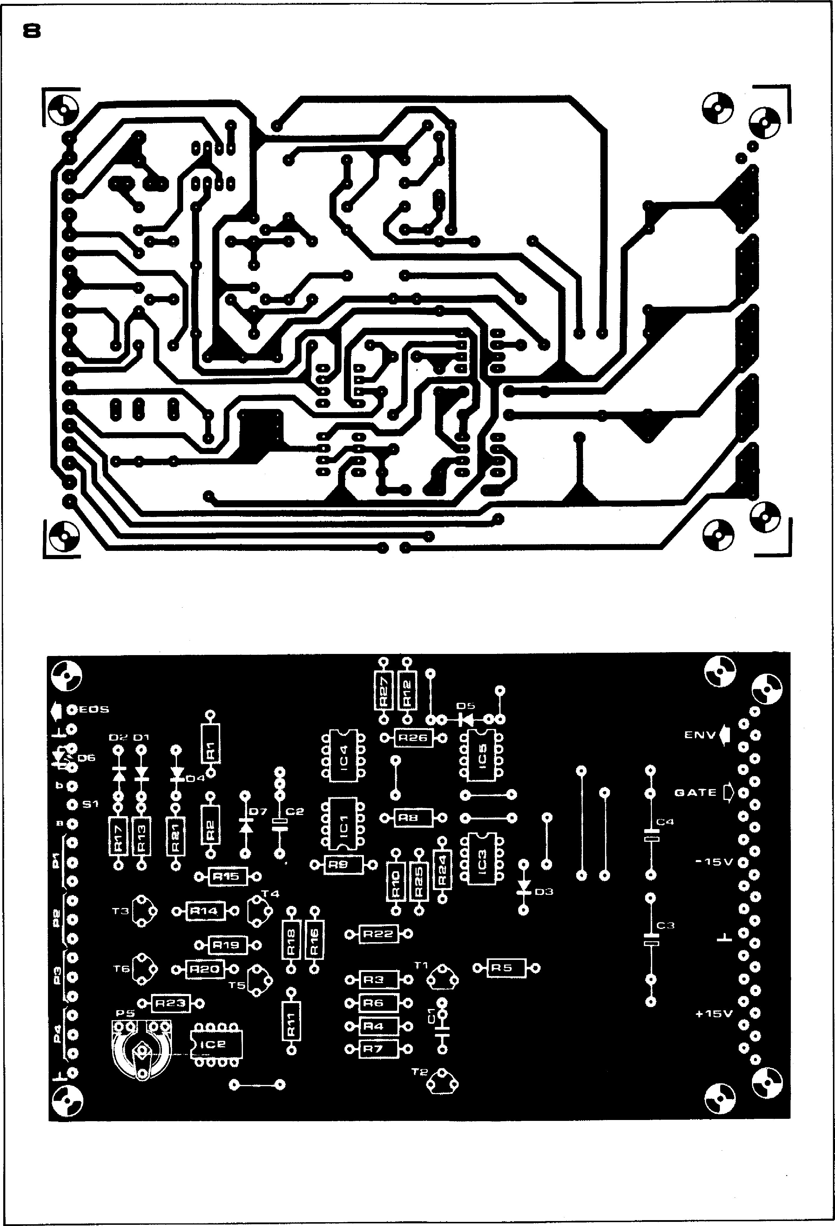

**FORMANT — 069**

**E N V
  
INDICATOR**

**OUT**

**Parts list for figures 7 and 8**

**Resistors:**

**R1,R9,R23 = 10 k**

**R2,R25 = 4k7 R3,R7 = 5k6**

**R4,R6,R8,R16,R18 = 10.0 k R5,R10,R11,1122 = 33 k R12,R26,R27 = 470** 1 **R13,R21 = 1 k**

**R14,R20 = 27 k R15,R19 = 6k8 R17 = 220 11**

**Potentiometers:**

**P1,P2,P3 = 1 M log.**

**P4 = 10 k lin.**

**P5 = 25 k preset**

**Semiconductors:**

**T1 .. T6 = BC 108C, BC 109C or
  
equivalent**

**D1 D5,D7 = 1N4148, 1 N914**

**D6 = LED (TI L 209 or similar) IC1 . IC5 = AA 741C, MC 1741**

**CP1 (MINI DIP)**

**Capacitors:**

**Cl = 10 n**

**C2 = 10 i/16 V tantalum C3,C4 = 10 A/16 V**

**Miscellaneous:**

**31-way Euro connector**

**( D IN 41617)**

**1 x 3.5 mm jack socket**

**4 x 13 15 mm collet knobs**

**with pointer**

**polyester or polycarbonate type. It is a good idea to test T3 and T6 for leakage, using the method detailed in chapter 5. A printed circuit board and component layout for the envelope shaper are given in figure 8, and a front panel layout is shown in figure 9. Connections to the front panel are fairly simple, the only front panel-mounted components being the four potentiometers for attack time, decay time, release time and sustain level, switch S 1, the external output socket and the envelope indi­cator LED.**

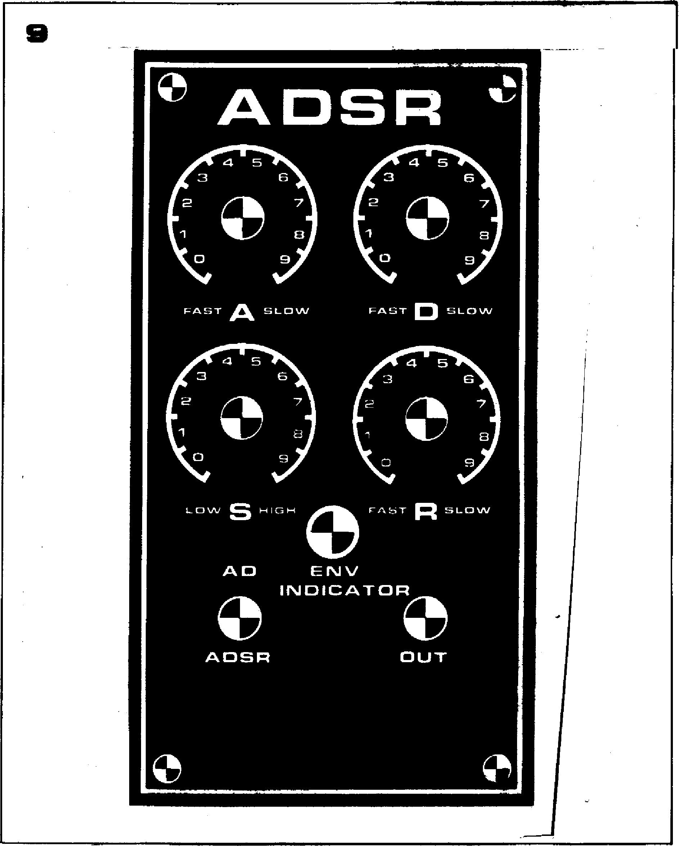

**Figure 8. Printed cheek bawd and otOM­ponent layout for the eneekspe shaper (EPS 9725-1).**

**Figure 9. Front panel layout for the envelope shaper module.**

**Testing and adjustment**

**To test the envelope shaper a gate pulse must be available from the 'GATE' out­put of the interface receiver board. The EOS output of the envelope shaper is monitored on an oscilloscope with the Y sensitivity set to about 1 V/div and the timebase set to about 10 ms/div. For the first test, the sustain level is set to zero, SI is set to the `AD' position and the attack and decay poten­tiometers are set to `fast'. The release potentiometer has no effect during this test. If a key is depressed at short intervals then a short AD envelope curve will be seen, which rises and falls between about 0.5 V and 5 V. The out-**

**put of IC3 can also be monitored, to check that it swings briefly between —15 V and +15 V when the peak of the attack curve is reached.**

**The only adjustment required to the envelope shaper is to set the 100% sustain level, using P5, to correspond with the voltage on C2 at the end of the attack period. If it is too low, then there will always be a decay, even at 100% sustain level; if it is too high then the calibration of P4 will be inaccurate, since 100% sustain will be reached before maximum rotation of the poten­tiometer.**

**To make the adjustment, the sustain level is set to 100% and medium attack and decay times are selected. Preset P5 is then adjusted until there is just no decay** after the attack period **(i.e. the attack period blends into the sustain level with no dip). The adjust­ment can be checked by turning P4 slightly to the** left, **when a slight dip after the peak of the attack period should be noted. As P4 is turned further anticlockwise then the decay down to the sustain level will become greater and greater, until finally, at 0% sustain level, pure AD curves will be produced. The envelope shaper is now ready for use.**