**070— FORMANT**

**chapter 10**

**voltage controlled amplifier (VCA)**

**This chapter continues the discussion of the tone-forming circuits with a description of the Dual VCA module, which can be used in conjunction with the envelope shaper for dynamic control signal amplitude, and   
also for • riodic amplitude modulati • n of the signal waveform (tremolo**

**The voltag' controlled amplifier module is called • 'Dual VCA' because it contains t o cascaded, but indepen­dently con rolled, amplifiers. The gain of the first • mplifier is voltage controlled via an expo ential converter, and is used for envelop shaping. The second has a linear gain-c •ntrol input and is used for periodic mollulation of signal amplitude (tremolo). TI e VCA is provided with a modulation ndicator, which allows the best comp omise to be obtained between si nal-t**

**overload mar**

**Connection • f the VCA in the synthesiser slam**

**Figure 1 illustrates how the VCA fits into the synthesiser system. The VCA takes its input from the output of the VCF, which in turn takes its input signal from the VCOs.**

**The VCF and VCA can both be controlled by the ADS R envelope shapers, so allowing dynamic variation of tone colour and amplitude during the playing of a note. However, the VCF has a KOV input from the keyboard to allow it to function as a tracking filter, but the VCA lacks this, since there is no pitch related control of signal amplitude.**

**Using the VCA and the VC F**

**It may be interesting at this point to spend a little time comparing and contrasting the effects produced by the VCA and VCF, and discussing how they are used to complement one another in the synthesiser system. As an example, consider the case where the VCA and VCF are both controlled by the same waveform from the envelope shaper, consisting of a rapid attack and a relatively slow exponential decay, as shown in figure 2a, and are fed with a 440 Hz sawtooth waveform.**

**If the VCF is used alone in the lowpass   
mode and the cutoff frequency of the**

**filter is initally set very low, the input signal will be completely suppressed. Yiviivem -wring Vitt Wank phase of the envelope control waveform the cutoff frequency of the filter vill rise very rapidly, and the amlitude and harmonic content of the note will both increase as first the fundamental, then the harmonics, are passed. During the slow decay phase the note will die away slowly as the cutoff frequency falls, starting with the higher harmonics, then the lower harmonics, anc finally the fundamental. The variatioi in turnover frequency of the filter is illustrated in figure 2b.**

**The tone thus produced .s not unlike that of a clavichord, or of a piano which has had drawing pins stuck into the hammers to produce a jaagly, honky-tonk effect.**

**If the same signal and control waveforms are fed to the VCA, the signal amplitude will rise rapidly as the gain increases during the attack phase, and will fall away slowly during the decay phase. However, the harmonic content of**

**signal will remain unaltered The sound thus produced is similar to that of percussion instruments stch as the piano and xylophone.**

**By varying the attack and decay times of the envelope shapers a vide variety of tone colour and amplitude dynamics can be produced using tin VCF and VCA in conjunction.**

**VCA design considerations**

**The dual VCA contains two amplifiers whose gains are independently voltage-controllable, and the design 3f the VCA poses certain problems, the principal one being that of obtaining adequate dynamic range, as is illustrated in figures 3a to 3d.**

**Figure 3a shows a control contour from the envelope shaper. At the peak of the control contour the VCA must have a finite maximum gain, which, for the purposes of the discussion, it will be assumed is unity, or 0 dB. At the beginning and end of the note the signal must be inaudible, which means that the gain of the amplifier should ideally be infinitesimally small at these moments in time. In practice, if the gain is around —70 dB•then this will be adequate.**

**What happens if the dynamic range is inadequate is shown in figure 3b. Suppose the gain of the amplifier can be varied by a range of only 40 dB or so, and is set to 0 dB on the peak of the control contour. At the start and end of the note the signal will only be 40 dB down, and if the note is being played fortissimo then this residual signal will still be quite audible.**

**Another fault of badly-designed VCAs is illustrated in figure 3c. In this example, the VCA cuts off completely below a certain level of control voltage, and so misses part of the attack and decay period of the note. This might be said to be the opposite fault to that of**

**figure 3b, though it is not directly related to dynamic range, but rather to extreme non-linearity of the control characteristic.**

**Returning to the example of the VCA with only 40 dB dynamic range, if the gain is adjusted so that the signal is inaudible at the beginning and end of the note** (i.e. **some 70 dB down), it will only be able to increase by 40 dB when the control voltage is applied, instead of the 70 dB required to reach the 0 dB level. The result is an amplitude plateau, as shown in figure 3d.**

**As mentioned briefly earlier, control of the envelope shaping section of the VCA is carried out exponentially. This** is **to compensate for the logarithmic loudness response of the human ear. On the other hand control of the periodic amplitude modulation section (tremolo) is linear, since this gives the 'softest' and `sweetest' sound to the tremolo effect.**

**Principle of the Formant VCA**

**The VCA in Formant uses the CA3080 OTA as the controllable amplifier, as in the VCF. The principle of the Formant VCA is illustrated in figure 4. The input voltage Ui is converted to a proportional output current Io = gm • 14 However, since we are interested in voltage ampli­fication this output current must be converted into an output voltage, and this is done simply by feeding the current** through a load resistor RL **to produce an output voltage U0 = gm • Ui • RL.**

**The** transconductance **of the amplifier, gm, may of course be varied by a control current IABc, as explained in chapter 6, and the gain of the VCA may thus be controlled — although at this stage of course it is a CCA!**

**The output of the OTA may not drive any external load** in **addition to RL, as this would lower the load impedance and alter the gain, so the output of the OTA is connected to a voltage follower/buffer with a high input impedance.**

**Both sections of the VCA operate on the same principle. However, only the output of the second OTA is buffered, since it is this output that is connected to any external loads. As the output of the first OTA has no external connection it is simply connected to the input of the second OTA.**

**The OTA has one disadvantage that cannot be ignored. As mentioned in the previous chapter,** its **linearity is good only for small input signals (typically ± 10 mV) which is why a large degree of input signal attenuation is required. This means that the signal-to-noise ratio is not exceptionally good, and for this reason it is best to use the VCA with the largest possible input signal consistent with low distortion. A modulation indicator is provided, which allows the best compromise to be obtained between excessive noise, at low input levels, and distortion at high input levels.**

**FORMANT — 071**

**Figure 1. Block diagram illustrating how the   
VCA fits into the Formant synthesiser system.**

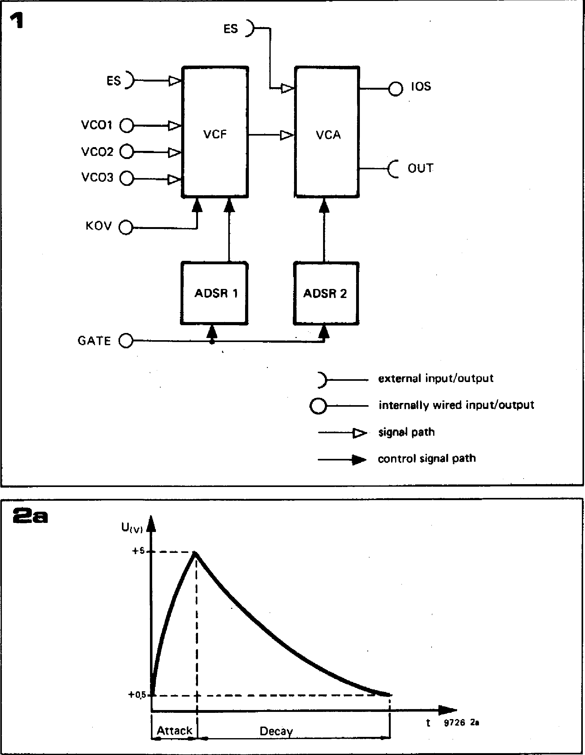

**VCF**

**ES)**

v col 0

**VCO2 0**

**VCO3**

**KOV 0**

1>

**VCA**

Uiv)

+5

**+0,5**

**Attack**

**Decay**

**t 9726 2a**

**ES )—**

—0 IOS

**C OUT**

**ADSR 1**

**ADSR 2**

**GATE 0**

**4**

**0-**

**external input/output internally wired input/output signal path**

**control signal path**

**4**

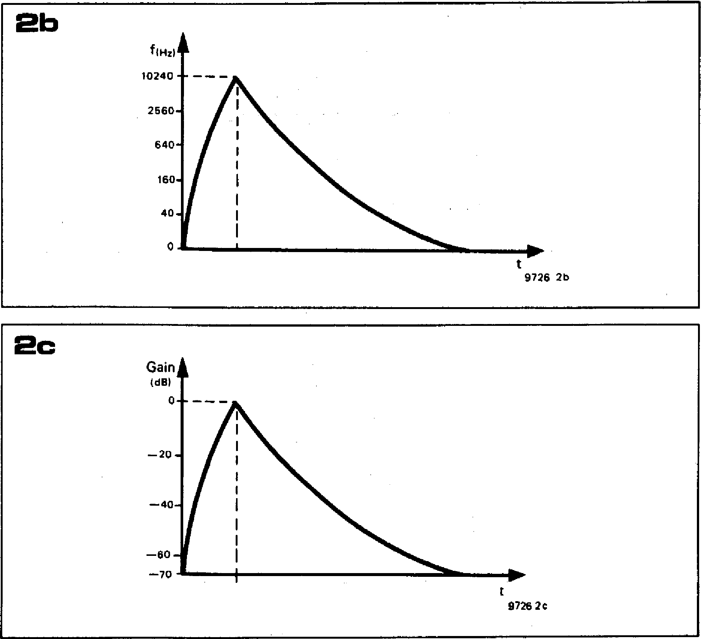

**Figure 2. Envelope control of the VCF and VCA. The attack-decay contour of figure 2a, when applied to the VCF, varies the turnover frequency of the filter, which provides dynamic alteration in the tone colour of the sound (figure 2b). When applied to the VCA, the envelope contour alters the gain of the VCA, and thus the amplitude of the sound (figure 2c).**

**Circuit of the. VCA**

**The complete circuit of the VCA is given in figure 5. The exponential converter built around IC1 and 1C3 will immediately be recognised, since it is very similar to that used in the VCF. The input configuration, however, is much simpler, there being but one external input, ENV, from the envelope shaper. If required this can be switched out by setting Si in position 'a', in which case a fixed gain results.**

**The gain/control voltage characteristic of the VCF is roughly 12 dB/volt, but as the use of the word 'roughly' suggests, the accuracy of this characteristic is relatively unimportant, unlike the octave/volt characteristics of the VCO and VCF. The ear is much less critical of amplitude errors than it is of frequency errors. The dB/volt characteristic of the VCA may be adjusted by P2, whilst P1 is an offset trimmer. The output current of the exponential converter controls the gain of the first OTA, 106.**

**The linear voltage-current converter is constructed around IC2, which is connected as an inverting, summing amplifier. An input signal may be fed to P4 via the AM input socket, and a DC input voltage is available from P3 (`Gain'). Both these input voltages cause proportional currents to flow through R12 and R 13, and since these currents cannot flow into the inverting input of the op-amp they flow round the feedback loop through T 1, and into the control input of IC7.**

**The audio signal to the VCA comes either from the permanently wired internal signal input (IS) or from the external signal socket (ES) on the front panel of the VCA module. The amplitude of the external input signal is controlled by P5, whereas the amplitude of the internal signal is controlled at the IOS output of the VCF, by P6 of the VCF module.**

**IC4 functions as a summing amplifier with a gain of —1, and the signal level at the output of IC4 is monitored by the modulation indicator constructed around IC5. This is a non-inverting amplifier feeding a bridge rectifier D1 to D4, the output of which drives the modulation indicator LED D5. Once the**

**072 — FORMANT**

**peak signal level at the output of 105 exceeds the combined knee voltages of 131 plus D5 plus D4 (or D3 plus D5 plus D2) then the LED will start to glow and will glow brighter as the signal level increases. P6 is used to adjust the gain of 105 so that D5 starts to glow at the signal level where overmodulation begins to occur.**

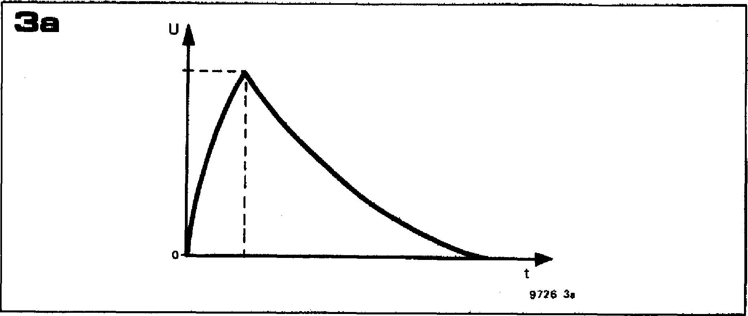

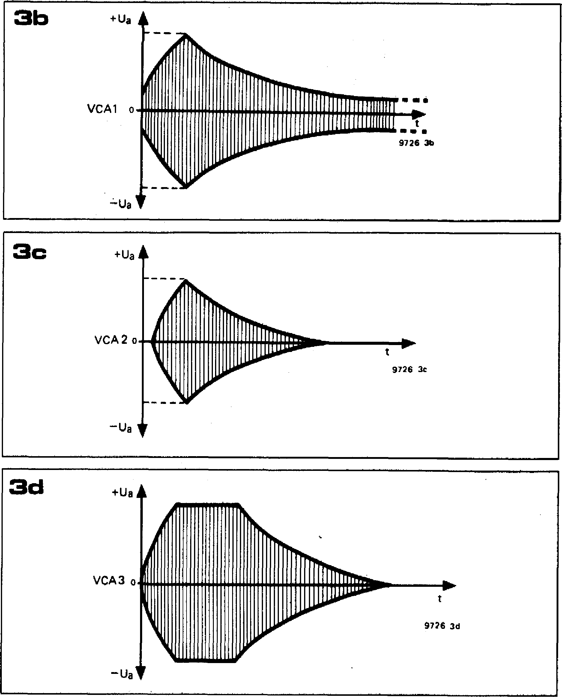

**3b**

+ Ua

**9726 3e**

+Ua

**3d**

**a**

**9726 3d**

**VCA 3 0**

**—Ua**

SI •

l• •

**9726 3b**

**VCA1**

**3c +ua**

**VCA 2 0**

**a**

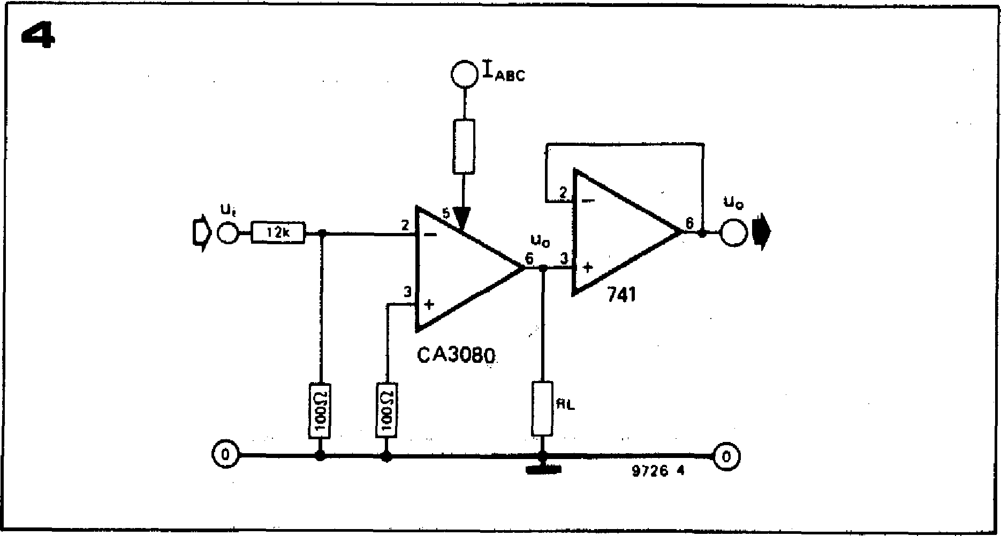

**The output signal from 1C4 is attenuated by R19 and R20 down to a level which the OTA, 106, can handle. The output of the exponentially controlled OTA, 106, is fed via a second attenuator R25/R26, to the input of the linearly-controlled OTA, 1C7. The output of 1C7 is buffered by voltage-follower 1C8 and two outputs from the VCA are provided, an internally wired output, 10S, and an output to a front panel socket, EOS. Potentiometers P7 and P8 are provided for trimming the offset voltages of IC6 and IC7.**

**Construction**

**The comments with regard to com­ponent quality that have been made in previous chapters apply equally to the construction of the VCA, and will not be repeated. A printed circuit board and component layout for the VCA are**

**Figures 3a to 3d. Some typical faults of badly-designed or badly-adjusted VCAs are illus­trated here. None of the amplitude envelopes in figures 3b to 3d follows the control contour of figure 3a.**

**In figure 3b there is feedthrough of the signal after the control contour finishes; in figure 3c the signal is still cut off for some time after the control contour starts, and cuts off again before it finishes:. in figure 3d the VCA has insufficent headroom and limits causing a 'plateau' on top of the envelope curve.**

**Figure 4. The principle of the Formant VCA is illustrated here. The OTA produces an output current proportional to the product of the Input voltage and the control current !Ag• This causes a voltage drop across the load resistor R L, and the output is buffered by an op-amp voltage follower. The input attenuator is necessary to avoid overloading the OTA.**

**Figure 5. Complete circuit of the Formant Dual VCA. This contains two, cascaded, voltage-controlled amplifiers with independent control inputs; exponential control for envel­ope shaping and linear control for amplitude modulation (tremolo).**

**FORMANT — 073**

**given in figure 6, and a front panel layout is given in figure 7.**

**Testing and adjustment**

**For optimum performance the VCA must be matched to a particular envelope shaper, and thereafter the VCA and envelope shaper should be used as a pair. This is not necessary in the case of the VCF, which may be used with any envelope shaper.**

**To test and adjust the VCA, the completed keyboard and interface receiver must be available, together with VCOs, VCF and the envelope shaper to which the VCA is to be matched. The IOS output of the VCO is connected to one of the VCO inputs of the VCF, and the IOS output of the VCF is connected to the IS input of the VCA. The GATE output of the interface receiver is connected to the GATE input of the envelope shaper and output ENV of the envelope shaper is connected to input ENV of the VCA.**

**For the initial test, the sawtooth output of the VCO is selected and the output level is set to maximum. The VCF is set to the lowpass mode, but the turnover frequency is set to maximum by turning the octaves control fully clockwise. The**

**Q control is set to minimum, the KOV input is switched off and the output level is set to maximum.**

* **At the IOS output of the VCF, the sawtooth signal from the VCO should now be available in phase with, and at the same amplitude as, the VCO output (about 2.5 V p-p).**
* **At the output of IC4 of the VCA, the signal should be available at the same level, but inverted.**
* **With S1. of the VCA in position 'a' (ENV input switched off) and P7 and P8 in mid-position, the sawtooth signal should be available at the output of IC6 in phase with the VCO output, and the amplitude should be adjustable by Pl.**
* **At the output of IC7 the signal should again be in phase, and both PI and P3 should vary the amplitude.**
* **Finally, the signal should be available at outputs IOS and EOS.**

**This concludes the basic functional check of the VCA, and the adjustment procedure can now be carried out.**

**Modulation indicator**

**Using the same input signal, P6 is adjusted until the modulation indicator D5 just begins to glow. Increase the signal amplitude by switching in the**

**second and third VCOs, when the LED should glow brighter.**

**After this test, the second and third VCOs should be switched off again.**

**Offset adjustment**

**Turn the output level of the VCF to zero and short the IS input of the VCA to ground. Set SI of the envelope shaper to 'AD' and the A, D, S and R controls to minimum (shortest attack and decay, and 0% sustain). Turn P5 of the VCA fully anticlockwise, set Si of the VCA to position 'b' (ENV) and observe the DC output voltage of IC6 on an oscilloscope.**

**When a key is depressed, a step output voltage will be observed at the output of IC6. This is the offset voltage of the IC, which is amplified as the gain of IC6 increases under the influence of the envelope control voltage; if it is not nulled out then it will break through to the output as 'cracks' or 'plops'. P7 is adjusted until the step voltage is as small as possible on the most sensitive range of the oscilloscope.**

**The offset nulling procedure must then be repeated for IC7. Si is switched to the `off position, P3 is turned fully anti-clockwise and the external output of the envelope shaper is connected to**

**5**

**R7 2k2**

10

**ICI**

**15V**

0

**Am()**

**15V 15V**

O

**FI3 c 10 (11-111c**

**R5**

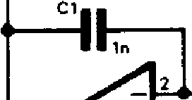

**IC 3**

**3**

**RS**

**R12**

**12k HI**

**d**

**RI4**

e_liC6 1 in

**D6**

**1N4148**

**T1**

**I**

**R11**

**C2**

**1.0**

**P2**

**BC 177 C**

**R2 P1**

**47k 1-6**

**R4 ,**

**AM**

**P4**

**Gain**

**P3**

**10k**

**100k**

**1k In**

**4 11**

**15V**

**9**

0

**R13**

**-4 12k 1--►-=**

**R10**

**5**

**R25**

**IC6**

**15V**

• Olos

ENV() SI

**1005**

**C3**

**IS00-11**

**680n**

**C2**

**ESO**

**680n**

**R30**

**LEM**

**IC8**

**IC 7**

**27   
330**

**R29 L—C OEOS**

* **see text**

**R19 2**

**R24 330k**

**R2** C

**1000**

**R26** , **aI R28** ,

**8 00k**

R15 **R18**

* **--1, 100k**

**IC4**

**5 R**

**wok**

log,

ot*

**D1**

**R22**

57111

C**4**

**CI15V**

**015V**

**R21**

**9726 5**

**02**

0

015v

**359**

CS



|  |  |  |  |
| --- | --- | --- | --- |
| **4k7** | **03** | **D5** | **4** |

**ICI = CA3084**

**IC2 IC5,1C8 = pA741C, MC1741CP1 (MINI DIP) IC6 ... IC7 = CA3080(A) (MINI DIP)**

**DI ... D4= 0A91, AAI 19, AA118**

T

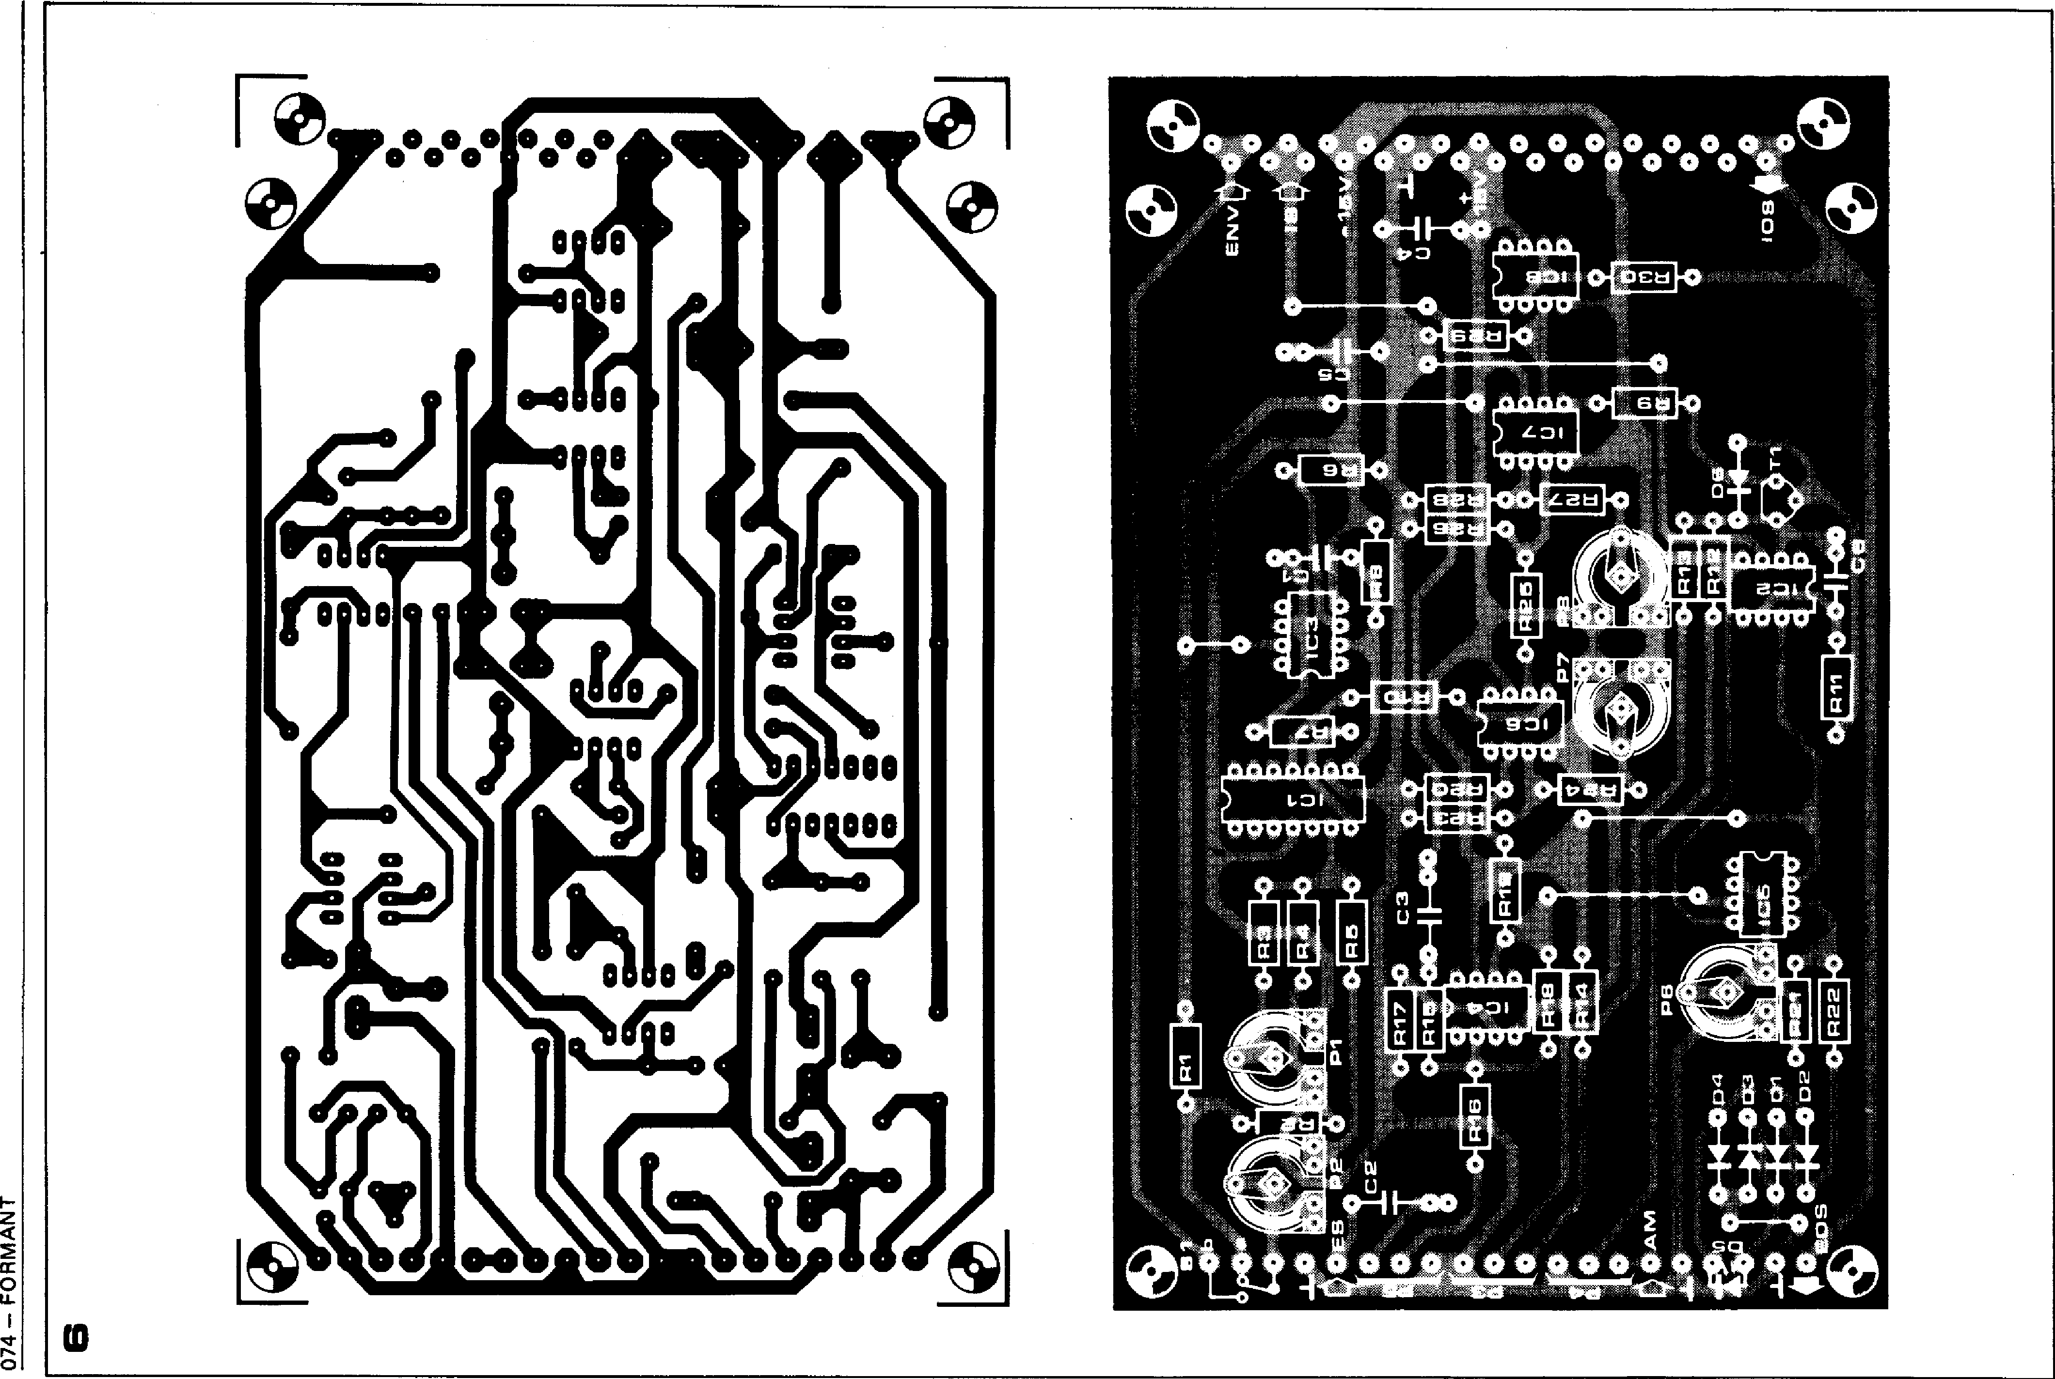

**074 -- FOIRMANT**

**FORMANT — 075**

|  |
| --- |
| **Parts list for figures 5 and 6 Resistors:**  **R1 = 6k8**  **R2 = 3k3 R3,R15,R16,R18 = 100 k**  **R4 = 4k7**  **R5 = 47 k R6,R8,R24,R27 = 330 k**  **R7,R11,R14 = 2k2**  **R9,R10 = 27 k**  **R12,R13,R19,R25 = 12 k**  **R17 = 33 k R20,R23,R26,R28 = 100 *St***  **R21 = 3k9 R22,R30 = 470 St**  **R29 = 15 k (nominal value,**  **see text)**  **Potentiometers:**  **P1,P2,P7,P8 = 100 k preset**  **P3 = 1 k lin.**  **P4 = 10 k lin.**  **P5 = 100 k log.**  **P6 = 4k7 (5 k) preset**  **Capacitors:**  **C1,C6 = 1 n**  **C2,C3,C4,C5 = 680 n**  **Semiconductors:**  **1C1 = CA 3084 (DI L package)**  **1C2,1C3,IC4,IC5, IC8 = AA 741C,**  **MC 1741 CP1 (Mini DIP) IC6,1C7 = CA 3080 (A)**  **T1 = BC 177B, BC 178C, BC 179C,**  **BC 5578, BC 558C, BC 559C D1 ... D4 = DUG (0A91,**  **AA118, AA119)**  **D5 = LED (TIL 209 or similar)**  **D6 = 1N4148**  **Miscellaneous:**  **31-way Euro connector**  **(DIN 41617)**  **S1 = SPST miniature toggle**.  **switch**  **3 off, 3.5 mm jack socket**  **3 off, 13-15 mm collet knobs with pointer** |

**Figure 6 Printed circuit board and com­ponent layout for the VCA (EPS 97261 ).**

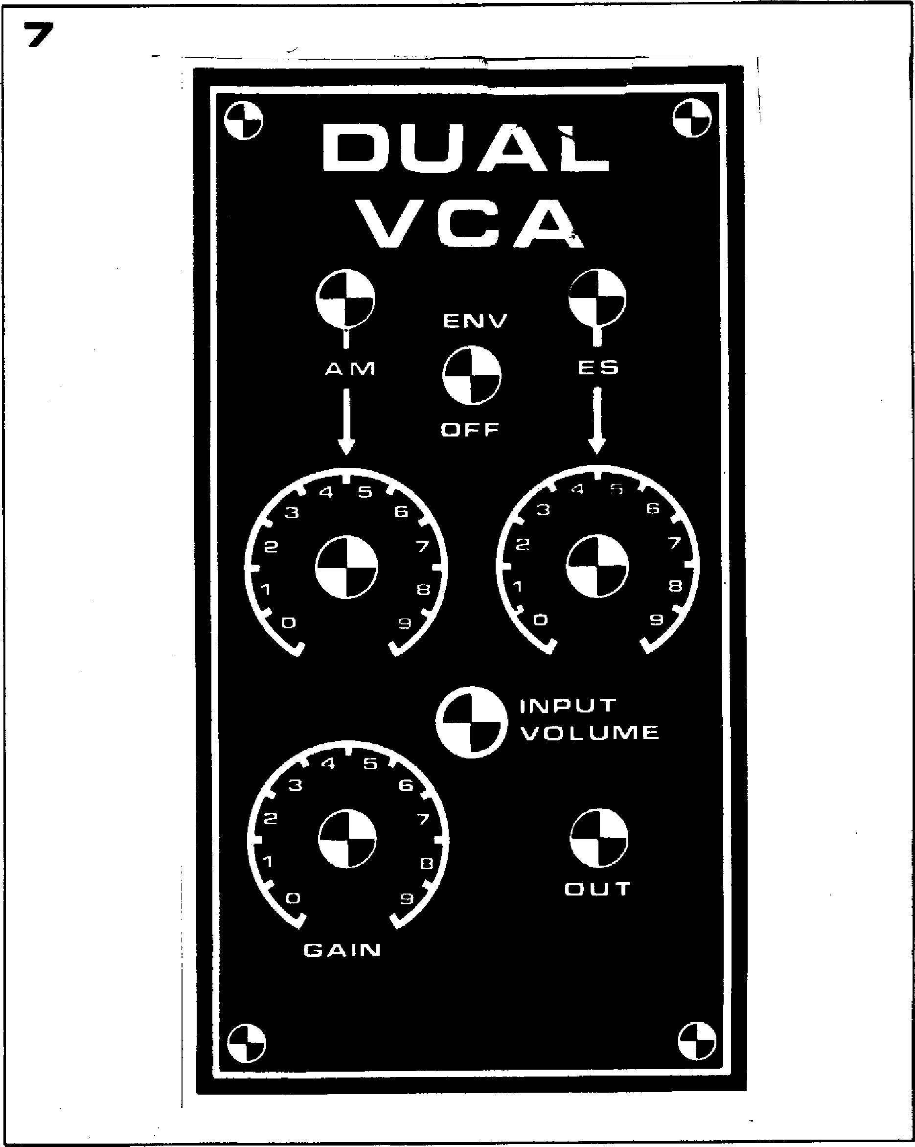

**Figure 7 Front panel layout of the VCA. is located between the AM and ES input sockets. Immediately below these sockets are the respective input level controls: P4 sets the AM modulation depth and P5 is the external input level control Below these again are the modulation indicator (D5), the manual gain control (P3) and the output socket (EOS).**

**the AM input of the VCA. The IOS output of the VCA is monitored on the oscilloscope and the offset nulling procedure is repeated, this time using P8.**

**Adjustment of exponential gain control**

**The exponential converter must be adjusted so that the required gain control range of IC6 is obtained from the +0.5 V to +5 V range of the envelope shaper.**

**Si of the envelope shaper is set to the `AD' position and fairly short attack and decay times are selected. The short circuit across the VCA input is removed, the VCF level control is turned to maximum and a signal is fed in from one of the VCOs. P2 on the VCA board is initially set to its mid-position.**

**The output of 106 is now monitored with an oscilloscope and a key is repeat­edly depressed, when AD envelope curves should be seen. P1 is then adjusted for minimum feed through when the key is not depressed, less than one or two millivolts will be acceptable. The Y sensitivity of the oscilloscope is now adjusted so that the entire envelope curve can be seen when a key is depressed. P2 should then be adjusted until a good attack/decay curve without limiting (seen as a flat top or plateau as**

**shown in figure 3d) is just obtained. Since P1 and P2 interact to some extent, it may be necessary to repeat the adjustment procedure several times to obtain the best results.**

**Adjustment of overall gain**

**The overall gain of the VCA should be**

**dB (unity) at maximum modulation of IC6 and 1C7. To achieve this it may be necessary to alter the value of R29, which is nominally 15 k. Set the gain control P3 to maximum, and the envelope shaper to the 'ADSR' mode with 100% sustain. A key is now depressed and held down, and the output level of the VCA (at IOS or EOS) is compared with the input level at IS. These levels should be the same; if the output level is too low, then R29 must be increased in value, and if the output level is too high then R29 must be reduced. A 3 dB difference (x 0.707 or x 1.414) between the input and output levels is acceptable.**

**This completes the adjustment of the VCA.**

**Use of the VCA**

**The input signal level to the internal   
input of the VCA is controlled by the   
output potentiometer of the VCF. In**