**076 — FORMANT**

**LFOs and noise module**

**The low frequency oscillators and noise generator are invaluable components in a synthesiser system. The LFOs allow amplitude and frequency modulation of the VCO outputs to provide tremolo, vibrato and other effects. The noise sources can be used for random modulation of the VCO signals, and in addition can be used as signal sources themselves.**

**Mambos he* already been made of the figt that conventional instruments exhibit more 'life' and variation in tonal emaingir than ntectrosic instruments due hi the way in -which they are played. For example, sal lio instruments and woodwind insteps/lets can exhibit marked** .**tremolo Tit vibrato due to variations in the *who or blowing. The keyboard of a mgothosiser provides a• relatively inflexile sad expressionless means of playing' that does not allow these nuances to he introduced into the sound, and in order to make the sound more 'lively' ampillaide and frequency modulation must be introduced using the LFOs and noise 110111fCe.**

**The noise source AID provides the basic material to produce a whole spectrum of sounds that do not have a defined pitch. White no* can be used to produce sounds such as wind, rain and surf. 'Coloured' mein, which is white noise with the low frequency com­ponents boosted, is used for sounds having a strong b content, such as the rumbling of thunder.**

**In addition to modulating the VCO signals, noise can 116P0 be added to these signals to simulate wind noise in organ pipes and woodwind instruments.**

**The. FO_ „**

**frequency function produce three diff Each LEO module con tw**

**basically low­**

**enerators that**

**nt waveforms.**

**s three LFOs,**

**al and produce**

**square, triangle and sawtooth**

**waveforms. The third LFO produces a triangular waveform and two sawtooth waveforms in antiphase with each other, i.e. one with a positive-going ramp and the other with a negative-going ramp.**

**The circuit of LFO1 is shown in figure la; LFO2 is identical. The basic oscillator circuit consists of two op-amps IC1 and A3 connected respectively as an integrator and a Schmitt trigger. When the output of A3 is positive a potential of about +2.5 V (depending on the position of the wiper of P3) is applied to R9. The full positive output voltage of A3 is applied to Pl, so a current (dependent on the wiper position of P1) flows into the integrator through RI . The output of IC1 ramps negative until it reaches about —2.5 V, when the voltage on the non-inverting input of A3 will fall below the voltage on the inverting input (zero volts) and the output of A3 will swing negative. The voltage applied to R9 is now —2.5 V, and the full negative output voltage of A3 is applied to P1. Current will flow out of the integrator through RI, and the integrator output will ramp positive until it reaches about +2.5 V, when the voltage on the non-inverting input of A3 will rise above zero and the output of A3 will swing positive. The whole cycle then repeats.**

**The output from IC1 is thus a triangular waveform with a peak-to-peak voltage of about 5 V, while at the wiper of P3 a squarewave of the same amplitude and frequency is available. P3 presets the trigger threshold of A3 and hence the signal amplitude. P1 is used to adjust the frequency of the LFO by varying the voltage applied to the integrator input, which alters the integrator input current and hence the rate at which the integrator ramps positive or negative. The triangular wave output is taken direct from IC1 via R13, whilst the squarewave output is buffered by voltage follower A4. The sawtooth waveform is derived from the triangle by A2. When the output of A3 is positive and the triangle output is on its negative-going slope, T1 is turned on, grounding the'non-inverting input of A2. A2 thus functions as a unity-gain inverting amplifier, producing a positive-going ramp. When the output of A3 is negative and the output of IC1 is positive going, Ti is turned off and A2 functions as a unity-gain non-inverting amplifier (voltage follower), again pro­ducing a positive-going ramp. The positive- and negative-going ramps of the triangular waveform are thus converted into a series of positive-going ramps. Since every half-cycle of the triangle is converted into a full cycle of the sawtooth, the frequency of the sawtooth is twice that of the triangle and square waveforms, as illustrated in figure 2.**

**To indicate that the LFO is functioning a LED indicator, constructed around Al , is connected to the triangle output.**

**FORMANT — 077**

**Figure la. Circuit of LFO 1, which is identical to LFO 2 and produces triangle, sawtooth and square waveforms.**

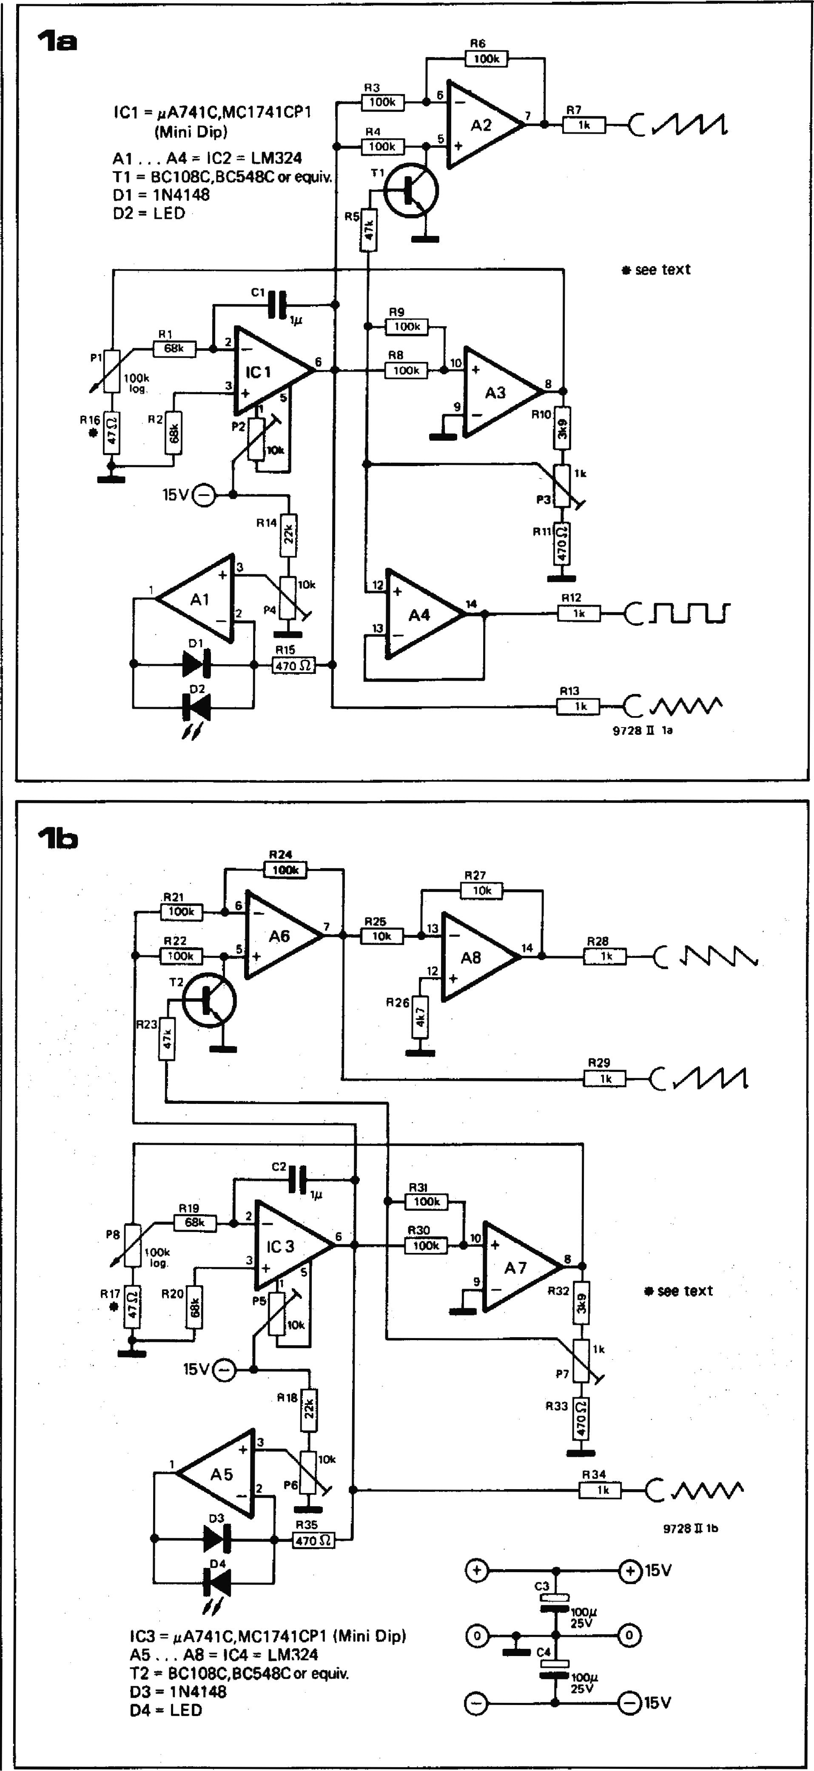

**Zia**

**P2**

R14

**A8**

**R30**

**A7**

**R28**

**R18**

**R22**

**T2**

**R25**

**R26**

**015V**

**lb**

**R33**

**P6**

**R34**

**Figure lb. LFO 3 also produces three waveforms, but instead of a squarewave output a negative-going sawtooth is provided.**

**The third LFO circuit, shown in figure lb, is similar to the first circuit, with two exceptions. Firstly, no squarewave output is provided; sec­ondly, a sawtooth with negative-going slope is provided by A8, which inverts the positive-going sawtooth from A6.**

**Construction of the LFO module Figure 3 shows the printed circuit board and component layout of the LFO module, which of course contains three LFOs. The components for LFO2 are identical to those for LFO1, being distinguished on the board and in the components list by an apostrophe ('). The board layout is fairly cramped, and care should be taken when soldering components to avoid solder bridges. A front panel layout is given in figure 4.**

**Adjustment of the LFOs**

**Each LEO requires four adjustments:   
P3, P3' and P7 set the signal amplitude.**

* **P2, P2' and P5 null the offset of the integrators.**
* **R16, R16' and R17 must be selected to set the lowest frequency of the LFO.**
* **P4, P4' and P6 adjust the LED indi­cators.**

**The adjustment procedure, which is identical for all three LFOs, will be described for LFO1.**

**Amplitude adjustment**

1. **Monitor the triangle output on an oscilloscope; set P2 to its mid-position and P1 for maximum fre­quency.**
2. **Adjust P3 to give a peak-to-peak output of 5 V.**
3. **Check the amplitude and waveform of the other outputs.**

**Offset adjustment**

1. **Disconnect RI from the wiper of PI and ground it.**
2. **Monitor the output voltage of IC1 with a multimeter. It will probably exhibit a tendency to drift positive or negative, and the voltage will settle at +15 V or —15 V. Reset the**

**0711— FORMANT**

**output voltage to zero by discharging Cl through a 1 k resistor. Adjust P2 until the voltage remains stable at zero volts for a period of several seconds (without the discharge re­sistor in circuit). Repeat this adjust­ment, progressively switching the multimeter to more sensitive ranges until the drift is only a few hundred millivolts in several seconds.**

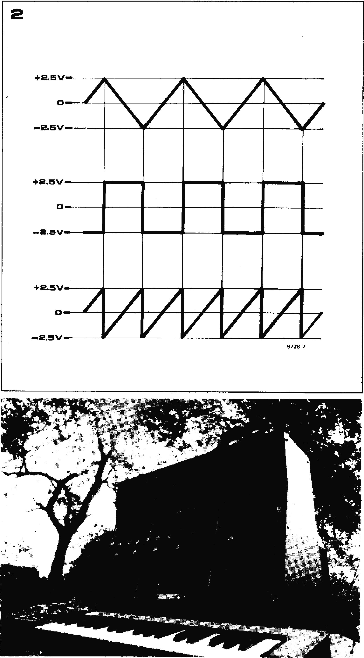

**Careful adjustment of the offset is vital,   
as it determines the minimum fre-**   
**quency at which the LFO will operate**

**reliably and the symmetry. of the waveforms at low frequencies.**

**Selection of R16**

**The value of R16 determines the minimum integrator input voltage that can be set by Pl, and hence the minimum frequency of the LFO. The value of R16 must not be chosen too high or the minimum LFO frequency will be too great. On the other hand it should not be chosen too low, or the integrator input current at the minimum**

**Figure 2. Showing the phase relationship of the triangle, square and sawtooth waveforms. Since the sawtooth is derived by inverting alternate half-cycles of the triangle waveform, its frequency is twice that of the other waveforms.**

**Figure 3. Printed circuit board and**

**component layout for the LFO module (EPS 9727-11.**

**setting of PI will be comparable with the input currents of ICI. This will result in unreliable operation of the oscillator at low frequencies.**

**R16 should be chosen so that the minimum frequency of the LFO is about one cycle every three minutes, but the value of R16 should not be less than 10 S2. If it is not possible to obtain this low frequency then the input currents of IC1 may be too high, or Cl may be leaky.**

**The maximum LFO frequency is about 20 Hz.**

**FORMANT — 079**

**R10,R10',R32 = 3k9**

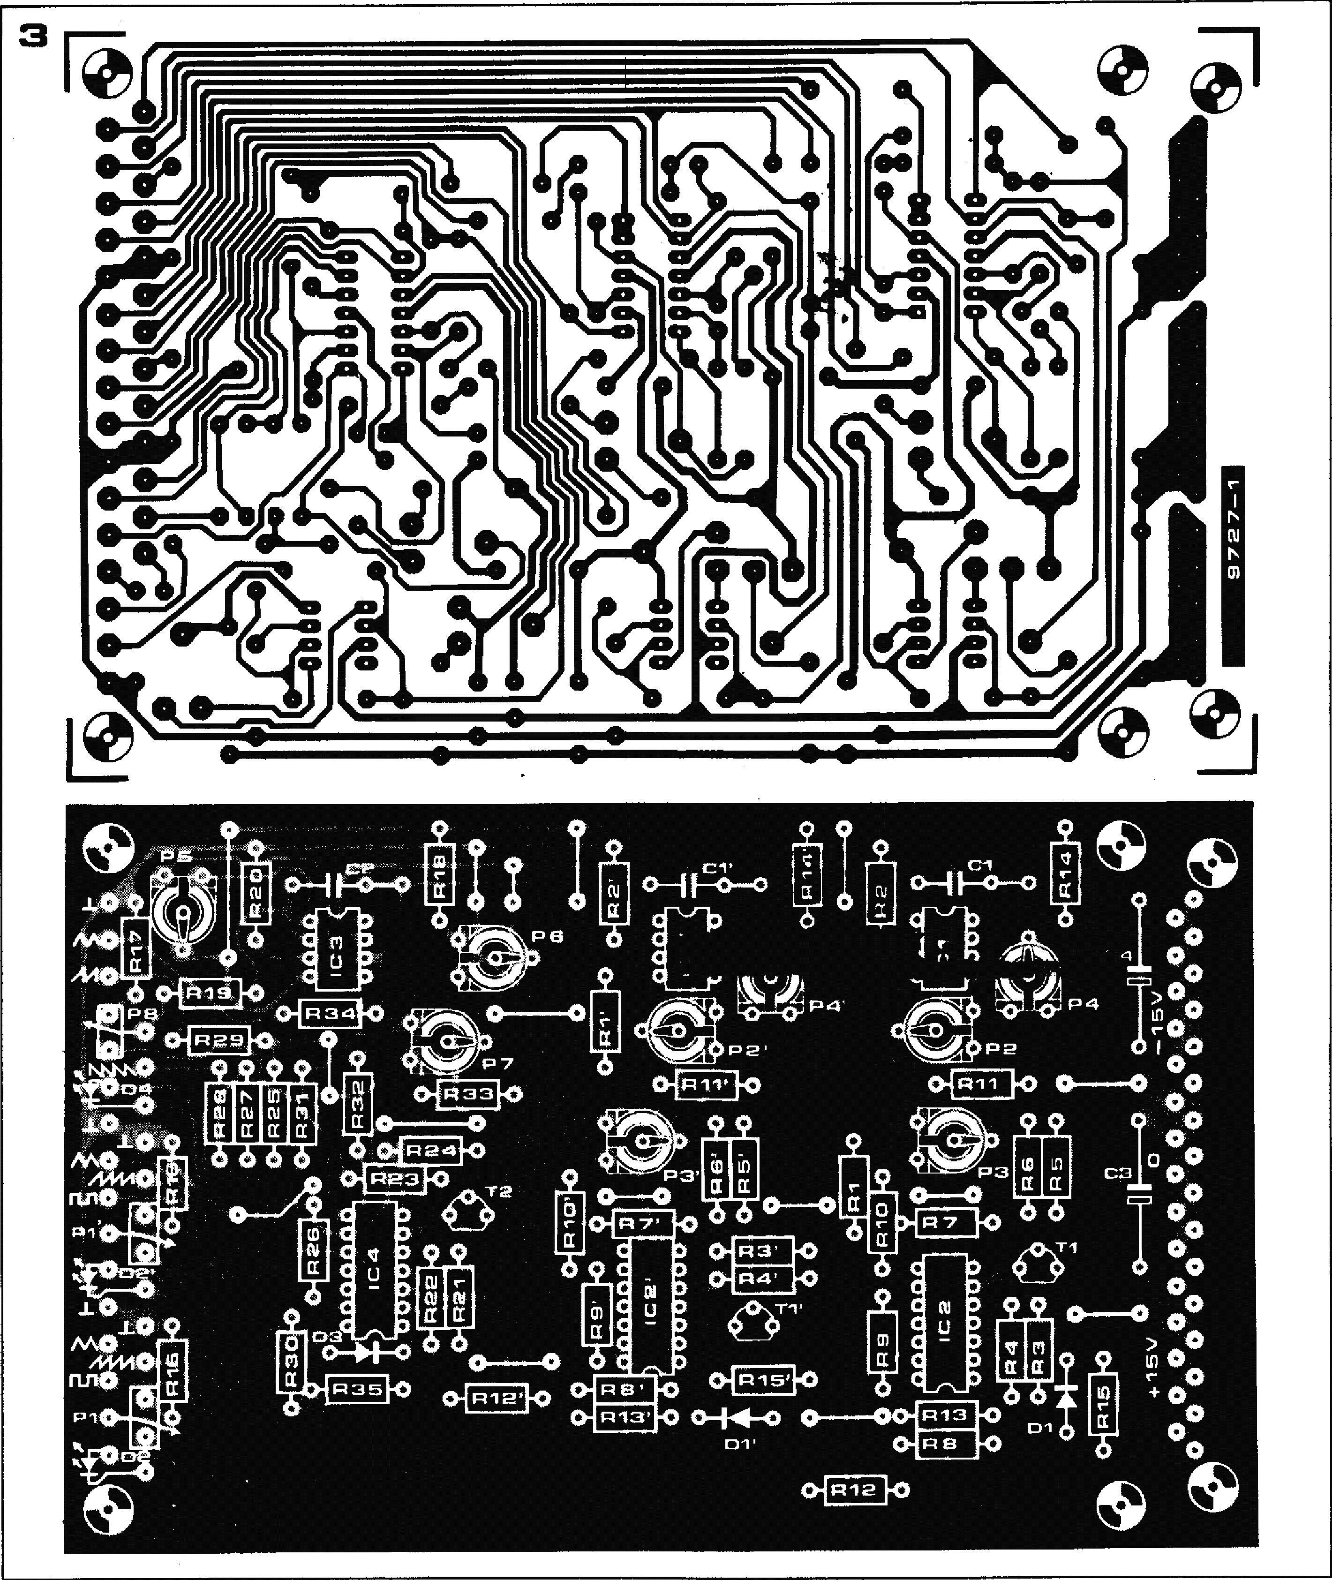

|  |  |  |  |
| --- | --- | --- | --- |
| **Parts list for LFO module** | **R11,R11',R15,R15',R33, R35 = 470** n | **Semiconductors: 1C1,IC1',IC3 *=ALA* 741C,** | **Capacitors:**  **C1,C1',C2 = 1 g (polyester or** |
| **Resistors:** | **R14,R14',R18 = 22 k** | **MC 1741CP1 (Mini DIP)** | **polycarbonate)** |
| **R1,R1',R2,R2',R19,R20 = 68 k** | **R16,R16',R17 = 47 St (see text)** | **1C2,1C2',IC4 = LM 324 (DIP)** | **C3,C4 = 100 )2/25 V** |
| **R3,R3',R4,R4',R6,R6',R8,R8', R9,R9',R21,R22,R24,R30,** | **R26 = 4k7** | **T1,T1',T2 = BC 108C, BC 548C or  equivalent** | **Miscellaneous:** |
| **R31 = 100 k** | **Potentiometers:** | **D1,D1',D3 = 1N4148, 1N914** | **31-way connector (DIN 41617)** |
| **R5,R5',R23 = 47 k** | **P1,P1',P8 = 100 k log** | **D2,D2',D4 = LED (e.g. TI L209)** | **9 x 3.5 mm jack** |
| **R7,R7',R12,R12',R13,R13',R28, R29,R34 = 1 k** | **P2,P2',P4,P4',P5,P6 = 10 k preset P3,P3',P7 = 1 k preset** |  | **3 x 13 ... 15 mm knobs** |

**080 — FORMANT**

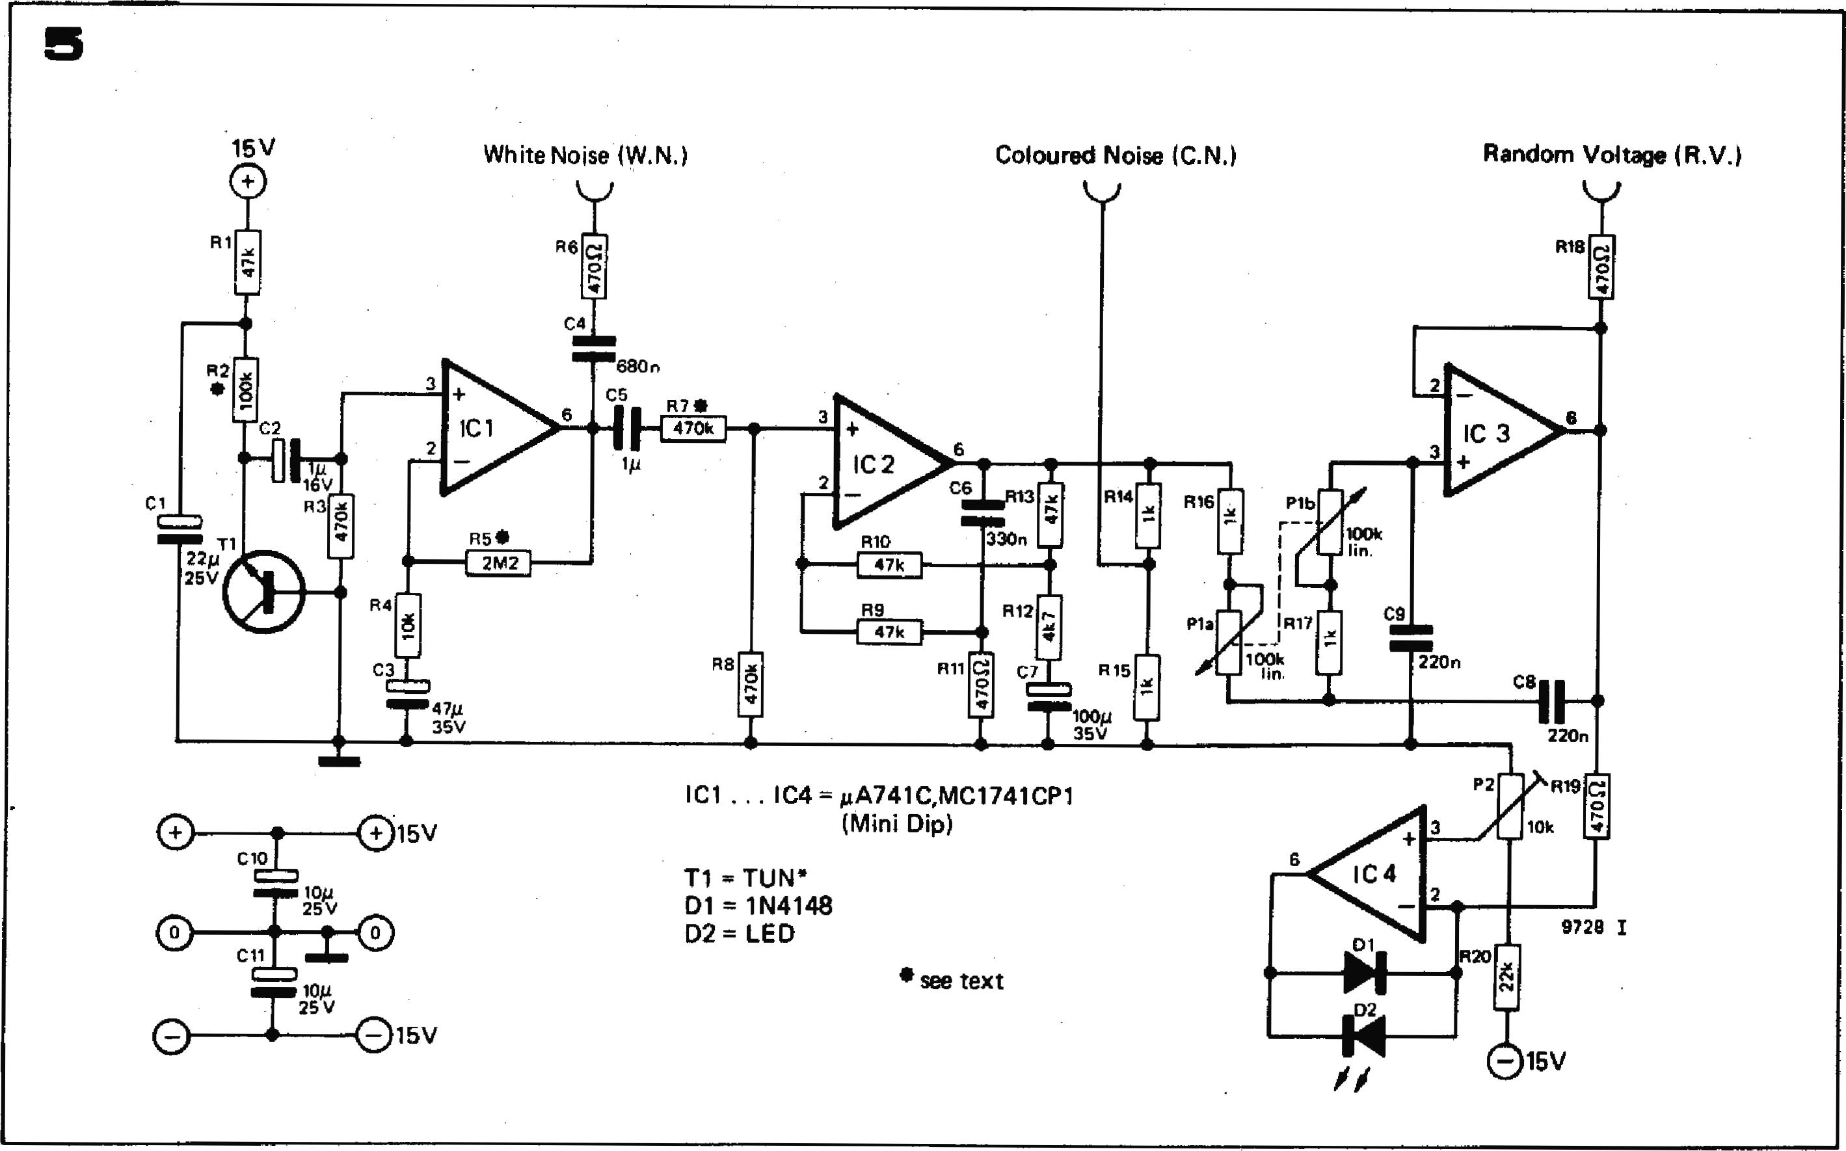

**R8**

**15V**

**2**

**RO**

**R18**

**15V**

**R20**

|  |  |
| --- | --- |
|  |  |
| **Figure 4. Front panel layout of She LFO module.**  **Figure 5. Circuit of the noise module.**  **Figure 6. Printed circuit board and com­ponent layout for the noise module (EPS 9728.1**). |
|  |