**080 — FORMANT**

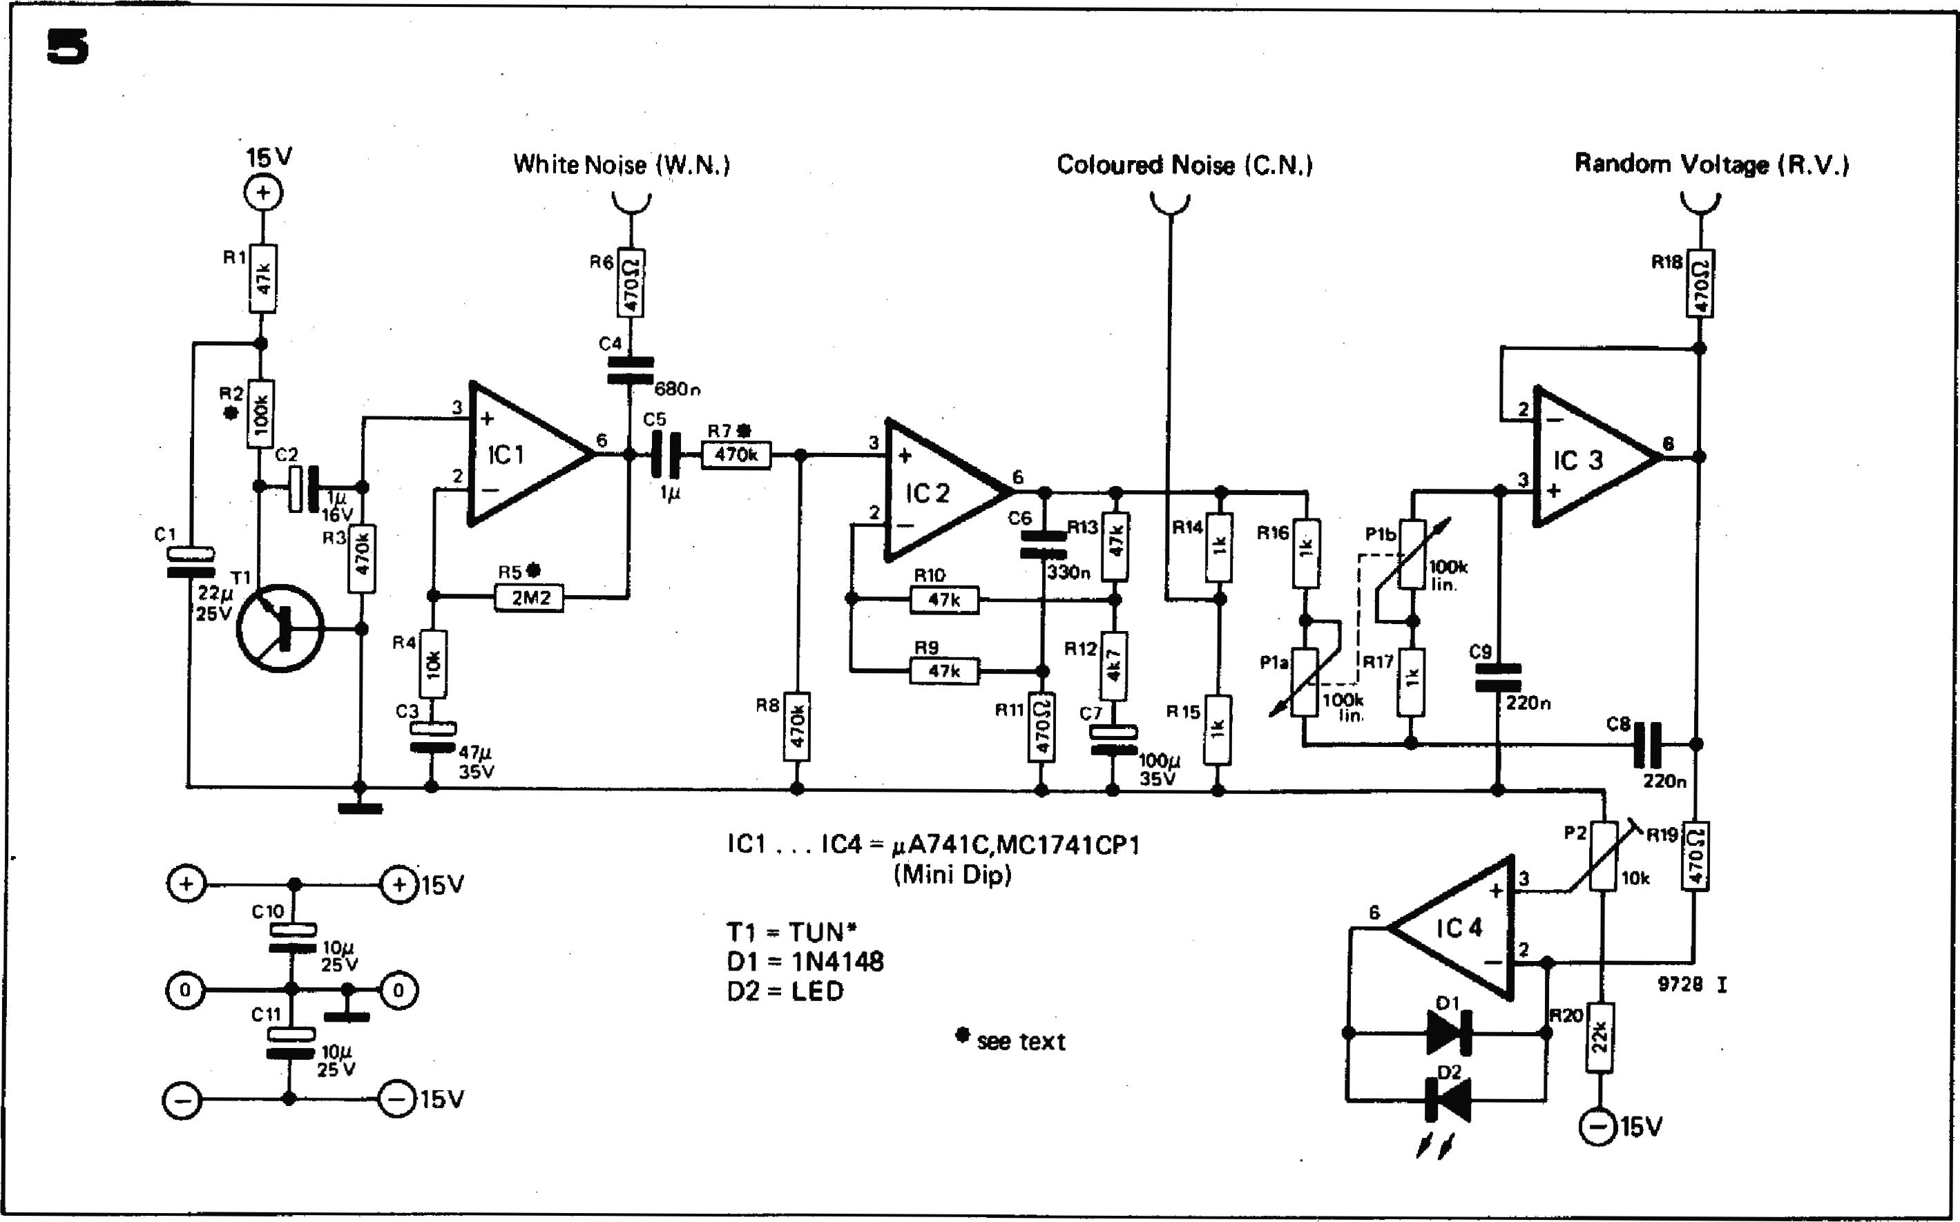

**6**

**IC 2**

1

**R510 2M2**

**R8**

**White Noise (W.N.)**

**R6**

**C4**

**2**

**330n**

**IC 3**

**100k**

**C9**

**220n**

**CS**

**220n**

**15V**

R

**3**

**R2   
•**

**2**

**16V**

**R3**

O

**25v**

**RO**

**7P**

**35V**

C1

**Coloured Noise iC.N.)**

V

**Random Voltage (R.V.)**

**R18**

**IC1 , IC4 = AA741C,MC1741CP1**

**(Mini Dip)**

**T1 = *TUN\****

**D1 1N4148**

**D2 = LED**

**9728 I**

* **see text**

**15V**

**R20**

N

**//**

|  |  |
| --- | --- |
|  |  |
| **Figure 4. Front panel layout of She LFO module.**  **Figure 5. Circuit of the noise module.**  **Figure 6. Printed circuit board and com­ponent layout for the noise module (EPS 9728.1**). |
|  |

**FORMANT — 081**

[Ill.t.cl](http://Ill.t.cl) 0o0

**00**

-15k/o0

o

**cj 0**

**o v 0**

**0**

**0o**

**0**

**00**

**+-isv**

**0 0o Oa**

**4!!!**

4t1

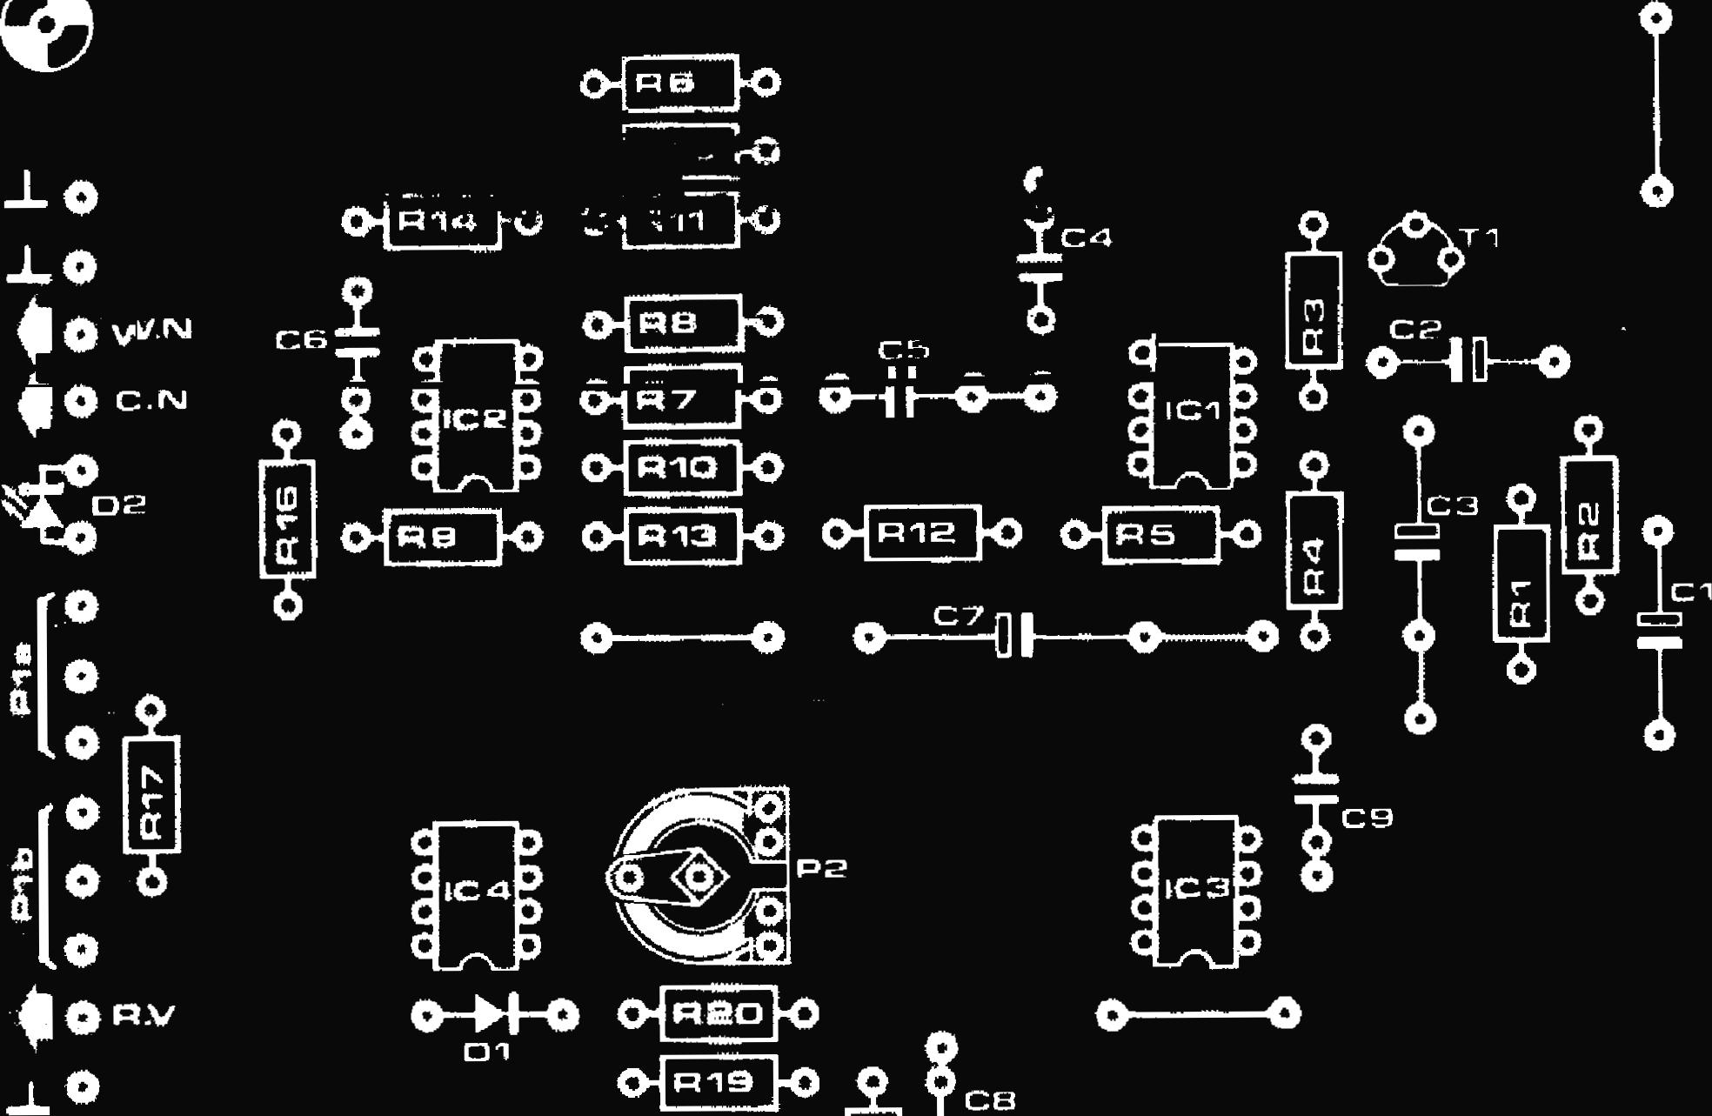

**a**

C

C

C

C

1C3

O------O

0-1pri 9 10

**C**

**0-01-0 04R20**

**c3-1**

**P**2

iF a

R8

**Ft**' **11:1 0-1**

**Ft10** •

**1.0 Of R13 I-0 0-11R12. 10 0.18**5 f

**0-52-0 I 0—*0**

15 JO

- ri4

AryO i x i

I

C1

I

**C D**

**C IC** 4 **D**

**D**

Ei

r

**a**

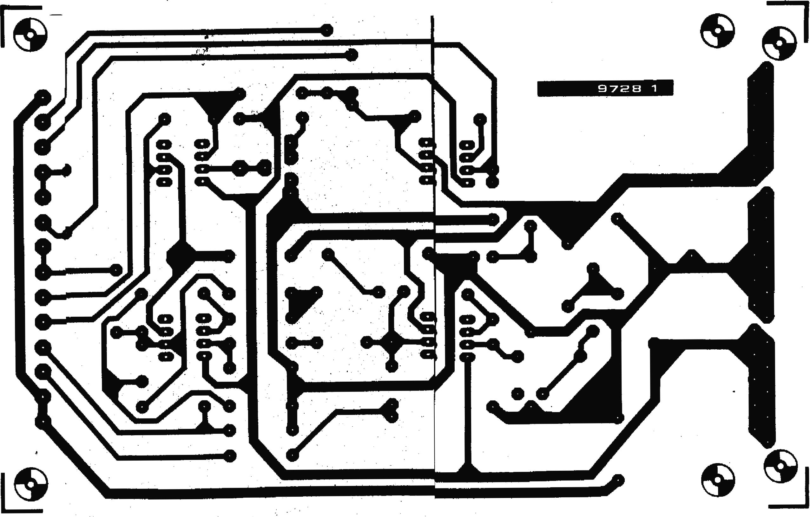

|  |  |  |  |
| --- | --- | --- | --- |
| **Parts list for noise module** | **Capacitors:** | **Semiconductors:** | **Potentiometers:** |
| **Resistors:** | **C1 = 2214/25 V**  **C2 = 1 g/16 V** | **IC1,1C2,1C3,1C4, =*14A* 741C, MC 1741CP1 (Mini DIP)** | **P1 = 100 k lin. ganged potentiometer** |
| **R1,R9,R10,R13 = 47 k** | **C3 = 4714/35 V** | **T1 = TUN (selected)** | **P2 = 100 k preset** |
| **R2 = 100 k (see text)** | **C4 = 680 n** | **= 1N4148, 1N914** |  |
| **R3,R7,R8 = 470 k** | **C5 = 1 1.4 (polyester or** | **D2 = LED (e.g. TIL 209)** | **Miscellaneous:** |
| **R4 = 10 k** | **polycarbonate)** |  | **1 x transistor socket** |
| **R5 = 2M2 (see text)** | **C6 = 330 n** |  | **1 x 31-way connector (DIN** |
| **R6,R11,R18,R19 =470** sz | **C7 = 10014/35 V** |  | **41617)** |
| **1312 4k7** | **C8,C9 = 220 n** |  | **3 x 3.5 mm jack sockets** |
| **R14,R15,R16,R17 = 1 k** | **C10,C11 = 1014/25 V** |  | **1 x 13 ... 15 mm knob** |
| **R20 = 22 k** |  |  |  |

**082 — FQRMANT**

**Adjustment of the LED indicator**

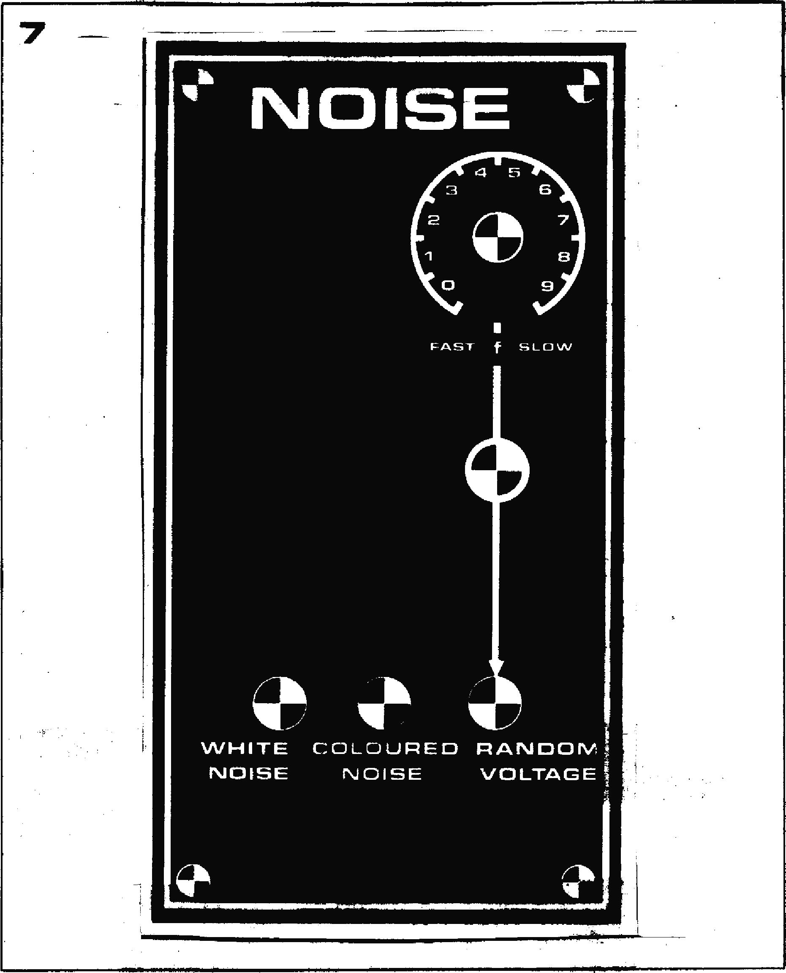

**WHITE COLOURED RANDOM NOISE NOISE VOLTAGE**

**Figure 7. Front IMAM "Went of Ike min module.**

**P4 should be adjusted so that the brightness of the LED follows the amplitude of the triangle output, i.e. the LED should be at minimum brightness when the triangle voltage is at its most negative, and at maximum brightness when the triangle is at its most positive. P4 should adjusted so that the LED . brightness does not reach maximum before the peak of the triangle, but on the other hand it should not extinguish completely before the trough of the triangle.**

**The noise module**

**The complete circuit of the noise module is shown in figure 5. The noise is produced by the base-emitter junction of an NPN transistor T I, which is reverse-biased. The noise is amplified to a level of about 2.5 V peak-to-peak. This white noise output is fed out via C4 and R6.**

**The white noise is also fed into a filter constructed around 1C2, which has two frequency dependent elements in the feedback path. These two elements interact as follows. On its own, the feedback network comprising R10, R12, R13 and C7 would produce a 6 dB/octave rise in the gain of 1C2, from 0 dB at zero Hz via 3 dB at 9 Hz to approximately 20 dB at 90 Hz. The feedback network R9, R11, C6, on its own would produce a 6 dB/octave fall in gain from 0 Hz to 1 kHz, above which the gain would remain constant at 0 dB.**

**The combined effect of these feedback networks is that below 90 Hz the 6 dB/octave rise and 6 dB/octave fall cancel out, giving a gain of 20 dB. Above 90 Hz the gain falls at 6 dB/oc­tave to 0 dB at 1 kHz, above which it remains constant. The reset is that the bass end of the noise spectrum is boosted, and 'coloured' noise is avail­able at the output of IC2. The coloured noise output is taken from the junction of R14 and R15.**

**The coloured noise output is also fed to a second filter built around IC3. This is a 12 dB/octave lowpass filter with variable turnover frequency, which passes only the very low frequency components to produce an extremely low frequency 'random voltage'. The fluctuation rate of this random voltage is adjusted by means of P1, which varies the turnover frequency of the filter. Fluctuations of the random voltage are displayed on a LED indicator, which is identical to those used in the LFOs.**

**Construction and adjustment of the noise module**

**A printed circuit board and component layout for the noise module are given in figure 6, and the front panel layout is given in figure 7.**

**As not all transistors are suitable noise   
generators, a socket should be fitted in**

**the TI position on the board so that different transistors may be tried. Measuring with a multimeter on a suitable AC voltage range at the white -noise output,----a—voltage of 0.5 V to 0.8 V should be present. Alternatively, if an oscilloscope is used to monitor the output, a noise signal of about 2 V to 2.8 V peak-to-peak should be obtained. It may be necessary to try several transistors before a suitable one is found. Varying the value of R2 between 33 k and 150 k may also help.**

**If the transistor produces too high a noise level this can be reduced by making R5 smaller, thus reducing the gain of IC1.**

**The amplitude of the coloured noise output should also lie in the same range as the amplitude of the white noise output. If it is too small then R7 should be reduped and if it is too large R7 should be increased.**

**The random voltage output should vary between about +2.5 V and —2.5 V with P1 in the 'fast' position.**

**The final adjustment to the noise module is to set P2 so that the LED brightness indicates the amplitude of the random voltage output in a linear manner. This adjustment is carried out in exactly the same way as the ad­justment of the LFO indicators.**